kimkat3830 THE ENGLISH ELEMENT IN WELSH. A STUDY OF ENGLISH LOAN-WORDS IN WELSH. T. H. Parry-Williams. 1923.
…..
 | 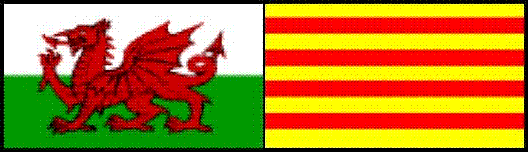  (delwedd 0003) | Gwefan Cymru-Catalonia  El Web de Gal·les i Catalunya  The Wales-Catalonia Website  THE ENGLISH ELEMENT IN WELSH. A STUDY OF ENGLISH LOAN-WORDS IN WELSH.  T. H. Parry-Williams.  1923.  Rhan 3 – Tudalennau 200-278  Y Llyfr Ymwelwyr / El Llibre de Visitants / The Guestbook:  http://pub5.bravenet.com/guestbook/391211408/  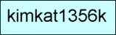  Beth sy’n newydd yn y wefan hon? | 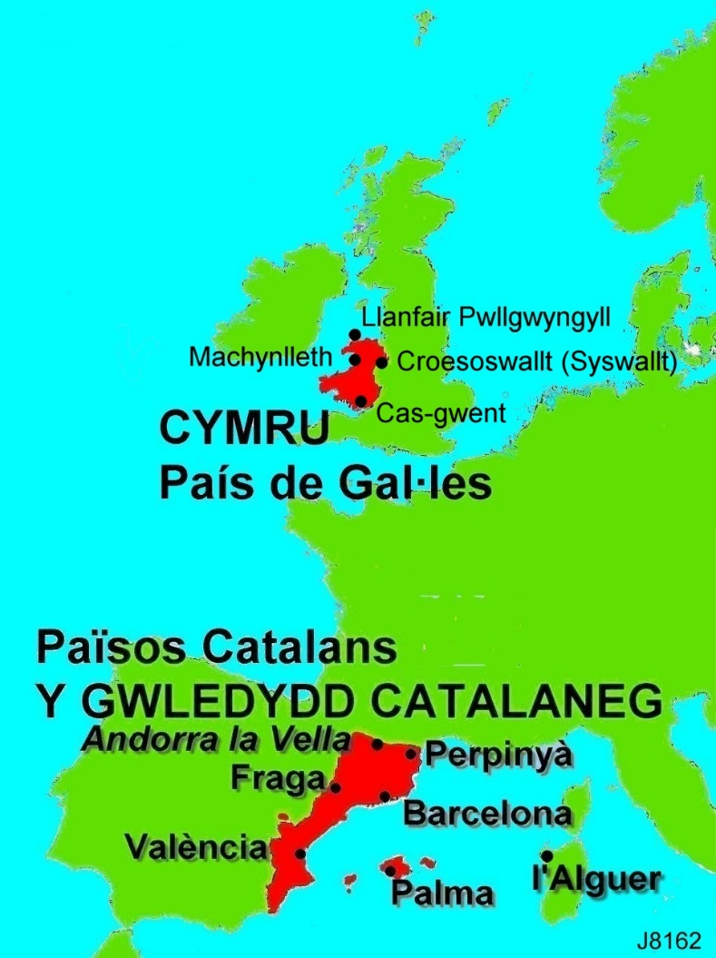  (delwedd J8162)

Lythrennau gwyrddion = y testun heb ei gywirio
Lythrennau duon = y testun wedi ei gywirio
…..
RHAN 1
Tudalennau 000-099
www.kimkat.org/amryw/1_testunau/english-element-in-welsh_1923_363_rhan-1_3828.htm
…..
RHAN 2
Tudalennau 100-199
www.kimkat.org/amryw/1_testunau/english-element-in-welsh_1923_363_rhan-2_3829.htm
…..
Ar ffurf tudalen FDG = FFORMAT DOGFEN GLUDADWY / PORTABLE DOCUMENT FORMAT = PDF:
http://www.kimkat.org/amryw/1_testunau/english-element-in-welsh_1923_363_fdg-pdf_3831.pdf
…..
Y PRIF DUDALEN AR GYFER Y LLYFR HWN / la pàgina principal per a aquest llibre / Main Page for this book
www.kimkat.org/amryw/1_testunau/english-element-in-welsh_1923_363_cyflwyniad_3827.htm

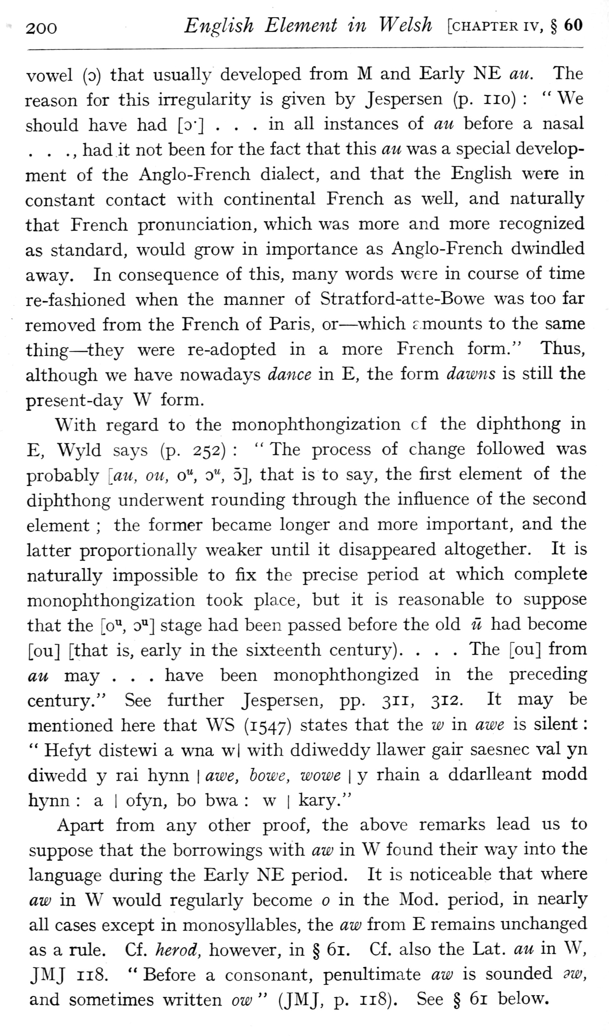  (delwedd F6951) (tudalen 200) | 200 English Element in Welsh [chapter iv, § 60  vowel (o) that usuall}- developed from M and Early NE ait. The reason for this irregularity is given by Jespersen (p. no): “We should have had [o"] • . .in all instances of an before a nasal . . . , had it not been for the fact that this an was a special development of the Anglo-French dialect, and that the English were in constant contact with continental French as well, and naturally that French pronunciation, which was more and more recognized as standard, would grow in importance as Anglo-French dwindled away. In consequence of this, many words were in course of time re-fashioned when the manner of Stratford-atte-Bowe was too far removed from the French of Paris, or — which r mounts to the same thing — ^they were re-adopted in a more French form." Thus, although we have nowadays dance in E, the form dawns is still the present-day W form.  With regard to the monophthongization cf the diphthong in E, Wyld says (p. 252): “The process of change followed was probably [au, on, o", o", 5], that is to say, the first element of the diphthong underwent rounding through the influence of the second element; the former became longer and more important, and the latter proportionally weaker until it disappeared altogether. It is naturally impossible to fix the precise period at which complete monophthongization took place, but it is reasonable to suppose that the [o'^, o'^] stage had been passed before the old li had become [ou] [that is, early in the sixteenth century). . . . The [ou] from au may . . . have been monophthongized in the preceding century." See further Jespersen, pp. 311, 312. It may be mentioned here that W^S (1547) states that the w in awe is silent: “Hefyt distewi a wna w| with ddiweddy llawer gair saesnec val yn diwedd y rai hynn | awe, howe, wowe | y rhain a ddarlleant modd hj'nn: a i ofyn, bo bwa: w | kary."  Apart from any other proof, the above remarks lead us to suppose that the borrowings with aw in W found their way into the language during the Early NE period. It is noticeable that where aw in W would regularly become in the Mod. period, in nearly aU cases except in monosyllables, the aw from E remains unchanged as a rule. Cf. herod, however, in § 61. Cf. also the Lat. au in W^ JMJ 118. “Before a consonant, penultimate aw is sounded 9W, and sometimes written ow” (JMJ, p. 118). See § 61 below.
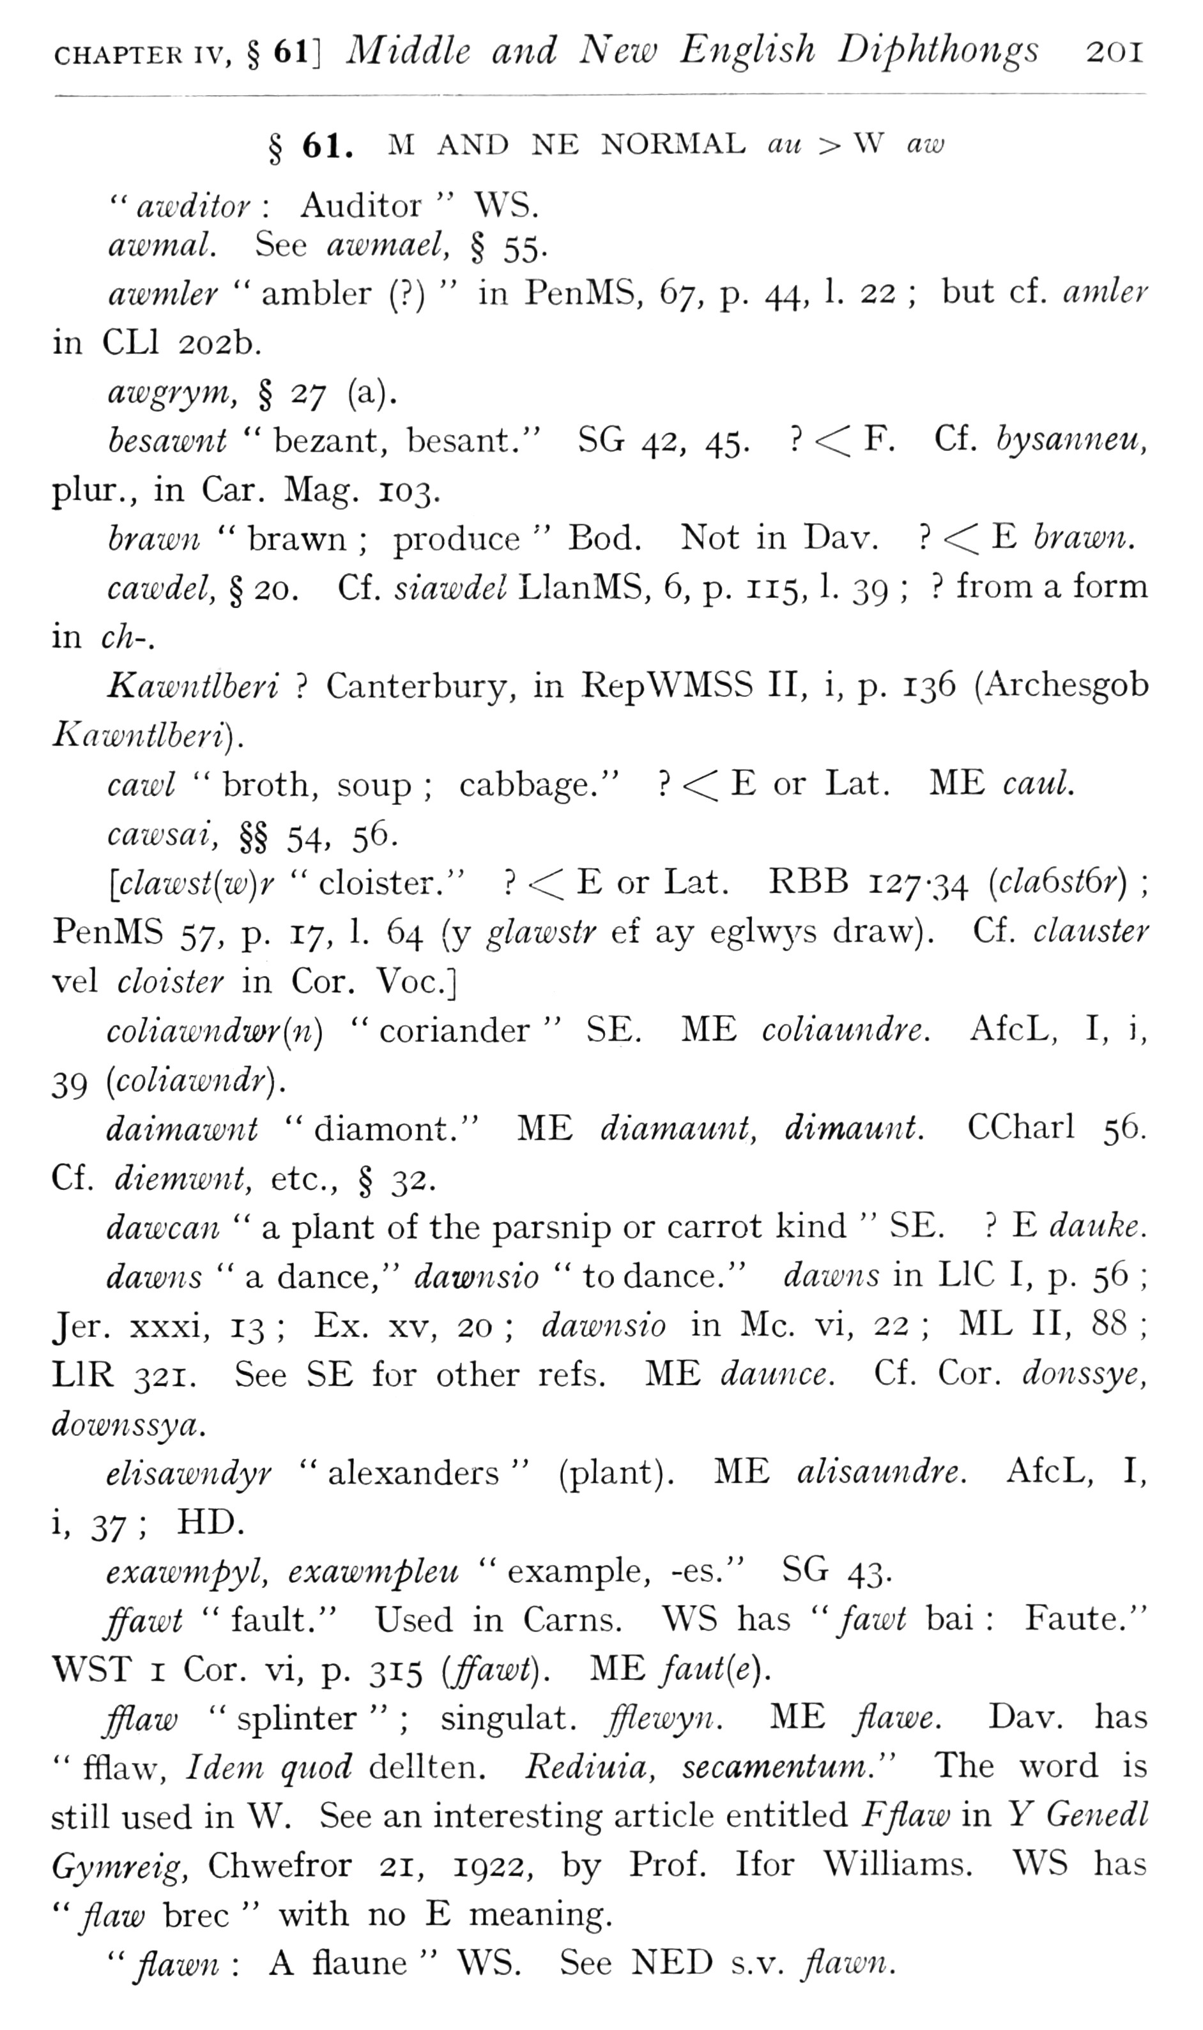  (delwedd F6952) (tudalen 201) | CHAPTER IV, § 61] Middle and New English Diphthongs 201  § 61. ^I AND NE NORMAL au > W aw  " awditor: Auditor “WS. awmal. See awmael, § 55.  awmler “ambler (?) “in PenMS, 67, p. 44, 1. 22; but cf. amler in CLl 202b.  awgrym, § 27 (a).  hesawnt “bezant, besant," SG 42, 45.? <C F. Cf. bysanneu, plur., in Car. Mag, 103.  brawn “brawn; produce “Bod. Not in Dav.? <C E brawn.  cawdel, § 20. Cf. siawdel LlanMS, 6, p. 115, 1. 39;? from a form in ch-.  Kawntlberi? Canterbury, in RepWMSS II, i, p. 136 (Archesgob Kawntlberi) .  cawl “broth, soup; cabbage."? •< E or Lat. ME caul.  cawsai, §§ 54, 56.  [clawst{w)r “cloister."? < E or Lat. RBB 127-34 {cla6st6r); PenMS 57, p. 17, 1. 64 (y glawstr ef ay eglw3^s draw). Cf. clauster vel cloister in Cor. Voc]  coliawndmr{n) “coriander “SE. ME coliaundre. AfcL, I, i, 39 [coliawndr).  daimawnt "diamont." ME diamamit, dimaunt. CCharl 56. Cf. diemwnt, etc., § 32.  dawcan “a plant of the parsnip or carrot kind “SE.? E dauke.  dawns “a dance," dawnsio “to dance." dawns in LlC I, p. 56; Jer. xxxi, 13; Ex. xv, 20; dawnsio in Mc. vi, 22; ML II, 88; LIR 321. See SE for other refs. ME daunce. Cf. Cor. donssye, downssya.  elisawndyr “alexanders” (plant), ME alisaundre. AfcL, I,  i,?,7; HD.  exawmpyl, exawmpleu “example, -es." SG 43.  ffawt "fault." Used in Cams. WS has “fawt bai: Faute." WST I Cor. vi, p. 315 (/^ze'O. ME faut{e).  fflaw “splinter”; singulat. fflewyn. ME flawe. Dav. has “fflaw. Idem quod dellten, Rediuia, secamentum." The word is still used in W, See an interesting article entitled Fflaw in Y Genedl Gymreig, Chwefror 21, 1922, by Prof. Ifor Williams. WS has "flaw brec “with no E meaning,  " flawn: A flaune “WS. See NED s.v. flawn.
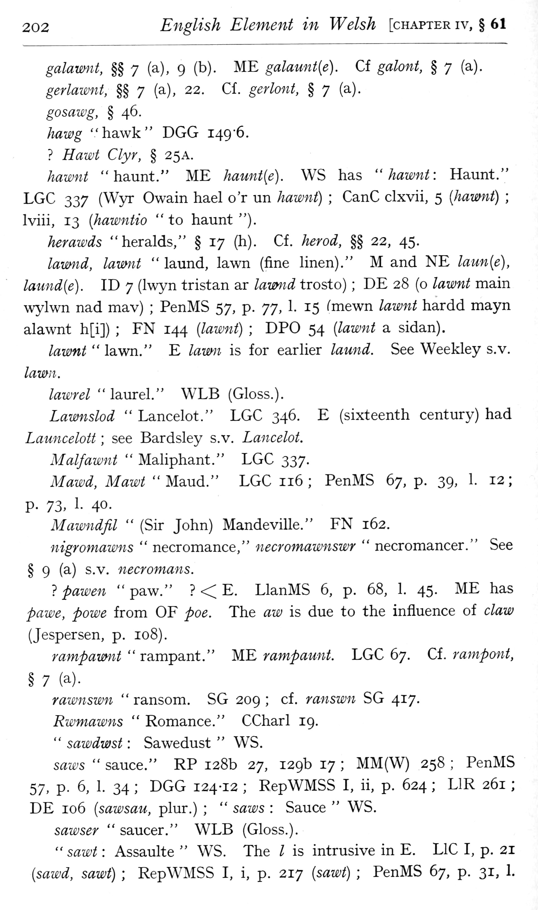  (delwedd F6953) (tudalen 202) | 202 English Element in Welsh [chapter iv, § 61  galamnt, §§ 7 (a), 9 (b). ME galaunt[e). Cf galont, § 7 (a).  gerlawnt, §§ 7 (a), 22. Cf. gerlont, § 7 (a).  gosawg, § 46.  Aflze'g "hawk" DGG I49'6.  ? i7flZ£'i C/y;', § 25A.  hawnt "haunt." ME haunt{e). WS has “hawnt: Haunt." LGC 337 (Wyr Owain hael o'r un hawnt); CanC clxvii, 5 [hawnt); Iviii, 13 [hawntio "to haunt").  herawds "heralds," § 17 (h). Cf. herod, §§ 22, 45.  lawnd, lamnt “laund, lawn (fine linen)." M and NE laun{e), laund{e). ID 7 (Iwyn tristan ar lamnd trosto); DE 28 (o lawnt main wj-^lwn nad mav); PenMS 57, p. 77, 1. 15 fmewn lawnt hardd mayn alawnt h[i]); FN 144 {lawnt); DPO 54 [lawnt a sidan).  lawnt “lawn." E lawn is for earlier laund. See Weekley s.v.  /az^^rg/ "laurel." WLB (Gloss.).  Lawnslod “Lancelot." LGC 346. E (sixteenth century) had Launcelott; see Bardsley s.v. Lancelot. Malfawnt “Maliphant." LGC 337. Mawd, Mawt “Md^nd." LGC 116; PenMS 67, p. 39, 1. 12;  p. 72>, 1- 40-  Mawndfil” (Sir John) Mandeville." FN 162.  nigromawns “necromance," necromawnswr “necromancer." See § 9 (a) s.v. necromans.  } pawen "paw."? < E. LlanMS 6, p. 68, 1. 45. ME has pawe, powe from OF poe. The aw is due to the influence of claw (Jespersen, p. 108).  rampamnt “rampant." ME rampaunt. LGC 67. Cf. rampont,  § 7 (a).  rawnswn “ransom. SG 209; cf. ranswn SG 417.  Rwmawns “Romance." CCharl 19,  " sawdwst: Sawedust “WS.  saw)s “sauce." RP 128b 27, 129b 17; MM(W) 258; PenMS 57, p. 6, 1. 34; DGG 124-12; RepWMSS I, ii, p. 624; LIR 261; DE 106 [sawsau, plur.); “saws: Sauce “WS.  sawser “saucer." WLB (Gloss.).  " sawt: Assaulte “WS. The I is intrusive in E. LlC I, p. 21 [sawd, sawt); RepWMSS I, i, p. 217 [sawt); PenMS 67, p. 31, 1.
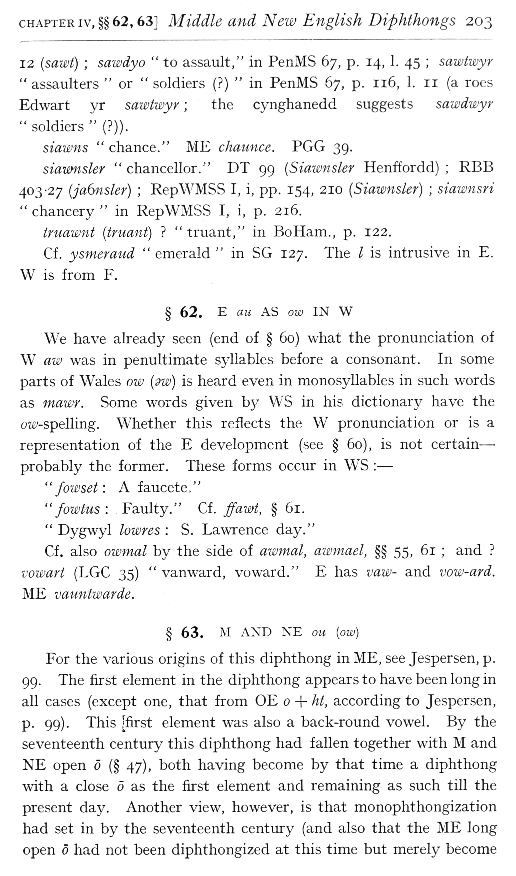  (delwedd F6954) (tudalen 203) | CHAPTER IV, §§62, 63] Middle and New English Diphthongs 203  12 {sawt); sawdyo “to assault," in PenMS 67, p. 14, 1. 45; sawtwyr "assaulters “or "soldiers (?) “in PenMS 67, p. 116, 1. 11 (a roes Edwart yr sawtwyr; the cynghanedd suggests sawdwyr "soldiers" (?)).  siawns “chance." ME chaunce. PGG 39.  siavDusler “chancellor." DT 99 [Siawnsler Henffordd); RBB 403-27 (jaGnsler); RepWMSS I, i, pp. 154, 210 (Siawnsler); siawnsri “chancery “in RepWMSS I, i, p. 216.  truawnt (truant)? "truant," in BoHam., p. 122.  Cf. ysmeraud “emerald “in SG 127. The / is intrusive in E. W is from F.  § 62. E au AS ow IN W  We have already seen (end of § 60) what the pronunciation of W aw was in penultimate S3dlables before a consonant. In some parts of Wales ow (9w) is heard even in monosyllables in such words as mawr. Some words given b}^ WS in hie dictionary have the oix'-spelling. Whether this reflects the W pronunciation or is a representation of the E development (see § 60), is not certain — probably the former. These forms occur in WS: —  ' ' fowset: A f aucete , ' '  " fowtus: Faulty." Ci. ffawt, § 61.  " Dygwyl lowres: S. Lawrence day."  Cf. also owmal by the side of awmal, awmael, §§ 55, 61; and? vowart (LGC 35) “vanward, voward." E has vaw- and vow-ard. ME vauntwarde.  § 63. M AND NE on [ow)  For the various origins of this diphthong in ME, see Jespersen, p. 99. The first element in the diphthong appears to have been long in all cases (except one, that from OE + ht, according to Jespersen, p. 99). This [first element was also a back-round vowel. By the seventeenth century this diphthong had fallen together with M and NE open (§ 47), both having become by that time a diphthong with a close 6 as the first element and remaining as such till the present day. Another view, however, is that monophthongization had set in by the seventeenth century (and also that the ME long open had not been diphthongized at this time but merely become
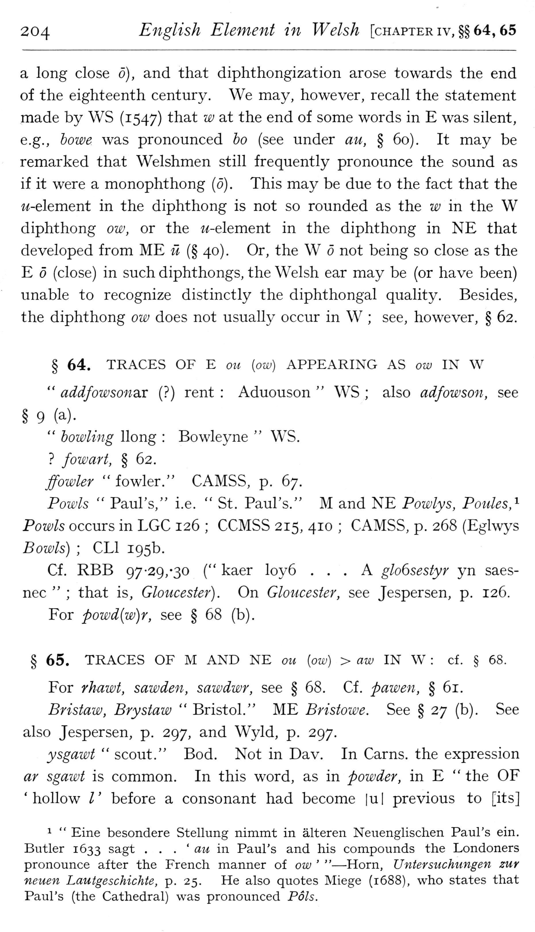  (delwedd F6955) (tudalen 204) | 204 English Element in Welsh [chapter iv, §§64,65  a long close 6), and that diphthongization arose towards the end of the eighteenth century. We may, however, recall the statement made by WS (1547) that w at the end of some words in E was silent, e.g., howe was pronounced ho (see under au, § 60). It may be remarked that Welshmen still frequently pronounce the sound as if it were a monophthong (0) . This may be due to the fact that the w-element in the diphthong is not so rounded as the w in the W diphthong ow, or the w-element in the diphthong in NE that developed from ME il (§ 40). Or, the W not being so close as the E (close) in such diphthongs, the Welsh ear may be (or have been) unable to recognize distinctly the diphthongal quality. Besides, the diphthong ow does not usually occur in W; see, however, § 62.  § 64. TRACES OF E on [ow) APPEARING AS ow IN W “addfowsomx (?) rent: Aduouson “WS; also adfowson, see  § 9 (a).  " howling Hong: Bowleyne “WS.  ? fowart, § 62.  ffowler “fowler." CAMSS, p. 67.  Fowls “Paul's," i.e. “St. Paul's." M and NE Powlys, Ponies,'' Fowls occurs in LGC 126; CCMSS 215, 410; CAMSS, p. 268 (Eglwys Bowls); CLl 195b.  Cf. RBB 97-29, -30 (" kaer loy6 ... A gloGsestyr yn saesnec”; that is, Gloucester). On Gloucester, see Jespersen, p. 126.  For powd{w)r, see § 68 (b).  § 65. TRACES OF M AND NE ou [ow] > aw IN W: cf. § 68.  For rhawt, sawden, sawdwr, see § 68. Cf. pawen, § 6i.  Bristaw, Brystaw “Bristol." ME Bristowe. See § 27 (b). See also Jespersen, p. 297, and Wyld, p. 297.  ysgawt “scout." Bod. Not in Dav. In Cams, the expression ar sgawt is common. In this word, as in powder, in E “the OF 'hollow /' before a consonant had become |u| previous to [its]  1 “Eine besondere Stellung nimmt in alteren Neuenglischen Paul's ein. Butler 1633 sagt . . . ' au in Paul's and his compounds the Londoners pronounce after the French manner of ow ' " — Horn, Untersuchungen zur neuen Lautgeschichte, p. 25. He also quotes Miege (1688), who states that Paul's (the Cathedral) was pronounced Pols.
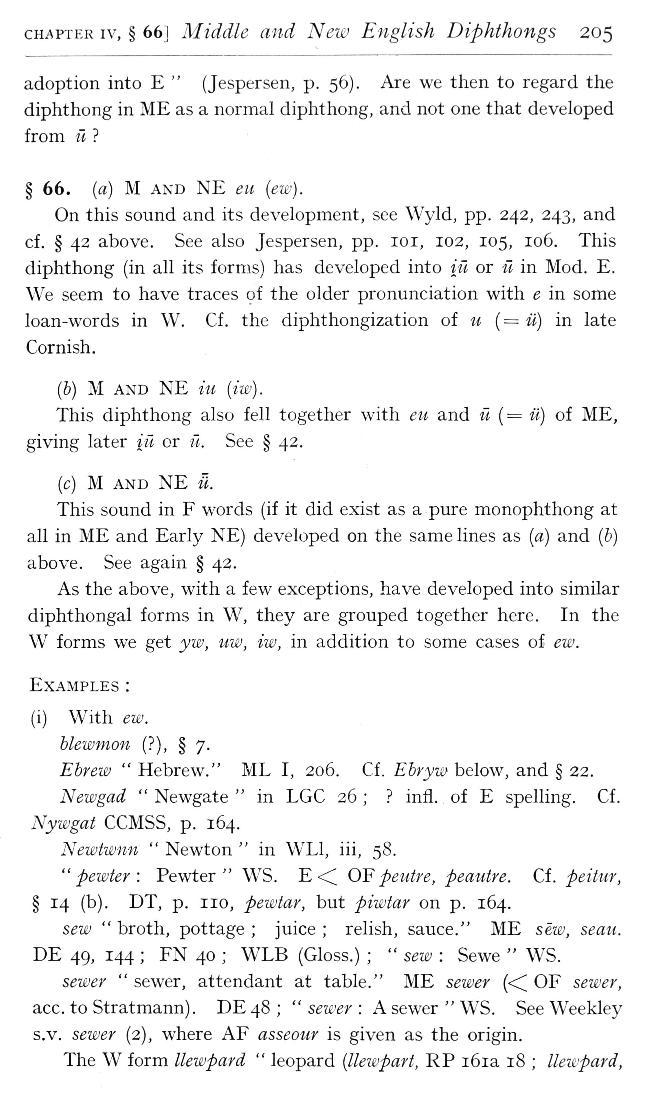  (delwedd F6956) (tudalen 205) | CHAPTER IV, § 661 Middle and New English Diphthongs 205  adoption into E” (Jespersen, p. 56). Are we then to regard the diphthong in ME as a normal diphthong, and not one that developed from it?  § 66. {a) M AND NE eu (ew).  On this sound and its development, see Wyld, pp. 242, 243, and cf. § 42 above. See also Jespersen, pp. loi, 102, 105, 106. This diphthong (in all its forms) has developed into itl or ii in Mod. E. We seem to have traces of the older pronunciation with e in some loan-words in W. Cf. the diphthongization of u {= ii) in late Cornish.  ih) M AND NE iu (iw).  This diphthong also fell together with eit and ii {— ii) of ME, giving later in or ft. See § 42.  (c) M AND NE a.  This sound in F words (if it did exist as a pure monophthong at all in ME and Early NE) developed on the same lines as [a] and {b) above. See again § 42.  As the above, with a few exceptions, have developed into similar diphthongal forms in W, they are grouped together here. In the W forms we get yw, uw, iw, in addition to some cases of ew.  Examples:  (i) With ew.  blewmon (?), § 7.  Ehrew “Hebrew." ML I, 206. Cf. Ebryw below, and § 22.  Newgad “Newgate “in LGC 26;? infl. of E spelling. Cf. Nywgat CCMSS, p. 164.  Newtwnn “Newton “in WLl, iii, 58.  "pewter: Pewter" WS. E <^ OF peutre, pemitre. Cf. peitur, § 14 (b). DT, p. no, pewtar, but piwtar on p. 164.  sew “broth, pottage; juice; relish, sauce." ME sew, sean. DE 49, 144; FN 40; WLB (Gloss.); “sew: Sewe “WS.  sewer “sewer, attendant at table." ME sewer (<^ OF sewer, ace. to Stratmann). DE48; "sewer: A sewer "WS. See Weekley s.v. sewer (2), where AF asseour is given as the origin.  The W form llewpard “leopard {Hewpart, RP i6ia 18; Ueicpard,
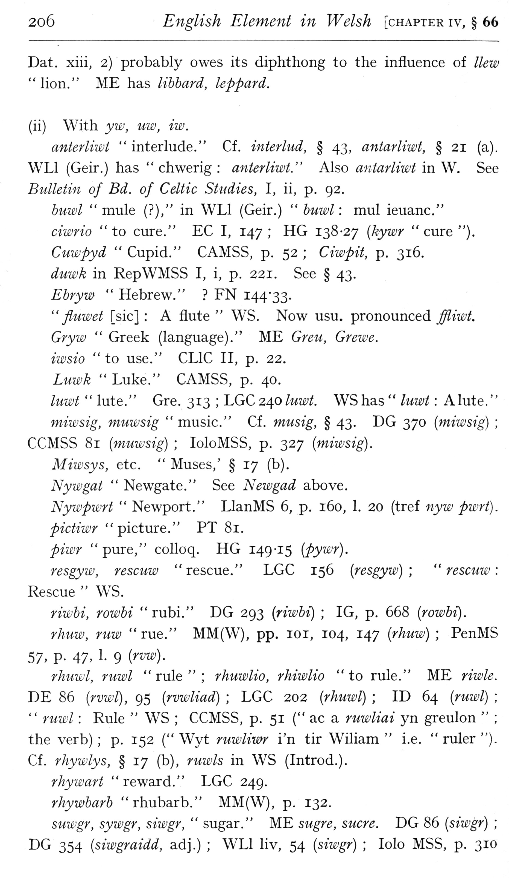  (delwedd F6957) (tudalen 206) | 2o6 English Element in Welsh [chapter iv, § 66  Dat. xiii, 2) probably owes its diphthong to the influence of Hew "hon." ME has lihhard, kppard.  (ii) With yw, uw, iw.  anterliwt “interlude." Cf. interhid, § 43, antarliwt, § 21 (a). WLl (Geir.) has “chwerig: anterliwt." Also antarliwt in W. See Bulletin of Bd. of Celtic Studies, I, ii, p. 92.  huwl “mule (?)," in WLl (Geir.) “huwl: mul ieuanc."  ciwrio "to cure." EC I, 147; HG 138-27 {kywr "cure").  Cuwpyd “Cupid." CAMSS, p. 52; Ciwpit, p. 316.  duwk in RepWMSS I, i, p. 221. See § 43.  Ehryw “Hebrew."? FN I44'33.  " fluwet [sic]: A flute “WS. Now usu. pronounced ffliwt.  Gryw “Greek (language)." ME Greu, Grewe.  iwsio “to use." CLIC II, p. 22.  Luwk “Luke." CAMSS, p. 40.  luwt “lute." Gre. 313; LGC 240 luwi. WS has “luwt: A lute."  miwsig, muwsig “music." Cf. musig, § 43. DG 370 {miwsig); CCMSS 81 [muwsig); loloMSS, p. 327 [miwsig).  Miwsys, etc. “Muses,' § 17 (b).  Nywgat “Newgate." See New gad above.  Nywpwrt “Newport." LlanMS 6, p. 160, 1. 20 (tref nyw pwrt).  pictiwr “picture." PT 81.  piwr “pure," colloq. HG 149-15 [pywr).  resgyw, rescuw "rescue." LGC 156 [resgyw); “rescuw: Rescue “WS.  riwbi, rowbi "rubi." DG 293 [riwhi]; IG, p. 668 [rowbi).  rhuw, ruw “rue." MM(W), pp. loi, 104, 147 [rhuw); PenMS  57. P- 47, 1- 9 (^^^)-  rhuwl, ruwl "rule"; rhuwlio, rhiwlio "to rule." ME riwle.  DE 86 [rvwl), 95 [rvwliad); LGC 202 [rhuwl); ID 64 [ruwl);  " ruwl: Rule “WS; CCMSS, p. 51 (" ac a ruwliai yn greulon”;  the verb); p. 152 (" Wyt ruwliwr i'n tir Wiliam “i.e. "ruler").  Cf. rhywlys, § 17 (b), ruwls in WS (Introd.).  rhywart “reward." LGC 249.  rhywharh "rhubarb." MM(W), p. 132.  suwgr, sywgr, siwgr, “sugar." ME sugre, sucre. DG 86 [siwgr); DG 354 [siwgraidd, adj.); WLl liv, 54 [siwgr); lolo MSS, p. 310
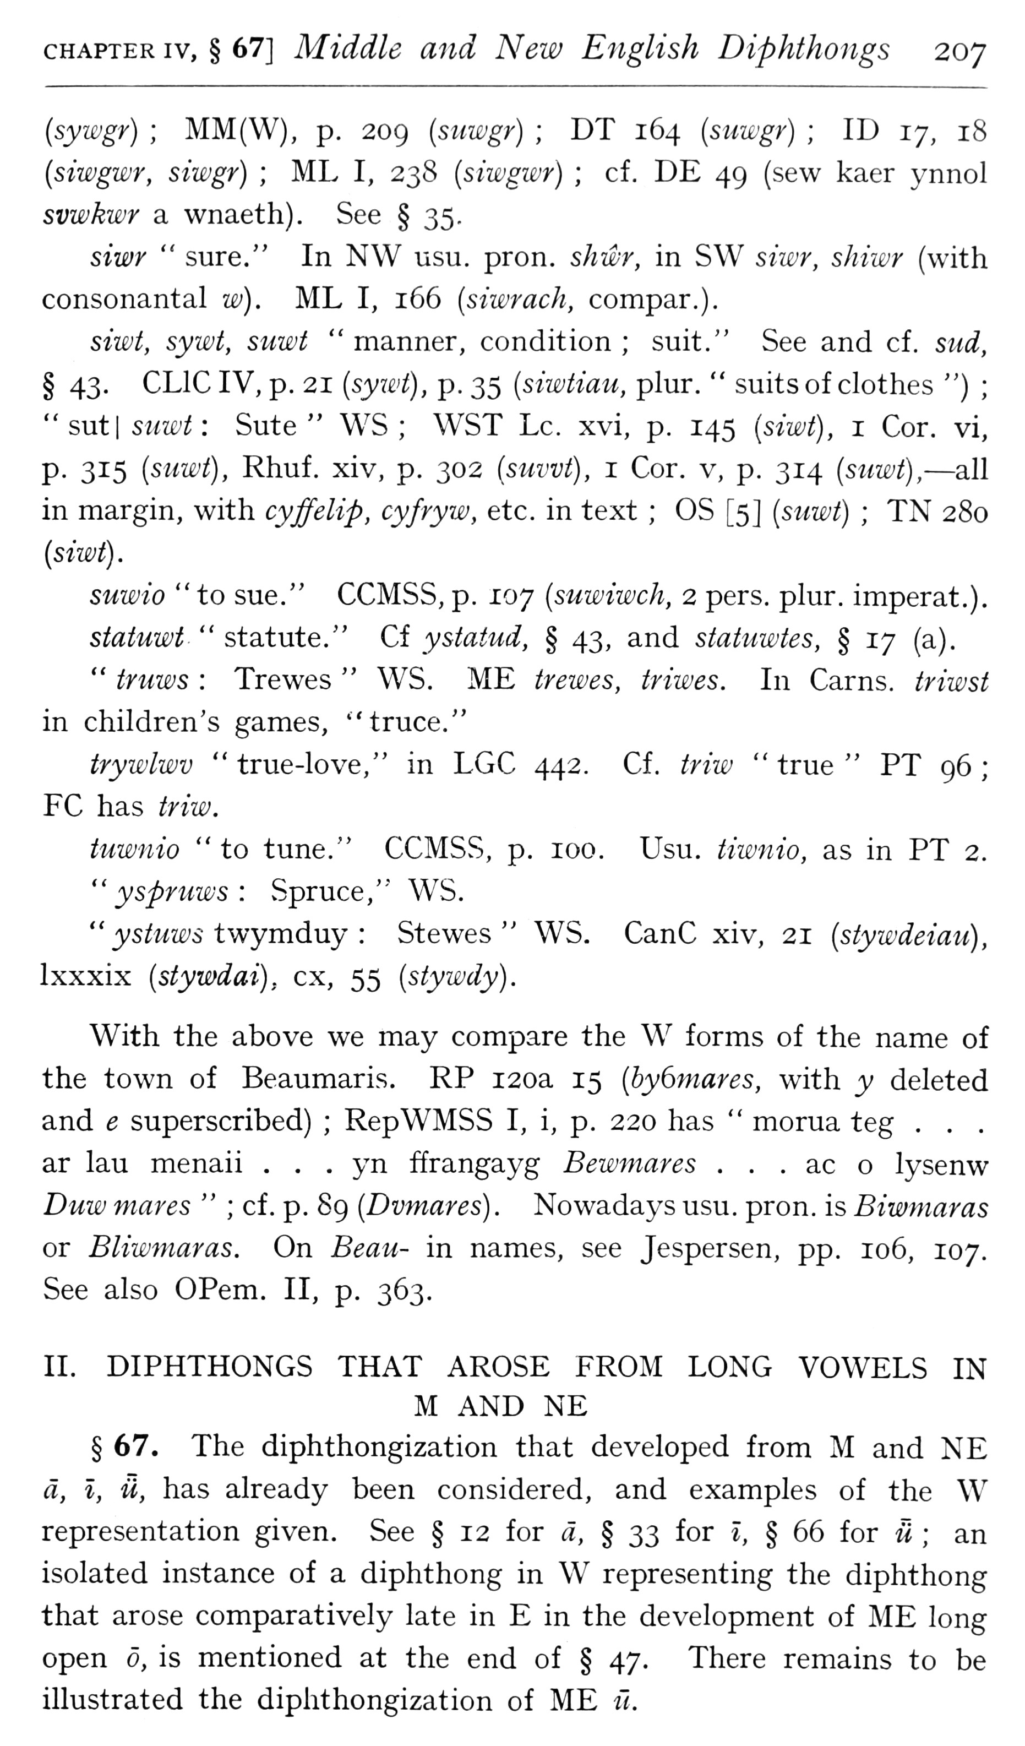  (delwedd F6958) (tudalen 207) | CHAPTER IV, § 67] Middle and New English Diphthongs 207  {sywgy); MM(W), p. 209 {siiwgr); DT 164 {snwgr); ID 17, 18 {siwgwr, siwgr); ML I, 238 {siwgwr); cf. DE 49 (sew kaer ynnol svwkwr a wnaeth). See § 35.  siW “sure," In NW usu. pron. shwr, in SW s?W, sMwr (with consonantal w). ML I, 166 {siwrach, compar.).  siwt, sywt, snwt “manner, condition; suit." See and cf. siid, § 43. CLIC IV, p. 21 {syxi>t), p. 35 {siwtiau, plur. “suits of clothes "); "sut| suwt: Sute “WS; WST Lc. xvi, p. 145 [siwt), i Cor. vi, p. 315 [suwt), Rhuf. xiv, p. 302 (suwt), 1 Cor. v, p. 314 (suwt), — all in margin, with cyffelip, cyfryw, etc. in text; OS [5] [suwt); TN 280 [siwt).  suwio "to sue." CCMSS, p. 107 [suwiwch, 2 pers. plur. imperat.),  statuwt “statute." Cf ystatud, § 43, and statuwtes, § 17 (a).  " truws: Trewes “WS. ME trewes, triwes. In Cams, triwst in children's games, "truce,"  trywlwv "true-love," in LGC 442. Cf. iriw "true" PT 96; FC has triw.  tuwnio "to tune." CCMSS, p. 100. Usu. tiwnio, as in PT 2.  " yspruws: Spruce," WS.  " ystuws twymduy: Stewes “WS. CanC xiv, 21 [stywdeiau), Ixxxix [stywdai), ex, 55 [stywdy).  With the above we may compare the W forms of the name of the town of Beaumaris. RP 120a 15 [byGmares, with y deleted and e superscribed); RepWMSS I, i, p. 220 has “morua teg . . . ar lau menaii . , . yn ffrangayg Bewmares . , , ac o lysenw Duw mares”; cf. p. 89 [Dvmares). Nowadays usu. pron. is Biwmaras or Bliwmaras. On Beau- in names, see Jespersen, pp. 106, 107. See also OPem. II, p. 363,  II. DIPHTHONGS THAT AROSE FROM LONG VOWELS IN  M AND NE § 67. The diphthongization that developed from M and NE a, I, U, has already been considered, and examples of the W representation given. See § 12 for «, § 33 for i, § 66 for u; an isolated instance of a diphthong in W representing the diphthong that arose comparatively late in E in the development of ME long open 0, is mentioned at the end of § 47, There remains to be illustrated the diphthongization of ME n.
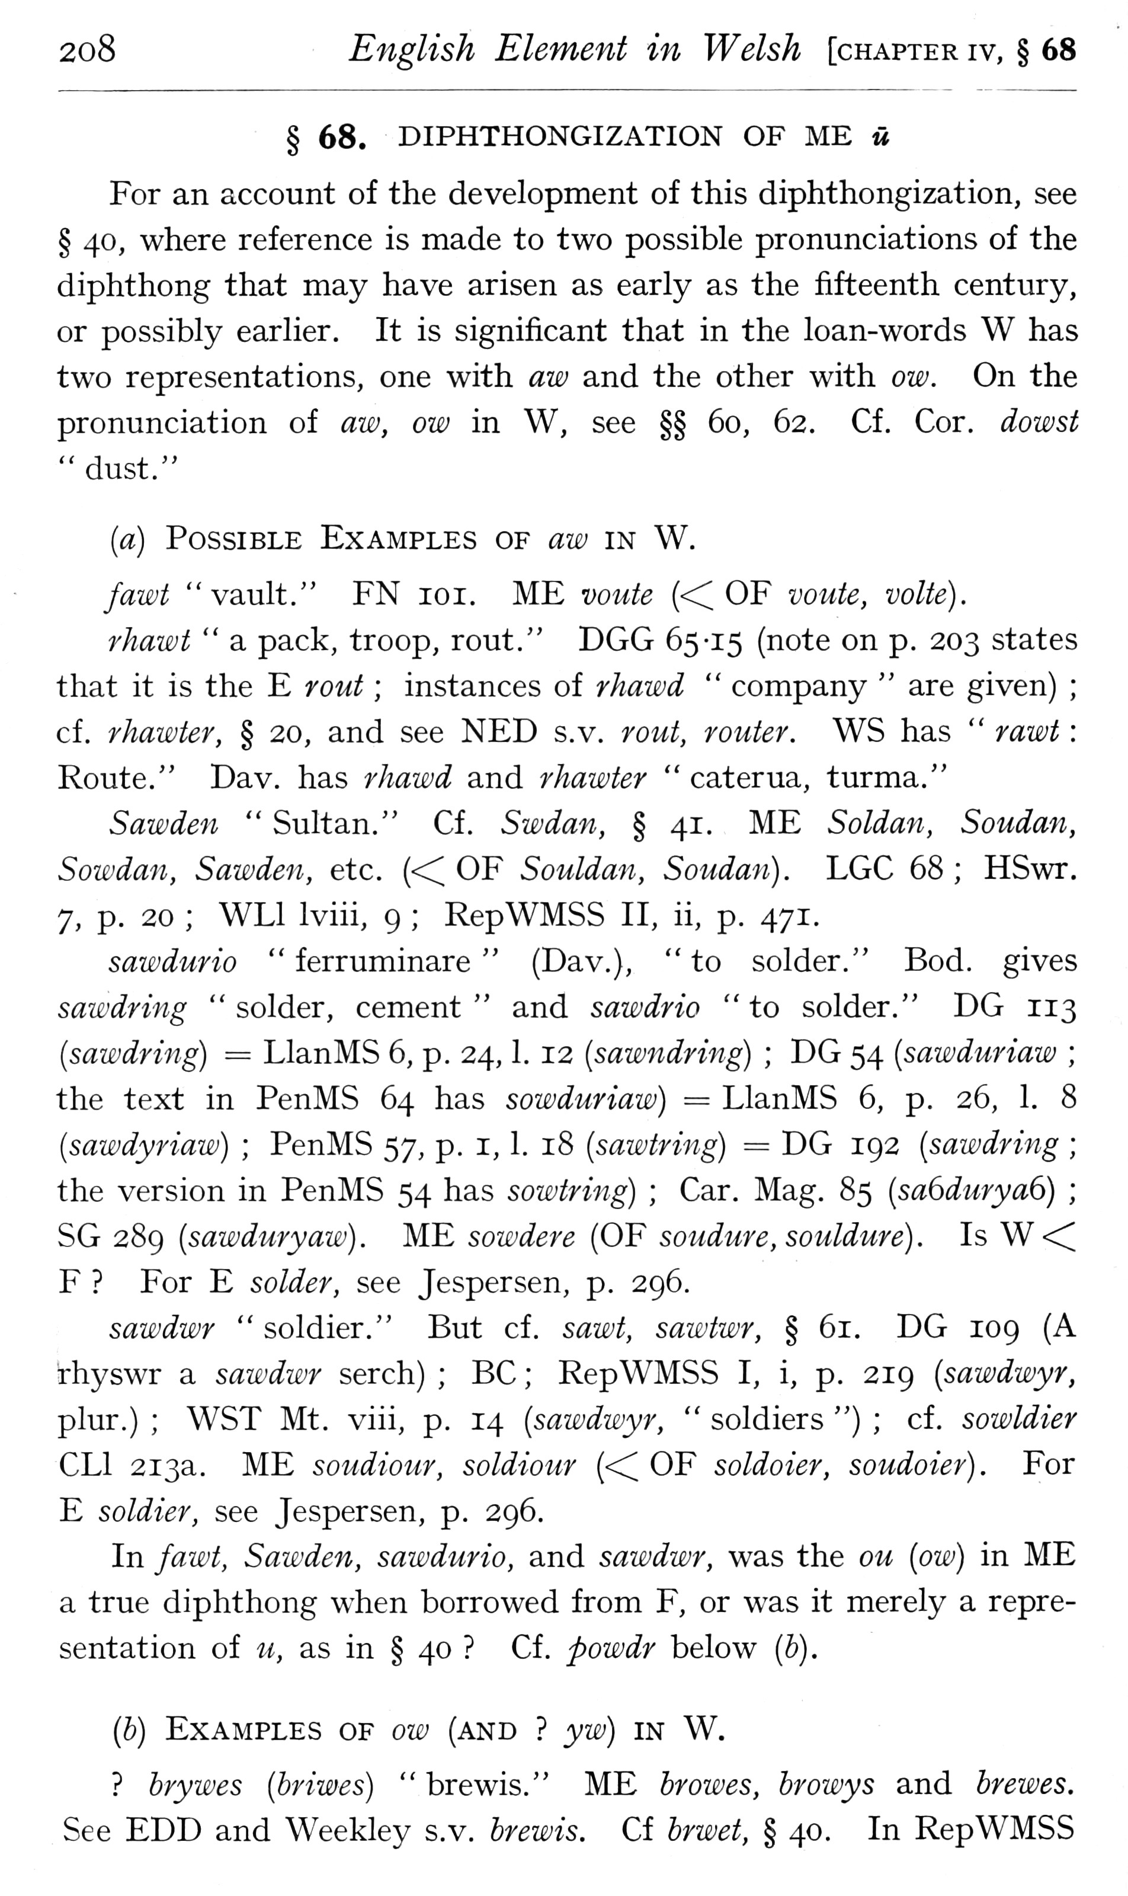  (delwedd F6959) (tudalen 208) | 2o8 English Element in Welsh [chapter iv, § 68 § 68. DIPHTHONGIZATION OF ME u  For an account of the development of this diphthongization, see § 40, where reference is made to two possible pronunciations of the diphthong that may have arisen as early as the fifteenth century, or possibly earlier. It is significant that in the loan-words W has two representations, one with aw and the other with ow. On the pronunciation of aw, ow in W, see §§ 60, 62. Cf. Cor. dowst “dust."  [a) Possible Examples of aw in W.  fawt "vault." FN loi. ME voute {<! OF vonte, volte).  rhawt “a pack, troop, rout." DGG 65-15 (note on p. 203 states that it is the E rout; instances of rhawd “company “are given); cf. rhawter, § 20, and see NED s.v. rout, router. WS has “rawt: Route." Dav. has rhawd and rhawter “caterua, turma."  Sawden “Sultan." Cf. Swdan, § 41. ME Soldan, Soudan, Sowdan, Sawden, etc. (<^ OF Souldan, Soudan). LGC 68; HSwr. 7, p. 20; WLl Iviii, 9; RepWMSS II, ii, p. 471.  sawdurio “ferruminare” (Dav.), “to solder." Bod. gives sawdring "solder, cement" and sawdrio "to solder." DG 113 [sawdring) = LlanMS 6, p. 24, 1. 12 [sawndring); DG 54 [sawduriaw; the text in PenMS 64 has sowduriaw) = LlanMS 6, p. 26, 1. 8 {sawdyriaw); PenMS 57, p. i, 1. 18 {sawtring) = DG 192 [sawdring; the version in PenMS 54 has sowtring); Car. Mag. 85 (saGduryaG); SG 289 (sawduryaw). ME sowdere (OF soudure, souldure). Is W<^ F? For E solder, see Jespersen, p. 296.  sawdwr “soldier." But cf. sawt, sawtwr, § 61. DG 109 (A rhyswr a sawdwr serch); BC; RepWMSS I, i, p. 219 [sawdwyr, plur.); WST Mt. viii, p. 14 (sawdwyr, “soldiers "); cf. sowldier CLl 213a. ME soudiour, soldiour (<^ OF soldoier, soudoier). For E soldier, see Jespersen, p. 296.  In fawt, Sawden, sawdurio, and sawdwr, was the ou [ow] in ME a true diphthong when borrowed from F, or was it merely a representation of u, as in § 40? Cf. powdr below [h).  (b) Examples of ow (and? yw) in W.  ? hrywes (briwes) “brewis." ME browes, browys and brewes. See EDD and Weekley s.v. brewis. Cf brwet, § 40. In RepWMSS
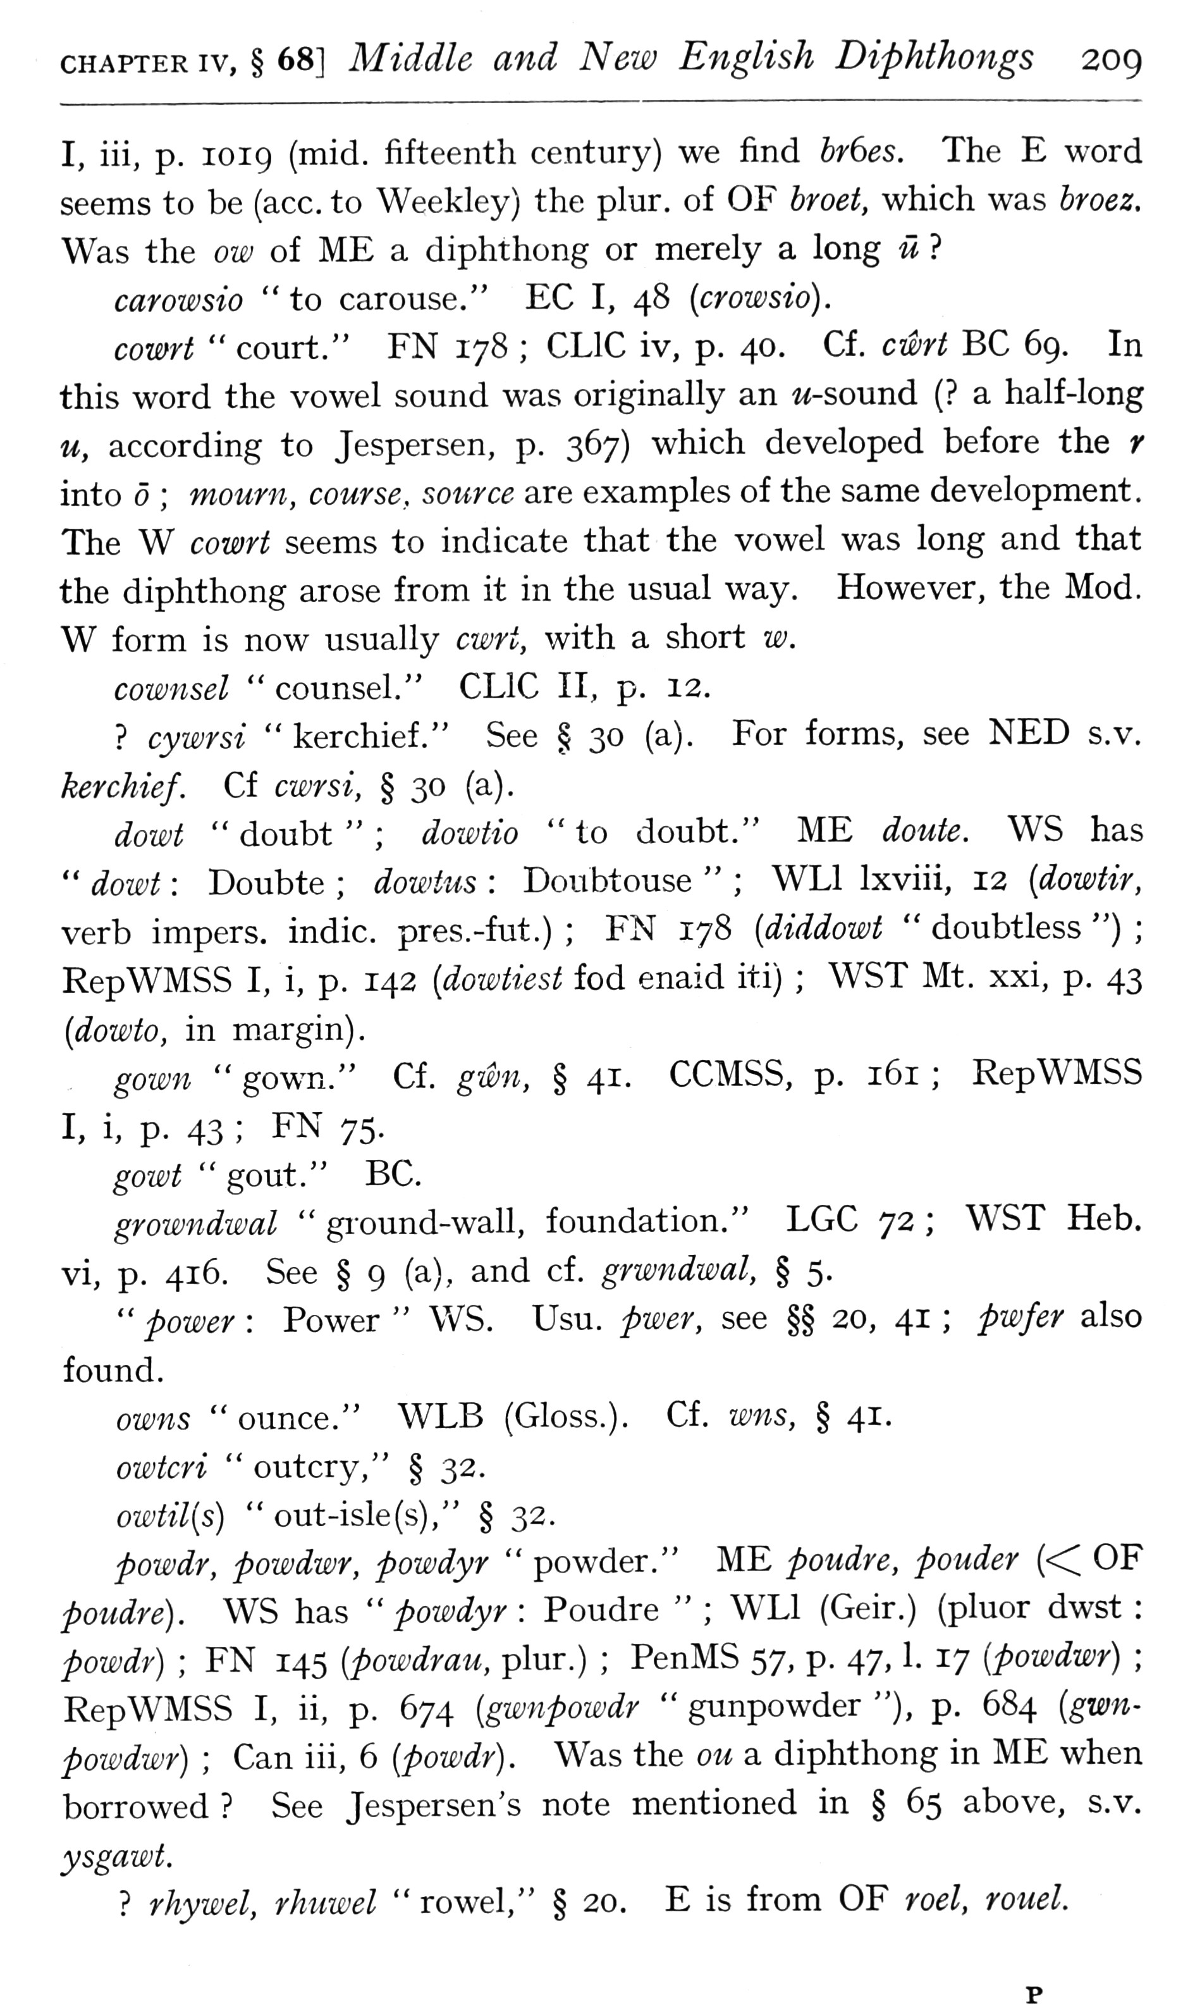  (delwedd F6960) (tudalen 209) | CHAPTER IV, § 68] Middle and New English Diphthongs 209  I, iii, p. 1019 (mid. fifteenth century) we find hy6es. The E word seems to be (ace. to Weekley) the plur. of OF broet, which was hroez. Was the ow of ME a diphthong or merely a long u?  carowsio "to carouse," EC I, 48 {crowsio).  cowrt “court." FN 178; CLIC iv, p. 40. Cf. cwrt BC 69. In this word the vowel sound was originally an w-sound (? a half-long u, according to Jespersen, p. 367) which developed before the r into; mourn, course, source are examples of the same development. The W cowrt seems to indicate that the vowel was long and that the diphthong arose from it in the usual way. However, the Mod. W form is now usually cwrt, with a short w.  cownsel “counsel." CLIC II, p. 12.  ? cywrsi “kerchief." See § 30 (a). For forms, see NED s.v. kerchief. Cf cwrsi, § 30 (a).  dowt "doubt"; dowtio "to doubt." ME dotite. WS has “dowt: Doubte; dowtus: Doubtouse”; WLl Ixviii, 12 [dowtir, verb impers. indie, pres.-fut.); FN 178 [diddowt “doubtless "); RepWMSS I, i, p. 142 [dowtiest fod enaid iti); WST Mt. xxi, p. 43 {dowto, in m.argin).  gow7i “gown." Cf. gwn, § 41. CCMSS, p. 161; RepWMSS I, i, p. 43; FN 75.  gowt “gout." BC.  growndwal “ground-wall, foundation." LGC 72; WST Heb. vi, p. 416. See § 9 (a), and cf. grwndwal, § 5.  " power: Power “WS. Usu. pwer, see §§ 20, 41; pwfer also found.  ow7ts "ounce." WLB (Gloss.). Cf. W7is, § 41.  owtcri “outcry," § 32.  owtil{s) “out-isle (s)," § 32.  powdr, powdwr, powdyr “powder." ME poudre, pouder “OF poiidre). WS has "powdyr: Poudre”; WLl (Geir.) (pluor dwst: powdr); FN 145 [powdrau, plur.); PenMS 57, p. 47, 1. 17 {powdwr); RepWMSS I, ii, p. 674 {gwnpowdr “gunpowder "), p. 684 {gwnpowdwr); Can iii, 6 {powdr). Was the ou a diphthong in ME when borrowed? See Jespersen's note mentioned in § 65 above, s.v. ysgawt.  ? rhywel, rhuwel “rowel," § 20. E is from OF roel, rouel.
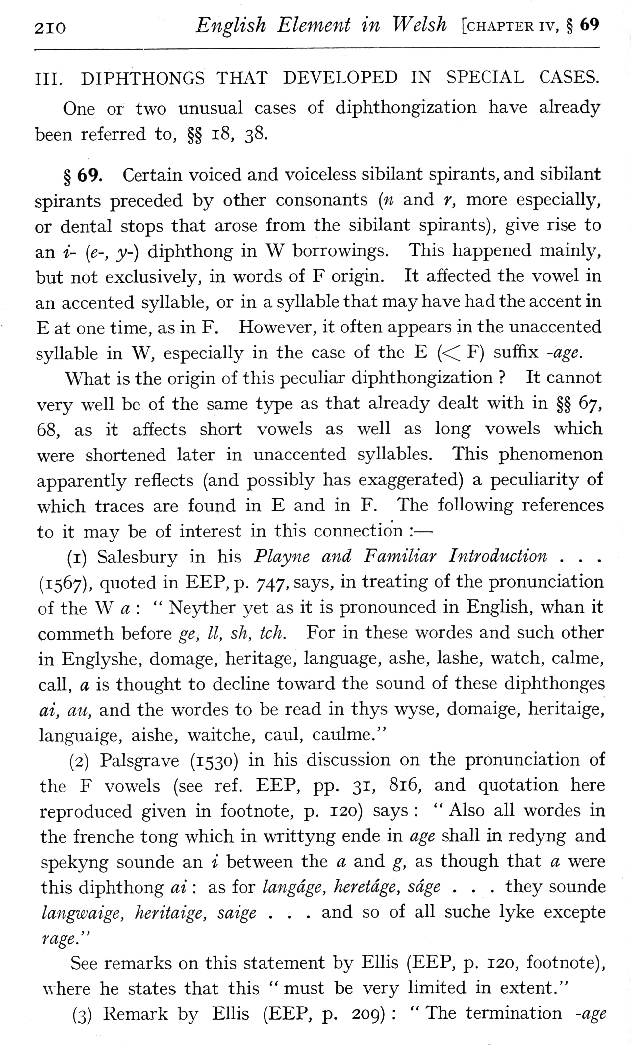  (delwedd F6961) (tudalen 210) | 210 English Element in Welsh [chapter iv, § 69  III. DIPHTHONGS THAT DEVELOPED IN SPECIAL CASES. One or two unusual cases of diphthongization have already been referred to, §§ i8, 38.  § 69. Certain voiced and voiceless sibilant spirants, and sibilant spirants preceded by other consonants [n and r, more especially, or dental stops that arose from the sibilant spirants), give rise to an i- [e-, y-) diphthong in W borrowings. This happened mainly, but not exclusively, in words of F origin. It affected the vowel in an accented syllable, or in a syllable that may have had the accent in E at one time, as in F. However, it often appears in the unaccented syllable in W, especially in the case of the E « F) suffix -age.  What is the origin of this peculiar diphthongization? It cannot very well be of the same type as that already dealt with in §§ 67, 68, as it affects short vowels as well as long vowels which were shortened later in unaccented syllables. This phenomenon apparently reflects (and possibly has exaggerated) a peculiarity of which traces are found in E and in F. The following references to it may be of interest in this connection: —  (i) Salesbury in his Play^ie and Familiar Introduction . . . (1567), quoted in EEP, p. 747, says, in treating of the pronunciation of the W a: “Neyther yet as it is pronounced in English, whan it commeth before ge, II, sh, tch. For in these wordes and such other in Englyshe, domage, heritage, language, ashe, lashe, watch, calme, call, a is thought to decline toward the sound of these diphthonges ai, au, and the wordes to be read in thys wyse, domaige, heritaige, languaige, aishe, waitche, caul, caulme."  (2) Palsgrave (1530) in his discussion on the pronunciation of the F vowels (see ref. EEP, pp. 31, 816, and quotation here reproduced given in footnote, p. 120) says: “Also all wordes in the frenche tong which in wTittyng ende in age shall in redyng and spekyng sounde an i between the a and g, as though that a were this diphthong ai: as for langdge, Jieretdge, sage . . . they sounde langwaige, heritaige, saige . . . and so of all suche lyke excepte rage."  See remarks on this statement by Ellis (EEP, p. 120, footnote), where he states that this “must be very limited in extent."  (3) Remark by Ellis (EEP, p. 209): “The termination -age
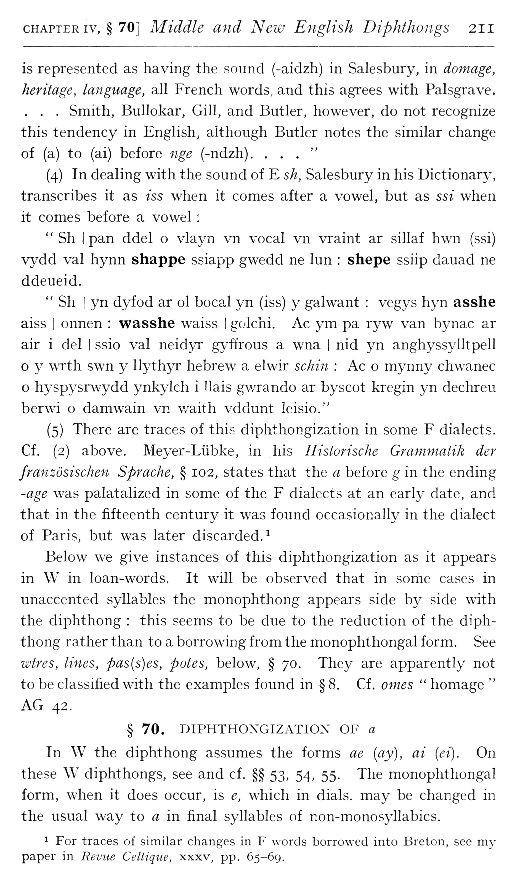  (delwedd F6962) (tudalen 211) | CHAPTER IV, § 70] Middle and New English Diphthongs 211  is represented as having the sound (-aidzh) in Salesbury, in damage, heritage, language, all French words, and this agrees with Palsgrave. . . . Smith, Bullokar, Gill, and Butler, however, do not recognize this tendency in English, although Butler notes the similar change of (a) to (ai) before nge (-ndzh). ..."  (4) In dealing with the sound of E sh, Salesbury in his Dictionary, transcribes it as iss when it comes after a vowel, but as ssi when it comes before a vowel:  " Sh I pan ddel o vlayn vn vocal vn vraint ar sillaf hwn (ssi) vydd val hynn shappe ssiapp gwedd ne lun: shepe ssiip dauad ne ddeueid.  " Sh I yn dyfod ar ol bocal yn (iss) y gal want: vegys hyn asshe aiss I onnen: wasshe waiss I golchi. Ac ym pa ryw van bynac ar air i del I ssio val neidyr gyffrous a wna | nid yn anghyssylltpell o y WTth swn y llythyr hebrew a elwir sclmi: Ac o mynny chwanec o hyspysrwydd ynkylch i llais gv/rando ar byscot kregin yn dechreu berwi o damwain vn v/aith vddunt leisio."  (5) There are traces of this diphthongization in some F dialects. Cf. (2) above. Meyer-Liibke, in his Historische Grammatik der franzosischen Sprache, § 102, states that the a before g in the ending -age was palatalized in some of the F dialects at an early date, and that in the fifteenth century it was found occasionally in the dialect of Paris, but was later discarded.^  Below we give instances of this diphthongization as it appears in W in loan-words. It will be observed that in some cases in unaccented syllables the monophthong appears side by side with the diphthong: this seems to be due to the reduction of the diphthong rather than to a borrowing from the monophthongal form. See wires, lines, pas{s)es, potes, below, § 70. They are apparently not to be classified with the examples found in § 8. Cf. omes “homage “AG 42.  § 70. DIPHTHONGIZATION OF a  In W the diphthong assumes the forms ae [ay], ai (ei). On these W diphthongs, see and cf. §§ 53, 54, 55. The monophthongal form, when it does occur, is e, which in dials, may be changed in the usual way to a in final syllables of non-monosyllabics.  1 For traces of similar changes in F words borrowed into Breton, see my paper in Revue Celtiqiie, xxxv, pp. 65-69.
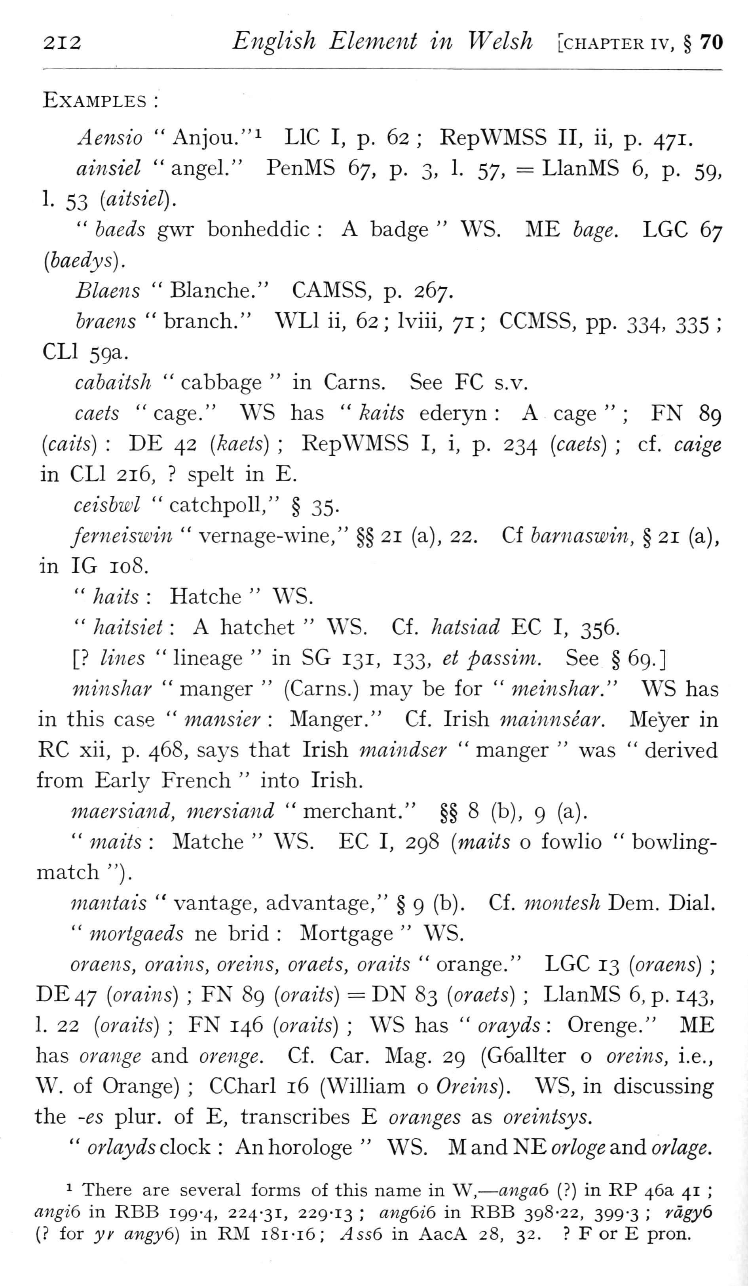  (delwedd F6963) (tudalen 212) | 212 English Element in Welsh [chapter iv, § 70  Examples:  Aensio "Anjou."i LlC I, p. 62; RepWMSS II, ii, p. 471.  ainsiel “angel." PenMS 67, p. 3, 1. 57, = LlanMS 6, p. 59, 1. 53 [aitsiel).  " baeds gwr bonheddic: A badge “WS. ME bage. LGC 67 (baedys) .  Blaens “Blanche." CAMSS, p. 267.  braens “branch." WLl ii, 62; Iviii, 71; CCMSS, pp. 334, 335; CLl 59a.  cabaiish “cabbage “in Cams. See FC s.v.  caets “cage." WS has “kaits ederyn: A cage”; FN 89 (caits): DE 42 (kaets); RepWMSS I, i, p. 234 [caets); cf. caige in CLl 216,? spelt in E.  ceisbwl “catchpoll," § 35.  ferneiswin “vernage-wine," §§ 21 (a), 22. Cf barnaswin, § 21 (a), in IG 108.  " haits: Hatche “WS.  " haitsiet: A hatchet “WS. Cf. hatsiad EC I, 356.  [? lines “lineage “in SG 131, 133, et passim. See § 69.]  minshar “manger” (Cams.) may be for “meinshar." W^S has in this case “mansier: Manger." Cf. Irish mainnsear. Meyer in RC xii, p. 468, says that Irish maiiidser “manger “was “derived from Early French “into Irish.  maersiand, mersiand “merchant," §§ 8 (b), 9 (a).  " maits: Matche “WS. EC I, 298 [maits o fowlio “bowling-match ").  mantais “vantage, advantage," § 9 (b), Cf. montesh Dem. Dial.  " mortgaeds ne brid: Mortgage “WS.  oraens, orains, oreins, oraets, oraits “orange." LGC 13 [oraens); DE47 {orains); FN 89 {oraits) = DN 83 {oraets); LlanMS 6, p. 143, 1. 22 {oraits); FN 146 {oraits); WS has “orayds: Orenge." ME has orange and orenge. Cf. Car. Mag. 29 (G6allter o oreins, i.e., W. of Orange); CCharl 16 (William o Oreins). WS, in discussing the -es plur. of E, transcribes E oranges as oreintsys.  " orlayds clock: An horologe “WS. M and NE or/o^g and o;'/a^(2.  1 There are several forms of this name in W, — anga6 (?) in RP 46a 41; angib in RBB 199-4, 224-31, 229-13; ang6i6 in RBB 398-22, 399-3; rdgy6 (? for yy angyd) in RJM i8i-i6; AssG in AacA 28, 32.? F or E pron.
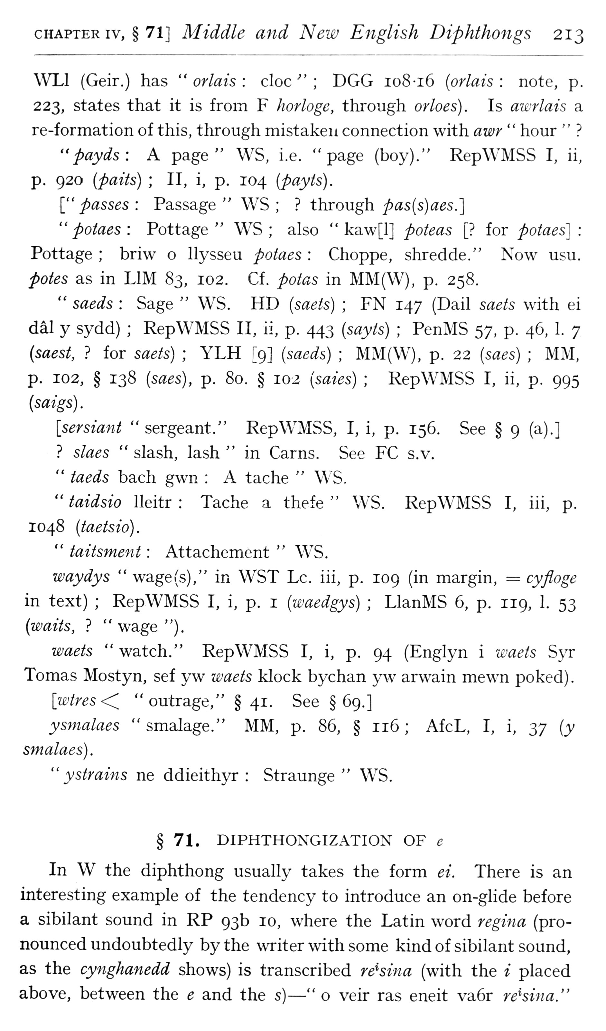  (delwedd F6964) (tudalen 213) | CHAPTER IV, § 71] Middle and New English Diphthongs 213  WLl (Geir.) has “orlais: cloc”; DGG io8-i6 (orlais: note, p. 223, states that it is from F Iiorlogc, through orloes). Is awrlais a re-formation of this, through mistaken connection with awr “hour "?  "payds: A page" WS, i.e. "page (boy)." RepWMSS I, ii, p. 920 (paits); II, i, p. 104 (payts).  ["passes: Passage" WS;? through pas{s)aes.]  " potaes: Pottage" WS; also “kaw[l] poteas [? for potaes]: Pottage; briw o llysseu potaes: Choppe, shredde." Now usu. potes as in LIM S^), 102. Cf. potas in MM(W), p. 258.  " saeds: Sage “WS. HD (saets); FN 147 (Dail saets with ei dal y sydd); RepWMSS II, ii, p. 443 (sayts); PenMS 57, p. 46, 1. 7 {saest,? for saets); YLH [9] (saeds); MM(W), p. 22 (saes); MM, p. 102, § 138 [saes), p. 80. § 102 [saies); RepWMSS I, ii, p. 995 (saigs).  [sersiant “sergeant." RepWMSS, I, i, p. 156. See § 9 (a).]  ? slaes “slash, lash “in Cams. See FC s.v,  " taeds bach gwn: A tache “WS.  " taidsio lleitr: Tache a thefe “WS. RepWMSS I, iii, p. 1048 (taetsio).  " taitsment: Attachement “WS.  waydys “wage(s)," in WST Lc. iii, p. 109 (in margin, = cyfloge in text); RepWMSS I, i, p. i [waedgys); LlanMS 6, p. 119, 1. 53 [waits,? “wage ").  waets “watch." RepWMSS I, i, p. 94 (Englyn i waets S}T Tomas Mostyn, sef y w waets klock bychan y w arwain mewn poked) .  [wtres<^ "outrage," § 41. See §69.]  ysmalaes “smalage." MM, p. 86, § 116; AfcL, I, i, ^y [y smalaes).  " ystrains ne ddieith>T: Straunge “WS. § 71. DIPHTHONGIZATIOX OF e  In W the diphthong usually takes the form ei. There is an interesting example of the tendency to introduce an on-glide before a sibilant sound in RP 93b 10, where the Latin word regma (pronounced undoubtedly by the writer with some kind of sibilant sound, as the cynghanedd shows) is transcribed retina (with the i placed above, between the e and the s) — “o veir ras eneit va6r rehina."
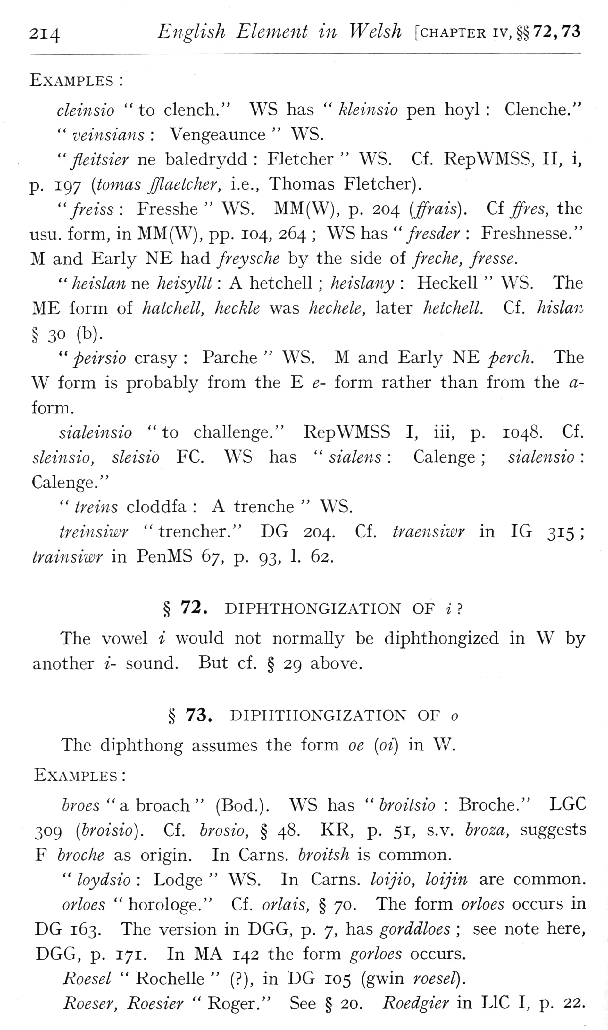  (delwedd F6965) (tudalen 214) | 214 English Element in Welsh [chapter iv, §§72,73  Examples:  cleinsio "to clench." WS has “kleinsio pen hoyl: Clenche."  " veinsians: Vengeaunce “WS.  " fleitsier ne baledrydd: Fletcher “WS. Cf. RepWMSS, II, i, p. 197 [tomas fflaetcher, i.e., Thomas Fletcher).  "freiss: Fresshe “WS. MM(W), p. 204 (ffrais). Ci ffres, the usu. form, in MM(W), pp. 104, 264; WS has “fresder: Freshnesse." M and Early NE had freyscJie by the side of freche, fresse.  " heislan ne heisyllt: A hetchell; heislany: Heckell “WS. The ME form of hatchell, heckle was hechele, later hetchell. Cf. hislan  § 30 (b).  " peirsio crasy: Parche “WS. M and Early NE perch. The W form is probably from the E e- form rather than from the a-form.  sialeinsio "to challenge." RepWMSS I, iii, p. 1048. Cf. sleinsio, sleisio EC. WS has “sialens: Calenge; sialensio: Calenge."  " treins cloddfa: A trenche “WS.  treinsiwr “trencher." DG 204. Cf. traensiwr in IG 315; trainsiwr in PenMS 67, p. 93, 1. 62.  § 72. DIPHTHONGIZATION OF i?  The vowel i would not normally be diphthongized in W by another i- sound. But cf. § 29 above.  § 73. DIPHTHONGIZATION OF o The diphthong assumes the form oe (oi) in W. Examples:  broes “a. broach” (Bod.). WS has “broitsio: Broche." LGC 309 (broisio). Cf. brosio, § 48. KR, p. 51, s.v, broza, suggests F broche as origin. In Cams, broitsh is common.  " loydsio: Lodge “WS. In Cams, loijio, loijin are common.  orloes “horologe." Cf. orlais, § 70. The form orloes occurs in DG 163. The version in DGG, p. 7, has gorddloes; see note here, DGG, p. 171. In MA 142 the form gorloes occurs.  Roesel “Rochelle” (?), in DG 105 (gwin roesel).  Roeser, Roesier “Roger." See § 20. Roedgier in LlC I, p. 22.
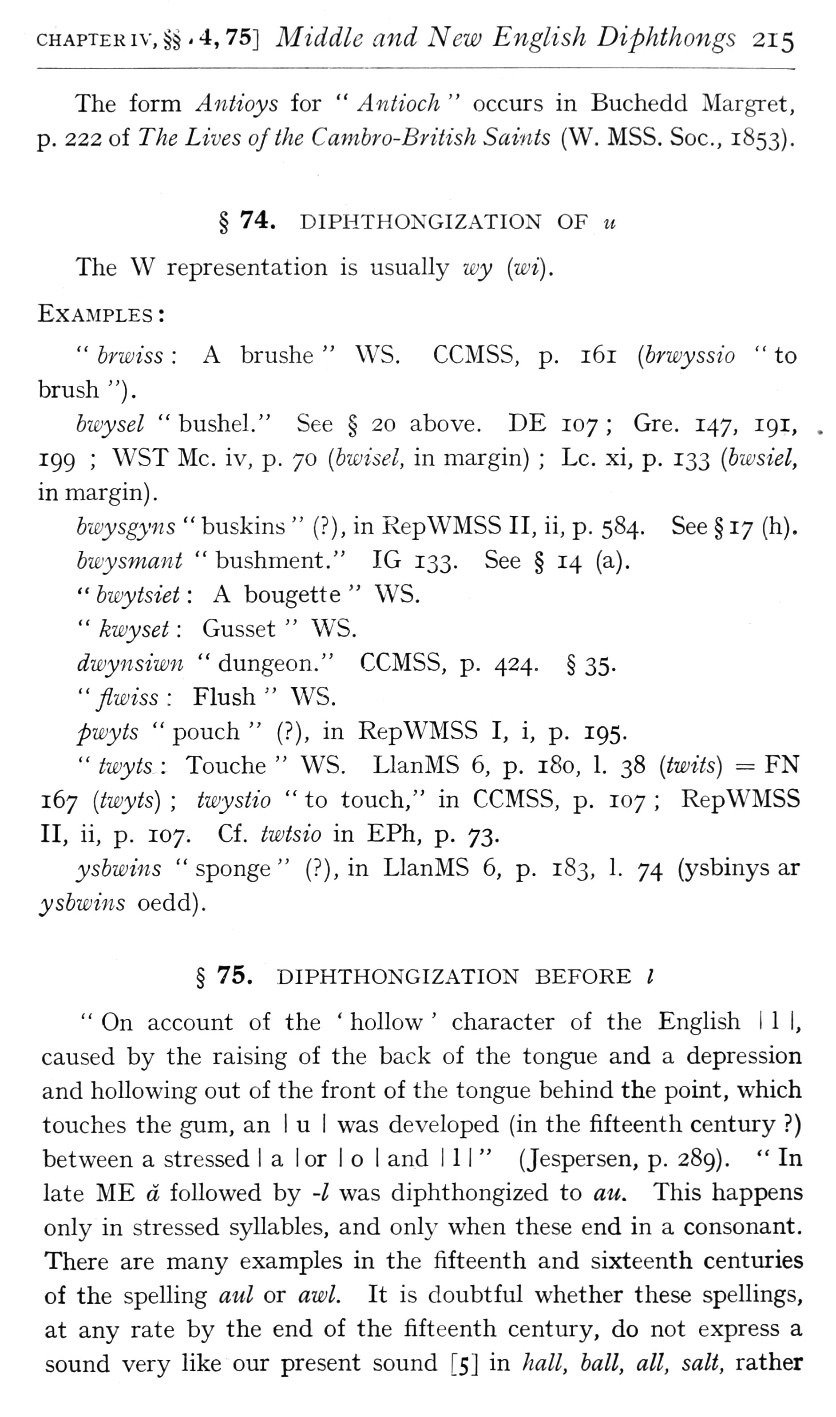  (delwedd F6966) (tudalen 215) | CHAPTERiv, §§ .4,75] Middle and New English Diphthongs 215  The form Antioys for “Aniioch “occurs in Buchedd Margret, p. 222 of The Lives of the Cambro-British Saints (W. MSS. Soc, 1853).  § 74. DIPHTHONGIZATION OF u The W representation is usually wy {wi).  Examples:  " brwiss: A brushe “WS. CCMSS, p. 161 {brwyssio "to brush ").  bwysel “bushel." See § 20 above. DE 107; Gre. 147, 191, 199; WST Mc. iv, p. 70 {bwisel, in margin); Lc. xi, p. 133 {bwsiel, in margin) .  bwysgyns “buskins” (?), in RepWMSS II, ii, p. 584. See § 17 (h).  bwysmant “bushment." IG 133. See § 14 (a).  " bwytsiet: A bougette “WS.  " kwyset: Gusset “WS.  dwynsiwn “dungeon." CCMSS, p. 424, § 35.  "flwiss: Flush" WS.  pwyts “pouch” (?), in RepWMSS I, i, p. 195.  " twyts: Touche “WS. LlanMS 6, p. 180, 1. 38 {twits) = FN 167 {twyts); twystio “to touch," in CCMSS, p. 107; RepWMSS II, ii, p. 107. Cf. twtsio in EPh, p. 73.  ysbwins “sponge” (?), in LlanMS 6, p. 183, 1. 74 (ysbinys ar ysbwins oedd).  § 75. DIPHTHONGIZATION BEFORE /  " On account of the ' hollow ' character of the English I 1 I, caused by the raising of the back of the tongue and a depression and hollowing out of the front of the tongue behind the point, which touches the gum, an 1 u I was developed (in the fifteenth century?) between a stressed I a lor I o I and III" (Jespersen, p. 289). “In late ME a followed by -I was diphthongized to au. This happens only in stressed syllables, and only when these end in a consonant. There are many examples in the fifteenth and sixteenth centuries of the spelling aid or awl. It is doubtful whether these spellings, at any rate by the end of the fifteenth century, do not express a sound very like our present sound [5] in hall, ball, all, salt, rather
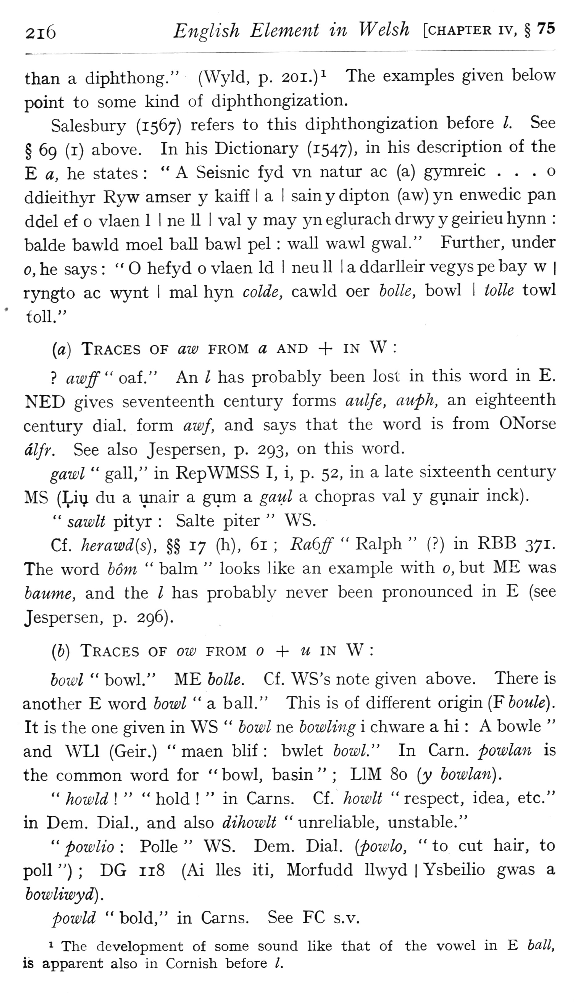  (delwedd F6967) (tudalen 216) | 2i6 English Element in Welsh [chapter iv, § 75  than a diphthong." (Wyld, p. 201.)^ The examples given below point to some kind of diphthongization.  Salesbury (1567) refers to this diphthongization before I. See § 69 (i) above. In his Dictionary (1547), in his description of the E a, he states: "A Seisnic fyd vn natur ac (a) gymreic . . . o ddieith}T Ryw amser y kaiff I a I sainydipton (aw)yn enwedic pan ddel ef o vlaen 1 I ne 11 I val y may yn eglurach drwy y geirieu hynn: balde bawld moel ball bawl pel: wall wawl gwal." Further, under 0, he says: “hefyd o vlaen Id i neu II I a ddarlleir vegys pe bay w | ryngto ac wynt I mal hyn colde, cawld oer hoik, bowl I toU& towl toll."  {a) Traces of aw from a and + in W:  ? awff" oaf." An I has probably been lost in this word in E. NED gives seventeenth century forms aulfe, auph, an eighteenth century dial, form awf, and says that the word is from ONorse dlfr. See also Jespersen, p. 293, on this word.  gawl “gall," in RepWMSS I, i, p. 52, in a late sixteenth centiu-y MS (;^iu du a unair a gum a gaul a chopras val y gunair inck).  " sawlt pityr: Salte piter “WS.  Cf. herawd{s), §§ 17 (h), 61; Ra6ff “Ralph” (?) in RBB 371. The word bom “balm “looks like an example with 0, but ME was baume, and the / has probably never been pronounced in E (see Jespersen, p. 296).  (6) Traces of ow from + m in W:  bowl “bowl." ME bolle. Cf. WS's note given above. There is another E word bowl “a ball." This is of different origin {Fboule). It is the one given in WS “bowl ne bowling i chware a hi: A bowle “and WLl (Geir.) “maen blif: bwlet bowl." In Carn. powlan is the common word for "bowl, basin"; LIM 80 [y bowlan).  " howld!” “hold! “in Cams. Cf. howlt “respect, idea, etc." in Dem. Dial., and also dihowlt “unreliable, unstable."  " powlio: Polle “WS. Dem. Dial, {powlo, “to cut hair, to poll "); DG 118 (Ai lies iti, Morfudd llwyd 1 Ysbeilio gwas a bowliwyd).  powld “bold," in Cams. See FC s.v.  ^ The development of some sound like that of the vowel in E ball, is apparent also in Cornish before /.
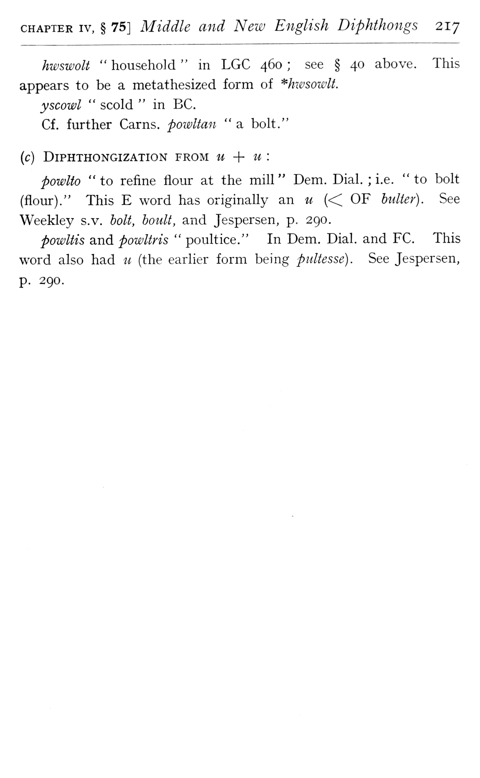  (delwedd F6968) (tudalen 217) | CHAPTER IV, § 75] Middle and New English Diphthongs 217  hwswolt “household “in LGC 460; see § 40 above. This appears to be a metathesized form of *hwsowlt. y scowl “scold “in BC. Cf. further Cams, powUan “a bolt."  (c) DiPHTHONGIZATION FROM U -\- U:  powlto “to refine flour at the mill “Dem. Dial.; i.e. “to bolt (flour)." This E word has originally an u “OF hidier). See Weekley s.v. holt, boult, and Jespersen, p. 290.  powltis and powltris “poultice." In Dem. Dial, and FC. This word also had u (the earlier form being pultesse). See Jespersen, p. 290.
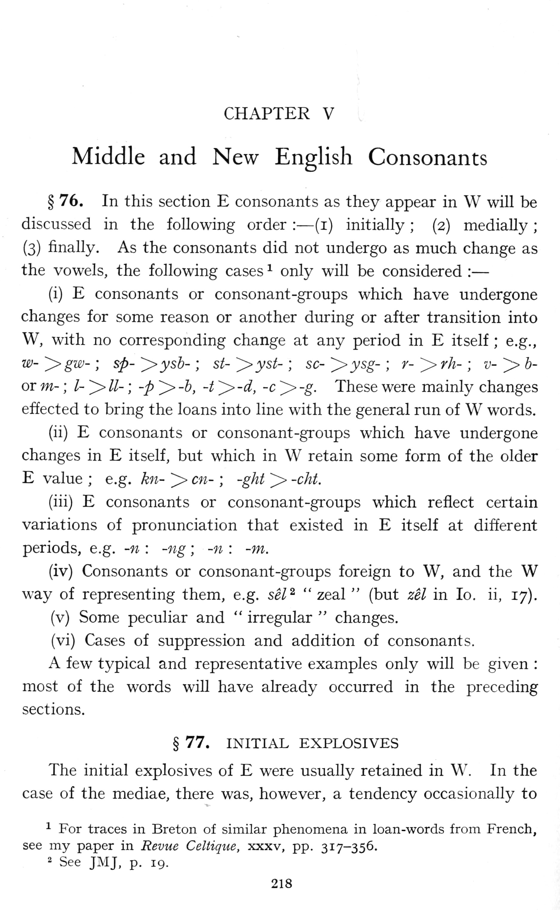  (delwedd F6969) (tudalen 218) | >  \  CHAPTER V  Middle and New English Consonants  § 76. In this section E consonants as they appear in W will be discussed in the following order: — (i) initially; (2) medially; (3) finally. As the consonants did not undergo as much change as the vowels, the following cases ^ only will be considered: —  (i) E consonants or consonant-groups which have undergone changes for some reason or another during or after transition into W, with no corresponding change at any period in E itself; e.g., w- '^gw-; sp- ^ysh-; st- ~^yst-; sc- '^ysg-; r- > rh-; v- >> b-or m-; /- ^ //-; -p ^ -b, -t > -d, -c ^ -g. These were mainly changes effected to bring the loans into line with the general run of W words.  (ii) E consonants or consonant-groups which have undergone changes in E itself, but which in W retain some form of the older E value; e.g. kn- >> en-; -ght >> -cht.  (iii) E consonants or consonant-groups which reflect certain variations of pronunciation that existed in E itself at different periods, e.g. -n: -ng; -n: -m.  (iv) Consonants or consonant-groups foreign to W, and the W way of representing them, e.g. sel^ “zeal” (but zel in lo. ii, 17).  (v) Some peculiar and “irregular “changes.  (vi) Cases of suppression and addition of consonants.  A few typical and representative examples only will be given: most of the words will have already occurred in the preceding sections.  § 77. INITIAL EXPLOSIVES  The initial explosives of E were usually retained in W. In the case of the mediae, there was, however, a tendency occasionally to  ■"■ For traces in Breton of similar phenomena in loan-words from French, see my paper in Revue Celtique, xxxv, pp. 317-356. ^ See JMJ, p. 19.  218
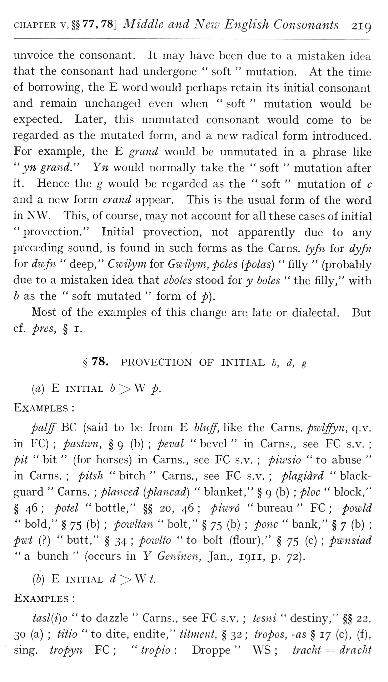  (delwedd F6970) (tudalen 219) | CHAPTER V, §§77, 78] Middle and New English Consonants 219  unvoice the consonant. It may have been due to a mistaken idea that the consonant had undergone “soft “mutation. At the time of borrowing, the E word would perhaps retain its initial consonant and remain unchanged even when “soft “mutation would be expected. Later, this unmutated consonant would come to be regarded as the mutated form, and a new radical form introduced. For example, the E grand would be unmutated in a phrase like “yn grand." Yn would normally take the “soft “mutation after it. Hence the g would be regarded as the “soft “mutation of c and a new form crand appear. This is the usual form of the word in NW. This, of course, may not account for all these cases of initial “provection." Initial provection, not apparently due to any preceding sound, is found in such forms as the Cams, tyfn for dyfii for dwfn “deep," Cwilym for Gwilym, poles (polas) “filly” (probably due to a mistaken idea that eholes stood for y boles “the filly," with b as the “soft mutated “form of p).  Most of the examples of this change are late or dialectal. But cf. pres, § I.  § 78. PROVECTION OF INITIAL b, d, g  (a) E INITIAL b'^W p.  Examples:  palff BC (said to be from E bluff, like the Cams, pwlffyn, q.v. in EC); pastwn, § 9 (b); peval “bevel “in Cams., see EC s.v.; pit “bit” (for horses) in Cams., see EC s.v.; piwsio “to abuse “in Cams.; pitsh “bitch “Cams., see EC s.v.; plagidrd “blackguard “Cams.; planced (plancad) “blanket," § 9 (b); ploc “block," § 46; potel “bottle," §§ 20, 46; piwro “bureau “EC; powld “bold," § 75 (b); powltan “bolt," § 75 (b); pone “bank," § 7 (b); pwt (?) "butt," § 34; poiolio "to bolt (flour)," § 75 (c); pwnsiad “a bunch” (occurs in Y Geninen, Jan., 1911, p. 72).  {b) E INITIAL d >> W t.  Examples:  tasl{i)o “to dazzle “Cams., see EC s.v.; tesni “destiny," §§ 22, 30 (a); titio "to dite, endite," titment, § 32; iropos, -as § 17 (c), (f), sing, tropyn EC; “tropio: Droppe “WS; iracht = dracht
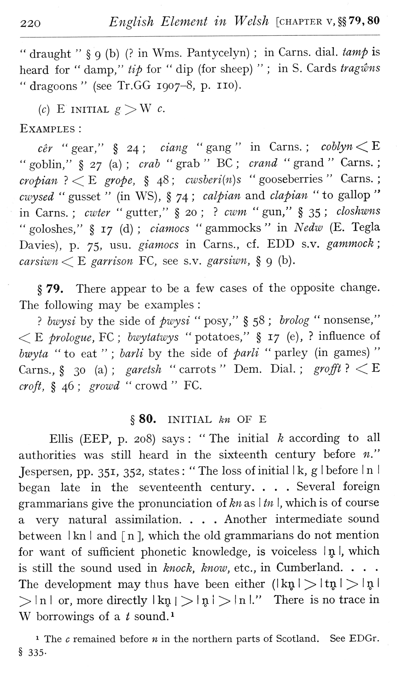  (delwedd F6971) (tudalen 220) | 220 English Element in Welsh [chapter v,§§ 79, 80 “draught” § 9 (b) (? in Wms. Pantycelyn); in Cams. dial, tamp is heard for “damp," tip for “dip (for sheep)”; in S. Cards tragwns “dragoons” (see Tr.GG 1907-8, p. no).  (c) E INITIAL g > W C.  Examples:  cer “gear," § 24; ciang “gang “in Cams.; coblyn < E "gobhn," § 27 (a); crab "grab" BC; crand "grand" Cams. cropian? < E grope, § 48; cwsberi{n)s “gooseberries “Cams. cwysed “gusset” (in WS), § 74; calpian and clapian “to gallop ' in Cams.; cwter “gutter," § 20;? cwm “gun," § 35; closhwns “goloshes," § 17 (d); ciamocs “gammocks “in Nedw (E. Tegla Da vies), p. 75, usu. giamocs in Cams., cf. EDD s.v. gammock; carsiwn -< E garrison EC, see s.v. garsiwn, § 9 (b).  § 79. There appear to be a few cases of the opposite change. The following may be examples:  ? bwysi by the side of pwysi “posy," § 58; brolog “nonsense," <E prologue, YC; bwytatwys "potatoes," § 17 (e),? influence of bwyta "to eat”; barli by the side of parli “parley (in games) “Carns., § 30 (a); garetsh “carrots “Dem. Dial.; grofft? < E croft, § 46; growd “crowd “EC.  § 80. INITIAL kn OF E  Ellis (EEP, p. 208) says: “The initial k according to all authorities was still heard in the sixteenth century before n." Jespersen, pp. 351, 352, states: “The loss of initial I k, g I before I n I began late in the seventeenth century. . . . Several foreign grammarians give the pronunciation of kn as I tn I, which is of course a very natural assimilation. . . . Another intermediate sound between I kn I and [ n ], which the old grammarians do not mention for want of sufficient phonetic knowledge, is voiceless I 51 1, which is still the sound used in knock, know, etc., in Cumberland. . . . The development may thus have been either (I kn I ^ I tn I ^ i n I ^ I n I or, more directly I kn | >> I n 1 >■! n I." There is no trace in W borrowings of a / sound. ^  1 The c remained before n in the northern parts of Scotland. See EDGr. § 335-
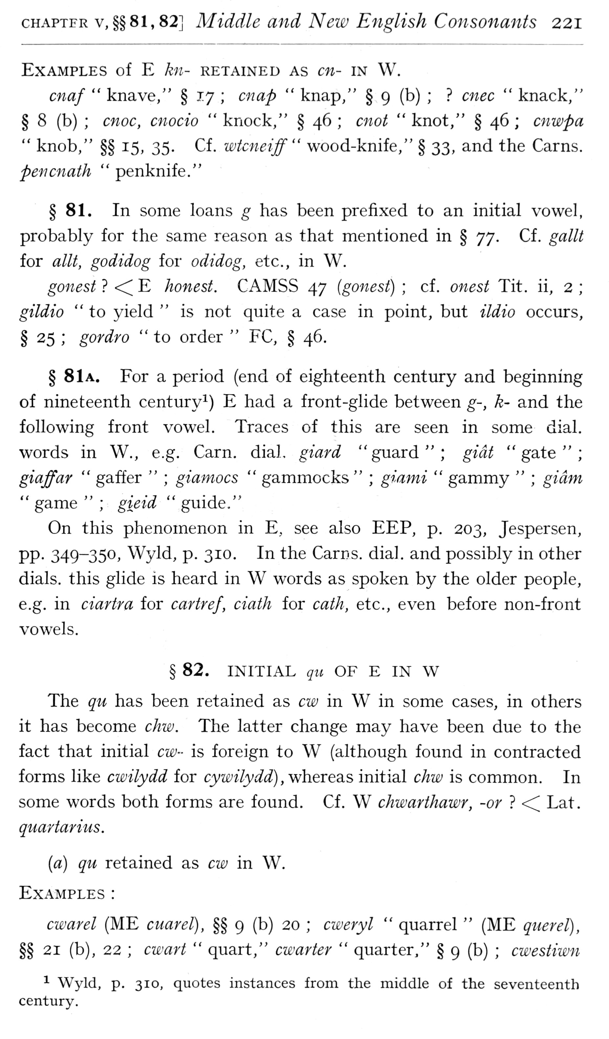  (delwedd F6972) (tudalen 221) | CHAPTER V, §§81,82] Middle and New English Consonants 221  Examples of E kn- retained as en- in W.  cnaf “knave," § 17; cnap “knap," § 9 (b);? cnec “knack," § 8 (b); cnoc, cnocio “knock," § 46; cnot “knot," § 46; cnwpa “knob," §§ 15, 35. Cf. wtcneiff" wood-knife," § 33, and the Cams. peficnath “penknife."  § 81. In some loans g has been prefixed to an initial vowel, probably for the same reason as that mentioned in § yy. Cf. gallt for allt, godidog for odidog, etc., in W.  gonest? <C E honest. CAMSS 47 (gonest); cf. onest Tit. ii, 2; gildio “to yield “is not quite a case in point, but ildio occurs, § 25; gordro “to order “FC, § 46.  § 81a. For a period (end of eighteenth century and beginning of nineteenth century^) E had a front-glide between g-, k- and the following front vowel. Traces of this are seen in some dial, words in W., e.g. Carn. dial, giard "guard"; gicit "gate"; giaffar “gaffer”; giamocs “gammocks”; giami “gammy”; gidm “game”; gieid “guide."  On this phenomenon in E, see also EEP, p. 203, Jespersen, pp. 349-350, Wyld, p. 310. In the Carns. dial, and possibly in other dials, this glide is heard in W words as spoken by the older people, e.g. in ciartra for cartref, ciath for cath, etc., even before non-front vowels.  § 82. INITIAL qu OF E IN W  The qu has been retained as cw in W in some cases, in others it has become chw. The latter change may have been due to the fact that initial cw- is foreign to W (although found in contracted forms like cwilydd for cywilydd) ,w\ieie2iS initial chw is common. In some words both forms are found. Cf. W chwarthawr, -or? <^ Lat. quartarius.  {a) qu retained as cio in W.  Examples:  cwarel (ME cuarel), §§ 9 (b) 20; civeryl “quarrel” (ME qiierel), §§ 21 (b), 22; cwart “quart," cwarter “quarter," § 9 (b); cwestiwn  ^ Wyld, p. 310, quotes instances from the middle of the seventeenth century.
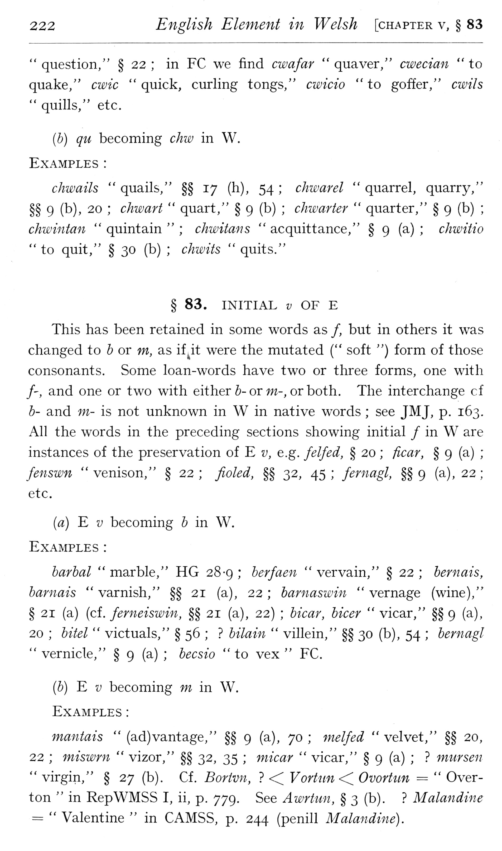  (delwedd F6973) (tudalen 222) | 222 English Element in Welsh [chapter v, § 83  " question," § 22; in FC we find cwafar “quaver," cwecian “to quake," cwic “quick, curling tongs," cwicio “to goffer," cwils “quills," etc.  (b) qu becoming chw in W.  Examples:  chwails “quails," §§ 17 (h), 54; cJiwarel “quarrel, quarry," §§ 9 (b), 20; chwart “quart," § 9 (b); chwarter “quarter," § 9 (b); chwintan “quintain”; chwitaiis “acquittance," § 9 (a); chwitio "to quit," § 30 (b); chwits “quits."  § 83. INITIAL z; OF E  This has been retained in some words as /, but in others it was changed to h or m, as if jt were the mutated (" soft ") form of those consonants. Some loan-words have two or three forms, one with /', and one or two with either 5- or w-, or both. The interchange cf h- and m- is not unknown in W in native words; see JMJ, p. 163. All the words in the preceding sections showing initial / in W are instances of the preservation of E v, e.g. felfed, § 20; ficar, § 9 (a); fenswn “venison," § 22; fioled, §§ 32, 45; fernagl, §§ 9 (a), 22; etc.  (a) E V becoming b in W.  Examples:  barbal “marble," HG 28-9; berfaen “vervain," § 22; bernais, barnais “varnish," §§ 21 (a), 22; barnaswin “vernage (wine)," § 21 (a) (cf. ferneiswin, §§ 21 (a), 22); bicar, bicer “vicar," §§ 9 (a), 20; bitel “victuals," § 56;? bilain “villein," §§ 30 (b), 54; bernagl “vernicle," § 9 (a); becsio “to vex “FC.  (b) E V becoming m in W.  Examples:  mantais” (ad)vantage," §§ 9 (a), 70; melfed “velvet," §§ 20, 22; miswrn “vizor," §§ 32, 35; micar “vicar," § 9 (a);? murseii “virgin," § 27 (b). Cf. Bortvn,? << Vortiin<^ Ovortun = “Overton “in RepWMSS I, ii, p. 779. See Awrtim, § 3 (b).? Malmidine = “Valentine “in CAMSS, p. 244 (penill Malandine).
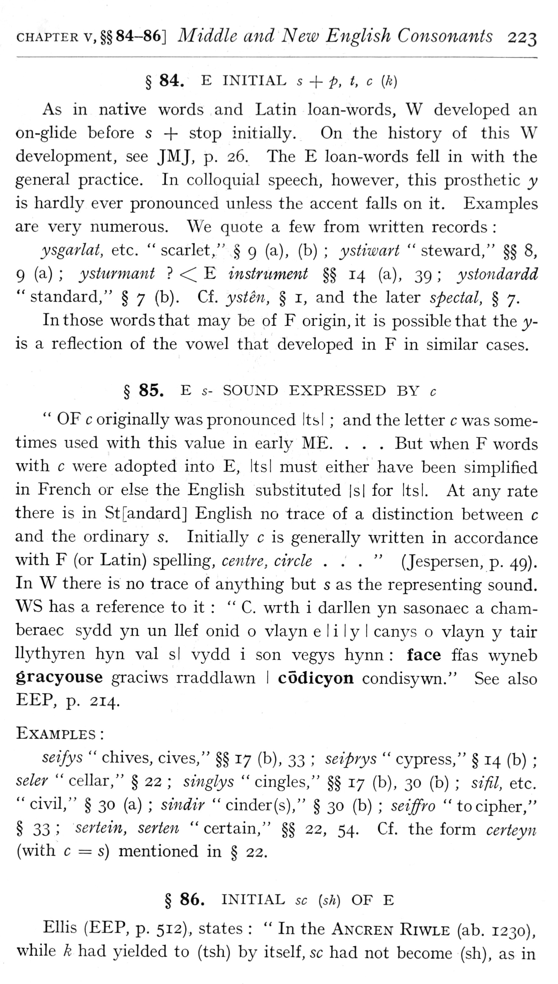  (delwedd F6974) (tudalen 223) | CHAPTER V, §§84-86] Middle and New English Consonants 223  § 84. E INITIAL s + p, t, c [k)  As in native words and Latin loan-words, W developed an on-glide before s + stop initially. On the history of this W development, see JMJ, p. 26. The E loan-words fell in with the general practice. In colloquial speech, however, this prosthetic y is hardly ever pronounced unless the accent falls on it. Examples are very numerous. We quote a few from written records:  ysgarlat, etc. “scarlet," § 9 (a), (b); ystiwart “steward," §§ 8, 9 (a); ysturmant? <C E instrument §§ 14 (a), 39; ystondardd “standard," § 7 (b). Cf. ysten, § i, and the later spectal, § 7.  In those words that may be of F origin, it is possible that the y- is a reflection of the vowel that developed in F in similar cases.  § 85. E s- SOUND EXPRESSED BY c  " OF c originally was pronounced Its I; and the letter c was sometimes used with this value in early ME. . . . But when F words with c were adopted into E, Its I must either have been simplified in French or else the English substituted |s| for Its I. At any rate there is in St[andard] English no trace of a distinction between c and the ordinary s. Initially c is generally written in accordance with F (or Latin) spelling, centre, circle ..." (Jespersen, p. 49). In W there is no trace of anything but s as the representing sound. WS has a reference to it: “C. wrth i darllen yn sasonaec a chamberaec sydd yn un lief onid o vlayn e I i I y I canj^s o vlayn y tair Ilythyren hyn val si vydd i son vegys hynn: face ffas wyneb gracyouse graciws rraddlawn I codicyon condisywn." See also EEP, p. 214.  Examples:  seifys “chives, cives," §§ 17 (b), 33; seiprys “cj^press," § 14 (b); seler “cellar," § 22; si7iglys “cingles," §§ 17 (b), 30 (b); sifil, etc. "civil," § 30 (a); sindir "cinder(s)," § 30 (b); seiffro "to cipher," § 33; sertein, serten "certain," §§ 22, 54. Cf. the form certeyn (with c = s) mentioned in § 22.  § 86. INITIAL sc [sh) OF E  Ellis (EEP, p. 512), states: “In the Ancren Riwle (ab. 1230), while k had yielded to (tsh) by itself, sc had not become (sh), as in
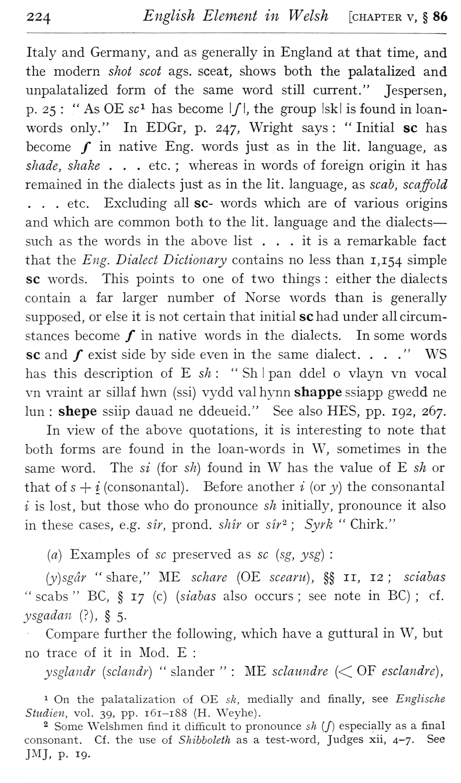  (delwedd F6975) (tudalen 224) | 224 English Element in Welsh [chapter v, § 86  Italy and Germany, and as generally in England at that time, and the modern shot scot ags. sceat, shows both the palatalized and unpalatalized form of the same word still current." Jespersen, p. 25: “As OE sc^ has become I/I, the group I ski is found in loan-words only." In EDGr, p. 247, Wright says: “Initial sc has become / in native Eng. words just as in the lit, language, as shade, shake . . . etc. 7 whereas in words of foreign origin it has remained in the dialects just as in the lit. language, as scab, scaffold . . . etc. Excluding all sc- words which are of various origins and which are common both to the lit. language and the dialects — such as the words in the above list . . . it is a remarkable fact that the Eng. Dialect Dictionary contains no less than 1,154 simple sc words. This points to one of two things: either the dialects contain a far larger number of Norse words than is generally supposed, or else it is not certain that initial sc had under all circumstances become / in native words in the dialects. In some words sc and / exist side by side even in the same dialect. . . ." WS has this description of E sA: “Sh I pan ddel o vlayn vn vocal vn vraint ar sillaf hwn (ssi) vydd val hynn shappe ssiapp gwedd ne lun: shepe ssiip dauad ne ddeueid." See also HES, pp. 192, 267. In view of the above quotations, it is interesting to note that both forms are found in the loan-words in W, sometimes in the same word. The si (for sh) found in W has the value of E sh or that ois -\- i (consonantal) . Before another i (or y) the consonantal i is lost, but those who do pronounce sh initially, pronounce it also in these cases, e.g. sir, prond. sMr or sir-; Syrk “Chirk."  [a) Examples of sc preserved as sc {sg, ysg):  {y)sgdr “share," ME schare (OE scearu), §§ 11, 12; sciabas “scabs “BC, § 17 (c) [siabas also occurs; see note in BC); cf. ysgadan (?), § 5- -  Compare further the following, which have a guttural in W, but no trace of it in Mod. E:  ysglandr [sclandr) “slander”: ME sclaundre (<C OF esclandre),  1 On the palatalization of OE sk, medially and finally, see Englische Studien, vol. 39, pp. 161-188 (H. Weyhe).  2 Some Welshmen find it difficult to pronounce sh (/) especially as a final consonant. Cf. the use of Shibboleth as a test-word, Judges xii, 4-7. See JMJ, p. 19.
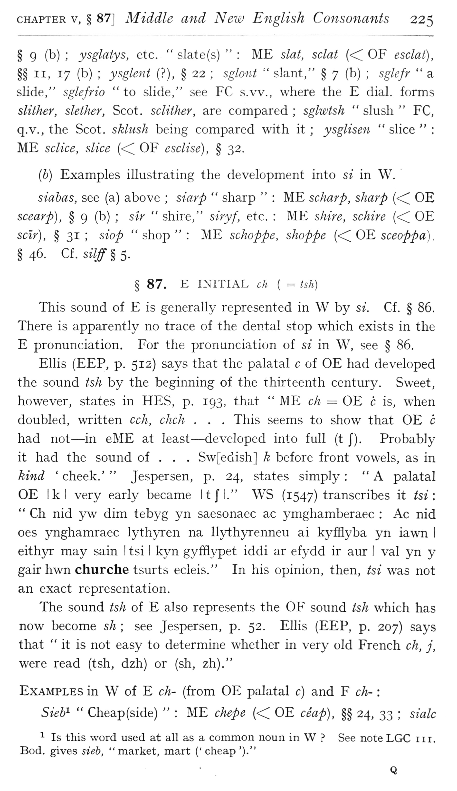  (delwedd F6976) (tudalen 225) | CHAPTER V, § 87] Middle and New English Consonants 225  § 9 (b); ysglatys, etc. “slate(s)”: ME slat, sclai (<< OF esclai), §§ II, 17 (b); ysglent (?), § 22; sglont “slant," § 7 (b); sglefr “a slide," sglefrio “to slide," see FC s.vv., where the E dial, forms slither, slether, Scot, sclither, are compared; sglwtsh “slush “FC, q.v., the Scot, sklush being compared with it; ysglisen “slice”: ME sclice, slice (<^ OF esclise), § 32.  [h) Examples illustrating the development into si in W. '  siahas, see (a) above; siarp “sharp”: ME scharp, sharp (<^ OE scearp), § 9 (b); sir “shire," siryf, etc.: ME shire, schire (<^ OE sclr), § 31; slop “shop”: ME schoppe, shoppe (<^ OE sceoppa), §46. Cf. si7#§5.  § 87. E INITIAL cJi ( = tsh)  This sound of E is generally represented in W by si. Cf. § 86. There is apparently no trace of the dental stop which exists in the E pronunciation. For the pronunciation of si in W, see § 86,  Ellis (EEP, p. 512) says that the palatal c of OE had developed the sound tsh by the beginning of the thirteenth century. Sweet, however, states in HES, p. 193, that “ME ch = OE c is, when doubled, written cch, chch . . . This seems to show that OE c had not^ — in eME at least — developed into full (t J). Probably it had the sound of . . . Sw[edish] k before front vowels, as in kind ' cheek.' “Jespersen, p. 24, states simply: "A palatal OE Ik I very early became It J" I." WS (1547) transcribes it tsi: “Ch nid yw dim tebyg yn saesonaec ac ymghamberaec: Ac nid oes ynghamraec lythyren na llythyrenneu ai kyfilyba yn iawn I eithjn: may sain I tsi I kyn gyfflypet iddi ar efydd ir aur I val yn y gair hwn churche tsurts ecleis." In his opinion, then, tsi was not an exact representation.  The sound tsh of E also represents the OF sound tsh which has now become sh; see Jespersen, p. 52. Ellis (EEP, p. 207) says that “it is not easy to determine whether in very old French ch, j, were read (tsh, dzh) or (sh, zh)."  Examples in W of E ch- (from OE palatal c) and F ch-:  Sieb"- “Cheap(side)”: ME chepe “OE ceap), §§ 24, 33; sialc  ^ Is this word used at all as a common noun in W? See note LGC iii. Bod. gives sieb, “market, mart (' cheap ')."
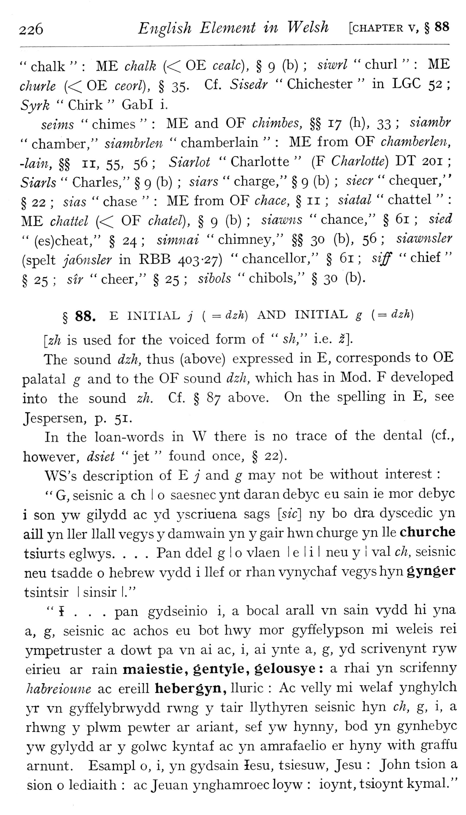  (delwedd F6977) (tudalen 226) | 226 English Element in Welsh [chapter v, § 88  " chalk”: ME chalk “OE cealc), § 9 (b); siwrl “churl”: ME clmrle “OE ceorl), § 35. Cf. Sisedr “Chichester “in LGC 52; Syrk “Chirk “GabI i.  seims “chimes”: ME and OF chimhes, §§ 17 (h), 33; siamhr “chamber/' siamhrlen “chamberlain”: ME from OF chamherlen, -lain, §§ II, 55, 56; Siarlot “Charlotte” (F Charlotte) DT 201; Siarls “Charles," § 9 (b); siars “charge," § 9 (b); siecr “chequer," § 22; sias “chase”: ME from OF chace, § 11; siatal “chattel”: ME chattel” OF chatel), § 9 (b); siawns “chance," § 61; sied” (es)cheat," § 24; simnai “chimney," §§ 30 (b), 56; siawnsler (spelt ja6nsler in RBB 403-27) "chancellor," § 61; siff "chief" § 25; sir “cheer," § 25; sibols “chibols," § 30 (b).  § 88. E INITIAL;■ ( = dzh) AND INITIAL g ( = dzh)  [zh is used for the voiced form of “sh," i.e. ^].  The sound dzh, thus (above) expressed in E, corresponds to OE palatal g and to the OF sound dzh, which has in Mod. F developed into the sound zh. Cf. § 87 above. On the spelling in E, see Jespersen, p. 51.  In the loan-words in W there is no trace of the dental (cf., however, dsiet “jet “found once, § 22).  WS's description of E j and g may not be without interest:  " G, seisnic a ch I o saesnec ynt daran debyc eu sain ie mor debyc i son yw gilydd ac yd yscriuena sags [sic] ny bo dra dyscedic yn aill yn Her Hall vegys y damwain yn y gair hwn churge yn He churche tsiurts eglwys. . . . Pan ddel g I o vlaen 1 e 1 i I neu y I val ch, seisnic neu tsadde o Hebrew vydd i lief or rhan vynychaf vegys hyn gynger tsintsir I sinsir I."  " { . . . pan gydseinio i, a bocal arall vn sain vydd hi yna a, g, seisnic ac achos eu bot hwy mor gyffelypson mi weleis rei ympetruster a dowt pa vn ai ac, i, ai ynte a, g, yd scrivenynt ryw eirieu ar rain maiestie, gentyle, gelousye: a rhai yn scrifenny habreioune ac ereill hebergyn, lluric: Ac velly mi welaf ynghylch >T vn gyffelybrwydd rwng y tair llythyren seisnic hyn ch, g, i, a rhwng y plwm pewter ar ariant, sef yw hynny, bod yn gynhebyc yw gylydd ar y golwc kyntaf ac yn amrafaelio er hyny with graffu arnunt. Esampl o, i, yn gydsain lesu, tsiesuw, Jesu: John tsion a sion o lediaith: ac Jeuan ynghamroec loyw: ioynt, tsioynt kymal."
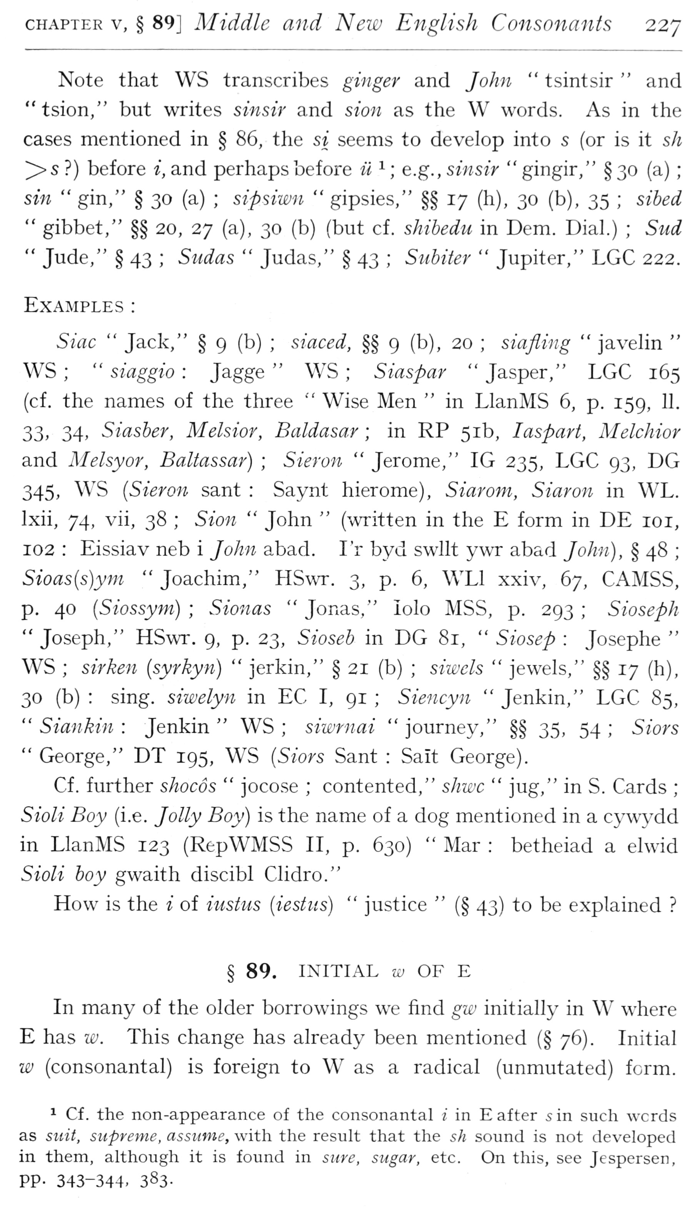  (delwedd F6978) (tudalen 227) | CHAPTER V, § 89] Middle and New English Consonants 227  Note that WS transcribes ginger and John “tsintsir “and "tsion," but writes sinsir and sion as the W words. As in the cases mentioned in § 86, the si seems to develop into s (or is it sh >s?) before i, and perhaps before ii ^; e.g., sinsir “gingir," § 30 (a); sin “gin," § 30 (a); sipsiwn “gipsies," §§ 17 (h), 30 (b), 35; sibed “gibbet," §§ 20, 27 (a), 30 (b) (but cf. shihedu in Dem. Dial.); Sud “Jude," § 43; Stidas “Judas," § 43; Subiier “Jupiter," LGC 222.  Examples:  Sine “Jack," § 9 (b); siaced, §§ 9 (b), 20; siaflvng “javelin “WS; “siaggio: Jagge “WS; Siaspar “Jasper," LGC 165 (cf. the names of the three “Wise Men “in LlanMS 6, p. 159, 11. 33> 34. Siasber, Melsior, Baldasar; in RP 51b, laspart, Melchior and Melsyor, Baltassar); Sieron “Jerome," IG 235, LGC 93, DG 345, WS {Sieron sant: Saynt hierome), Siarom, Siaron in WL. Ixii, 74, vii, 38; Sion “John” (written in the E form in DE loi, 102: Eissiav neb i John abad. Lr byd swllt ywr abad John), § 48; Sioas{s)ym “Joachim," HSwr. 3, p. 6, WLl xxiv, 67, CAMSS, p. 40 [Siossym]; Sionas “Jonas," lolo MSS, p. 293; Sioseph “Joseph," HSwr. 9, p. 23, Sioseb in DG 81, “Siosep: Josephe “WS; sirken [syrkyn) “jerkin," § 21 (b); siwcls “jewels," §§ 17 (h), 30 (b): sing, siwelyn in EC I, 91; Siencyn “Jenkin," LGC 85, “Siankin: Jenkin “WS; siwrnai “journey," §§ 35, 54; Siors “George," DT 195, WS {Siors Sant: Salt George).  Cf. further shocos “jocose; contented," sJiwc “jug," in S. Cards; Sioli Boy (i.e. Jolly Boy) is the name of a dog mentioned in a cywydd in LlanMS 123 (RepWMSS II, p. 630) “Mar: betheiad a elwid Sioli boy gwaith discibl Clidro."  How is the i of iustus {iestiis) “justice” (§ 43) to be explained?  § 89. INITIAL w OF E  In many of the older borrowings we find gw initially in W where E has w. This change has already been mentioned (§ 76). Initial w (consonantal) is foreign to W as a radical (unmutated) form.  ^ Cf . the non-appearance of the consonantal i in E after 5 in such words as suit, supreme, assume, with the result that the 5/^ sound is not developed in them, although it is found in sure, sugar, etc. On this, see Jespersen, PP- 343-344. 383-
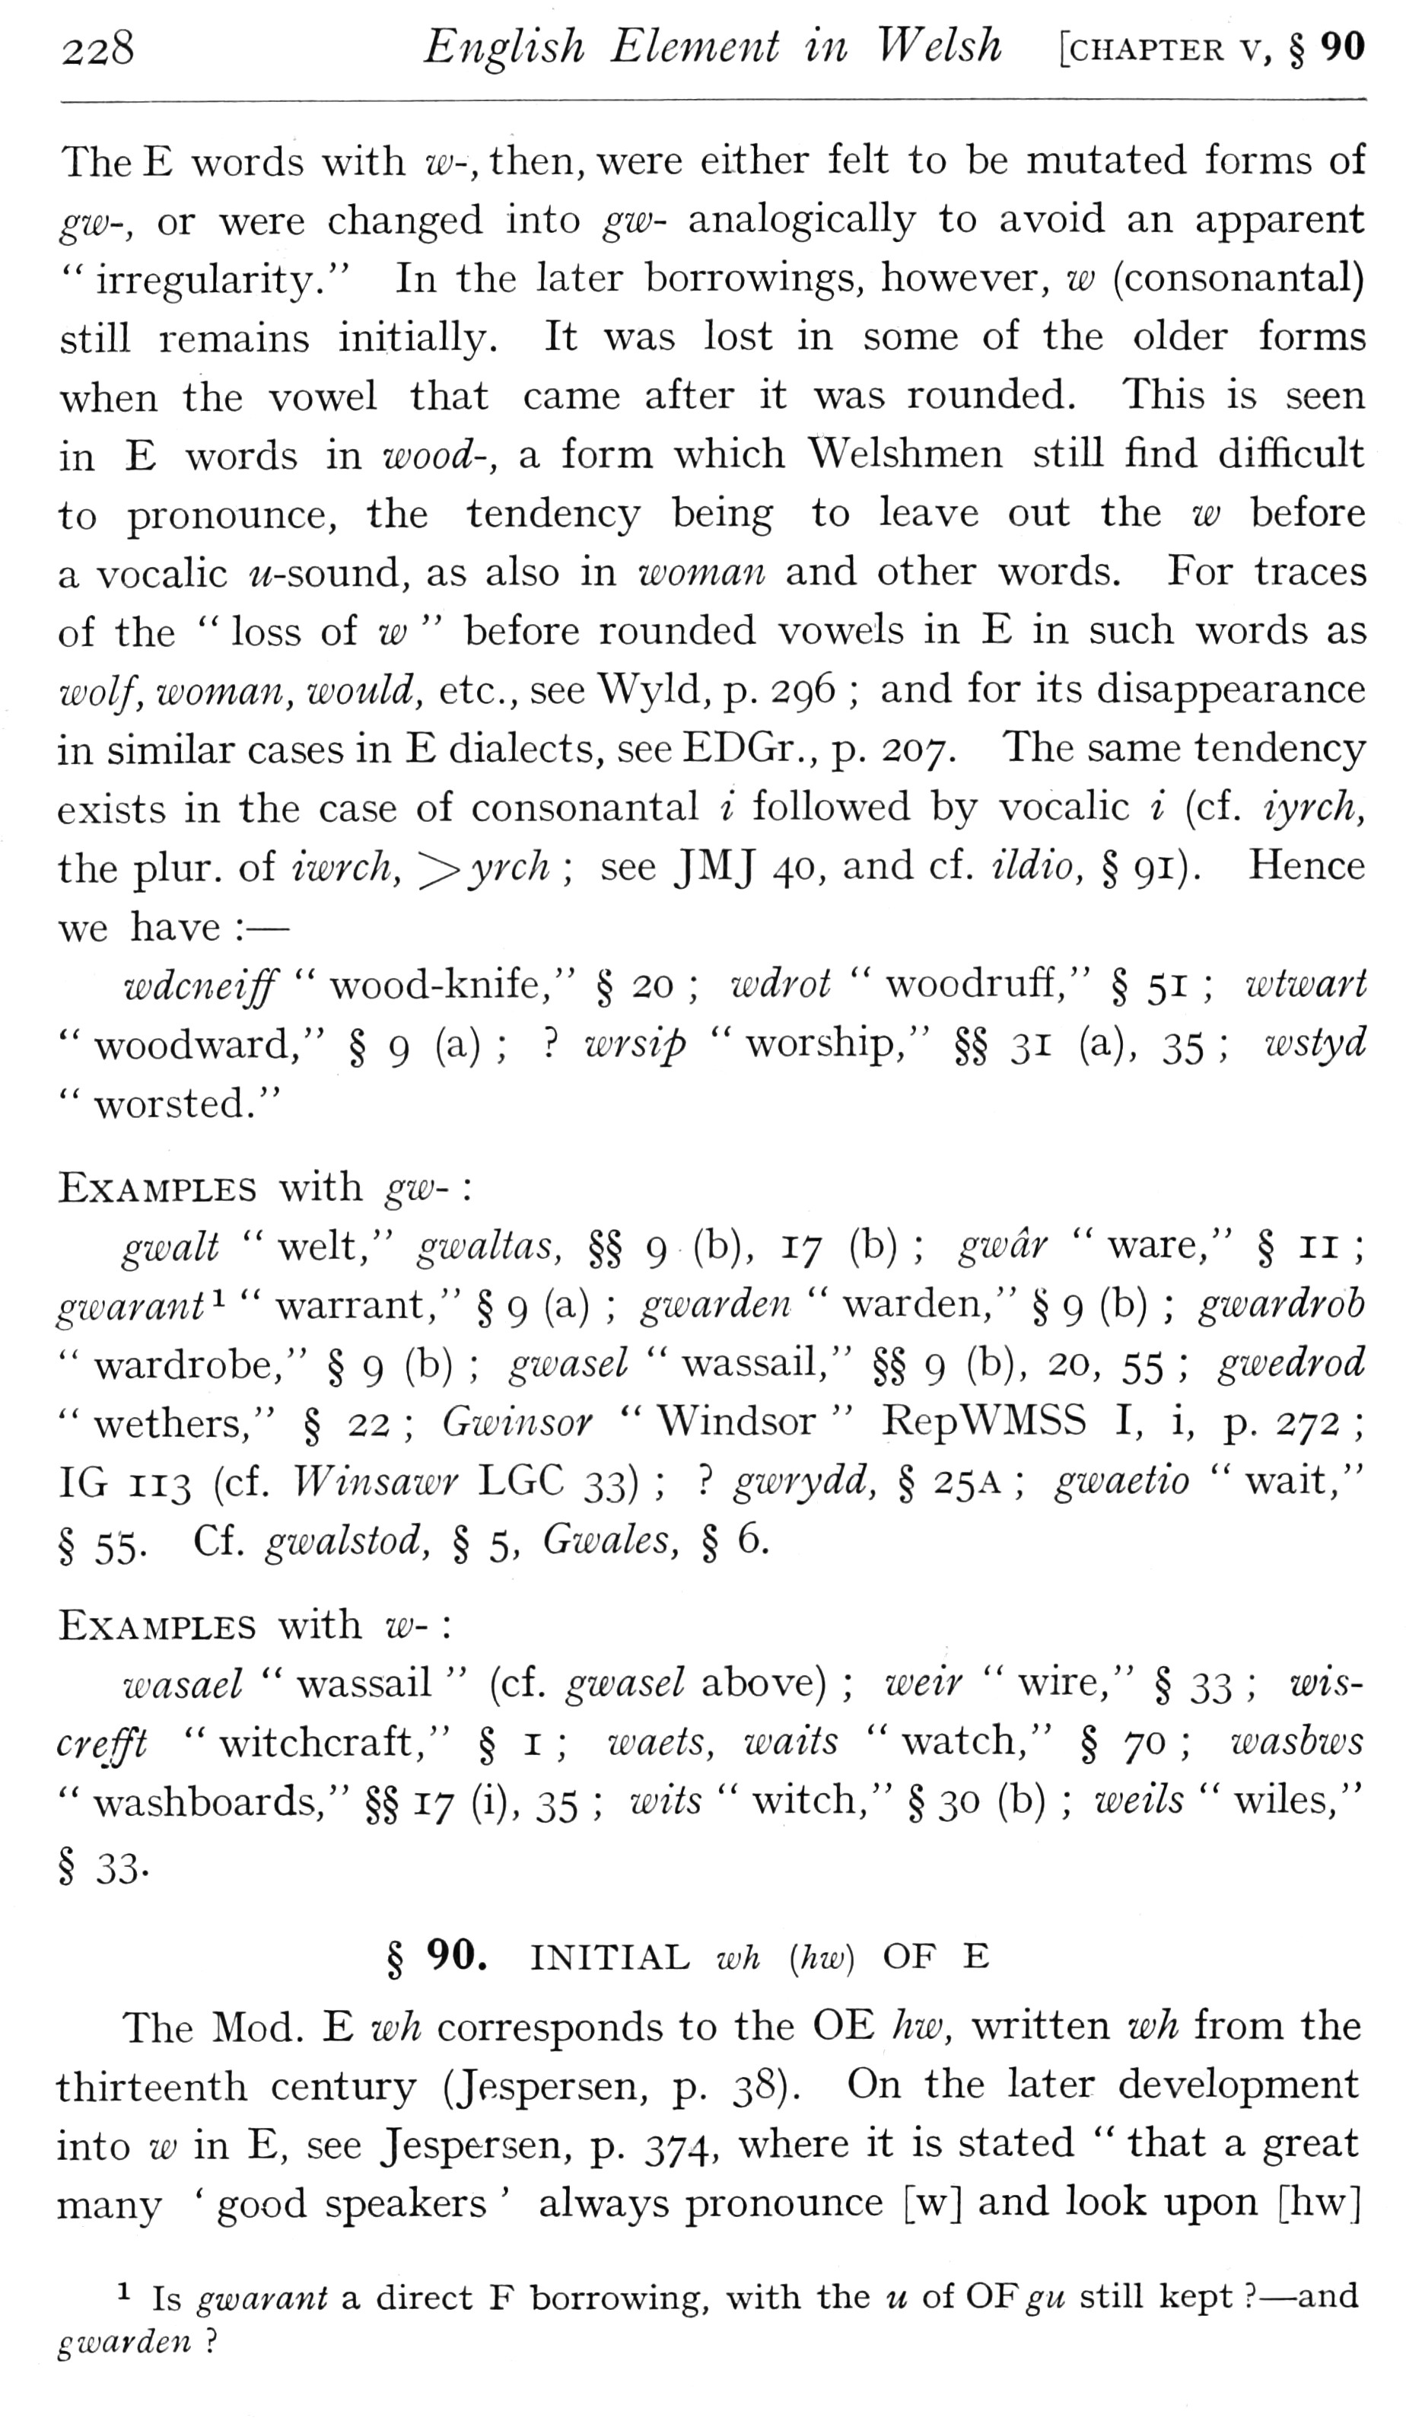  (delwedd F6979) (tudalen 228) | 228 English Element in Welsh [chapter v, § 90  The E words with w-, then, were either felt to be mutated forms of gw-, or were changed into gw- analogically to avoid an apparent "irregularity." In the later borrowings, however, w (consonantal) still remains initially. It was lost in some of the older forms when the vowel that came after it was rounded. This is seen in E words in wood-, a form which Welshmen still find difficult to pronounce, the tendency being to leave out the w before a vocalic w-sound, as also in woman and other words. For traces of the “loss of z£; “before rounded vowels in E in such words as wolf, woman, would, etc., see Wyld, p. 296; and for its disappearance in similar cases in E dialects, see EDGr., p. 207. The same tendency exists in the case of consonantal i followed by vocalic i (cf. iyrch, the plur. of iwrch, '^yrch; see JMJ 40, and cf. ildio, § 91). Hence we have: —  wdcneiff “wood-knife," § 20; wdrot “woodruff," § 51; wtwart “woodward," § 9 (a);? wrsip “worship," §§31 (a), 35; iDstyd “worsted."  Examples with gw-:  gwalt “welt," gwaltas, §§ 9 (b), 17 (b); gwdr “ware," § 11; gwarant^ “warrant," § 9 (a); gwarden “warden," § 9 (b); gimrdrob “wardrobe," § 9 (b); gwasel "wassail," §§ 9 (b), 20, 55; gwedrod “wethers," § 22; Gwinsor “Windsor “RepWMSS I, i, p. 272; IG 113 (cf. Winsawr LGC ^'^);? gwrydd, § 25A; gwaetio “wait," § 55. Cf. gwalstod, § 5, Gwales, § 6.  Examples with w-:  wasael “wassail” (cf. gwasel above); weir “wire," § ^^; wiscreft "witchcraft," § i; waets, waits "watch," § 70; wasbws “washboards," §§ 17 (i), 35; wits “witch," § 30 (b); weils “wiles,"  § 33.  § 90. INITIAL wh [hw) OF E  The Mod. E wh corresponds to the OE hw, written wh from the thirteenth century (Jespersen, p. 38). On the later development into w in E, see Jespersen, p. 374, where it is stated “that a great many ' good speakers ' always pronounce [w] and look upon [hw]  ^ Is gwarant a direct F borrowing, with the u of OF gu still kept? — and  gwarden?
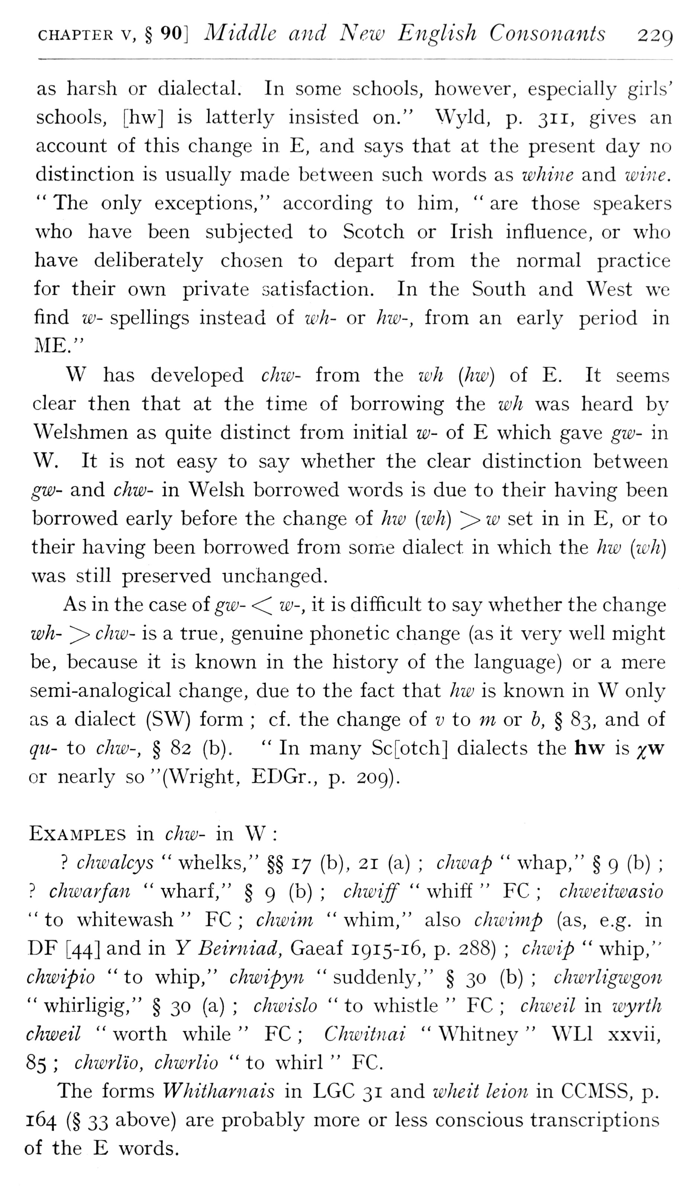  (delwedd F6980) (tudalen 229) | CHAPTER V, § 90] Middle and New English Consonants 229  as harsh or dialectal. In some schools, however, especially girls' schools, [hw] is latterly insisted on." Wyld, p. 311, gives an account of this change in E, and says that at the present day no distinction is usually made between such words as whine and wine. “The only exceptions," according to him, “are those speakers who have been subjected to Scotch or Irish influence, or who have deliberately chosen to depart from the normal practice for their own private satisfaction. In the South and West we find w- spellings instead of wli- or hw-, from an early period in ME."  W has developed chw- from the wh (hw) of E. It seems clear then that at the time of borrowing the wh was heard by Welshmen as quite distinct from initial w- of E which gave gw- in W. It is not easy to say whether the clear distinction between gw- and chw- in Welsh borrowed words is due to their having been borrowed early before the change of hw (wh) ^ w set in in E, or to their having been borrowed from some dialect in which the hw (wh) was still preserved unchanged.  As in the case of gw- <^ w-, it is difficult to say whether the change wh- ^ chw- is a true, genuine phonetic change (as it very well might be, because it is known in the history of the language) or a mere semi-analogical change, due to the fact that hw is known in W only as a dialect (SW) form; cf. the change of v to m or b, § 83, and of qu- to chw-, § 82 (b). “In many Sc[otch] dialects the hw is yw or nearly so "(Wright, EDGr., p. 209).  Examples in chw- in W:  ? chwalcys “whelks," §§ 17 (b), 21 (a); chwap “whap," § 9 (b);? chwarfan “wharf," § 9 (b); chwiff “whiff “EC; chweitwasio “to whitewash “EC; chwim “whim," also chwimp (as, e.g. in DE [44] and in Y Beirniad, Gaeaf 1915-16, p. 288); chwip “whip," chwipio “to whip," chwipyn “suddenly," § 30 (b); chwrligwgon “whirligig," § 30 (a); chwislo “to whistle “EC; chweil in wyrth chweil “worth while “EC; Chwitnai “Whitney “WLI xxvii, 85; chwrlio, chwrlio “to whirl “EC.  The forms Whitharnais in LGC 31 and wheit leion in CCMSS, p. 164 (§ 33 above) are probably more or less conscious transcriptions of the E words.
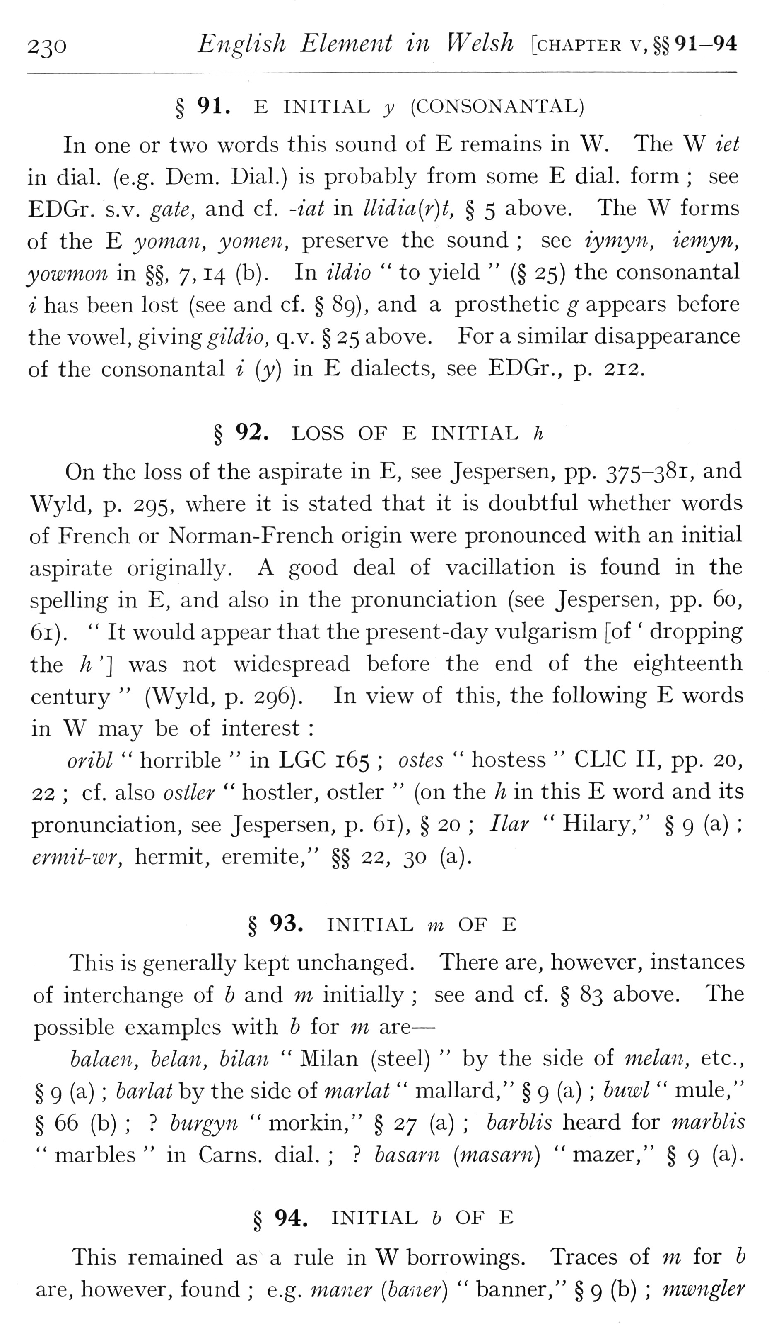  (delwedd F6981) (tudalen 230) | 230 English Element in Welsh [chapter v,§§ 91-94  § 91. E INITIAL y (CONSONANTAL)  In one or two words this sound of E remains in W. The W iet in dial. (e.g. Dem. Dial.) is probably from some E dial, form; see EDGr. s.v. gate, and cf. -iat in llidia[r)t, § 5 above. The W forms of the E yoman, yomen, preserve the sound; see iymyn, iemyn, yowmon in §§, 7, 14 (b). In ildio “to yield” (§ 25) the consonantal i has been lost (see and cf. § 89), and a prosthetic g appears before the vowel, giving gildio, q. v. § 25 above. For a similar disappearance of the consonantal i {y) in E dialects, see EDGr., p. 212.  § 92. LOSS OF E INITIAL h  On the loss of the aspirate in E, see Jespersen, pp. 375-381, and Wyld, p. 295, where it is stated that it is doubtful whether words of French or Norman-French origin were pronounced with an initial aspirate originally. A good deal of vacillation is found in the spelling in E, and also in the pronunciation (see Jespersen, pp. 60, 61). “It would appear that the present-day vulgarism [of ' dropping the h '] was not widespread before the end of the eighteenth century” (Wyld, p. 296). In view of this, the following E words in W may be of interest:  orihl “horrible “in LGC 165; ostes “hostess “CLIC II, pp. 20, 22; cf. also ostler “hostler, ostler” (on the h in this E word and its pronunciation, see Jespersen, p. 61), § 20; Bar “Hilary," § 9 (a); ermit-wr, hermit, eremite," §§ 22, 30 (a).  § 93. INITIAL m OF E  This is generally kept unchanged. There are, however, instances of interchange of b and m initially; see and cf. § 83 above. The possible examples with b for m are —  balaen, belan, bilan “Milan (steel) “by the side of melan, etc., § 9 (a); barlat by the side of marlat “mallard," § 9 (a); buwl “mule," § 66 (b);? burgyn “morkin," § 27 (a); barblis heard for marblis “marbles “in Cams. dial.;? basarn [masarn) “mazer," § 9 (a).  § 94. INITIAL & OF E  This remained as a rule in W borrowings. Traces of jji for b are, however, found; e.g. maner (baner) “banner," § 9 (b); mwngler
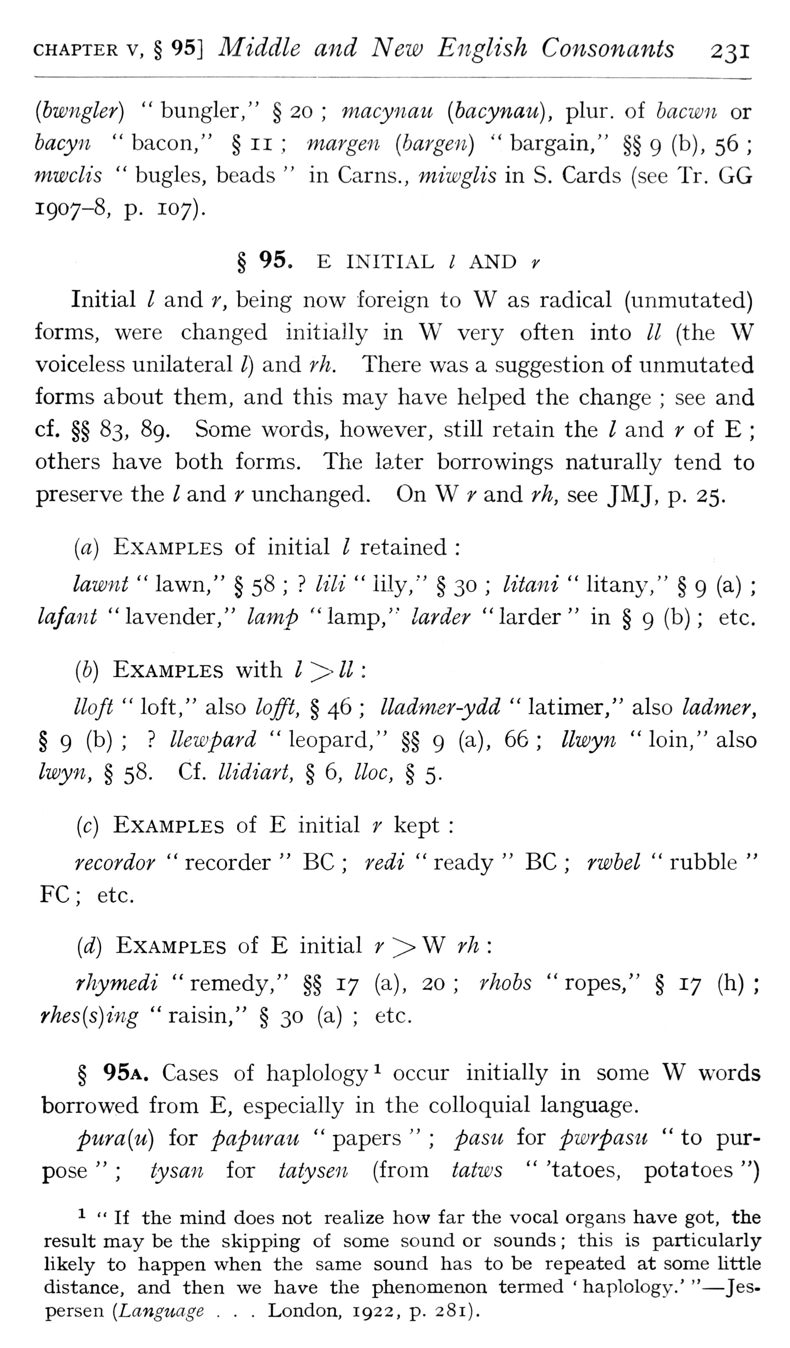  (delwedd F6982) (tudalen 231) | CHAPTER V, § 95] Middle and New English Co7isonants 231  {hwngler) "bungler," §20; macynau [bacynau], plur. of hacwn or hacyn “bacon," § 11; mar gen {bar gen) “bargain," §§ 9 (b), 56; mwclis “bugles, beads “in Cams., miwglis in S. Cards (see Tr. GG 1907-8, p. 107).  § 95. E INITIAL / AND y  Initial / and r, being now foreign to W as radical (unmutated) forms, were changed initially in W very often into // (the W voiceless unilateral I) and rh. There was a suggestion of unmutated forms about them, and this may have helped the change; see and cf. §§ 83, 89. Some words, however, still retain the / and r of E; others have both forms. The later borrowings naturally tend to preserve the I and r unchanged. On W;' and rh, see JMJ, p. 25.  {a) Examples of initial I retained:  lawnt “lawn," § 58;? lili “lily," § 30; litani “litany," § 9 (a); lafant "lavender," lamp "lamp," larder "larder" in § 9 (b); etc.  {h) Examples with l^-ll:  lloft “loft," also lofft, § 46; lladm-er-ydd “latimer," also ladmer, § 9 (b);? llewpard "leopard," §§ 9 (a), 66; llwy^i "loin," also Iwyn, § 58. Cf. llidiart, § 6, Hoc, § 5.  (c) Examples of E initial r kept:  recorder “recorder “BC; redi “ready “BC; rwhel “rubble “FC; etc.  {d) Examples of E initial f ^ W rh:  rhymedi “remedy," §§ 17 (a), 20; rhohs “ropes," § 17 (h); rhes{s)ing “raisin," § 30 (a); etc.  § 95a. Cases of haplology^ occur initially in some W words borrowed from E, especially in the colloquial language.  pura{u) for papurau “papers”; pasu for pwrpasu “to purpose”; tysan for tatysen (from tatws” 'tatoes, potatoes ")  ^ “If the mind does not realize how far the vocal organs have got, the result may be the skipping of some sound or sounds; this is particularly likely to happen when the same sound has to be repeated at some httle distance, and then we have the phenomenon termed ' haplology.'“ — Jespersen {Language . . . London, 1922, p. 281).
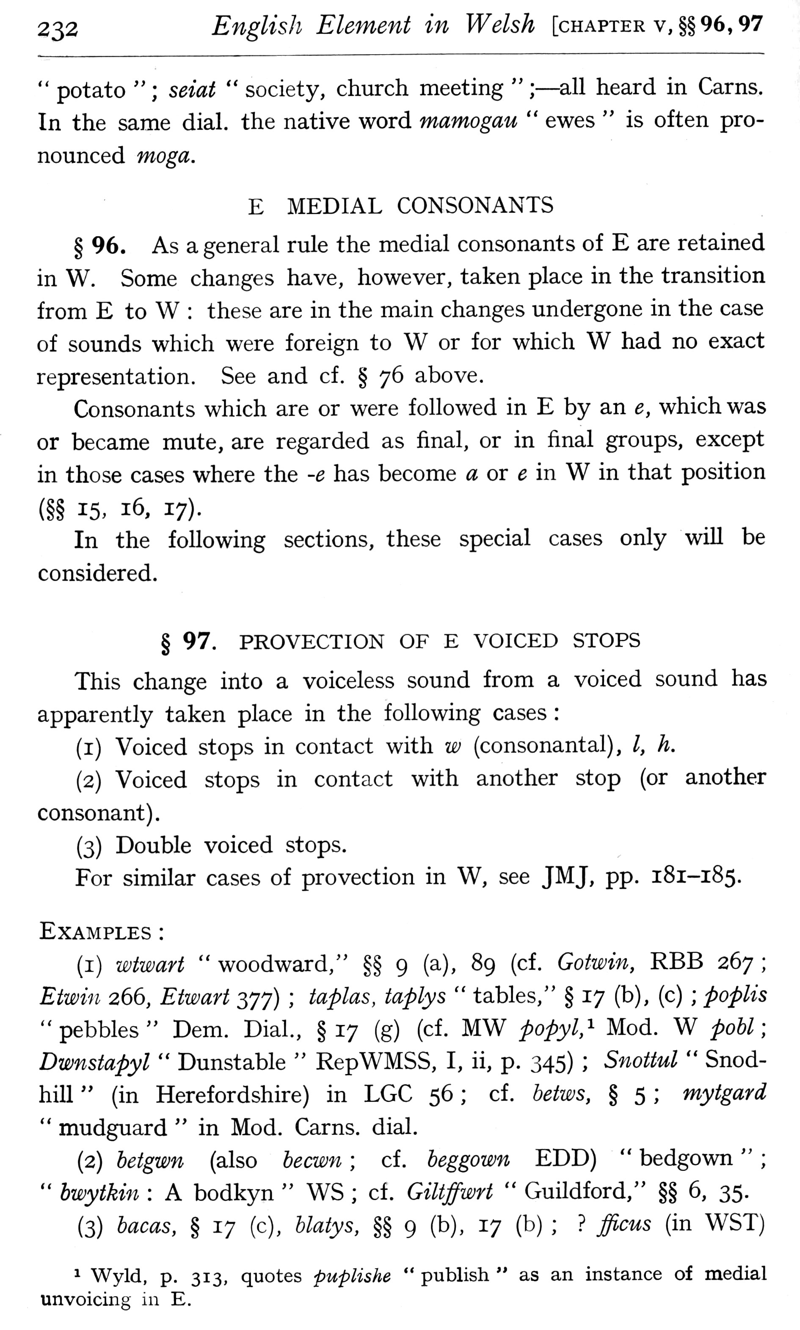  (delwedd F6983) (tudalen 232) | 232 Englisli Element in Welsh [chapter v, §§96,97  " potato”; seiat “society, church meeting”; — all heard in Cams, In the same dial, the native word mamogau “ewes “is often pronounced moga.  E MEDIAL CONSONANTS  § 96. As a general rule the medial consonants of E are retained in W. Some changes have, however, taken place in the transition from E to W: these are in the main changes undergone in the case of sounds which were foreign to W or for which W had no exact representation. See and cf. § 76 above.  Consonants which are or were followed in E by an e, which was or became mute, are regarded as final, or in final groups, except in those cases where the -e has become a gt e in W in that position  (§§ 15, 16, 17).  In the following sections, these special cases only will be  considered.  § 97. PROVECTION OF E VOICED STOPS  This change into a voiceless sound from a voiced sound has apparently taken place in the following cases:  (i) Voiced stops in contact with w (consonantal), /, h.  (2) Voiced stops in contact with another stop (or another consonant).  (3) Double voiced stops.  For similar cases of provection in W, see JMJ, pp. 181-185.  Examples:  (i) wtwart “woodward," §§ 9 (a), 89 (cf. Gotwin, RBB 267; Etwiii 266, Etwart 377); taplas, taplys “tables," § 17 (b), (c); poplis "pebbles" Dem. Dial., §17 (g) (cf. MW popyl,"- Mod. W pohl \ Dwnstapyl “Dunstable “RepWMSS, I, ii, p. 345); Snottul “Snodhill” (in Herefordshire) in LGC 56; cf. betws, § 5; mytgard “mudguard “in Mod. Cams. dial.  (2) hetgwn (also hecwn; cf. heggown EDD) “bedgown”; “hwytkin: A bodkyn “WS; cf. Giltffwrt “Guildford," §§ 6, 35.  (3) hacas, § 17 (c), hlatys, §§ 9 (b), 17 (1^);? fficus (in WST)  ^ Wyld, p. 313, quotes pupUshe “publish “as an instance of medial unvoicing in E.
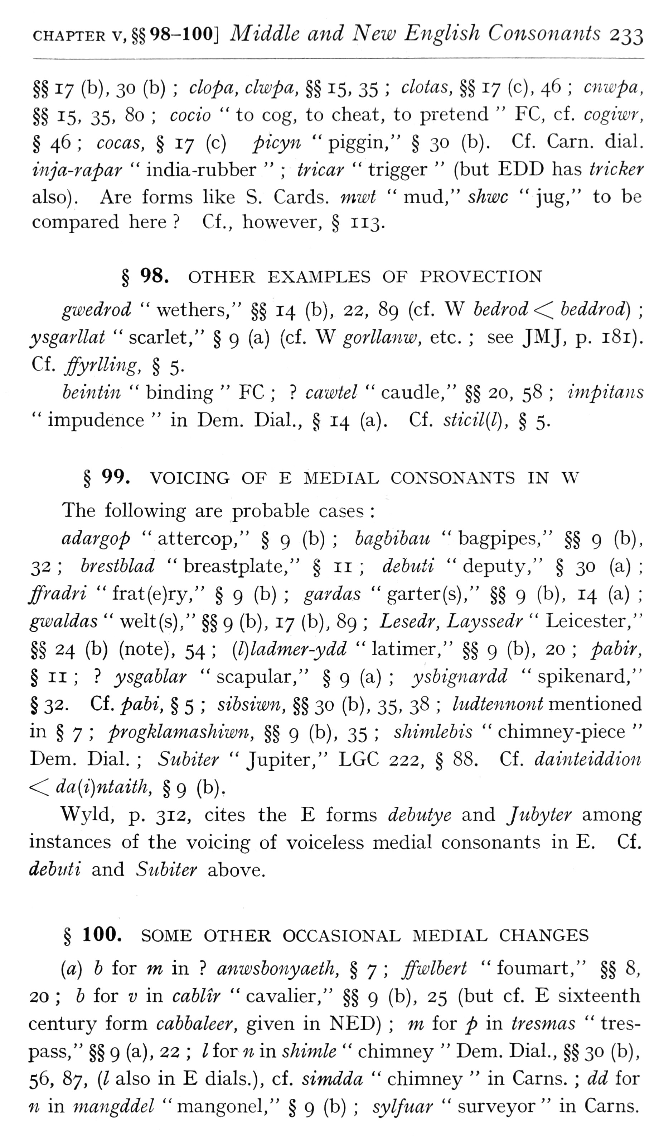  (delwedd F6984) (tudalen 233) | CHAPTER v,§§ 98-100] Middle and New English Consonants 233  §§ 17 (b), 30 (b); clopa, clwpa, §§ 15, 35; clotas, §§ 17 (c), 46; cnwpa, §§ 15. 35» 80; cocio “to cog, to cheat, to pretend “FC, cf. cogiwr, § 46; cocas, § 17 (c) picyn “piggin," § 30 (b). Cf. Carn. dial. inja-rapar “india-rubber”; tricar “trigger” (but EDD has tricker also). Are forms like S. Cards, mwt “mud," shwc “jug," to be compared here? Cf., however, § 113.  § 98. OTHER EXAMPLES OF PROVECTION  gwedrod “wethers," §§ 14 (b), 22, 89 (cf. W bedrod<C beddrod); ysgarllat “scarlet," § 9 (a) (cf. W gorllanw, etc.; see JMJ, p. 181). Cf. ffyrlling, § 5.  heintin “binding “FC;? cawtel “caudle," §§ 20, 58; impitans “impudence “in Dem. Dial., § 14 (a). Cf. sticil(l), § 5.  § 99. VOICING OF E MEDIAL CONSONANTS IN W  The following are probable cases:  adargop “attercop," § 9 (b); hagbihau "bagpipes," §§ 9 (b), 32; brestblad "breastplate," § 11; debuii "deputy," § 30 (a); ffmdri "frat(e)ry," § 9 (b); gar das “garter (s)," §§ 9 (b), 14 (a); gwaldas “welt(s)," §§ 9 (b), 17 (b), 89; Lesedr, Layssedr “Leicester," §§ 24 (b) (note), 54; [l)ladmer-ydd “latimer," §§ 9 (b), 20; pabir, § II;? ysgablar “scapular," § 9 (a); ysbignardd “spikenard," § 32. Cf. pabi, § 5; sibsiwn, §§ 30 (b), 35, 38; ludtennont mentioned in § 7; progkla7nashiwn, §§ 9 (b), 35; shinilebis “chimney-piece “Dem. Dial.; Subiter “Jupiter," LGC 222, § 88. Cf. dainteiddion <C da{i)ntaith, § 9 (b).  Wyld, p. 312, cites the E forms debutye and Jubyter among instances of the voicing of voiceless medial consonants in E. Cf. debiiti and Subiter above.  § 100. SOME OTHER OCCASIONAL MEDIAL CHANGES  (a) b for w in? anwsbonyaeth, § 7; ffwlbert "foumart," §§ 8, 20; 6 for y in cablir “cavalier," §§ 9 (b), 25 (but cf. E sixteenth century form cabbaleer, given in NED); m for p in tresmas “trespass," §§ 9 (a), 22; /for n in shimle “chimney “Dem. Dial., §§ 30 (b), 56, 87, (/ also in E dials.), cf, simdda “chimney “in Cams.; dd for 11 in mangddel "mangonel," § 9 (b); sylfuar “surveyor" in Cams.
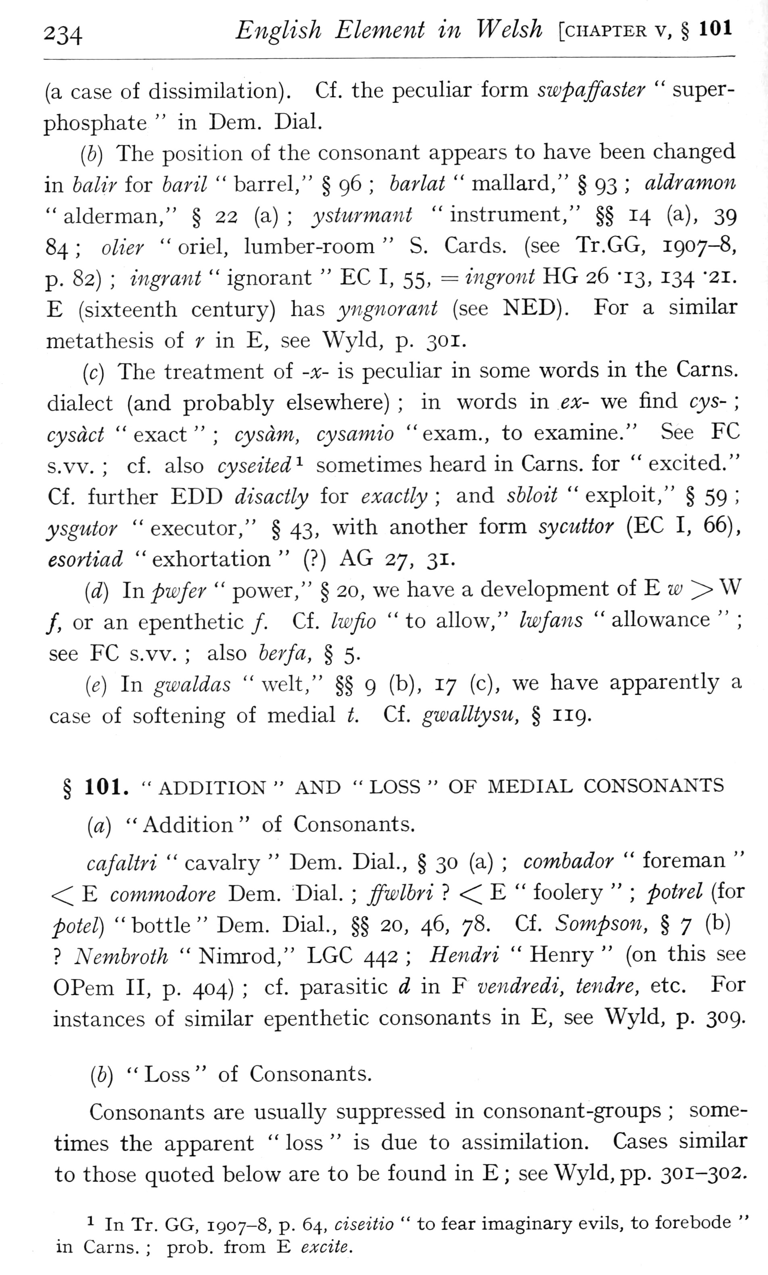  (delwedd F6985) (tudalen 234) | 234 English Element in Welsh [chapter v, § 101  (a case of dissimilation). Cf. the peculiar form swpaffaster “super-phosphate “in Dem. Dial.  (6) The position of the consonant appears to have been changed in halir for haril “barrel," § 96; harlat “mallard/' § 93; aldramon “alderman," § 22 (a); ysturmant “instrument," §§ 14 (a), 39 84; olier “oriel, lumber-room “S. Cards, (see Tr.GG, 1907-8, p. 82); ingrant “ignorant “EC I, 55, = ingront HG 26 '13, 134 -21. E (sixteenth century) has yngnorant (see NED). For a similar metathesis of r in E, see Wyld, p. 301.  (c) The treatment of -x- is peculiar in some words in the Cams, dialect (and probably elsewhere); in words in ex- we find cys-; cysdct "exact"; cysdm, cysamio "exam., to examine." See EC s.vv.; cf. also cyseited^ sometimes heard in Cams, for “excited." Cf. further EDD disactly for exactly; and shloit “exploit," § 59; ysgutor "executor," § 43, with another form sycuttor (EC I, 66), esortiad “exhortation” (?) AG 27, 31.  (d) In pwfer “power," § 20, we have a development of E tiy > W /, or an epenthetic /. Cf. Iwfio “to ahow," Iwfans “allowance”; see EC s.vv.; also berfa, § 5.  (e) In gwaldas “welt," §§ 9 (b), 17 (c), we have apparently a case of softening of medial t. Cf. gwalUysu, § 119.  § 101. “ADDITION “AND “LOSS “OF MEDIAL CONSONANTS  [a) “Addition “of Consonants.  cafaltri “cavalry “Dem. Dial., § 30 (a); combador “foreman” < E commodore Dem. ^Dial.; ffwlhri? < E “foolery”; petrel (for potel) "bottle" Dem. Dial, §§ 20, 46, 78. Cf. Sompson, § 7 (b)? Nembroth “Nimrod," LGC 442; Hendri “Henry” (on this see OPem II, p. 404); cf. parasitic ^ in F vendredi, tendre, etc. Eor instances of similar epenthetic consonants in E, see Wyld, p. 309.  (6) “Loss “of Consonants.  Consonants are usually suppressed in consonant -groups; sometimes the apparent “loss “is due to assimilation. Cases similar to those quoted below are to be found in E; see Wyld, pp. 301-302.  1 In Tr. GG, 1907-8, p. 64, ciseitio “to fear imaginary evils, to forebode “in Cams.; prob. from E excite.
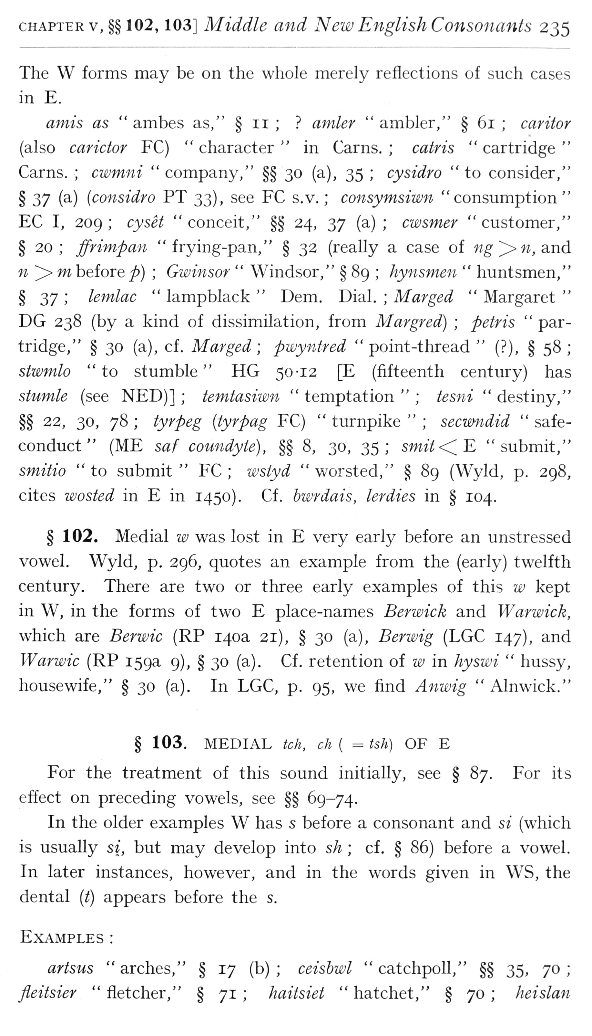  (delwedd F6986) (tudalen 235) | CHAPTER v,§§ 102, 103] Middle and New English Consonants 235  The W forms may be on the whole merely reflections of such cases in E.  amis as “ambes as," § 11;? aniler “ambler," § 61; cantor (also carictor FC) “character “in Cams.; catris “cartridge ' Cams.; cwmni “company," §§ 30 (a), 35; cysidro "to consider,' § 37 {^) (considro PT 33), see FC s.v.; consymsiwn "consumption ' EC I, 209; cyset “conceit," §§ 24, 37 (a); cwsmer “customer,' § 20; ffrimpan "frying-pan," § 32 (really a case of w^^«, and 11 > w before^); Gwinsor “Windsor," § 89; hynsmen “huntsmen,' § ^y; lemlac “lampblack “Dem. Dial.; Marged “Margaret ' DG 238 (by a kind of dissimilation, from Margred); petris “partridge," § 30 (a), cf. Marged; pwyntred “point -thread” (?), § 58 siwmlo "to stumble" HG 50-12 [E (fifteenth century) has stumle (see NED)]; temtasiwn “temptation”; tesni “destiny,' §§ 22, 30, 78; iyrpeg {tyrpag FC) “turnpike”; secwndid “safe-conduct” (ME saf coundyte), §§ 8, 30, 35; smit<C^ "submit,' smitio “to submit “FC; 7£)styd “worsted," § 89 (Wyld, p. 298 cites wasted in E in 1450), Cf. bwrdais, lerdies in § 104.  § 102. Medial w was lost in E very early before an unstressed vowel. Wyld, p. 296, quotes an example from the (early) twelfth century. There are two or three early examples of this w kept in W, in the forms of two E place-names Berwick and Warwick, which are Berwic (RP 140a 21), § 30 (a), Berwig (LGC 147), and Warwic (RP 159a 9), § 30 (a). Cf. retention of w in hyswi “hussy, housewife," § 30 (a). In LGC, p. 95, we find Anwig “Alnwick." § 103. MEDIAL tch, ch { = tsh) OF E  For the treatment of this sound initially, see § 87. For its effect on preceding vowels, see §§ 69-74.  In the older examples W has s before a consonant and si (which is usually si, but may develop into sh; cf. § 86) before a vowel. In later instances, however, and in the words given in WS, the dental [t) appears before the s.  Examples:  artsus “arches," § 17 (b); ceisbwl “catchpoll," §§ 35, 70; fleitsier “fletcher," § 71; haitsiet “hatchet," § 70; heislan
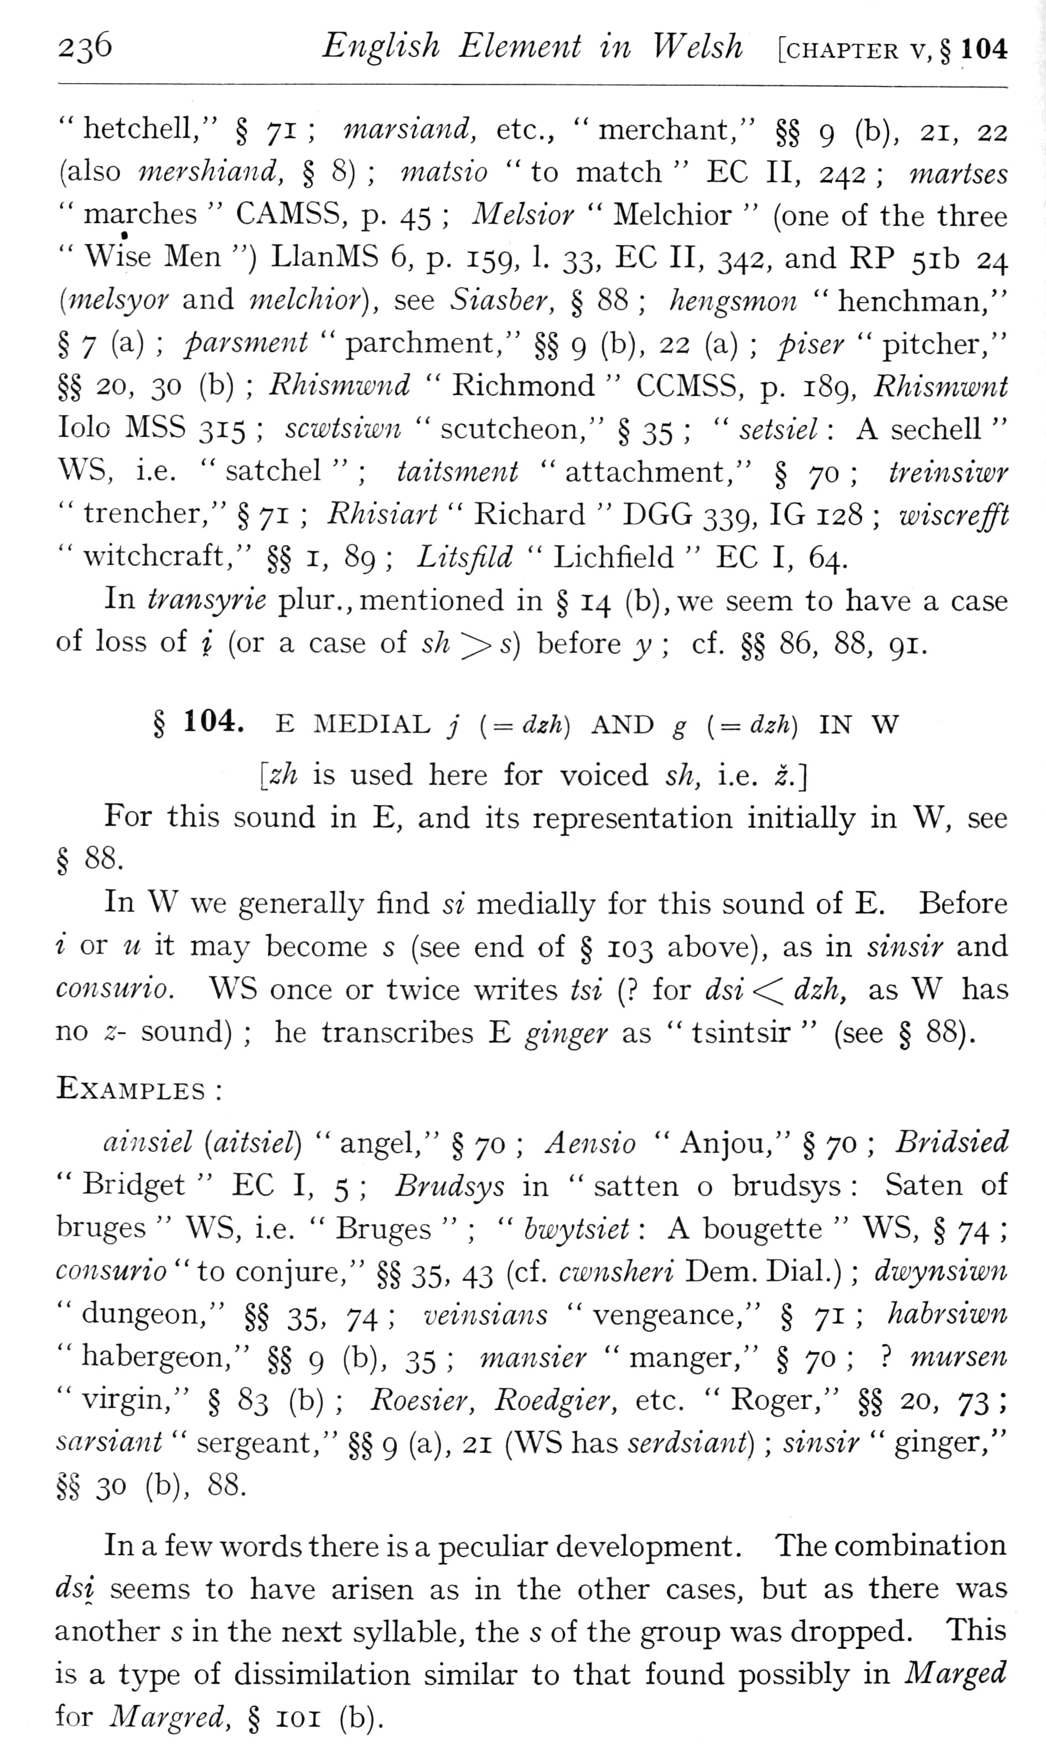  (delwedd F6987) (tudalen 236) | 236 English Element in Welsh [chapter v,§ 104  " hetchell," § 71; marsiand, etc., “merchant," §§ 9 (b), 21, 22 (also mershiand, § 8); matsio “to match “EC II, 242; martses “marches “CAMSS, p. 45; Melsior “Melchior” (one of the three “Wise Men ") LlanMS 6, p. 159, 1. 33, EC II, 342, and RP 51b 24 {melsyor and melchior), see Siasber, § 88; hengsmon “henchman," § 7 (a); parsment “parchment," §§ 9 (b), 22 (a); piser “pitcher," §§ 20, 30 (b); Rhismwnd “Richmond “CCMSS, p. 189, Rhismwnt lolo MSS 315; scwtsiwn “scutcheon," § 35; “setsiel: A sechell “WS, i.e. “satchel”; taitsment “attachment," § 70; treinsiwr “trencher," § 71; Rhisiart “Richard “DGG 339, IG 128; wiscrefft “witchcraft," §§ i, 89; Litsfild “Lichfield “EC I, 64.  In transyrie plur., mentioned in § 14 (b),we seem to have a case of loss of i (or a case of sh >> s) before y; cf. §§ 86, 88, 91.  § 104. E MEDIAL j [=dzh) AND g {= dzh) IN W  [zh is used here for voiced sh, i.e. i.] For this sound in E, and its representation initially in W, see § ^^.  In W we generally find si medially for this sound of E. Before i or u it may become s (see end of § 103 above), as in sinsir and consurio. WS once or twice writes tsi (? for dsi <^ dzh, as W has no z- sound); he transcribes E ginger as “tsintsir” (see § 88).  Examples:  ainsiel [aitsiel) “angel," § 70; Aeiisio “Anjou," § 70; Bridsied “Bridget “EC I, 5; Brndsys in “satten o brudsys: Saten of bruges “WS, i.e. “Bruges”; “bwytsiet: A bougette “WS, § 74; consurio “to conjure," §§ 35, 43 (cf. cwnsheri Dem. Dial.); dwynsiwn “dungeon," §§ 35, 74; veinsians “vengeance," § 71; hahrsiwn "habergeon," §§ 9 (b), 35; mansier "manger," §70;? mursen “virgin," § ^^ (b); Roesier, Roedgier, etc. “Roger," §§ 20, 73; sarsiant “sergeant," §§ 9 (a), 21 (WS has serdsiant); sinsir “ginger," §§ 30 (b), 88.  In a few words there is a peculiar development . The combination dsi seems to have arisen as in the other cases, but as there was another s in the next syllable, the s of the group was dropped. This is a type of dissimilation similar to that found possibly in Marged for Margred, § loi (b).
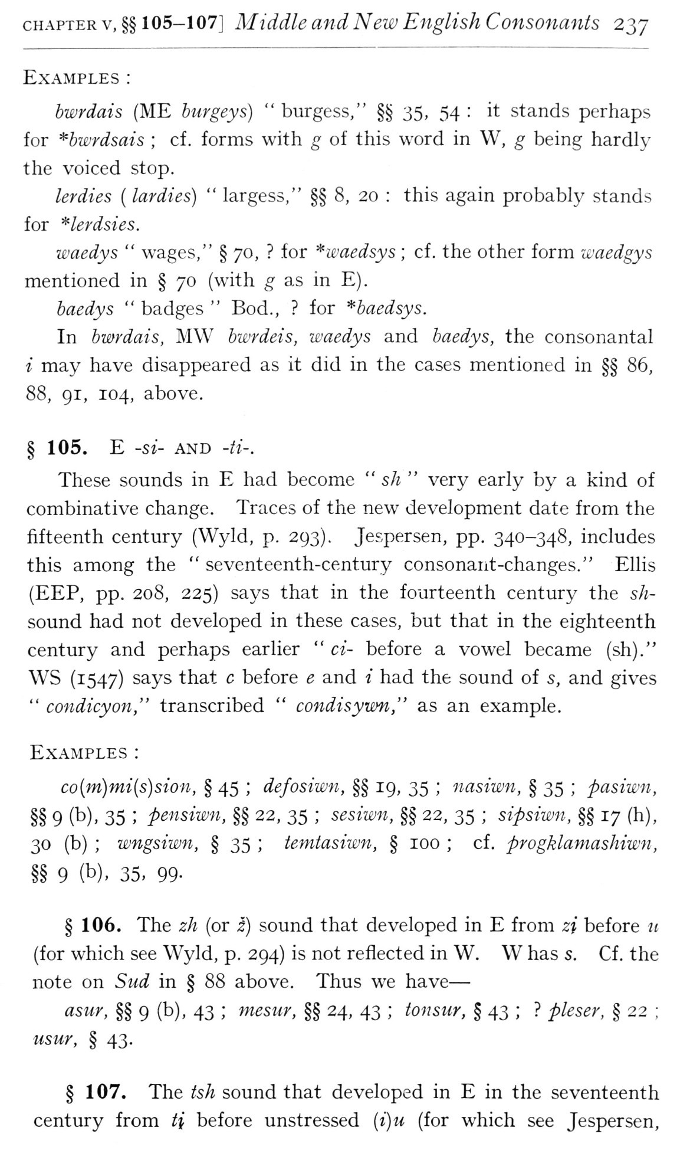  (delwedd F6988) (tudalen 237) | CHAPTER V, §§ 1 05-1 07J Middle and New English Consonants 237  Examples:  hwrdais (ME burgeys) “burgess," §§ 35, 54: it stands perhaps for *bwrdsais; cf. forms with g of this word in W, g being hardly the voiced stop.  lerdies ( lardies) “largess," §§ 8, 20: this again probably stands for *lerdsies.  waedys “wages," § 70,? for *waedsys; cf. the other form waedgys mentioned in § 70 (with g as in E).  baedys “badges “Bod.,? for ^baedsys.  In bwrdais, MW bwrdeis, waedys and baedys, the consonantal i may have disappeared as it did in the cases mentioned in §§ 86, 88, 91, 104, above.  § 105. E -si- AND -//-.  These sounds in E had become “sh “very early by a kind of combinative change. Traces of the new development date from the fifteenth century (Wyld, p. 293). Jespersen, pp. 340-348, includes this among the “seventeenth-century consonant-changes." Ellis (EEP, pp. 208, 225) says that in the fourteenth century the sh-sound had not developed in these cases, but that in the eighteenth century and perhaps earlier “ci- before a vowel became (sh)." WS (1547) says that c before e and i had the sound of s, and gives “condicyon," transcribed “condisywn," as an example.  Examples:  co(jn)mi{s)sion, § 45; defosiwn, §§ 19, 35; nasiwn, § 35; pasiwn, §§ 9 (b), 35; pensiwn, §§ 22, 35; sesiwn, §§ 22, 35; sipsiimi, §§ 17 (h), 30 (b); wngsiwn, § 35; temtasiwn, § 100; cf. progklamashiwn, §§ 9 (b), 35, 99-  § 106. The zh (or i) sound that developed in E from zi before u (for which see Wyld, p. 294) is not reflected in W. W has s. Cf . the note on Sud in § 88 above. Thus we have —  asur, §§ 9 (b), 43; 77tesur, §§ 24, 43; tonsur, § 43;? pleser, § 22; usur, § 43.  § 107. The ish sound that developed in E in the seventeenth century from H before unstressed {i)u (for which see Jespersen,
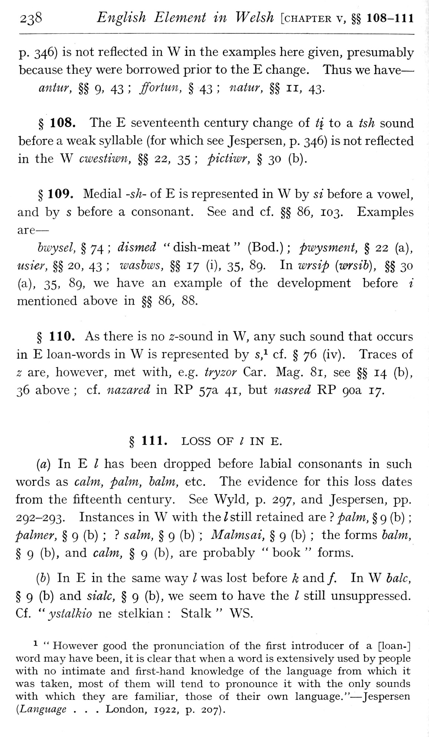  (delwedd F6989) (tudalen 238) | 238 English Element in Welsh [chapter v, §§ 108-111  p. 346) is not reflected in W in the examples here given, presumably because they were borrowed prior to the E change. Thus we have — antur, §§ 9, 43; jforUm, § 43; natur, §§ 11, 43.  § 108. The E seventeenth century change of ti to a tsh sound before a weak syllable (for which see Jespersen, p. 346) is not reflected in the W cwestiwn, §§ 22, 35; pictiwr, § 30 (b).  § 109. Medial -sh- of E is represented in W by si before a vowel, and by s before a consonant. See and cf. §§ 86, 103. Examples are —  hwysel, §74; dismed "dish-meat" (Bod.); pwysment, § 22 (a), usier, §§ 20, 43; washws, §§ 17 (i), 35, 89. In wrsip {wrsih), §§ 30 (a), 35, 89, we have an example of the development before i mentioned above in §§ 86, 88.  § 110. As there is no -s'-sound in W, any such sound that occurs in E loan-words in W is represented by s,^ cf. § 76 (iv). Traces of z are, however, met with, e.g. tryzor Car. Mag. 81, see §§ 14 (b), 36 above; cf. nazared in RP 57a 41, but nasred RP 90a 17. § 111. LOSS OF I IN E.  (a) In E / has been dropped before labial consonants in such words as calm, palm, halm, etc. The evidence for this loss dates from the fifteenth century. See Wyld, p. 297, and Jespersen, pp. 292-293. Instances in W with the Z still retained are? palm, § 9 (b); palmer, § 9 (b);? salm, § 9 (b); Malmsai, § 9 (b); the forms halm, § 9 (b), and calm, § 9 (b), are probably “book “forms.  (6) In E in the same way / was lost before k and /. In W bale, § 9 (b) and sialc, § 9 (b), we seem to have the / still unsuppressed. Cf. “ystalkio ne stelkian: Stalk" WS.  ^ “However good the pronunciation of the first introducer of a [loan-] word may have been, it is clear that when a word is extensively used by people with no intimate and first-hand knowledge of the language from which it was taken, most of them will tend to pronounce it with the only sounds with which they are familiar, those of their own language." — Jespersen {Language . . . London, 1922, p. 207).
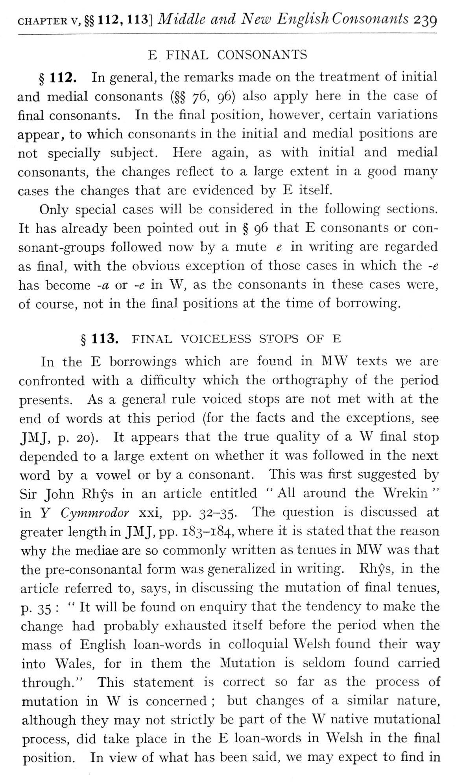  (delwedd F6990) (tudalen 239) | cHAPTERv, §§ 112, 113] Middle and New English Consonants 239  E FINAL CONSONANTS  § 112. In general, the remarks made on the treatment of initial and medial consonants (§§ 76, 96) also apply here in the case of final consonants. In the final position, however, certain variations appear, to which consonants in the initial and medial positions are not specially subject. Here again, as with initial and medial consonants, the changes reflect to a large extent in a good many cases the changes that are evidenced by E itself.  Only special cases will be considered in the following sections. It has already been pointed out in § 96 that E consonants or consonant-groups followed now by a mute e in writing are regarded as final, with the obvious exception of those cases in which the -e has become -a or -e in W, as the consonants in these cases were, of course, not in the final positions at the time of borrowing.  § 113. FINAL VOICELESS STOPS OF E  In the E borrowings which are found in MW texts we are confronted with a diificulty which the orthography of the period presents. As a general rule voiced stops are not met with at the end of words at this period (for the facts and the exceptions, see JMJ, p. 20). It appears that the true quality of a W final stop depended to a large extent on whether it was followed in the next word by a vowel or by a consonant. This v/as first suggested by Sir John Rhys in an article entitled “All around the Wrekin “in Y Cymmrodor xxi, pp. 32-35. The question is discussed at greater length in JMJ, pp. 183-184, where it is stated that the reason why the mediae are so commonly written as tenues in MW was that the pre-consonantal form was generalized in writing. Rhys, in the article referred to, says, in discussing the mutation of final tenues, p. 35: "It will be found on enquiry that the tendency to make the change had probably exhausted itself before the period when the mass of English loan-words in colloquial Welsh found their way into Wales, for in them the Mutation is seldom found carried through." This statement is correct so far as the process of mutation in W is concerned; but changes of a similar nature, although they may not strictly be part of the W native mutational process, did take place in the E loan-words in Welsh in the final position. In view of what has been said, we may expect to find in
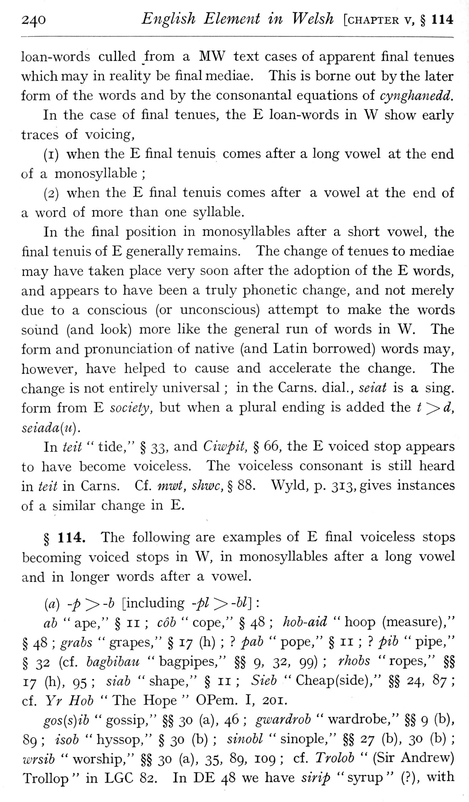  (delwedd F6991) (tudalen 240) | 240 English Element in Welsh [chapter v, § 114  loan-words culled from a MW text cases of apparent final tenues which may in reality be final mediae. This is borne out by the later form of the words and by the consonantal equations of cynghanedd.  In the case of final tenues, the E loan-words in W show early traces of voicing,  (i) when the E final tenuis comes after a long vowel at the end of a monosyllable;  (2) when the E final tenuis comes after a vowel at the end of a word of more than one syllable.  In the final position in monosyllables after a short vowel, the final tenuis of E generally remains. The change of tenues to mediae may have taken place very soon after the adoption of the E words, and appears to have been a truly phonetic change, and not merely due to a conscious (or unconscious) attempt to make the words soimd (and look) more like the general run of words in W. The form and pronunciation of native (and Latin borrowed) words may, however, have helped to cause and accelerate the change. The change is not entirely universal; in the Cams, dial., seiat is a sing, form from E society, but when a plural ending is added the f^d, seiada{u).  In teit “tide," § 2^, and Ciwpit, § 66, the E voiced stop appears to have become voiceless. The voiceless consonant is still heard in teit in Cams. Cf. mwt, shmc, § 88. Wyld, p. 313, gives instances of a similar change in E.  § 114. The following are examples of E final voiceless stops becoming voiced stops in W, in monosyllables after a long vowel and in longer words after a vowel.  [a) -p > -b [including -pi > -U]:  ah “ape," § 11; cob “cope," § 48; hob-aid “hoop (measure)," § 48; grabs “grapes," § 17 (h);? pab “pope," § 11;? pib “pipe," § 32 (cf. bagbibau “bagpipes," §§ 9, 32, 99); rhobs “ropes," §§ 17 (h), 95; siab “shape," § 11; Sieb “Cheap (side)," §§ 24, 87; cf. Yr Hob “The Hope “OPem. I, 201.  gos{s)ib “gossip," §§ 30 (a), 46; gwardrob “wardrobe," §§ 9 (b), 89; isob “hyssop," § 30 (b); sinobl “sinople," §§ 27 (b), 30 (b); i£jrsib “worship," §§ 30 (a), 35, 89, 109; cf. Trolob” (Sir Andrew) Trollop" in LGC 82. In DE 48 we have sirip "syrup" (?), with
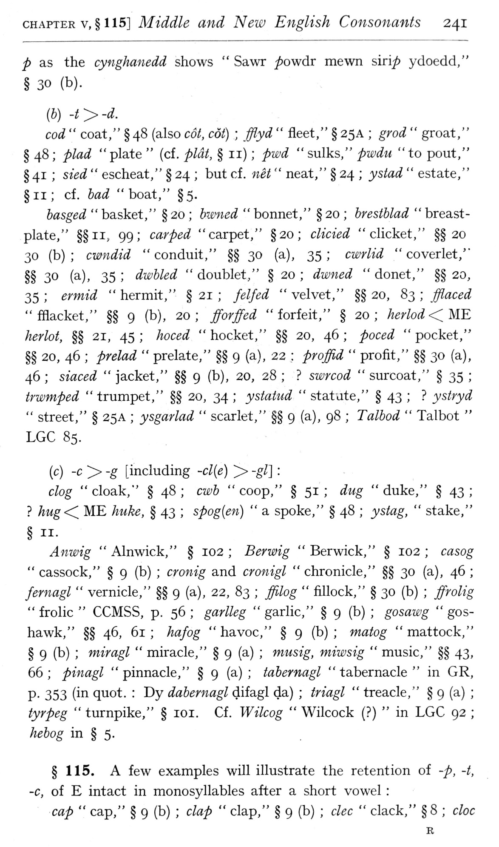  (delwedd F6992) (tudalen 241) | CHAPTER v,§ 115] Middle and New English Consonants 241  p as the cyngJianedd shows “Sawr ^owdr mewn sinp ydoedd," § 30 (b).  {h) -ty-d.  cod “coat," §48 (also coi, cot); fflyd “fleet," § 25A; grod “groat," § 48; plad "plate” (cf. plcit, § 11); pwd "sulks," pwdu "to pout," § 41; sied “escheat," § 24; but cf. net “neat," § 24; ystad “estate," §11; cf. bad “boat," §5.  basged “basket," § 20; bwned “bonnet," § 20; brestblad “breast-plate," §§ii. 99; carped "carpet," §20; elided "clicket," §§20 30 (b); cwndid “conduit," §§ 30 (a), 35; cwrlid “coverlet," §§ 30 (a), 35; dwbled “doublet," § 20; dwned “donet," §§ 20, 35; ermid “hermit," § 21; felfed “velvet," §§ 20, 83; flaced "fflacket," §§ 9 (b), 20; fforffed "forfeit," § 20; herlod<^WE herlot, §§ 21, 45; hoced “hocket," §§ 20, 46; poced “pocket," §§ 20, 46; prelad “prelate," §§ 9 (a), 22: proffid “profit," §§ 30 (a), 46; siaced “jacket," §§ 9 (b), 20, 28;? swrcod “surcoat," § 35; trwmped “trumpet," §§ 20, 34; ystatud “statute," § 43;? ystryd “street," § 25A; ysgarlad “scarlet," §§ 9 (a), 98; Talbod “Talbot “LGC 85.  (c) -c > -g [including -cl{e) > -gl]:  clog "cloak," § 48; cwb "coop," § 51; dug "duke," § 43;? hug<^ ME Jiuke, § 43; spog{en) “a spoke," § 48; ystag, “stake,"  § II-  Anwig “Alnwick," § 102; Berwig “Berwick," § 102; casog  " cassock," § 9 (b); cronig and cronigl “chronicle," §§ 30 (a), 46; fernagl “vernicle," §§ 9 (a), 22, 83; ffilog “fillock," § 30 (b); ffrolig “frolic “CCMSS, p. 56; garlleg “garlic," § 9 (b); gosawg “goshawk," §§ 46, 61; hafog “havoc," § 9 (b); matog “mattock," § 9 (b); miragl “miracle," § 9 (a); musig, miwsig “music," §§ 43, 66; pinagl “pinnacle," § 9 (a); tabernagl “tabernacle “in GR, P- 353 (ill quot.: Dy dabernagl difagl da); triagl “treacle," § 9 (a); tyrpeg “turnpike," § loi. Cf. Wilcog “Wilcock (?) “in LGC 92; hebog in § 5.  § 115. A few examples will illustrate the retention of -p, -t, -c, of E intact in monosyllables after a short vowel:  cap “cap," § 9 (b); clap “clap," § 9 (b); dec “clack," §8; doc  R
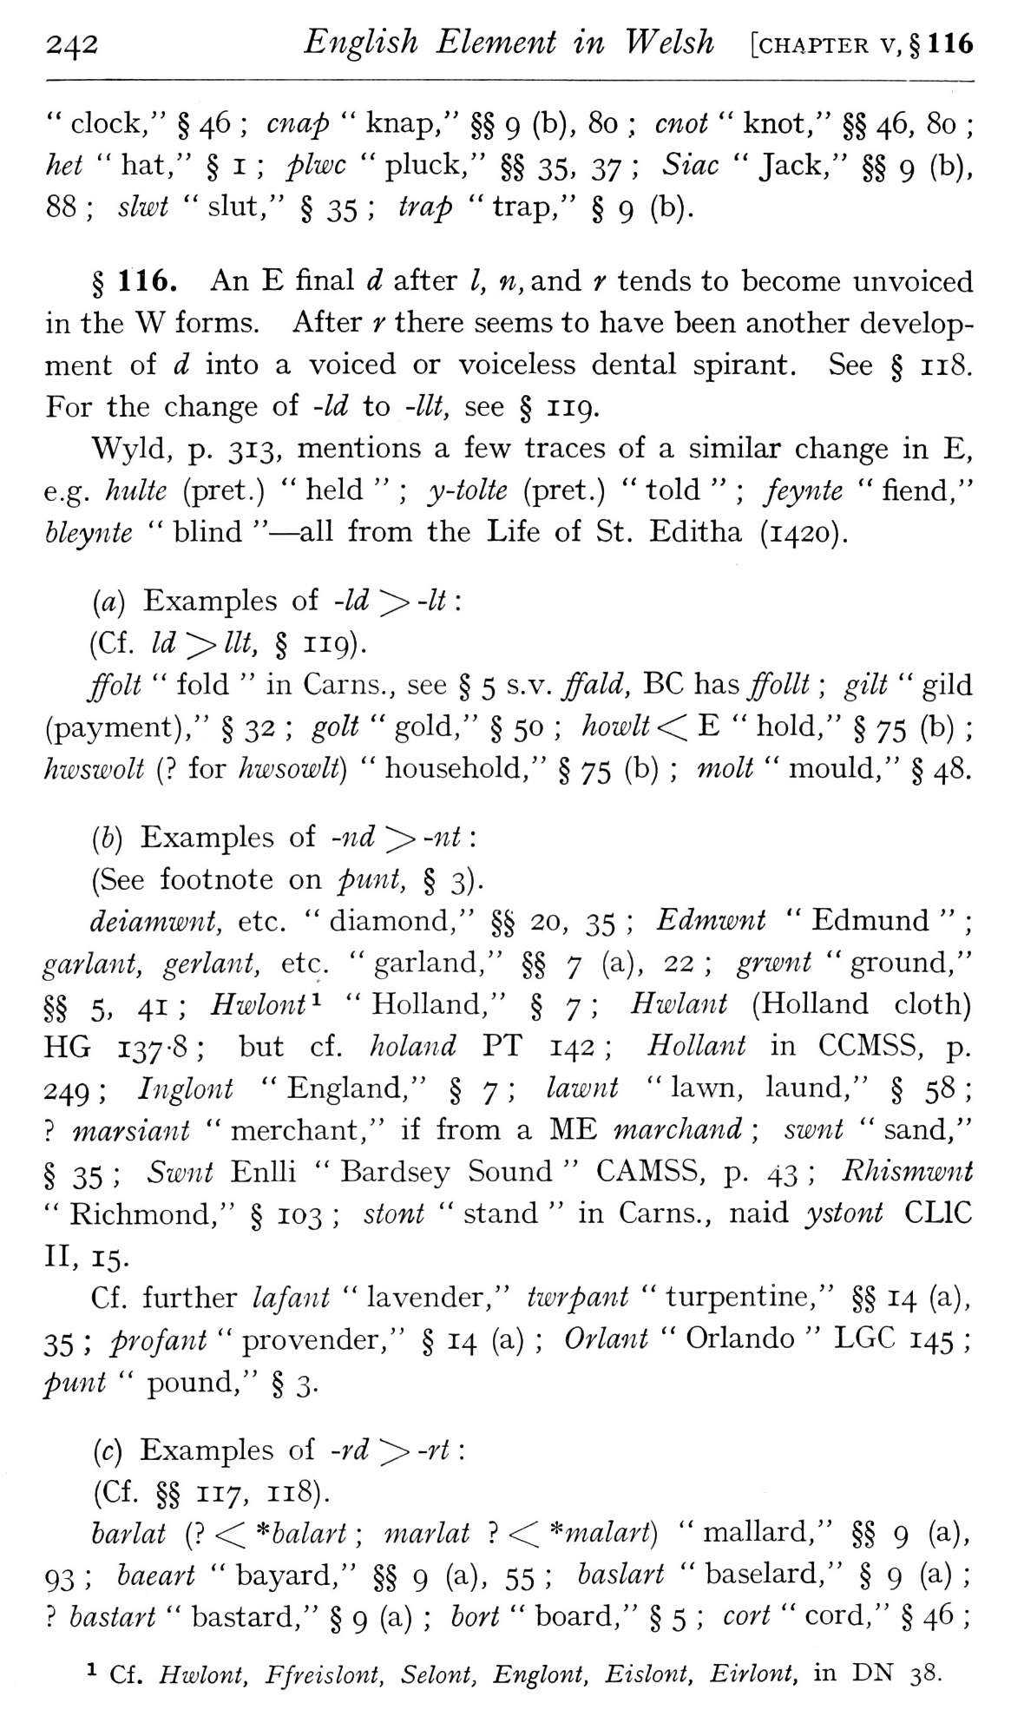  (delwedd F6993) (tudalen 242) | 242 English Element in Welsh [chapter v,§ 116  " clock," § 46; cnap “knap," §§ 9 (b), 80; cnot “knot," §§ 46, 80; het “hat," § I; plwc “pluck," §§ 35, 37; 5mc “Jack," §§ 9 (b), 88; slwt “slut," § 35; ^m^ “trap," § 9 (b).  § 116. An E final d after /, w, and ^' tends to become unvoiced in the W forms. After r there seems to have been another development of d into a voiced or voiceless dental spirant. See § 118. For the change of -Id to -lit, see § 119.  Wyld, p. 313, mentions a few traces of a similar change in E, e.g. hulte (pret.) “held”; y-tolte (pret.) “told”; feynte “fiend," bleynte “blind” — all from the Life of St. Editha (1420).  (a) Examples of -Id ^ -//:  (Cf. ld-:>llt, § 119).  ffolt “fold “in Cams., see § 5 s.v. ffald, BC hd.s ffollt; gilt “gild (payment)," § 32; golf “gold," § 50; Aoz£;/2!< E “hold," § 75 (b); hwswoU (? for hwsowlt) “household," § 75 (b); molt “mould," § 48.  (6) Examples of -«(^ ^ -«^:  (See footnote on punt, § 3).  deiamwnt, etc. “diamond," §§ 20, 35; Edmwnt “Edmund”; garlant, gerlant, etc. “garland," §§ 7 (a), 22; grwnt “ground," §§ 5, 41; Hwlont^ "Holland," § 7; i:^z£;/a«2! (Holland cloth) HG 137-8; but cf. holand PT 142; Hollant in CCMSS, p. 249; Inglont “England," § 7; lawnt “lawn, laund," § 58;? marsiant “merchant," if from a ME marchmtd; swnt “sand," § 35; Swnt Enlli “Bardsey Sound “CAMSS, p. 43; Rhismwnt “Richmond," § 103; stont “stand “in Cams., naid ystont CLIC  II, 15-  Cf. further lafant "lavender," twrpant "turpentine," §§ 14 (a),  35; profajit “provender," § 14 (a); Orlant “Orlando “LGC 145; punt “pound," § 3.  (c) Examples of -rd ^-rt:  (Cf. §§ 117, 118).  barlat (? <C *balart; marlat? ■< ^malart) “mallard," §§ 9 (a), 93; baeart “bayard," §§ 9 (a), 55; baslart “baselard," § 9 (a);? bastart “bastard," § 9 (a); bort “board," § 5; cort “cord," § 46;  ^ Cf. Hwlont, Ffreislont, Selont, Englont, Eislont, Eirlont, in DN 38.
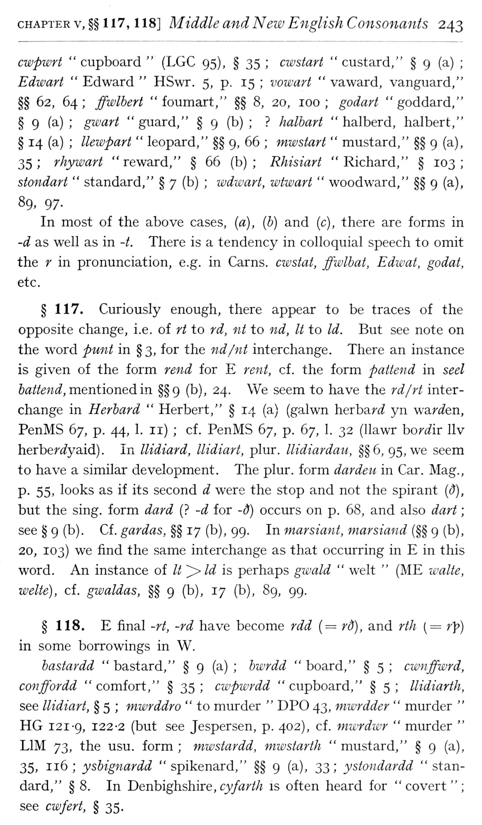  (delwedd F6994) (tudalen 243) | CHAPTER V, §§ 1 17, 1 18] Middle and New English Consonants 243  cwpwrt “cupboard” (LGC 95), § 35; cwstart "custard," § 9 (a); Edwart “Edward “HSwt. 5, p. 15; vowart “vaward, vanguard," §§ 62, 64; ffwlhert "foumart," §§ 8, 20, 100; godart "goddard," § 9 (a); gwart “guard," § 9 (b);? halhart “halberd, halbert," § 14 (a); Uewpart “leopard," §§ 9, 66; mwstart “mustard," §§ 9 (a), 35; rhywart "reward," § 66 (b); Rhisiart "Richard," § 103; stondart “standard," § 7 (b); wdwart, wtwart “woodward," §§ 9 (a), 89, 97.  In most of the above cases, [a], {b) and (c), there are forms in -d as well as in -t. There is a tendency in colloquial speech to omit the r in pronunciation, e.g. in Cams, cwstat, ffwlbat, Edivat, godat, etc.  § 117. Curiously enough, there appear to be traces of the opposite change, i.e. of rt to rd, nt to nd, It to Id. But see note on the word punt in §3, for the nd/nt interchange. There an instance is given of the form rend for E rent, cf. the form pattend in seel hattend, meiitionedim. §§9 (b), 24. We seem to have the rd/rt interchange in Herbard “Herbert," § 14 (a) (galwn h.eTha.rd yn warden, PenMS 67, p. 44, 1. 11); cf. PenMS 67, p. 67, 1. 32 (Ilawr bor^ir llv herbef (i^yaid) . In llidiard, llidiart, plur. llidiardau, §§6, 95, we seem to have a similar development. The plur. form dardeu in Car. Mag., p. 55, looks as if its second d were the stop and not the spirant {d), but the sing, form dard (? -d for -d) occurs on p. 68, and also dart; see § 9 (b). Cf. gar das, §§ 17 (b), 99. In marsiant, marsiand (§§ 9 (b), 20, 103) we find the same interchange as that occurring in E in this word. An instance of It ^ Id is perhaps gwald “welt” (ME walte, welte), cf. gwaldas, §§ 9 (b), 17 (b), 89, 99.  § 118. E final ~rt, -rd have become rdd {= rd), and rtJi [= rp) in some borrowings in W.  bastardd “bastard," § 9 (a); bwrdd “board," § 5; cwnffwrd, conffordd "comfort," § 35; cwpwrdd "cupboard," § 5; llidiarth, see llidiart, § 5; mwrddro “to murder “DPO 43, mwrdder “murder “HG 121-9, 122-2 (but see Jespersen, p. 402), cf. mwrdwr “murder “LIM 73, the usu. form; mwstardd, mwstarth “mustard," § 9 (a), 35, 116; ysbignardd "spikenard," §§ 9 (a), 33; ystondardd "standard," § 8. In Denbighshire, cy/<a:;'/A is often heard for "covert"; see cwfert, § 35.
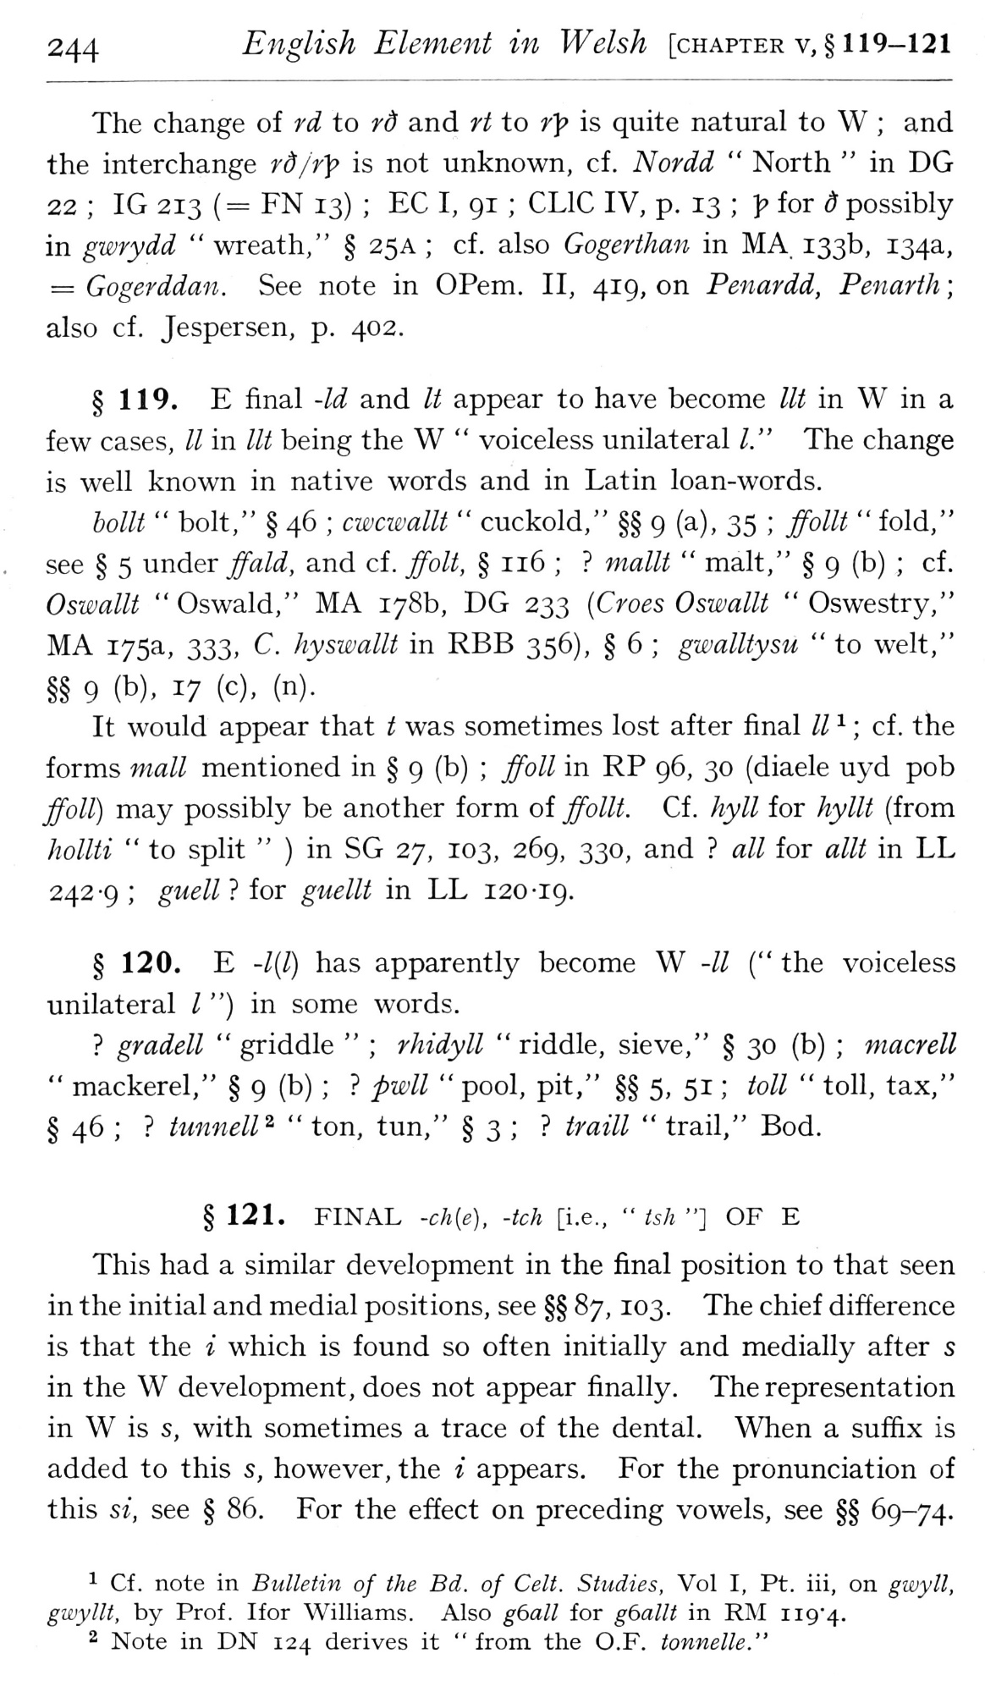  (delwedd F6995) (tudalen 244) | 244 English Element in Welsh [chapter v,§ 119-121  The change of rd to rd and ft to r]? is quite natural to W; and the interchange rd/r'^ is not unknown, cf. Nordd “North “in DG 22; IG 213 (= FN 13); EC I, 91; CLIC IV, p. 13; 1? for d possibly in gwrydd “wreath," § 25 a; cf. also Gogerthan in MA. 133b, 134a, = Gogerddan. See note in OPem. II, 419, on Penardd, Penarth; also cf. Jespersen, p. 402.  § 119. E final -Id and It appear to have become lit in W in a few cases, // in lit being the W “voiceless unilateral I." The change is well known in native words and in Latin loan-words.  hollt “bolt," § 46; cwamllt “cuckold," §§ 9 (a), 35; ffollt “fold," see § 5 under ffald, and cf. ffolt, § 116;? inallt “malt," § 9 (b); cf. Oswallt "Oswald," MA 178b, DG 233 [Croes Oswallt "Oswestry," MA 175a, 333, C. hyswallt in RBB 356), § 6; gwalltysu “to welt," §§ 9 (b), 17 (c), (n).  It would appear that t was sometimes lost after final II ^; cf . the  forms mall mentioned in § 9 (b); jfoll in RP 96, 30 (diaele uyd pob  ffoll) may possibly be another form of ffollt. Cf . Jiyll for hyllt (from  hollti “to split “) in SG 27, 103, 269, 330, and? all for allt in LL  242-9; guell? for guellt in LL 120-19.  § 120. E -1(1) has apparently become W -// (" the voiceless unilateral / ") in some words.  ? gradell “griddle”; rhidyll “riddle, sieve," § 30 (b); macrell “mackerel," § 9 (b);? pwll “pool, pit," §§ 5, 51; toll “toll, tax," § 46;? tunnell^ “ton, tun," § 3;? traill “trail," Bod.  § 121. FINAL -ch{e), -tch [i.e., “ish "] OF E  This had a similar development in the final position to that seen in the initial and medial positions, see §§ 87, 103. The chief difference is that the i which is found so often initially and medially after s in the W development, does not appear finally. The representation in W is s, with sometimes a trace of the dental. When a suffix is added to this s, however, the i appears. For the pronunciation of this si, see § 86. For the effect on preceding vowels, see §§ 69-74.  1 Cf. note in Bulletin of the Bd. of Celt. Studies, Vol I, Pt. iii, on givyll, gwyllt, by Prof. Ifor Williams. Also gball for gballt in R]\I ii9'4.  2 Note in DN 124 derives it “from the O.F. tonnelle."
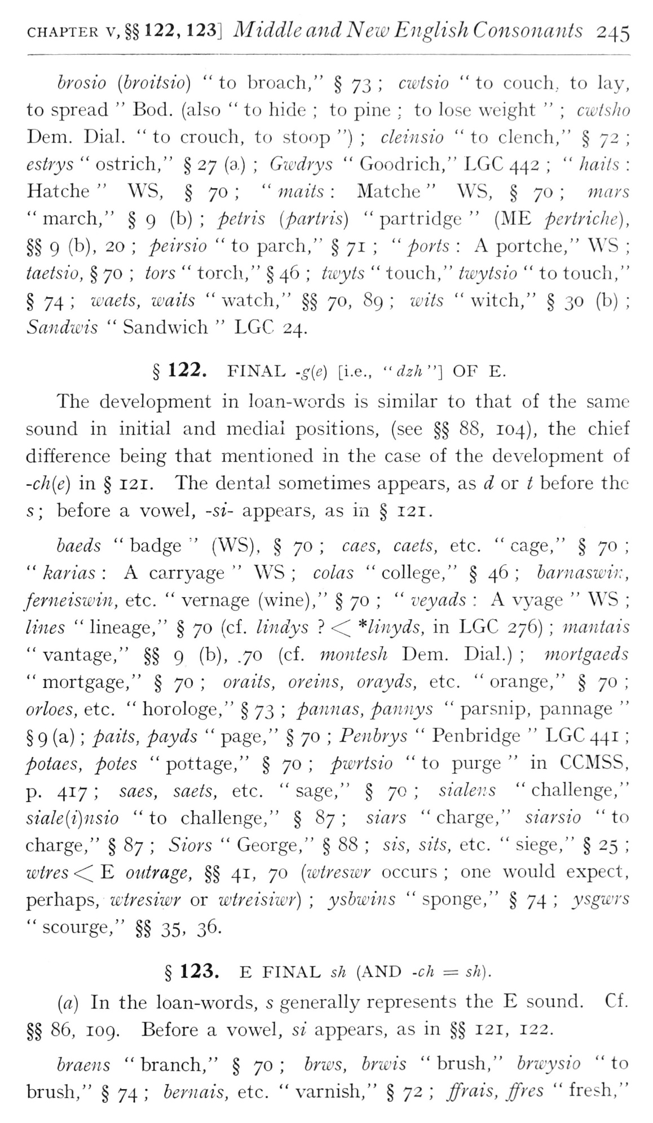  (delwedd F6996) (tudalen 245) | CHAPTER V, §§122, 123] Middle and New English Consonants 245  brosio [hroitsio] "to broach," § 73; cwtsio "to couch, to lay, to spread “Bod. (also “to hide; to pine; to lose weight”; cwtsho Dem. Dial. “to crouch, to stoop "); cleinsio “to clench," § 72; estrys “ostrich," § 27 (a); Gwdrys “Goodrich," LGC 442; “haits: Hatche “WS, § 70; “maiis: Matche “WS, § 70; mars “march," § 9 (b); petris [partris) “partridge” (ME pertriche), §§ 9 (b), 20; peirsio “to parch," § 71; “ports: A portche," WS; taetsio, § 70; tors “torch," § 46; twyts “touch," twytsio “to touch," § 74; waets, waits "watch," §§ 70, 89; wits "witch," § 30 (b); Sandwis “Sandwich “LGC 24.  § 122. FINAL -g{e) [i.e., “dzh"} OF E.  The development in loan-words is similar to that of the same sound in initial and medial positions, (see §§ 88, 104), the chief difference being that mentioned in the case of the development of -ch[e) in § 121. The dental sometimes appears, as (^ or ^ before the s; before a vowel, -si- appears, as in § 121.  baeds “badge” (WS), § 70; caes, caets, etc. “cage," § 70; “karias: A carryage “W^S; colas “college," § 46; barnaswi):, ferneiswin, etc. “vernage (wine)," § 70; “veyads: A vyage “WS; lines “lineage," § 70 (cf. lindys? <:^ *linyds, in LGC 276); mantais “vantage," §§ 9 (b), .70 (cf. montesh Dem. Dial.); mortgaeds “mortgage," § 70; oralis, orevns, orayds, etc. “orange," § 70; orloes, etc. “horologe," § 73; pannas, pannys “parsnip, pannage” § 9 (a); paits, payds “page," § 70; Penbrys “Penbridge “LGC 441; potaes, potes “pottage," § 70; pwrtsio “to purge “in CCMSS, p. 417; saes, saets, etc. "sage," § 70; sialens "challenge," siale{i)nsio "to challenge," § 87; siars "charge," siarsio "to charge," § 87; Siors “George," § 88; sis, sits, etc. “siege," § 25; wtres <^ E outrage, §§ 41, 70 {ivtreswr occurs; one would expect, perhaps, wtresiwr or wtreisiwr); ysbwins “sponge," § 74; ysgwrs "scourge," §§ 35, 36.  § 123. E FINAL sh (AND -ch = sh). [a] In the loan-words, s generally represents the E sound. Cf. §§ 86, 109. Before a vowel, si appears, as in §§ 121, 122.  braeiis "branch," § 70; bncs, brwis "brush," brwysio "to brush," § 74; bernais, etc. “varnish," § 72; ffrais, ffres “fresh,"
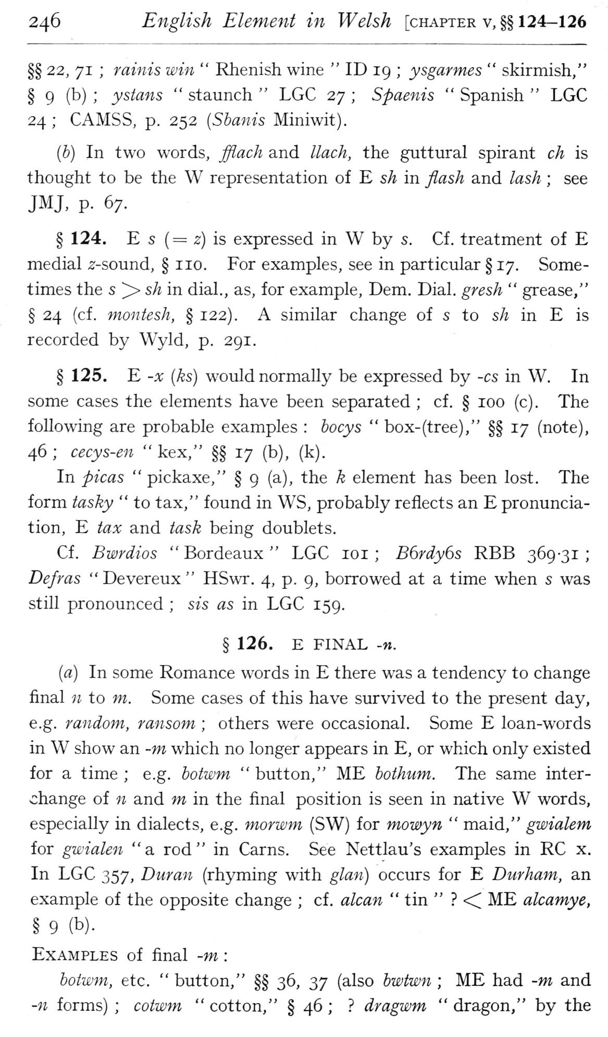  (delwedd F6997) (tudalen 246) | 246 English Element in Welsh [chapter v,§§ 124-126  §§ 22, 71; rainis win “Rhenish wine “ID 19; ysgarmes “skirmish," § 9 (^) '> ysiMis “staunch “LGC 27; Spaenis “Spanish “LGC 24; CAMSS, p. 252 {Sbanis Miniwit).  (6) In two words, fflach and llach, the guttural spirant ch is thought to be the W representation of E sh in flash and lash; see JMJ, p. 67.  § 124. E s (= 2) is expressed in W by s. Cf. treatment of E medial 2-sound, § no. For examples, see in particular § 17. Sometimes the s ^ sh in dial., as, for example, Dem. Dial, gresh “grease," § 24 (cf. montesh, § 122). A similar change of s to sh in E is recorded by Wyld, p. 291.  § 125. E -X [ks) would normally be expressed by -cs in W. In some cases the elements have been separated; cf. § 100 (c). The following are probable examples: bocys “box-(tree)," §§ 17 (note), 46; cecys-en “kex," §§ 17 (b), (k).  In picas “pickaxe," § 9 (a), the k element has been lost. The form tasky “to tax," found in WS, probably reflects an E pronunciation, E tax and task being doublets.  Cf. Bwrdios “Bordeaux “LGC 10 1; B6rdy6s RBB 369-31; Defras "Devereux" HSwr. 4, p. 9, borrowed at a time when s was still pronounced; sis as in LGC 159.  § 126. E FINAL -n.  (a) In some Romance words in E there was a tendency to change final n to m. Some cases of this have survived to the present day, e.g. random, ransom; others were occasional. Some E loan-words in W show an -m which no longer appears in E, or which only existed for a time; e.g. hotwm “button," ME bothum. The same interchange of n and m in the final position is seen in native W words, especially in dialects, e.g. morwm (SW) for momyn “maid," gwialem for gwialen "a rod" in Cams. See Nettlau's examples in RC x. In LGC 357, Duran (rhyming with glan) occurs for E Durham, an example of the opposite change; cf. alcan “tin "? <^ ME alcamye, § 9 (b). Examples of final -m:  boiwm, etc. “button," §§ 36, 37 (also bwtwn; ME had -m and -n forms); cotwm “cotton," § 46;? dragwm “dragon," by the
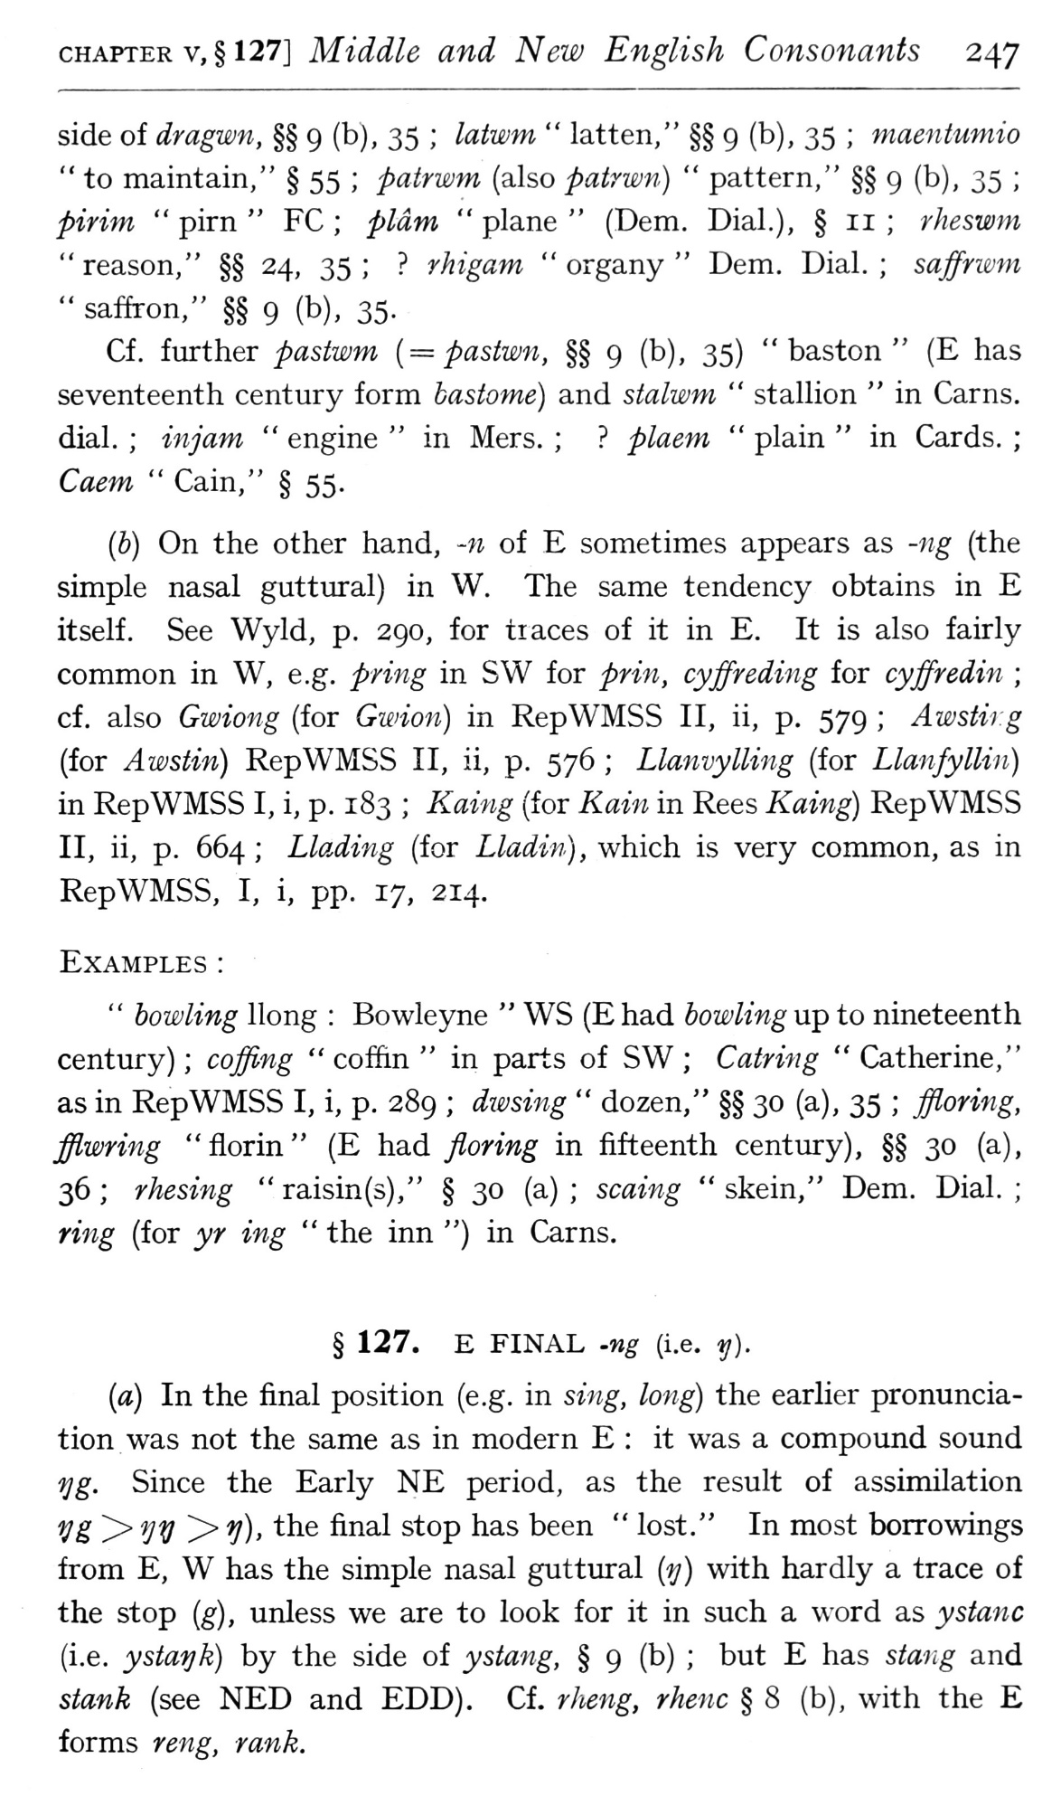  (delwedd F6998) (tudalen 247) | CHAPTER v,§ 127] Middle and New English Consonants 247  side of dragwn, §§ 9 (b), 35; latwm “latten," §§ 9 (b), 35; maentumio “to maintain," § 55; patrwm (also patrwn) “pattern," §§ 9 (b), 35; pirim “pirn “FC; pldm “plane” (Dem. Dial.), § 11; rheswm “reason," §§ 24, 35;? rhigam “organy “Dem. Dial.; saffnmn “saffron," §§ 9 (b), 35-  Cf. further pastwm {= pastwn, §§ 9 (b), 35) “baston” (E has seventeenth century form bastome) and stalwm “stallion “in Cams, dial.; injam “engine “in Mers.;? plaem “plain “in Cards.; Caem “Cain," § 55.  (b) On the other hand, -n of E sometimes appears as -ng (the simple nasal guttural) in W. The same tendency obtains in E itself. See Wyld, p. 290, for traces of it in E. It is also fairly common in W, e.g. pring in SW for prin, cyffreding for cyffredin; cf. also Gwiong (for Gwion) in RepWMSS II, ii, p. 579; Awstirg (for Awstin) RepWMSS II, ii, p. 576; LlanvyUing (for LlanfylUn) in RepWMSS I, i, p. 183; Kaing (for Kain in Rees Kaing) RepWMSS II, ii, p. 664; Llading (for Lladin), which is very common, as in RepWMSS, I, i, pp. 17, 214.  Examples:  " bowling Hong: Bowleyne “WS (E had bowling up to nineteenth century); coffing “coffin “in parts of SW; Catring “Catherine," as in RepWMSS I, i, p. 289; divsing “dozen," §§ 30 (a), 35; ffloring, fflwring "florin" (E h3.d Jloring in fifteenth century), §§ 30 (a), 36; rhesing “raisin(s)," § 30 (a); scaing “skein," Dem. Dial.; ring (for yr ing “the inn ") in Cams.  § 127. E FINAL -ng (i.e. y).  {a) In the final position (e.g. in sing, long) the earlier pronunciation was not the same as in modern E: it was a compound sound?;g. Since the Early NE period, as the result of assimilation V& ^ VV ^ V)' ^^^ fi^^^ s'^^P h^^ been “lost." In most borrowings from E, W has the simple nasal guttural {y) with hardly a trace of the stop (g), unless we are to look for it in such a word as ystanc (i.e. ystayk) by the side of ystang, § 9 (b); but E has staiig and stank (see NED and EDD), Cf. rheng, rhenc § 8 (b), with the E forms reiig, rank.
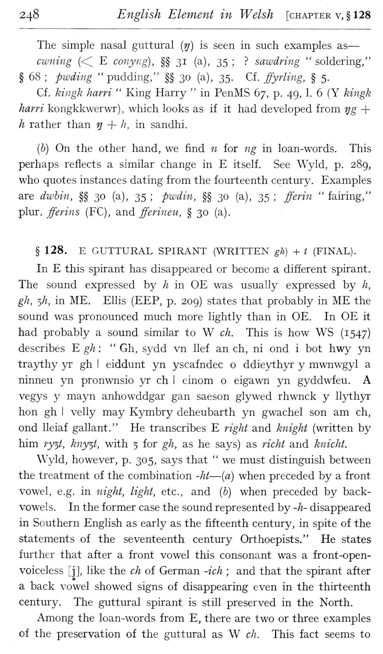  (delwedd F6999) (tudalen 248) | 248 English Element in Welsh [chapter v, § 128  The simple nasal guttural [ij] is seen in such examples as — owning (<^ E conyiig), §§ 31 (a), 35;? sawdring “soldering,"  § 68; pwding "pudding," §§ 30 (a), 35. Cf. ffyrling, § 5.  Cf. kingk harri “King Harry “in PenMS 67, p. 49, 1. 6 (Y kingk  harri kongkkwerwr) , which looks as if it had developed from 'ijg +  h rather than ij + Ii, in sandhi.  (b) On the other hand, we find w for ng in loan-words. This perhaps reflects a similar change in E itself. See Wyld, p. 289, who quotes instances dating from the fourteenth century. Examples are dwbin, §§ 30 (a), 35; pwdin, §§ 30 (a), 35; fferin “fairing," plur. fferins (FC), and fferineu, § 30 (a).  § 128. E GUTTURAL SPIRANT (WRITTEN gh) + t (FINAL).  In E this spirant has disappeared or become a different spirant. The sound expressed by h in OE was usually expressed by h, gh, 5/?, in ME. Ellis (EEP, p. 209) states that probably in ME the sound was pronounced much more lightly than in OE. In OE it had probably a sound similar to W ch. This is how WS (1547) describes E gh: “Gh, sydd vn lief an ch, ni ond i bot hwy yn traythy yr gh I eiddunt yn yscafndec o ddieythyr y mwnwgyl a ninneu yn pronwnsio yr ch I einom o eigawn yn gyddwfeu. A vegys y mayn anhowddgar gan saeson glywed rhwnck y llythyr hon gh I velly may Kymbry deheubarth yn gwachel son am ch, ond lleiaf gallant." He transcribes E right and knight (written by him ry^t, kny^t, with 5 for gh, as he says) as richt and knicht.  Wyld, however, p. 305, says that “we must distinguish between the treatment of the combination -ht — {a) when preceded by a front vowel, e.g. in night, light, etc., and {h) when preceded by back-vowels. In the former case the sound represented by -h- disappeared in Southern English as early as the fifteenth century, in spite of the statements of the seventeenth century Orthoepists." He states further that after a front vowel this consonant was a front-open-voiceless [j], like the ch of German -ich; and that the spirant after  9  a back vowel showed signs of disappearing even in the thirteenth century. The guttural spirant is still preserved in the North.  Among the loan-words from E, there are two or three examples of the preservation of the guttural as W ch. This fact seems to
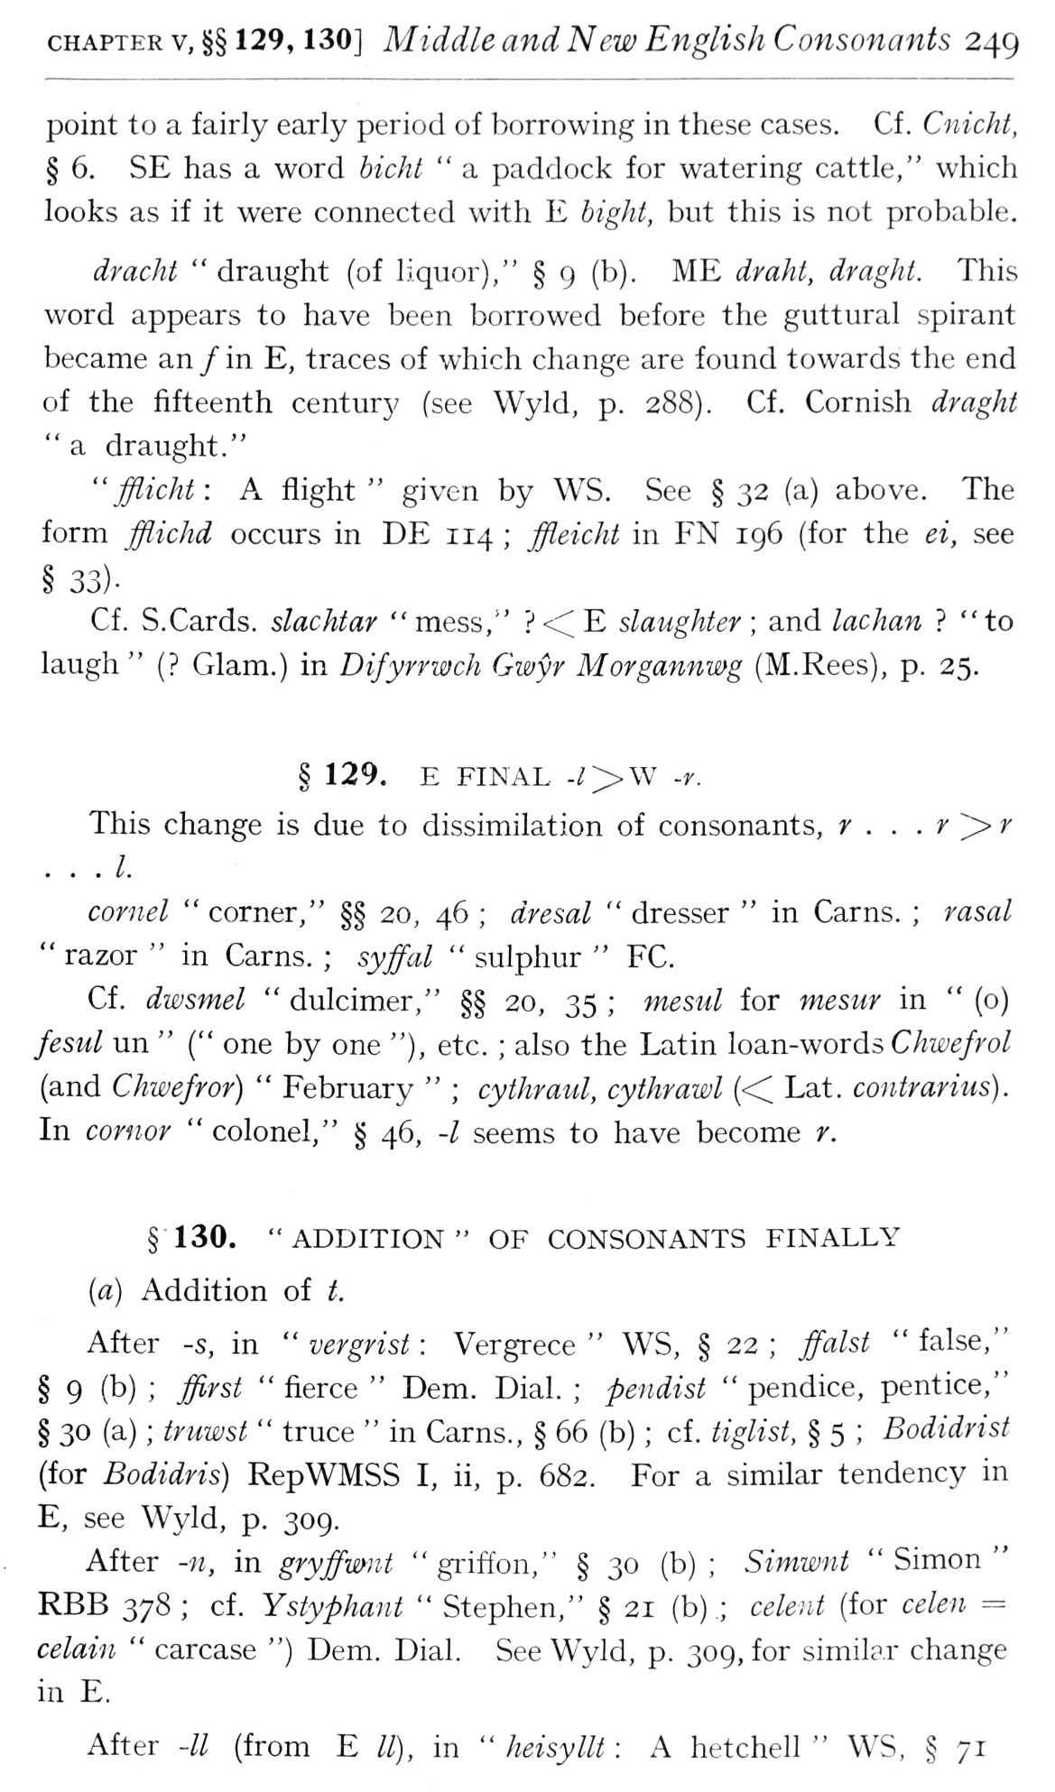  (delwedd F7000) (tudalen 249) | CHAPTER V, §§129, 130] Middle and New English Consonants 249  point to a fairly early period of borrowing in these cases. Cf . C7iicht, § 6. SE has a word bicht “a paddock for watering cattle," which looks as if it were connected with E bight, but this is not probable.  dracht “draught (of liquor)," § 9 (b). ME draht, draghi. This word appears to have been borrowed before the guttural spirant became an / in E, traces of which change are found towards the end of the fifteenth centur}/ (see Wyld, p. 288). Cf. Cornish draght "a draught."  "fflicht: A flight" given by WS. See §32 (a) above. The form fflichd occurs in DE 114; ffleicht in FN 196 (for the ei, see  Cf. S. Cards, slachtar "mess,"?<CE slaughter; and lachan? "to laugh” (? Glam.) in Difyrrwch Gwyr Morgannmg (M.Rees), p. 25.  § 129. E FINAL -/>W ~r.  This change is due to dissimilation of consonants, r . . . r ^ r . . .1.  cornel “corner," §§ 20, 46; dresal “dresser “in Cams.; rasal “razor “in Cams.; syffal “sulphur “FC.  Cf. dwsmel “dulcimer," §§ 20, 35; mesul for mesur in” (o) fesul un” (" one by one "), etc.; also the Latin loa.n-woids Chwefrol (and Chwefror) “February”; cythratU, cythrawl « Lat. contrarius). In cornor “colonel," § 46, -/ seems to have become r.  § 130. "ADDITION" OF CONSONANTS FINALLY (a) Addition of t.  After -s, in “vergrisi: Vergrece “WS, § 22; ffalst “false," § 9 (b); ffirst “fierce “Dem. Dial.; pendist “pendice, pentice," § 30 (a); tniwst “truce “in Cams., § 66 (b); cf. tiglist, § 5; Bodidrist (for Bodidris) RepWMSS I, ii, p. 682. For a similar tendency in E, see Wyld, p. 309.  After -11, in gryffwnt "griffon," § 30 (b); Simwnt "Simon" RBB 378; cf. Ystyphant “Stephen," § 21 (b); celent (for celen = celain “carcase ") Dem. Dial. See Wyld, p. 309, for similar change in E.  After -// (from E //), in “heisyllt: A hetchell “WS, § 71
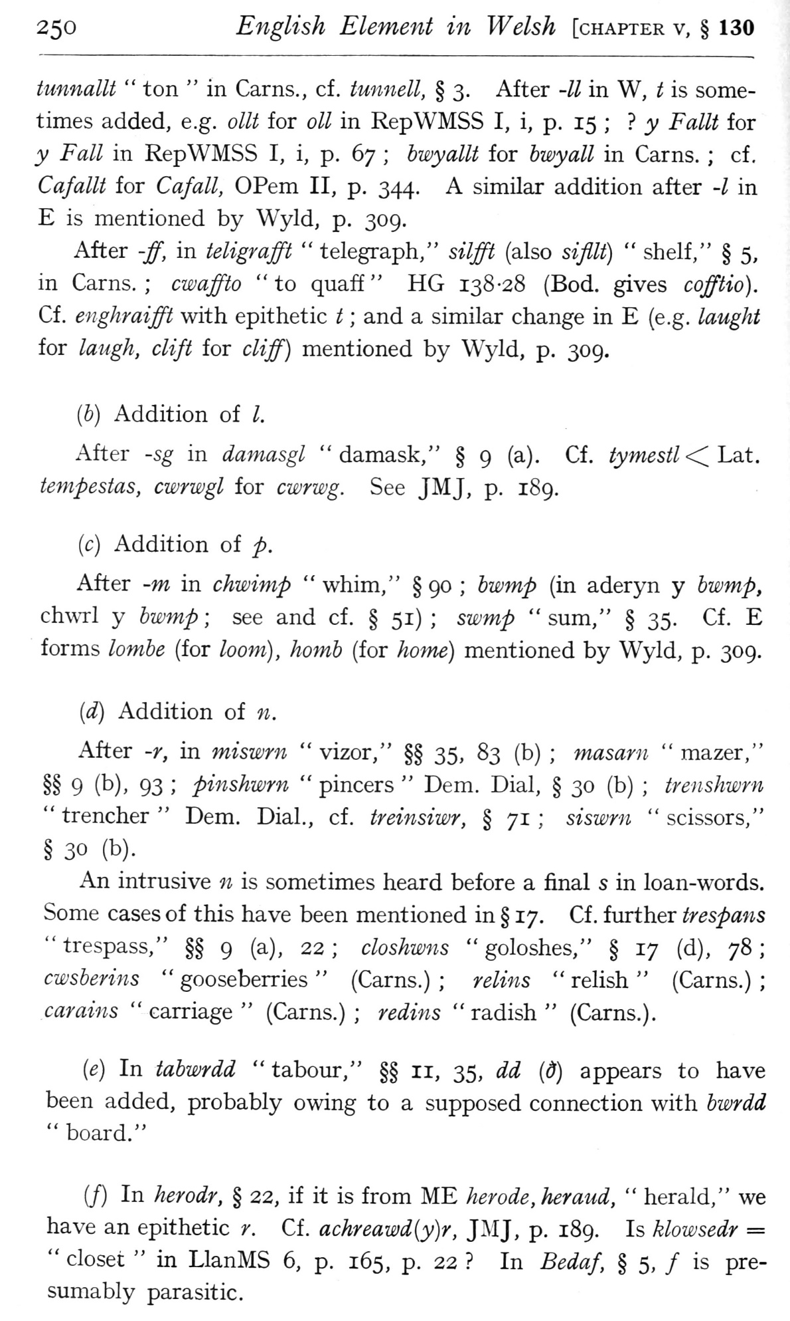  (delwedd F7001) (tudalen 250) | 250 English Element in Welsh [chapter v, § 130  tunnalU “ton “in Cams., cf. tunnell, § 3. After -II in W, t is sometimes added, e.g. olU for oil in RepWMSS I, i, p. 15; } y Fallt for y Fall in RepWMSS I, i, p. 67; hwyallt for hwyall in Cams.; cf , Cafallt for Cafall, OPem II, p. 344. A similar addition after -/ in E is mentioned by Wyld, p. 309,  After -ff, in teligmfft “telegraph," silfft (also sifllt) “shelf," § 5, in Cams.; cwaffto "to quaff" HG 138-28 (Bod. gives cofftio). Cf. enghraifft with epithetic t; and a similar change in E (e.g. laught for laugh, clift for cliff) mentioned by Wyld, p. 309.  [h] Addition of I.  After -sg in damasgl "damask," § 9 (a), Cf. tymestl<iLait. tempestas, cwrwgl for cwrwg. See JMJ, p. 189.  (c) Addition of p.  After -w in chwimp “whim," § 90; hwmp (in aderyn y hwmp, chwrl y hwmp; see and cf. § 51); swmp "sum," § 35. Cf. E forms lomhe (for loom), homh (for /fowe) mentioned by Wyld, p. 309.  {d) Addition of n.  After -r, in miswrn “vizor," §§ 35, 83 (b); masarn “mazer," §§ 9 (b), 93; pinshwrn “pincers “Dem. Dial, § 30 (b); trenshwrn “trencher “Dem. Dial., cf. treinsiwr, § 71; siswrn “scissors," § 30 (b).  An intrusive n is sometimes heard before a final s in loan-words. Some cases of this have been mentioned in § 17. Cf . further trespans "trespass," §§ 9 (a), 22; closhwns "goloshes," § 17 (d), 78; cwsberins “gooseberries” (Cams.); relins “relish” (Cams.); carains “carriage” (Cams.); redins “radish” (Cams.).  {e) In tabwrdd “tabour," §§ 11, 35, dd (d) appears to have been added, probably owing to a supposed connection with bwrdd “board."  (J) In herodr, § 22, if it is from ME her ode, her and, “herald," we have an epithetic r. Cf. achreawd{y)r, JMJ, p. 189. Is klowsedr = “closet “in LlanMS 6, p. 165, p. 22? In Bedaf, § 5, / is presumably parasitic.
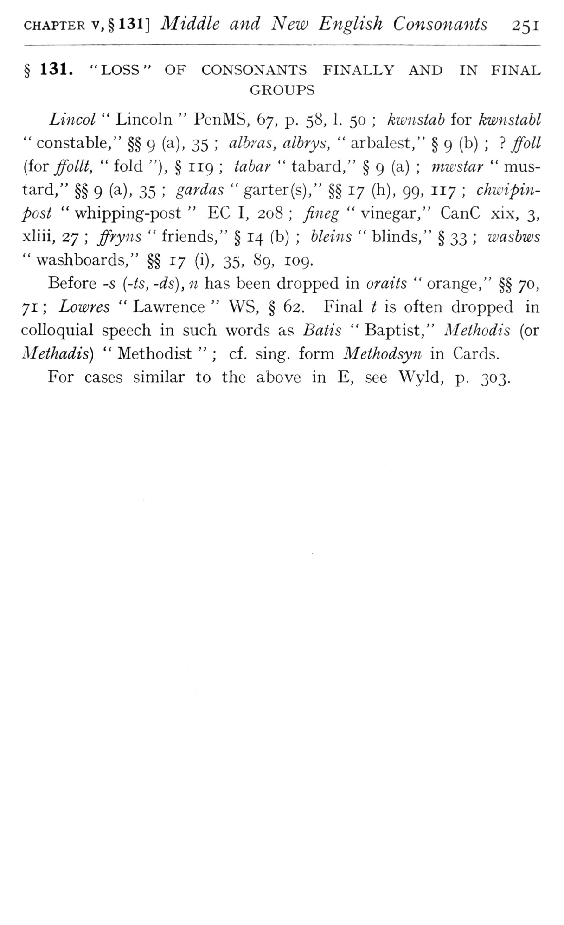  (delwedd F7002) (tudalen 251) | CHAPTER v,§ 131] Middle and New English Consonants 251  § 131. "LOSS" OF CONSONANTS FINALLY AND IN FINAL  GROUPS  Lincol “Lincoln “PenMS, 67, p. 58, 1. 50; kwnstab for kwnstahl “constable," §§ 9 (a), 35; albras, albrys, “arbalest," § 9 (b);? ffoll {ioT ffollt, “fold "), § 119; tabar “tabard," § 9 (a); mwstar “mustard," §§ 9 (a), 35; gardas “garter(s)," §§ 17 (h), 99, 117; chwipin-post “whipping-post “EC I, 208; fineg “vinegar," CanC xix, 3, xliii, 27; ffryns “friends," § 14 (b); bleins “blinds," § 33; wasbws “washboards," §§ 17 (i), 35, 89, 109.  Before -s {-is, -ds), n has been dropped in or aits “orange," §§ 70, 71; Lowres “Lawrence “WS, § 62. Final t is often dropped in colloquial speech in such words as Batis “Baptist," Methodis (or Methadis) “Methodist”; cf. sing, form Methodsyn in Cards.  For cases similar to the above in E, see Wyld, p. 303.
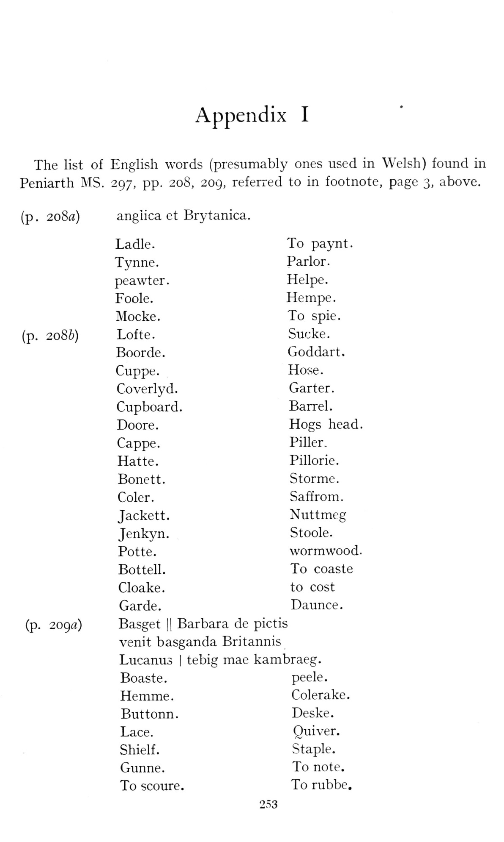  (delwedd F7004) (tudalen 253) | Appendix I The list of English words (presumably ones used in Welsh) found in Peniarth MS. 297, pp. 208, 209, referred to in footnote, page 3, above.  (p . 2o8fl) angiica et Brytanica. (p. 208b) (p. 209rt) Ladle.  To paynt.  Tynne.  Parlor.  peawter.  Helpe.  Foole.  Hempe.  Mocke.  To spie.  Lofte.  Sucke.  Boorde.  Goddart.  Cuppe.  Hose.  Coverlyd.  Garter.  Cupboard.  Barrel.  Doore.  Hogs head  Cappe.  Piller.  Hatte.  Pillorie.  Bonett.  Storme.  Coler.  Saffrom.  Jackett.  Nuttmeg  Jenkyn.  Stoole.  Potte.  wormwood  Bottell.  To coaste  Cloake.  to cost  Garde.  Daunce.  Basget 1 Barbara de  pictis  venit basganda Britannis  Lucanus | tebig mae  kambraeg.  Boaste.  peele.  Hemme.  Colerake.  Buttonn.  Deske.  Lace.  Quiver.  Shielf.  Staple.  Gunne.  To note.  To scoure.  To rubbe.
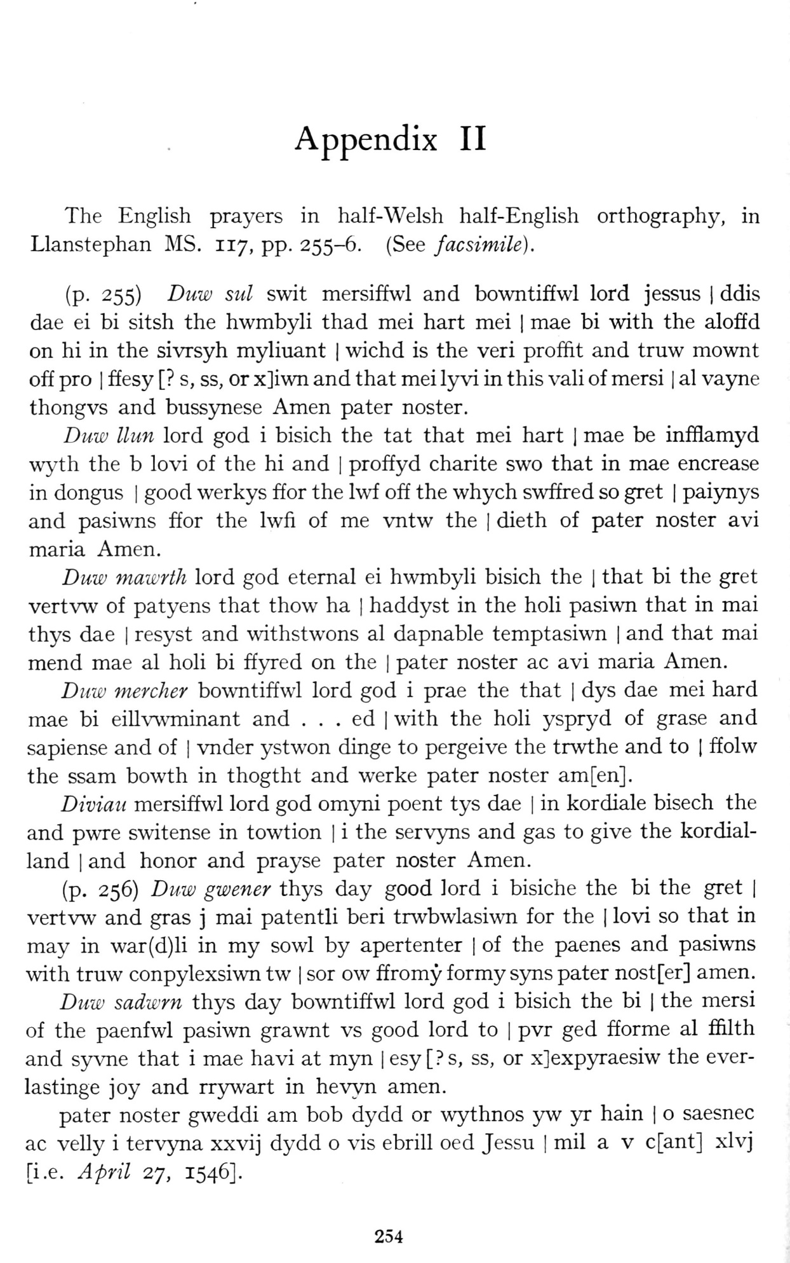  (delwedd F7005) (tudalen 254) | 253 Appendix II The English prayers in half-Welsh half-English orthography, in Llanstephan MS. 117, pp. 255-6. (See facsimile).  (p. 255) Duw sul swit mersiffwl and bowntiffwl lord jessus 1 ddis dae ei bi sitsh the hwmbyli thad mei hart mei | mae bi with the aloffd on hi in the sivrsyh myliuant | wichd is the veri proffit and truw mownt off pro I ffesy [? s, ss, or x]iwn and that mei ly vi in this vali of mersi | al vayne thongvs and bussynese Amen pater noster.  Duw llun lord god i bisich the tat that mei hart 1 mae be infflamyd wyth the b lovi of the hi and | proffyd charite swo that in mae encrease in dongus | good werkys ffor the Iwf off the whych swffred so gret | paiynys and pasiwTis ffor the Iwfi of me vntw the | dieth of pater noster avi maria Amen.  Duw mawrth lord god eternal ei hwmbyli bisich the | that bi the gret vertvw of patyens that thow ha | haddyst in the holi pasiwn that in mai thys dae | resyst and withstwons al dapnable temptasiwn | and that mai mend mae al holi bi ffyred on the | pater noster ac avi maria Amen.  Duw mercher bowntiffwl lord god i prae the that | dys dae mei hard mae bi eiU\'\\Tninant and . . . ed | with the holi yspryd of grase and sapiense and of | vnder ystwon dinge to pergeive the trwthe and to [ ffolw the ssam bowth in thogtht and werke pater noster am[en].  Diviau mersiffwl lord god omyni poent tys dae | in kordiale bisech the and pwre switense in towtion | i the servyns and gas to give the kordial- land I and honor and prayse pater noster Amen.  (p. 256) Duw gwener thys day good lord i bisiche the bi the gret | vertvw and gras j mai patentli beri trwbwlasiwn for the | lovi so that in may in war(d)li in my sowl by apertenter | of the paenes and pasiwns with truw conpylexsiwn tw | sor ow ffromy formy syns pater nost[er] amen.  Duw sadwrn thys day bowntiffwl lord god i bisich the bi | the mersi of the paenfwl pasiwn grawnt vs good lord to | pvr ged fforme al ffilth and syvne that i mae havi at m}^ | esy [?s, ss, or xjexpyraesiw the ever-lastinge joy and rrywart in hevyn amen.  pater noster gweddi am bob dydd or wythnos yw yr hain | o saesnec ac velly i tervyna xxvij dydd o vis ebrill oed Jessu | mil a v c[ant] xlvj [i.e. April 27, 1546].
xyz
xxxxx
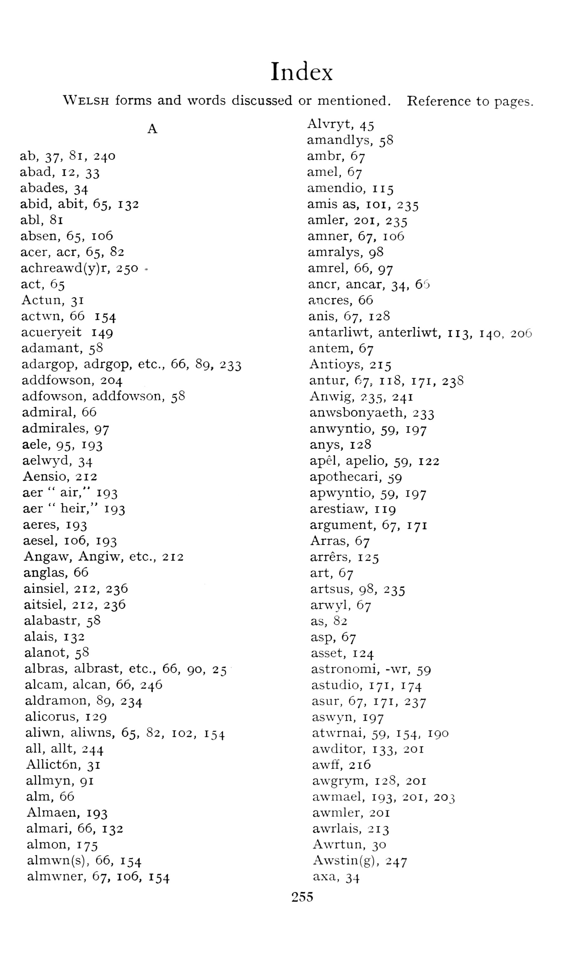  (delwedd F7006) (tudalen 255) | 254  Index  Welsh forms and words discussed or mentioned. Reference to pages.  A  ab, 37, 8i, 240  abad, 12, 33  abades, 34  abid, abit, 65, 132  abl, 81  absen, 65, 106  acer, acr, 65, 82  achreawd(y)r, 250 .  act, 65  Actun, 31  actwn, 66 154  acueryeit 149  adamant, 58  adargop, adrgop, etc., 66, 89, 233  addfowson, 204  adfowson, addfowson, 58  admiral, 66  admirales, 97  aele, 95, 193  aelw^-d, 34  Aensio, 212  aer “air," 193  aer “heir," 193  aeres, 193  aesel, 106, 193  Angaw, Angiw, etc., 212  anglas, 66  ainsiel, 212, 236  aitsiel, 212, 236  alabastr, 58  alais, 132  alanot, 58  albras, albrast, etc., 66, 90, 25  alcam, alcan, 66, 246  aldramon, 89, 234  alicorus, 129  aliwn, aliwns, 65, 82, 102, 154  all, allt, 244  Allict6n, 31  allmyn, 91  aim, 66  Almaen, 193  almari, 66, 132  almon, 175  almwn(s), 66, 154  almwner, 67, 106, 154 | Alvryt, 45  amandlys, 58  ambr, 67  amel, 67  amendio, 115  amis as, loi, 235  amler, 201, 235  amner, 67, 106  amralys, 98  amrel, 66, 97  ancr, ancar, 34, 65  ancres, 66  anis, 67, 128  antarliwt, anterliwt, 113, 140, 206  antem, 67  Antioys, 215  antur, 67, 118, 171, 238  Anwig, 235, 241  anwsbonyaeth, 233  anwyntio, 59, 197  anys, 128  apel, apelio, 59, 122  apothecari, ^9  apwyntio, 59, 197  arestiaw, 119  argument, 67, 171  Arras, 67  arrers, 125  art, 67  artsus, 98, 235  arwyl, 67  as, 82  asp, 67  asset, 124  astronomi, -wr, 59  astudio, 171, 174  asur, 67, 171, 237  aswyn, 197  atwrnai, 59, 154, 190  awditor, 133, 201  awff, 216  awgrym, 128, 201  awmael, 193, 201, 203  awmler, 201  awrlais, 213  Awrtun, 30  Awstin(g), 247  axa, 34
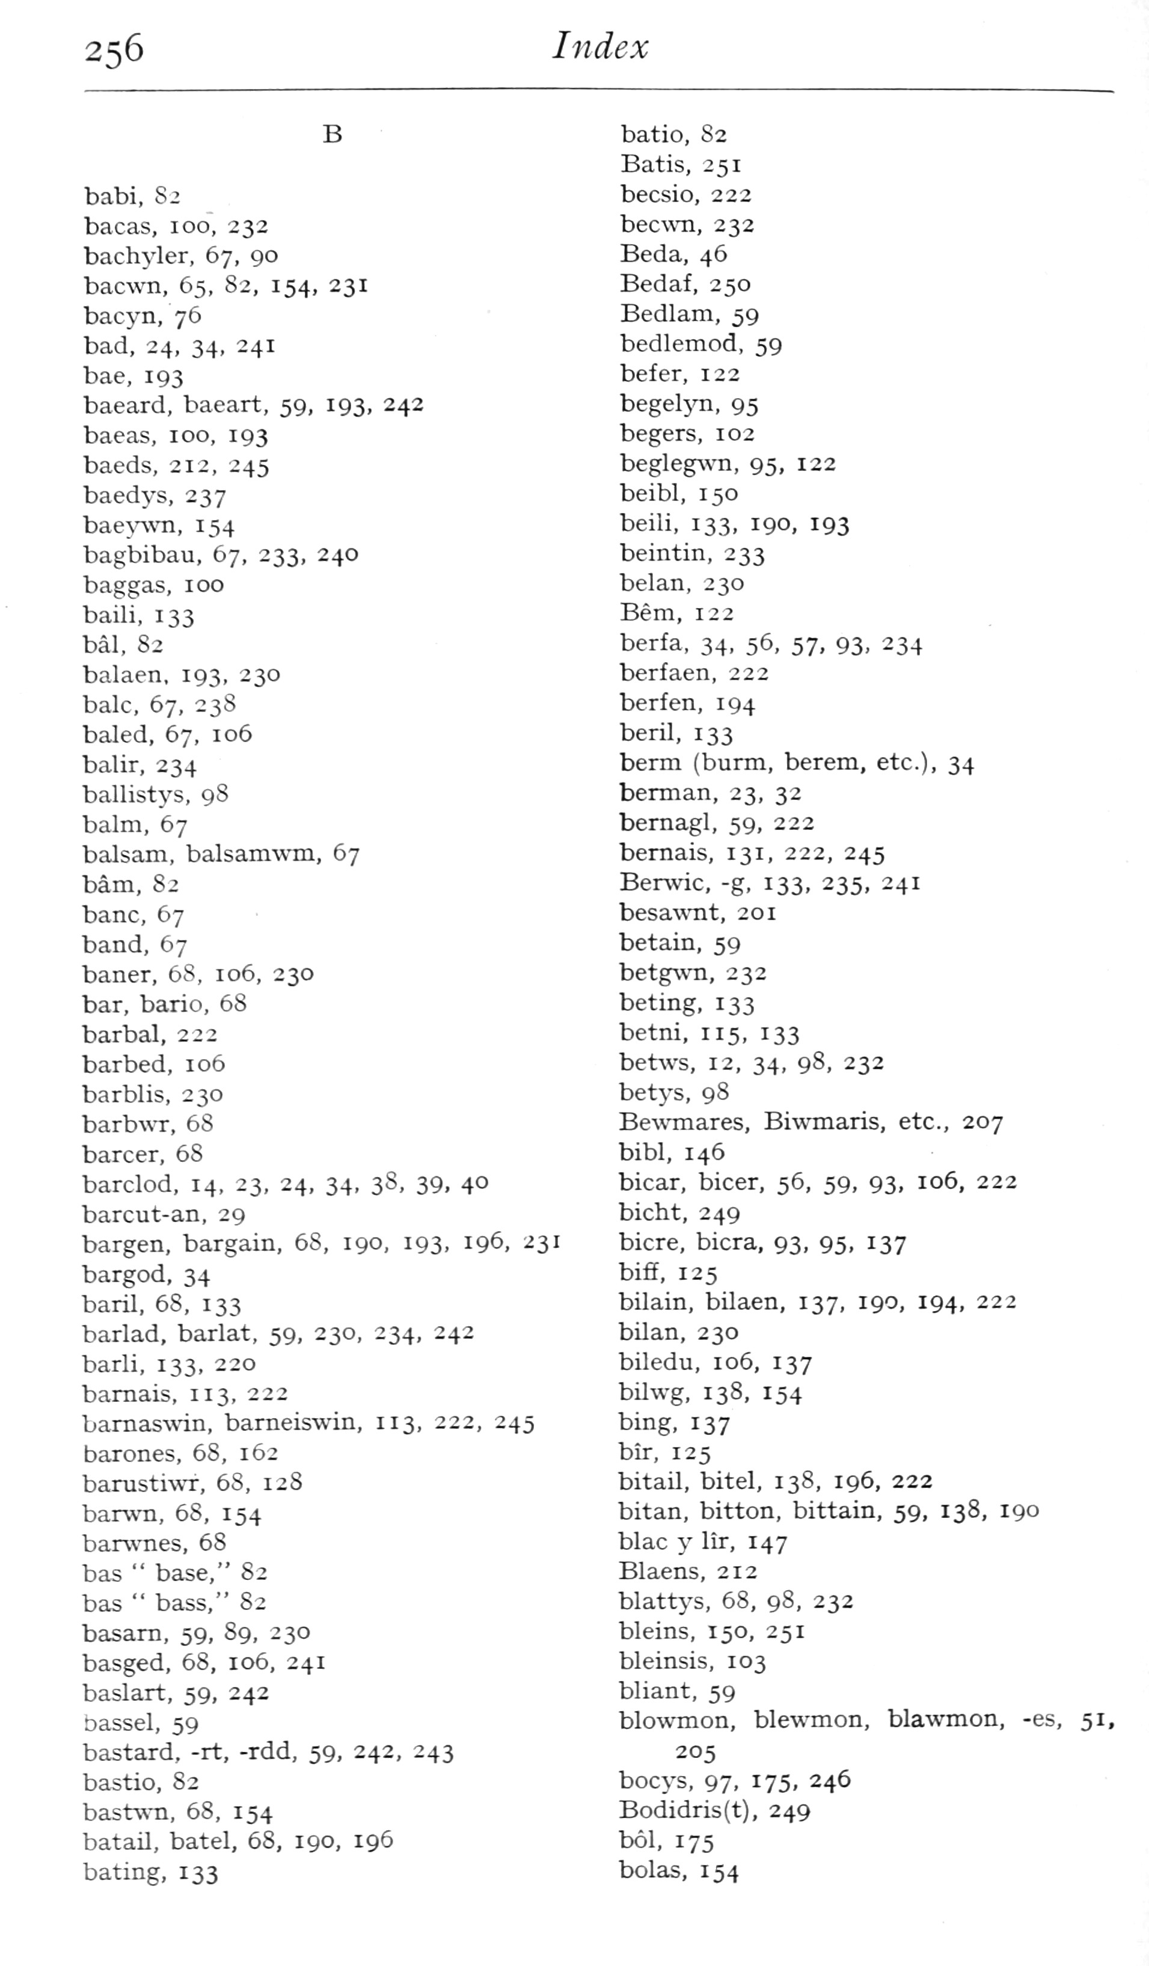  (delwedd F7007) (tudalen 256) | 256  Index  B  babi, 82  bacas, loo, 232  bachyler, 67, 90  bacwn, 65, 82, 154, 231  bacyn, 76  bad, 24, 34, 241  bae, 193  baeard, baeart, 59, 193, 242  bae as, 100, 193  baeds, 212, 245  baedys, 237  bae\^\Ti, 154  bagbibau, 67, 233, 240  baggas, 100  baili, 133  bal, 82  balaen, 193, 230  bale, 67, 23S  baled, 67, 106  balir, 234  ballistys, 98  balm, 67  balsam, balsamwm, 67  bam, 82  banc, 67  band, 67  baner, 68, 106, 230  bar, bario, 68  barbal, 222  barbed, 106  barblis, 230  barbwT, 68  barcer, 68  barclod, 14, 23, 24, 34. 38, 39. 40  barcut-an, 29  bargen, bargain, 68, 190, 193, 196, 231  bargod, 34  baril, 68, 133  barlad, barlat, 59, 230, 234, 242  barli, 133, 220  bamais, 113, 222  bamaswin, barneiswin, 113, 222, 245  barones, 68, 162  barusth\-r, 68, 128  barv\'n, 68, 154  barwTies, 68  bas “base," 82  bas “bass," 82  basarn, 59, 89, 230  basged, 68, 106, 241  baslart, 59, 242  bassel, 59  bastard, -rt, -rdd, 59, 242, 243  bastio, 82  bastw-n, 68, 154  batail, batel, 68, 190, 196  bating, 133  Index | batio, 82  Batis, 251  becsio, 222  bec\\Ti, 232  Beda, 46  Bedaf, 250  Bedlam, 59  bedlemod, 59  befer, 122  begelyn, 95  begers, 102  begleg^vn, 95, 122  beibl, 150  belli, 133, 190, 193  beintin, 233  belan, 230  Bem, 122  berfa, 34, 56, 57, 93. ^34  berfaen, 222  berfen, 194  beril, 133  berm (burm, berem, etc.), 34  berman, 23, 32  bernagl, 59, 222  bernais, 131, 222, 245  Ber^vic, -g, 133, 235, 241  besa^^'nt, 201  betain, 59  betgwn, 232  beting, 133  betni, 115, 133  betws, 12, 34, 98, 232  betys, 98  Be-\\Tnares, Biwmaris, etc., 207  bibl, 146  bicar, bicer, 56, 59, 93, 106, 222  bicht, 249  bicre, bicra, 93, 95, 137  biff, 125  bilain, bilaen, 137, 190, 194, 222  bilan, 230  biledu, 106, 137  bilwg, 138, 154  bing, 137  bir. 125  bitail, bitel, 138, 196, 222  bitan, bitton, bittain, 59, 138, 190  blac y lir, 147  Blaens, 212  blattys, 68, 98, 232  bleins, 150, 251  bleinsis, 103  bliant, 59  blowTnon, blewmon, blawmon, -es, 51,  205  bocys, 97, 175, 246  Bodidris{t), 249  bol, 175  bolas, 154
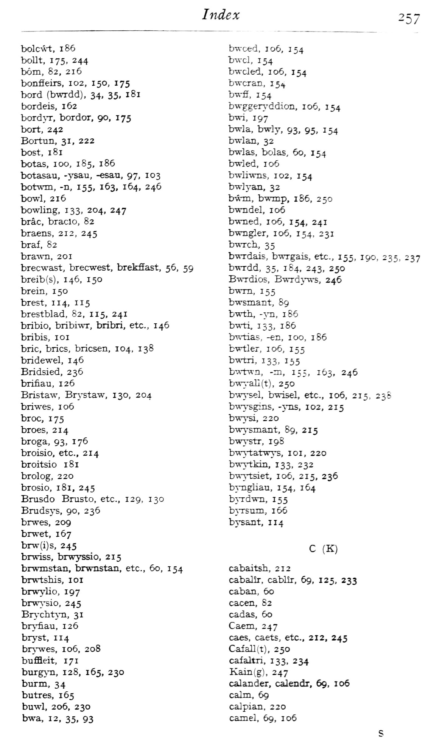  (delwedd F7008) (tudalen 257) | 257  bolcwt, 186  bollt, 175, 244  bom, 82, 216  bonfleirs, 102, 150, 175  bord (bwrdd), 34, 35. 181  bordeis, 162  bordjT, bordor, 90, 175  bort, 242  Bortun, 31, 222  bost, 181  betas, 100, 185, 186  botasau, -ysau, -esau, 97, 103  botw-m, -n, 155, 163, 164, 246  bowl, 216  bowling, 133, 204, 247  brae, braclo, 82  braens, 212, 245  braf, 82  brawn, 201  brecwast, brecwest, brekfiast, 56, 59  breib(s), 146, 150  brein, 150  brest, 114, 115  brestblad, 82, 115, 241  bribio, bribi-wTT, bribri, etc., 146  bribis, loi  brie, brics, bricsen, 104, 138  bridewel, 146  Bridsied, 236  brifi.au, 126  Bristaw, Brystaw, 130, 204  briwes, 106  broe, 175  broes, 214  broga, 93, 176  broisio, etc., 214  broitsio 181  brolog, 220  brosio, 181, 245  Brusdo Brusto, etc., 129, 130  Brudsj^s, 90, 236  brwes, 209  brwet, 167  brw(i)s, 245  bn\T.ss, brw^j'ssio, 215  brwTnstan, brwnstan, etc., 60, 154  brwtshis, loi  brwjdio, 197  brwi'sio, 245  Bn-chtj-n, 31  bn.'fiau, 126  bryst, 114  br\nves, 106, 208  bufBeit, 171  burg\-n, 128, 165, 230  burm, 34  butres, 165  buwl, 206, 230  bwa, 12, 35, 93 | bwxed, 106, 154  bwel, 154  bweled, 106, 154  bweran, 15^  bwfi, 154  bwgger^'ddion, 106, 154  bwi, 197  bwla, bwly, 93. 95, 154  bwlan, 32  bwlas, bolas, 60, 154  bwled, 106  bwli-wTis, 102, 154  bwlj^an, 32  b-w-m, bwmp, 186, 250  bwndel, 106  b-wTied, 106, 154, 241  bwngler, 106, 154, 231  b-wTcli, 35  b-wrdais, bwrgais, etc., 155, 190, 235, 237  b-wTdd, 35, 184, 243, 250  B-svTdios, BwTdjTJvs, 246  bwm, 155  bwsmant, 89  bwth, -5T1, 186  bwti, 133, 186  bwtias, -en, 100, 186  bwtler, 106, 155  ^3^'5'tri, 133, 155  bijs'twn, -m, 155, 163, 246  bw3rall(t), 250  bwysel, bwisel, etc., 106, 215, 238  b-wysgins, -yns, 102, 215  bw^j^i, 220  bwysmant, 89, 215  bwj-str, 198  b-w^^atwj-s, loi, 220  bwytkin. 133, 232  bw3-tsiet, 106, 215, 236  bj-ngliau, 154, 164  byrdwn, 155  bj-rsum, i65  bj^ant, 114  C (K)  cabaitsh, 212  cabalir, cablir, 69, 125, 233  caban, 60  cacen, 82  cadas, 5o  Caem, 247  caes, caets, etc., 212, 245  Cafall(t), 250  cafaltri, 133, 234  Kain(g), 247  calander, calendr, 69, 106  calm, 69  calpian, 220  camel, 69, 106
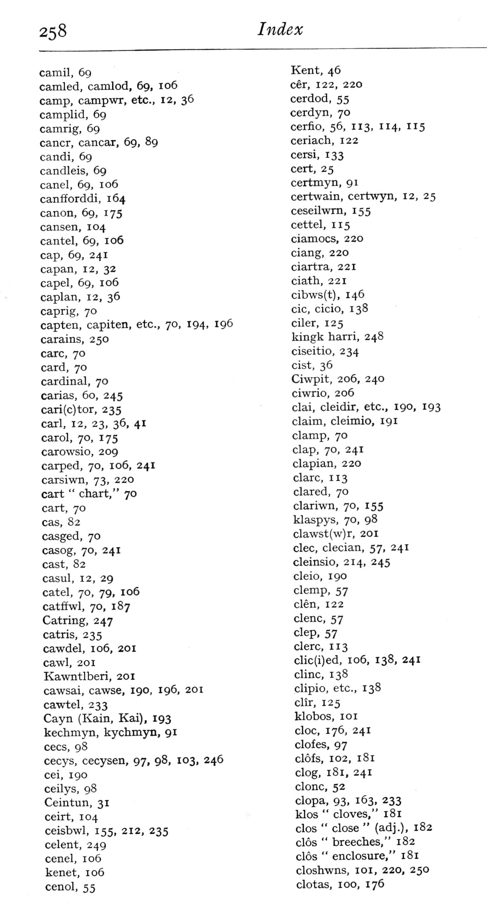  (delwedd F7009) (tudalen 258) | 258  Index  camil, 69  camled, camlod, 69, 106  camp, campwr, etc., 12, 36  camplid, 69  camrig, 69  cancr, cancar, 69, 89  candi, 69  candleis, 69  canel, 69, 106  canfforddi, 164  canon, 69, 175  cansen, 104  cantel, 69, 106  cap, 69, 241  capan, 12, 32  capel, 69, 106  caplan, 12, 36  caprig, 70  capten, capiten, etc., 70, 194, 196  carains, 250  care, 70  card, 70  cardinal, 70  carias, 60, 245  cari(c)tor, 235  carl, 12, 23, 36. 41  carol, 70, 175  carowsio, 209  carped, 70, 106, 241  carsiwn, 73, 220  cart “chart," 70  cart, 70  cas, 82  casged, 70  casog, 70, 241  cast, 82  casul, 12, 29  catel, 70, 79, 106  catffwl, 70, 187  Catring, 247  catris, 235  cawdel, 106, 201  cawl, 201  Kawntlberi, 201  cawsai, cawse, 190, 196, 201  cawtel, 233  Cayn (Kain, Kai), 193  kechmyn, kychmyn, 91  cecs, 98  cecys, cecysen, 97, 98, 103, 246  cei, 190  ceilys, 98  Ceintun, 31  ceirt, 104  ceisbwl, 155, 212, 235  celent, 249  cenel, 106  kenet, 106  cenol, 55  Kent, 46  cer, 122, 220  cerdod, 55  cerdyn, 70  cerfio, 56, 113, 114, 115  ceriach, 122  cersi, 133  cert, 25  certmyn, 91  certwain, certwyn, 12, 25  ceseilwm, 155  cettel, 115  ciamocs, 220  ciang, 220  ciartra, 221  ciath, 221  cibws(t), 146  cic, cicio, 138  ciler, 125  kingk harri, 248  ciseitio, 234  cist, 36  Ciwpit, 206, 240  ciwrio, 206  clai, cleidir, etc., 190, I93  claim, cleimio, 191  clamp, 70  clap, 70, 241  clapian, 220  clarc, 113  Glared, 70  clariwn, 70, 155  klaspys, 70, 98  clawst(w)r, 201  dec, clecian, 57, 241  cleinsio, 214, 245  cleio, 190  clemp, 57  clen, 122  clenc, 57  clep, 57  clerc, 113  clic(i)ed, 106, 138, 241  clinc, 138  clipio, etc., 138  clir, 125  klobos, loi  cloc, 176, 241  clofes, 97  clofs, 102, 181  clog, 181, 241  clone, 52  clopa, 93. 163, 233  klos “cloves," 181  clos “close” (adj.), 182  clos “breeches," 182  clos “enclosure," 181  closhwns, loi, 220, 250  clotas, 100, 176  Index
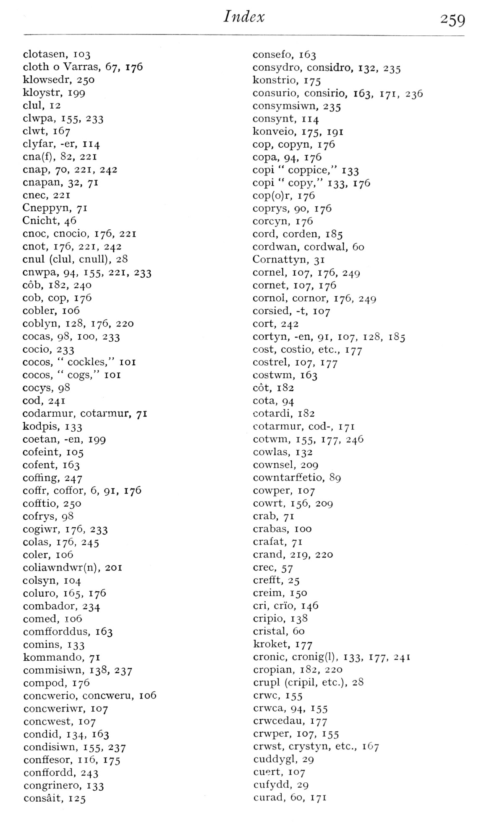  (delwedd F7010) (tudalen 259) | 259  clotasen, 103  cloth o Varras, 67, 176  klowsedr, 250  kloystr, 199  clul, 12  clwpa, 155, 233  clwt, 167  clyfar, -er, 114  cna(f), 82, 221  cnap, 70, 221, 242  cnapan, 32, 71  cnec, 221  Cneppyn, 71  Cnicht, 46  cnoc, cnocio, 176, 221  cnot, 176, 221, 242  cnul (clul, cnuU), 28  cnwpa, 94, 155, 221, 233  cob, 182, 240  cob, cop, 176  cobler, 106  coblyn, 128, 176, 220  cocas, 98, 100, 233  cocio, 233  cocos, “cockles," loi  cocos, “cogs," lOI  cocys, 98  cod, 241  codarmur, cotarmur, 71  kodpis, 133  coetan, -en, 199  cofeint, 105  cofent, 163  coffing, 247  coffr, coffor, 6, 91, 176  cofEtio, 250  cofrys, 98  cogiwr, 176, 233  colas, 176, 245  coler, 106  coliawndwr(n), 201  colsyn, 104  coluro, 165, 176  combador, 234  corned, 106  comfforddus, 163  comins, 133  kommando, 71  commisiwn, 138, 237  compod, 176  concwerio, concweru, 106  concweriwr, 107  concwest, 107  condid, 134, 163  condisiwn, 155, 237  conffesor, 116, 175  conffordd, 243  congrinero, 133  consait, 125  consefo, 163  consydro, considro, 132, 235  konstrio, 175  consurio, consirio, 163, 171, 236  consymsiwn, 235  consynt, 114  konveio, 175, 191  cop, copyn, 176  copa, 94, 176  copi “coppice," 133  copi “copy," 133, 176  cop(o)r, 176  coprys, 90, 176  corcyn, 176  cord, corden, 185  cordwan, cordwal, 60  Cornattyn, 31  cornel, 107, 176, 249  cornet, 107, 176  cornol, cornor, 176, 249  corsied, -t, 107  cort, 242  cortyn, -en, 91, 107, 128, 185  cost, costio, etc., 177  costrel, 107, 177  costwm, 163  cot, 182  cota, 94  cotardi, 182  cotarmur, cod-, 171  cotwm, 155, 177, 246  cowlas, 132  cownsel, 209  cowntarffetio, 89  cowper, 107  cowrt, 156, 209  crab, 71  crabas, 100  crafat, 71  crand, 219, 220  crec, 57  crefft, 25  creim, 150  cri, crio, 146  cripio, 138  cristal, 60  kroket, 177  cronic, cronig(l), 133, 177, 241  cropian, 182, 220  crupl (cripil, etc.), 28  crvvc, 155  crwca, 94, 155  crvvcedau, 177  crwper, 107, 155  crwst, crystyn, etc., 167  cuddygl, 29  cuert, 107  cufydd, 29  curad, 60, 171
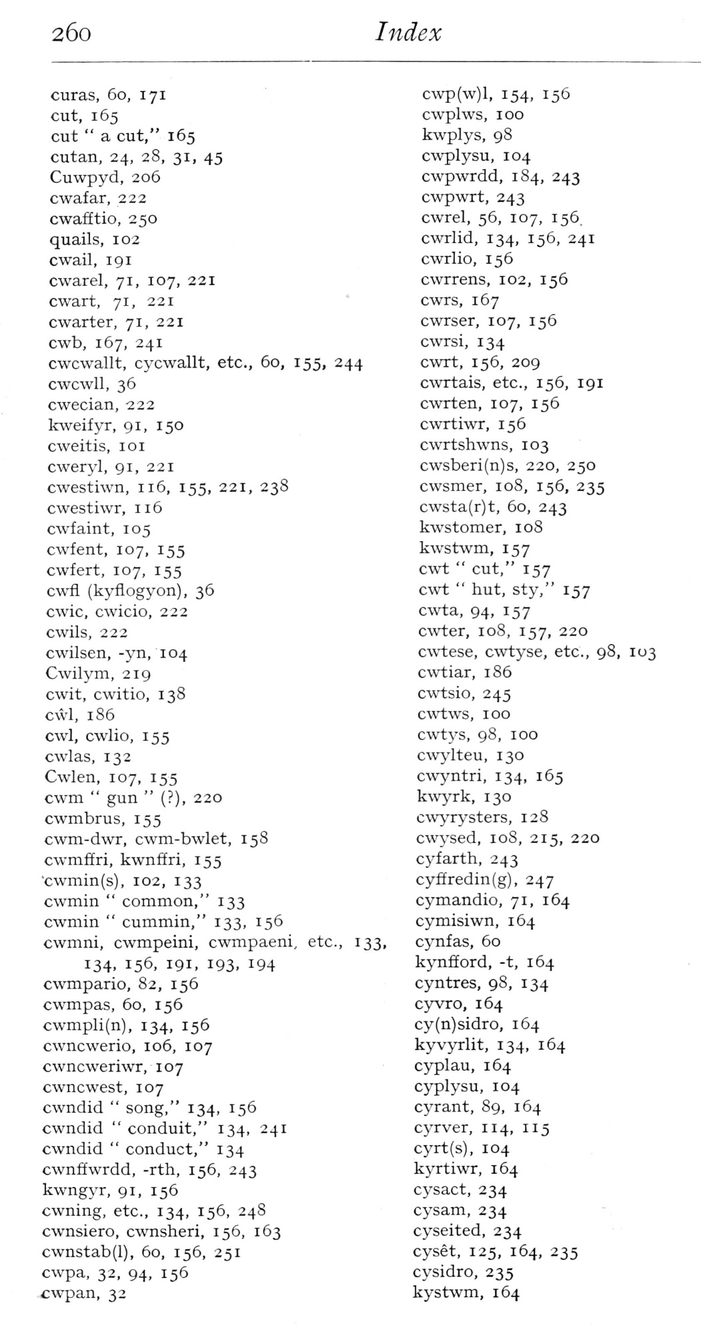  (delwedd F7011) (tudalen 260) | 26o  Index  curas, 60, 171  cut, 165  cut “a cut," 165  cutan, 24, 28, 31, 45  Cuwpyd, 206  cwafar, 222  cwafftio, 250  quails, 102  cwail, 191  cwarel, 71, 107, 221  cwart, 71, 221  cwarter, 71, 221  cwb, 167, 241  cwcwallt, cycwallt, etc., 60, 155, 244  cwcwll, 36  cwecian, 222  Icweifyr, 91, 150  cweitis, loi  cweryl, 91, 221  cwestiwn, 116, 155, 221, 238  cwestiwr, 116  cwfaint, 105  cwfent, 107, 155  cwfert, 107, 155  cwfl (kyflogyon), 36  cwic, cwicio, 222  cwils, 222  cwilsen, -yn, 104  Cwilym, 219  cwit, cwitio, 138  cwl, 186  cwl, cwlio, 155  cwlas, 132  Cwlen, 107, 155  cwna “gun” (?), 220  cwmbrus, 155  cwm-dwr, cwm-bwlet, 158  cwmffri, kwnffri, 155  'cwmin(s), 102, 133  cwmin “common," 133  cwmin “cummin," 133, 156  cwmni, cwmpeini, cwmpaeni, etc., 133,  134, 156, 191, 193, 194  cwmpario, 82, 156  cwmpas, 60, 156  c\vmpli(n), 134, 156  cwncwerio, 106, 107  cwncweriwr, 107  cwncwest, 107  cwndid “song," 134, 156  cwndid “conduit," 134, 241  cwndid “conduct," 134  cwnffwrdd, -rth, 156, 243  kwngyr, 91, 156  cwning, etc., 134, 156, 248  cwnsiero, cwnsheri, 156, 163  cwnstab(l), 60, 156, 251  cwpa, 32, 94, 156  cwpan, 32  c\vp(w)l, 154, 156  cwplws, 100  kwplys, 98  cwplysu, 104  cwpwrdd, 184, 243  cwpwrt, 243  cwrel, 56, 107, 156,  cwrlid, 134, 156, 241  cwrlio, 156  cwrrens, 102, 156  cwrs, 167  cwrser, 107, 156  cwrsi, 134  cwrt, 156, 209  cwrtais, etc., 156, 191  cwrten, 107, 156  cwrtiwr, 156  cwrtshwns, 103  cwsberi(n)s, 220, 250  cwsmer, 108, 156, 235  cwsta(r)t, 60, 243  kwstomer, 108  kwstwm, 157  cwt “cut," 157  cwt “hut, sty," 157  c\vta, 94, 157  c\vter, 108, 157, 220  cw-tese, cwtyse, etc., 98, 103  cwtiar, 186  cwtsio, 245  cwtws, 100  cwtys, 98, 100  cwylteu, 130  c^\Tntri, 134, 165  kwyrk, 130  cwyrysters, 128  cwysed, 108, 215, 220  cyfarth, 243  cyffredin(g), 247  cymandio, 71, 164  cymisiwn, 164  cynfas, 60  kynfford, -t, 164  cyntres, 98, 134  cyvro, 164  cy(n)sidro, 164  kyvyrlit, 134, 164  cjTplau, 164  cyplysu, 104  cyrant, 89, 164  cyrver, 114, 115  cyrt(s), 104  kyrtiwr, 164  cysact, 234  cysam, 234  cyseited, 234  cyset, 125, 164, 235  cysidro, 235  kystwm, 164
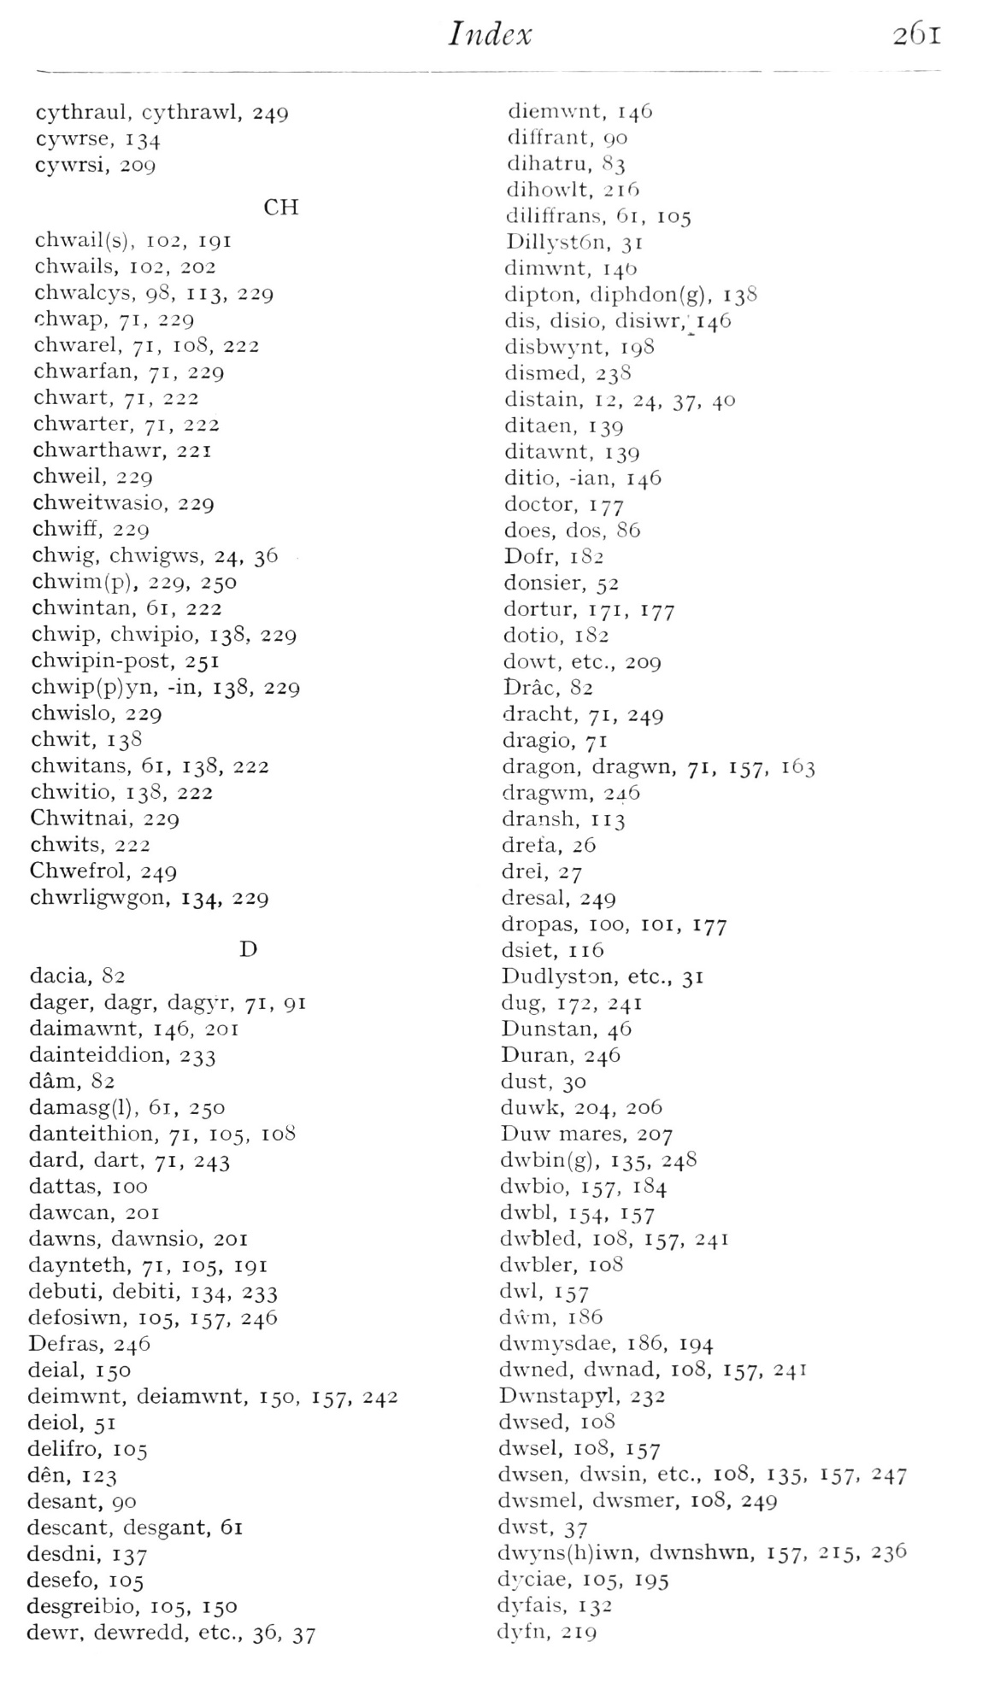  (delwedd F7012) (tudalen 261) | Index  261  cythraul, cythrawl, 249  cywrse, 134  cywrsi, 209  CH  chwail(s), 102, 191  chwails, 102, 202  chwalcys, 98, 113, 229  chwap, 71, 229  chwarel, 71, 108, 222  chwarfan, 71, 229  chwart, 71, 222  chwarter, 71, 222  chwarthawr, 221  chweil, 229  chweitwasio, 229  chwiff, 229  chwig, chwigws, 24, 36  chwim(p), 229, 250  chwintan, 61, 222  chwip, chwipio, 13S, 229  chwipin-post, 251  ch\vip(p)yn, -in, 138, 229  chwislo, 229  chwit, 138  chwitans, 61, 138, 222  chwitio, 138, 222  Chwitnai, 229  chwits, 222  Chwefrol, 249  chwrligwgon, 134, 229  D  dacia, 82  dager, dagr, dag^-r, 71, 91  daimawnt, 146, 201  dainteiddion, 233  dam, 82  damasg(l), 61, 250  danteithion, 71, 105, 108  dard, dart, 71, 243  dattas, 100  dawcan, 201  dawns, dawnsio, 201  daynteth, 71, 105, 191  debuti, debiti, 134, 233  defosiwn, 105, 157, 246  Defras, 246  deial, 150  deimwnt, deiamwnt, 150, 157, 242  deiol, 51  delifro, 105  den, 123  desant, 90  descant, desgant, 61  desdni, 137  desefo, 105  desgreibio, 105, 150  dewr, dewredd, etc., 36, 37  diemwnt, 146  dil'frant, 90  dihatru, 83  dihowlt, 216  diliffrans, 61, 105  Dillyst6n, 31  dimwnt, 14D  dipton, diphdon(g), 138  dis, disio, disiwr,' 146  disbwynt, 198  dismed, 238  distain, 12, 24, 37, 40  ditaen, 139  ditawnt, 139  ditio, -ian, 146  doctor, 177  does, dos, 86  Dofr, 182  donsier, 52  dortur, 171, 177  dotio, 182  do\vt, etc., 209  Drac, 82  dracht, 71, 249  dragio, 71  dragon, dragwn, 71, 157, 163  dragwm, 246  dransh, 113  drefa, 26  drei, 27  dresal, 249  dropas, 100, loi, 177  dsiet, 116  Dudlyston, etc., 31  dug, 172, 241  Dunstan, 46  Duran, 246  dust, 30  duwk, 204, 206  Duw mares, 207  dwbin(g), 135, 248  dwbio, 157, 184  dwbl, 154. 157  dwbled, 108, 157, 241  dwbler, 108  dwi, 157  dwm, 186  dwmysdae, 186, 194  dwned, dwnad, 108, 157, 241  Dwnstapyl, 232  dwsed, 108  dwsel, 108, 157  dwsen, dwsin, etc., 108, 135, 157, 247  dwsmel, dwsmer, 108, 249  dwst, 37  d\vyns(h)iwn, dwnshvvn, 157, 215, 236  dyciae, 105, 195  dj'fais, 132  dyfn, 219
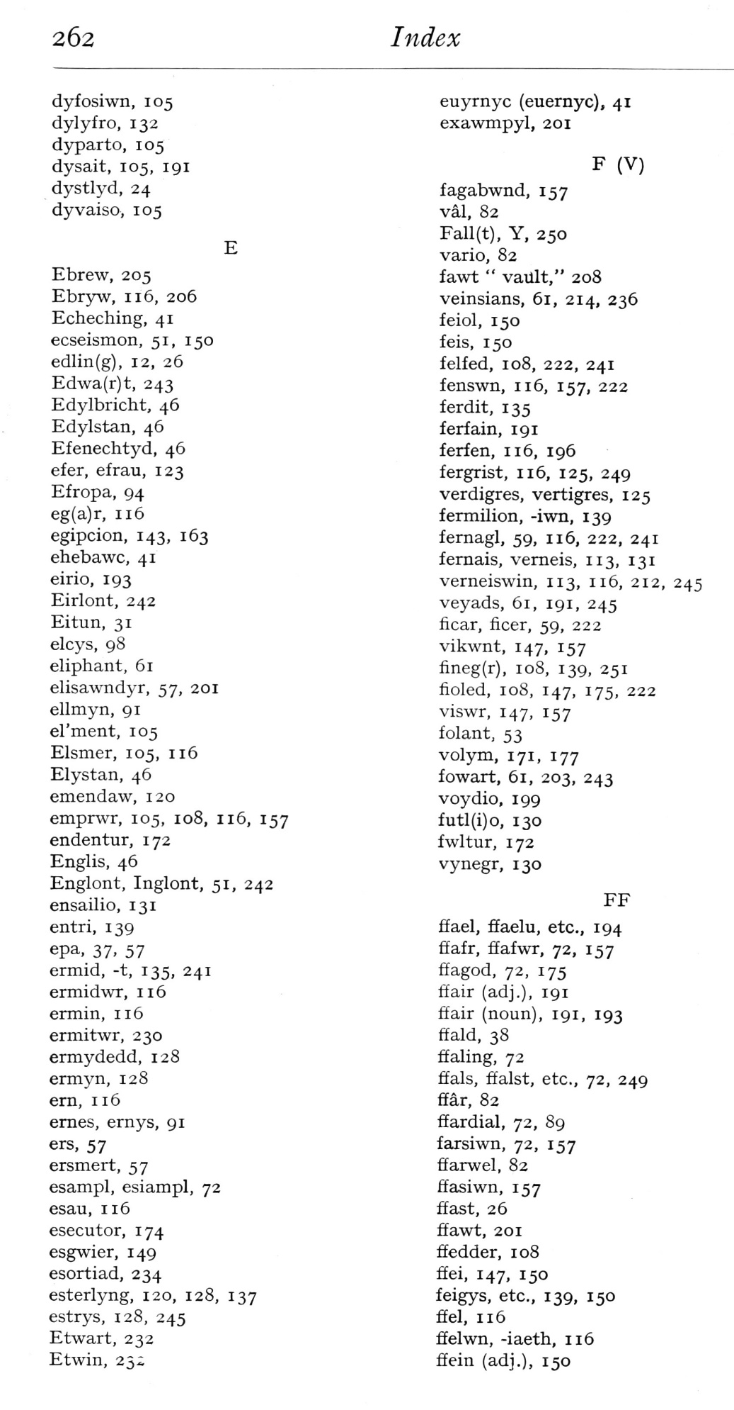  (delwedd F7013) (tudalen 262) | 262  Index  dyfosiwn, 105  dylyfro, 132  dyparto, 105  dysait, 105, 191  dystlyd, 24  dyvaiso, 105  Ebrew, 205  Ebryw, 116, 206  Echeching, 41  ecseismon, 51, 150  edlin(g), 12, 26  Edwa(r)t, 243  Edylbricht, 46  Edylstan, 46  Efenechtyd, 46  efer, efrau, 123  Efropa, 94  eg(a)r, 116  egipcion, 143, 163  ehebawc, 41  eirio, 193  Eirlont, 242  Eitun, 31  elcys, 98  eliphant, 61  elisawndyr, 57, 201  ellmyn, 91  el'ment, 105  Elsmer, 105, 116  Elystan, 46  emendaw, 120  emprwr, 105, 108, 116, 157  endentur, 172  Englis, 46  Englont, Inglont, 51, 242  ensailio, 131  entri, 139  epa. 37. 57  ermid, -t, 135, 241  ermidwr, 116  ermin, 116  ermitwr, 230  ermydedd, 128  ermyn, 128  ern, 116  ernes, ernys, 91  ers, 57  ersmert, 57  esampl, esiampl, 72  esau, 116  esecutor, 174  esgwier, 149  esortiad, 234  esterlyng, 120, 128, 137  estrys, 128, 245  Etwart, 232  Etwin, 25i  euyrnyc (euernyc), 41  exawmpyl, 201  F (V)  fagabwnd, 157  val, 82  Fall(t). Y, 250  vario, 82  fawt “vault," 208  veinsians, 61, 214, 236  feiol, 150  feis, 150  felfed, 108, 222, 241  fenswn, 116, 157, 222  ferdit, 135  ferfain, 191  f erf en, 116, 196  fergrist, 116, 125, 249  verdigres, vertigres, 125  fermilion, -iwn, 139  fernagl, 59, 116, 222, 241  fernais, vemeis, 113, 131  verneiswin, 113, 116, 212, 245  veyads, 61, 191, 245  ficar, ficer, 59, 222  vikwnt, 147, 157  fineg(r), 108, 139, 251  fioled, 108, 147, 175, 222  viswr, 147, 157  folant, 53  volym, 171, 177  fowart, 61, 203, 243  voydio, 199  futl(i)o, 130  fwltur, 172  vynegr, 130  FF  ffael, ffaelu, etc., 194  ffafr, ffafwr, 72, 157  ffagod, 72, 175  ffair (adj.), 191  ffair (noun), 191, 193  ffald, 38  ffaling, 72  ffals, ffalst, etc., 72, 249  ffar, 82  ffardial, 72, 89  farsiwn, 72, 157  ffarwel, 82  ffasiwn, 157  ffast, 26  ffawt, 201  ffedder, 108  ffei, 147, 150  feigys, etc., 139, 150  ffel, 116  ffelwn, -iaeth, 116  ffein (adj.), 150
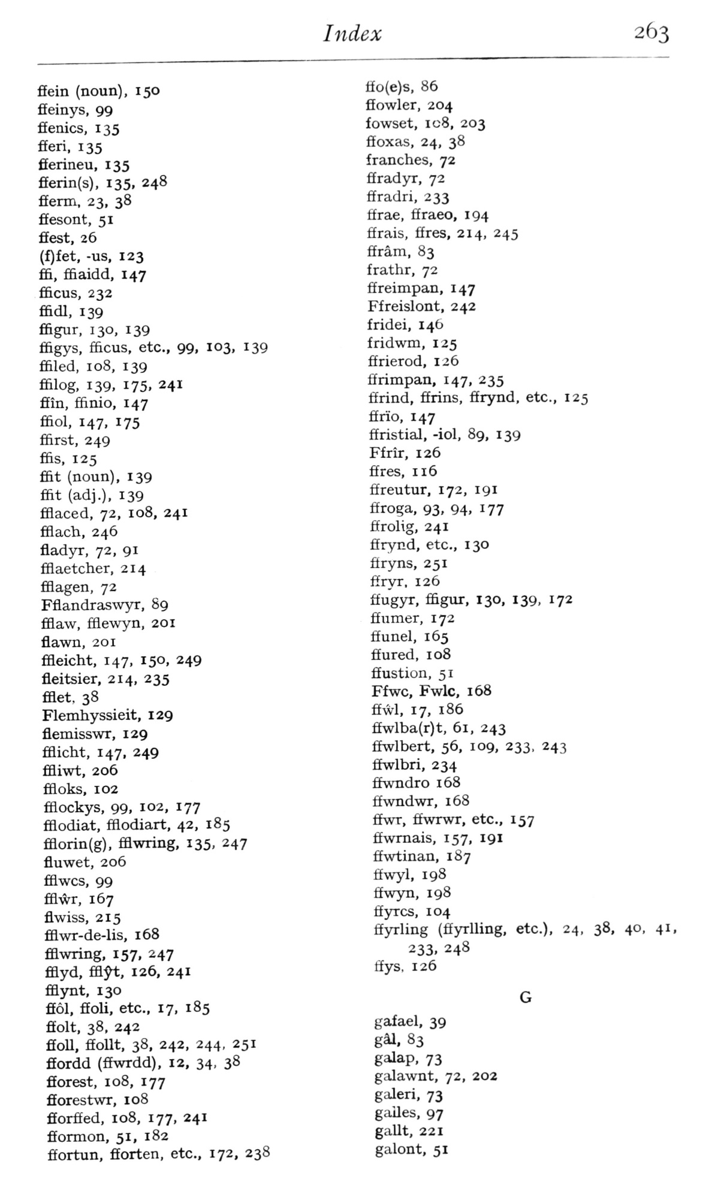  (delwedd F7014) (tudalen 263) | Index  263  flfein (noun), 150  ffeinys, 99  fifenics, 135  fieri, 135  fferineu, 135  fferin(s), 135, 248  fferm, 23, 38  ffesont, 51  ffest, 26  (f)fet, -us, 123  ffi, ffiaidd, 147  f&cus, 232  ffidl, 139  ffigur, 130, 139  ffigys, £&cus, etc., 99, 103, 139  filled, 108, 139  ffilog, 139. 175. 241  ffin, fftnio, 147  ffiol, 147, 175  fiirst, 249  ffis, 125  fi&t (noun), 139  fiit (adj.), 139  fiiaced, 72, 108, 241  fiiach, 246  fladyr, 72, 91  filaetcher, 214  fiiagen, 72  Fflandras\vyr, 89  fiiaw, fflewyn, 201  flawn, 201  fiieicht, 147, 150, 249  fleitsier, 214, 235  fflet, 38  Flemhyssieit, 129  flemisswr, 129  filicht, 147, 249  ffliwt, 206  fiioks, 102  fflockys, 99, 102, 177  fiiodiat, fflodiart, 42, 185  fflorin(g), fflwring, 135, 247  fluwet, 206  fBwcs, 99  fflA^r, 167  Swiss, 215  fiiwr-de-lis, 168  fflwring, 157, 247  fflyd, ffl;^, 126, 241  fflynt, 130  ffol, ffoli, etc., 17, 185  ffolt, 38, 242  ffoll, ffoUt, 38, 242, 244, 251  fifordd (ffwrdd), 12, 34, 38  fiorest, 108, 177  fforestwr, 108  fforffed, 108, 177, 241  fformon, 51, 182  ffortun, fEorten, etc., 172, 238  ffo(e)s, 86  fiowler, 204  fowset, icS, 203  ffoxas, 24, 38  franches, 72  ffradyx, 72  ffradri, 233  ffrae, ffraeo, 194  ffrais, fires, 214, 245  ffram, 83  frathr, 72  ffreimpan, 147  Ffreislont, 242  fridei, 146  fridwm, 125  firierod, 126  firimpan, 147, 235  ffrind, firins, firynd, etc., 125  ffrio, 147  ffristial, -iol, 89, 139  Ffrir, 126  fires, 116  ffreutur, 172, 191  ffroga, 93, 94, 177  firolig, 241  firynd, etc., 130  firyns, 251  ffryr. 126  fiugyr, ffigur, 130, 139, 172  ffumer, 172  fiunel, 165  fiured, 108  fiustion, 51  Ffwc, Fwlc, 168  ffwl, 17, 186  ffwlba(r)t, 61, 243  ffwlbert, 56, 109, 233, 243  ffwlbri, 234  ffwndro 168  fiwndwr, 168  ffwr, ffwrwT, etc., 157  ffwmais, 157, 191  ffwtinan, 1S7  ffwyl, 198  ffwyn, 198  ffyrcs, 104  ffyrling (ffyrlling, etc.), 24, 38, 40. 41,  233. 248  ffys, 126  gafael, 39  gai, 83  galap, 73  galawnt, 72, 202  galeri, 73  gailes, 97  gallt, 221  galont, 51
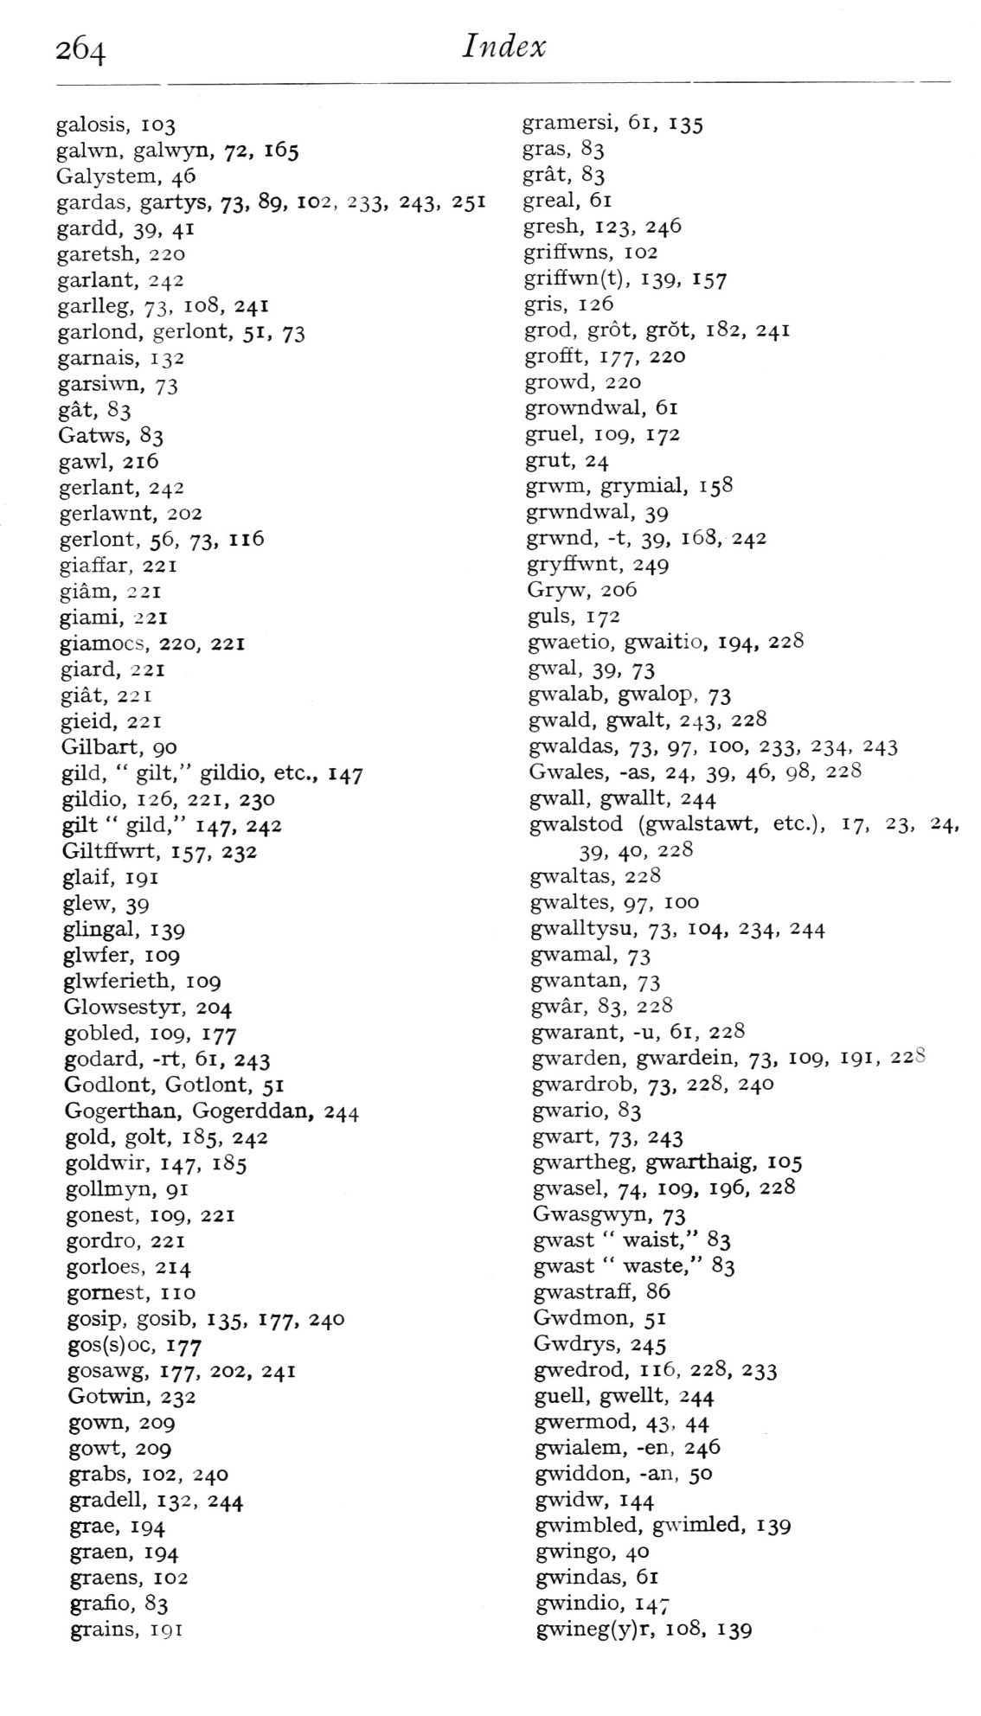  (delwedd F7015) (tudalen 264) | 264  Index  galosis, 103  gahxTi, gahvyn, 72, 165  Galj'stem, 46  gardas, gartys, 73, 89, 102, 233, 243, 251  gardd, 39, 41  garetsh, 220  garlant, 242  garlleg, 73, 108, 241  garlond, gerlont, 51, 73  garnais, 132  garsh\Ti, 73  gat, 83  Gatws, 83  gawl, 216  gerlant, 242  gerlawnt, 202  gerlont, 56, 73, 116  giaffar, 221  giam, 221  giami, 221  giamocs, 220, 221  giard, 221  giat, 221  gieid, 221  Gilbart, 90  gild, “gilt," gildio, etc., 147  gildio, 126, 221, 230  gilt “gild," 147. 242  Giltffwrt, 157, 232  glaif, 191  glew, 39  glingal, 139  glwfer, 109  glwferieth, 109  Glo\vsest5n:, 204  gobled, 109, 177  godard, -rt, 61, 243  Godlont, Gotlont, 51  Gogerthan, Gogerddan, 244  gold, golt, 185, 242  goldwir, 147, 1 85  goUmyn, 91  gonest, 109, 221  gordro, 221  gorloes, 214  gomest, no  gosip, gosib, 135, 177, 240  gos(s)oc, 177  gosawg, 177, 202, 241  Gotwin, 232  gown, 209  goui;, 209  grabs, 102, 240  gradell, 132, 244  grae, 194  graen, 194  graens, 102  grafio, 83  grains, 191  gramersi, 61, 135  gras, 83  grat, 83  greal, 61  gresh, 123, 246  griff wns, 102  griff\vn(t), 139, 157  gris, 126  grod, grot, grot, 182, 241  grofft, 177, 220  growd, 220  gro%vndwal, 61  gruel, 109, 172  grut, 24  grwm, grymial, 158  grvvndwal, 39  grwnd, -t, 39, 1 63, 242  gryflvvnt, 249  Gry^v, 206  guis, 172  gwaetio, gwaitio, 194, 228  g%val, 39, 73  g^valab, gwalop, 73  gwald, gwalt, 243, 228  gwaldas, 73, 97. 1°°. 233. 234. 243  Gwales, -as, 24, 39, 46, 98, 228  gwall, gwallt, 244  gwalstod (g^valstawt, etc.), 17, 23, 24,  39, 40, 228  gwaltas, 228  gAvaltes, 97, 100  gwalltysu, 73. 104, 234, 244  gwamal, 73  gwantan, 73  gwar, 83, 228  gw^arant, -u, 61, 228  g^va^den, gwardein, 73, 109, 191, 22S  gwardrob, 73, 228, 240  g^vario, 83  g\vart. 73, 243  gwartheg, gwarthaig, 105  gAvasel, 74, 109, 196, 228  Gwasgwyn, 73  g^vast “waist," 83  gwast “waste," 83  gwastraff, 86  Gwdmon, 51  Gwdrys, 245  gwedrod, 116, 228, 233  guell, gwellt, 244  gwermod, 43, 44  gwialem, -en, 246  gwiddon, -an, 50  gwidw, 144  g%\'imbled, g^vi^lled, 139  gwingo, 40  gwindas, 61  gwindio, 147  gwineg(y)r, 108, 139
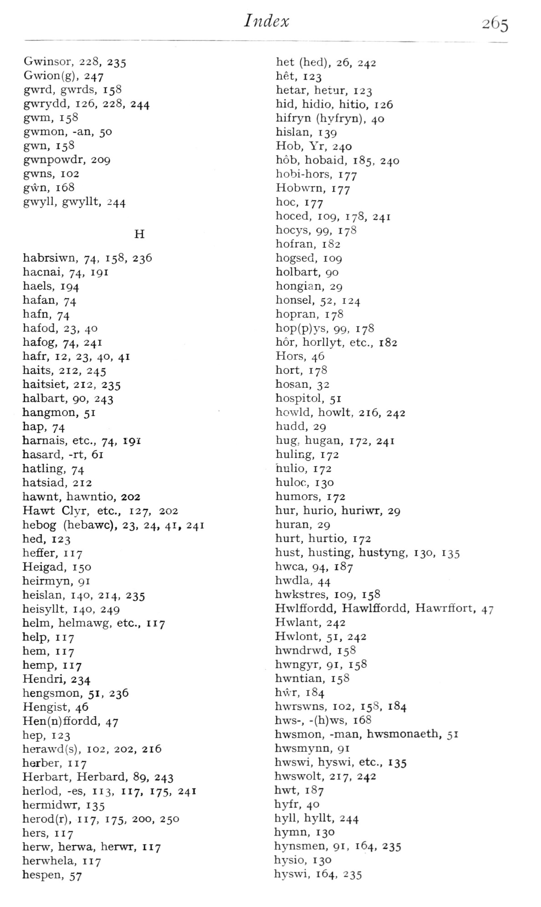  (delwedd F7016) (tudalen 265) | Index  265  Gwinsor, 228, 235  Gwion(g), 247  gwrd, gwrds, 158  gwrj'dd, 126, 228, 244  gwTii, 158  gwmon, -an, 50  g\vn, 158  g\vnpowdr, 209  gwns, 102  gwn, 168  gw'yll, gwyllt, 244  H  habrsiwn, 74, 158, 236  hacnai, 74, 191  haels, 194  hafan, 74  hafn, 74  hafod, 23, 40  hafog, 74, 241  hafr, 12, 23, 40, 41  halts, 212, 245  haitsiet, 212, 235  halbart, 90, 243  hangmon, 51  hap, 74  hamais, etc., 74, 191  hasard, -rt, 61  hathng, 74  hatsiad, 212  hawnt, hawntio, 202  Hawt C]yr, etc., 127, 202  hebog (hebawc), 23, 24, 41, 241  hed, 123  heffer, 117  Heigad, 150  heinnyn, 91  heislan, 140, 214, 235  heisyllt, 140, 249  helm, helmawg, etc., 117  help, 117  hem, 117  hemp, 117  Hendri, 234  hengsmon, 51, 236  Hengist, 46  Hen(n)ffordd, 47  hep, 123  hera\vd(s), 102, 202, 216  herber, 117  Herbart, Herbard, 89, 243  herlod, -es, 113, 117, 175, 241  hermid\vr, 135  herod(r), 117, 175, 200, 250  hers, 117  herw, herwa, herwr, 117  hersvhela, 117  hespen, 57  het (hed), 26, 242  het, 123  hetar, hetur, 123  hid, hidio, hitio, 126  hifryn (hyfryn), 40  hislan, 139  Hob, Yr, 240  hob, hobaid, 185, 240  hobi-hors, 177  Hobwrn, 177  hoc, 177  hoced, 109, 178, 241  hocys, 99, 178  hofran, 182  hogsed, 109  holbart, 90  hongian, 29  honsel, 52, 124  hopran, 178  hop(p)ys, 99, 178  hor, horllyt, etc., 182  Hors, 46  hort, 178  hosan, 32  hospitol, 51  hovvld, howlt, 216, 242  hudd, 29  hug, hugan, 172, 241  huling, 172  hulio, 172  huloc, 130  humors, 172  hur, hurio, huriwr, 29  huran, 29  hurt, hurtio, 172  hust, busting, hustyng, 130, 135  hwca, 94, 187  hwdla, 44  hwkstres, 109, 158  HwlfEordd, Hawlffordd, Hawrffort, 47  Hwlant, 242  Hwlont, 51, 242  hwndrwd, 158  hwngyr, 91, 158  hwntian, 158  h\vr, 184  hwrswns, 102, 158, 184  hws-, -(h)ws, 168  hwsmon, -man, hwsmonaeth, 51  hwsmynn, 91  hwswi, hyswi, etc., 135  hwswolt, 217, 242  hwt, 187  hyfr, 40  hyll, hyllt, 244  hymn, 130  hynsmen, 91, 164, 235  hysio, 130  hyswi, 164, 235
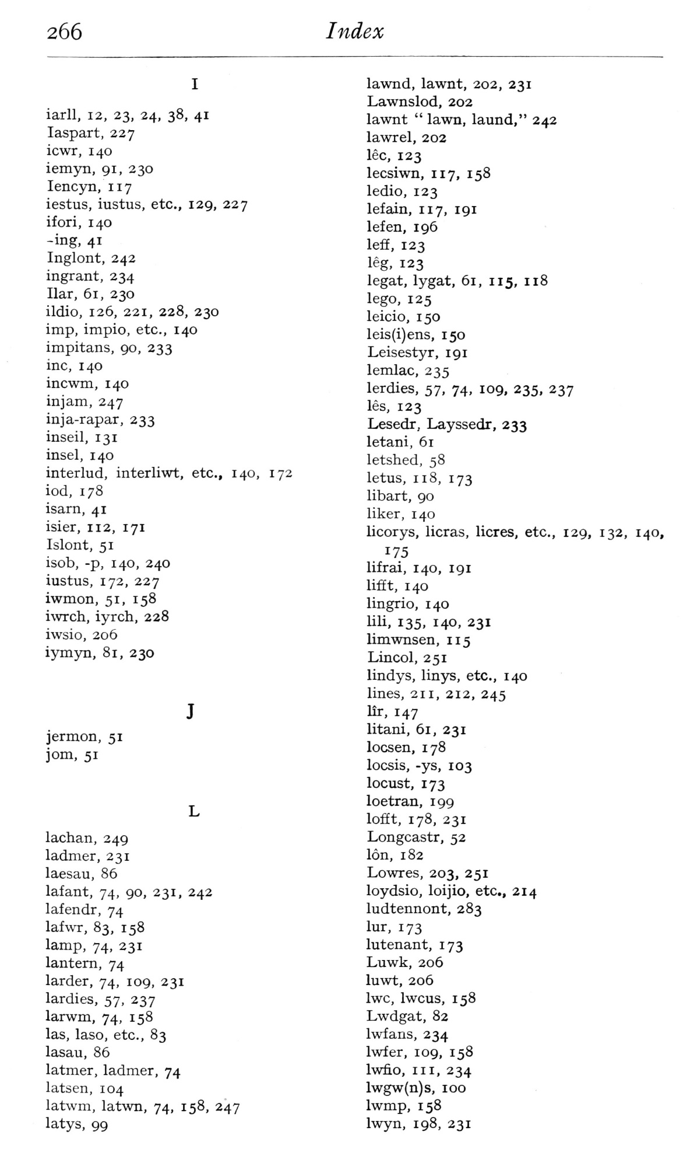  (delwedd F7017) (tudalen 266) | 266  Index  iarll, 12, 23, 24, 38, 41  laspart, 227  icwr, 140  iemyn, 91, 230  lencyn, 117  iestus, iustus, etc., 129, 227  ifori, 140  -ing, 41  Inglont, 242  ingrant, 234  liar, 61, 230  ildio, 126, 221, 228, 230  imp, impio, etc., 140  impitans, 90, 233  inc, 140  incwm, 140  injam, 247  inja-rapar, 233  inseil, 131  insel, 140  interlud, interliwt, etc., 140, 172  iod, 178  isam, 41  isier, 112, 171  Islont, 51  isob, -p, 140, 240  iustus, 172, 227  iwmon, 51, 158  iwrch, iyrch, 228  iwsio, 206  iymyn, 81, 230  jermon, 51  jom, 51  lachan, 249  ladmer, 231  laesau, 86  lafant, 74, 90, 231, 242  lafendr, 74  lafwr, 83, 158  lamp, 74, 231  lantern, 74  larder, 74, 109, 231  lardies, 57, 237  larwm, 74, 158  las, laso, etc., 83  lasau, 86  latmer, ladmer, 74  latsen, 104  latwm, latwn, 74, 158, 247  latys, 99  lawnd, lawnt, 202, 231  Lawnslod, 202  lawnt “lawn, laund," 242  lawrel, 202  lee, 123  lecsiwn, 117, 158  ledio, 123  lefain, 117, 191  lefen, 196  leff, 123  leg, 123  legat, lygat, 61, 115, 118  lego, 125  leicio, 150  leis(i)ens, 150  Leisestyr, 191  lemlac, 235  lerdies, 57, 74, 109, 235, 237  les, 123  Lesedr, Layssedr, 233  letani, 61  letshed, 58  letus, 118, 173  libart, 90  liker, 140  licorys, licras, licres, etc., 129, 132, 140,  175  lifrai, 140, 191  lifit, 140  lingrio, 140  lili, 135, 140, 231  limwnsen, 115  Lincol, 251  lindys, linys, etc., 140  lines, 211, 212, 245  lir, 147  litani, 61, 231  locsen, 178  locsis, -ys, 103  locust, 173  loetran, 199  lofiEt, 178, 231  Longcastr, 52  Ion, 182  Lowres, 203, 251  loydsio, loijio, etc., 214  ludtennont, 283  lur, 173  lutenant, 173  Luwk, 206  luwt, 206  Iwc, Iwcus, 158  Lwdgat, 82  Iwfans, 234  Iwfer, 109, 158  Iwfio, III, 234  lwgw(n)s, 100  Iwmp, 158  Iwyn, 198, 231
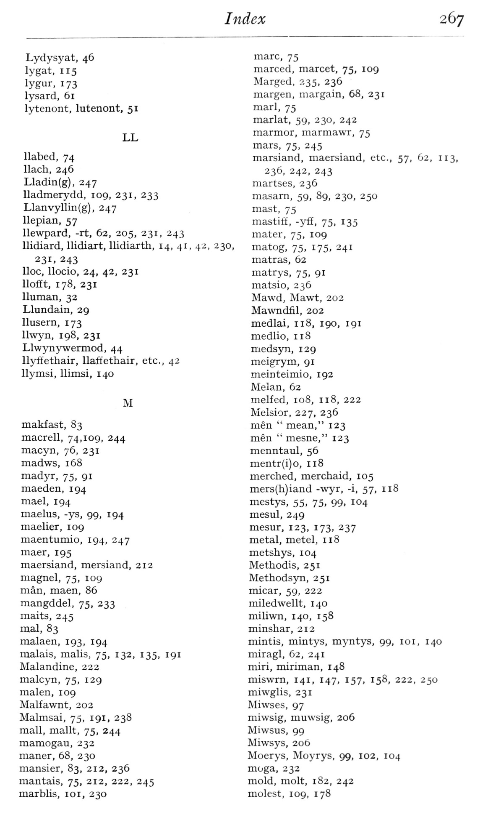  (delwedd F7018) (tudalen 267) | Index  267  Lydysyat, 46  lygat, 115  lygur, 173  lysard, 61  lytenont, lutenont, 51  LL  llabed, 74  llach, 246  Lladin(g), 247  lladmerydd, 109, 231, 233  Llanvyllin(g), 247  llepian, 57  llewpard, -rt, 62, 205, 231, 243  llidiard, llidiart, llidiarth, 14, 41, 4-i, 230,  231, 243  Hoc, llocio, 24, 42, 231  llofft, 178, 231  Human, 32  Llundain, 29  llusern, 173  llwyn, 198, 231  Llwynywermod, 44  llyjffethair, llaffethair, etc., 42  Uymsi, llimsi, 140  M  makfast, 83  macrell, 74,109, 244  macyn, 76, 231  madws, 168  madyr, 75, 91  maeden, 194  mael, 194  maelus, -ys, 99, 194  maelier, 109  maentumio, 194, 247  maer, 195  maersiand, mersiand, 212  magnel, 75, 109  man, maen, 86  mangddel, 75, 233  maits, 245  mal, 83  malaen, 193, 194  malais, malis, 75, 132, 135, 191  Malandine, 222  malcyn, 75, 129  malen, 109  Malfawnt, 202  Malmsai, 75, 191, 238  mall, mallt, 75, 244  mamogau, 232  maner, 68, 230  mansier, 83, 212, 236  mantais, 75, 212, 222, 245  marblis, loi, 230  marc, 75  marced, marcet, 75, 109  Marged, 235, 236  margen, margain, 68, 231  marl, 75  marlat, 59, 230, 242  marmor, marmawT, 75  mars, 75, 245  marsiand, maersiand, etc., 57, 62, 113,  236, 242, 243  niartses, 236  masam, 59, 89, 230, 250  mast, 75  mastiff, ->-ff, 75, 135  mater, 75, 109  matog, 75, 175, 241  matras, 62  matrys, 75, 91  matsio, 236  Mawd, Mawt, 202  Mawndfil, 202  medial, 118, 190, 191  medlio, 118  meds3m, 129  meigrym, gi  meinteimio, 192  Meian, 62  melfed, 108, 118, 222  Melsior, 227, 236  rnen “mean," 123  men “mesne," 123  menntaul, 56  mentr(i)o, 118  merched, merchaid, 105  mers(h)iand -wyr, -i, 57, 118  mestys, 55, 75, 99, 104  mesul, 249  mesur, 123, 173, 237  metal, metel, 118  metshys, 104  Methodis, 251  Methodsyn, 251  micar, 59, 222  miledwellt, 140  miliwn, 140, 158  minshar, 212  mintis, mintys, myntys, 99, loi, 140  miragl, 62, 241  miri, miriman, 148  miswm, 141, 147, 157, 158, 222, 250  miwglis, 231  Miwses, 97  miwsig, muwsig, 206  Miwsus, 99  Miwsj'S, 206  Moerys, Moyrys, 99, 102, 104  moga, 232  mold, molt, 1S2, 242  molest, 109, 178
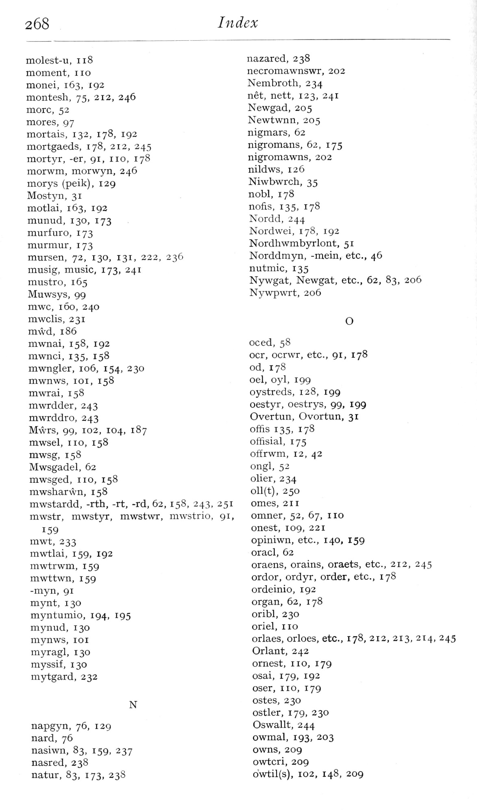  (delwedd F7019) (tudalen 268) | 268  Index  molest-u, ii8  moment, no  monei, 163, 192  montesh, 75, 212, 246  more, 52  mores, 97  mortals, 132, 178, 192  mortgaeds, 178, 212, 245  mortyr, -er, 91, no, 178  morwm, morwyn, 246  morys (peik), 129  Mostyn, 31  motlai, 163, 192  munud, 130, 173  murfuro, 173  murmur, 173  mursen, 72, 130, 131, 222, 236  musig, music, 173, 241  mustro, 165  Muwsys, 99  mwc, 160, 240  mwclis, 231  mwd, 186  mwnai, 158, 192  mwnci, 135, 158  mwngler, 106, 154, 230  mwnws, loi, 158  mwrai, 158  mwrdder, 243  mwrddro, 243  Mwrs, 99, 102, 104, 187  mwsel, no, 158  mwsg, 158  Mwsgadel, 62  mwsged, no, 158  mwsharwn, 158  mwstardd, -rth, -rt, -rd, 62, 158, 243, 251  mwstr, mwstyr, mwstwr, mwstrio, 91,  159  mwt, 233  mwtlai, 159, 192  mwtrwm, 159  mwttwn, 159  -myn, 91  mynt, 130  myntumio, 194, 195  mynud, 130  mynws, loi  myragl, 130  myssif, 130  mytgard, 232  N  napgyn, 76, 129  nard, 76  nasiwn, 83, 159, 237  nasred, 238  natur, 83, 173, 23S  nazared, 238  necromawnswr, 202  Nembroth, 234  net, nett, 123, 241  Newgad, 205  Newtwnn, 205  nigmars, 62  nigromans, 62, 175  nigromawns, 202  nildws, 126  Niwbwrch, 35  nobl, 178  nofis, 135, 178  Nordd, 244  Nordwei, 178, 192  Nordhwmbyrlont, 51  Norddmyn, -mein, etc., 46  nutmic, 135  Nywgat, Newgat, etc., 62, 83, 206  Nywpwrt, 206  O  oced, 58  ocr, ocrwr, etc., 91, 178  od, 178  oel, oyl, 199  oystreds, 128, 199  oestyr, oestrys, 99, 199  Overtun, Ovortun, 31  offis 135, 178  offisial, 175  ofErwm, 12, 42  ongl, 52  olier, 234  oll(t), 250  omes, 211  omner, 52, 67, no  onest, 109, 221  opiniwn, etc., 140, 159  oracl, 62  oraens, orains, oraets, etc., 212, 245  ordor, ordyr, order, etc., 178  ordeinio, 192  organ, 62, 178  oribl, 230  oriel, no  orlaes, orloes, etc., 178, 212, 213, 214, 245  Orlant, 242  ornest, no, 179  osal, 179, 192  oser, no, 179  ostes, 230  ostler, 179, 230  Oswallt, 244  owmal, 193, 203  owns, 209  owtcri, 209  owtil(s), 102, 148, 209
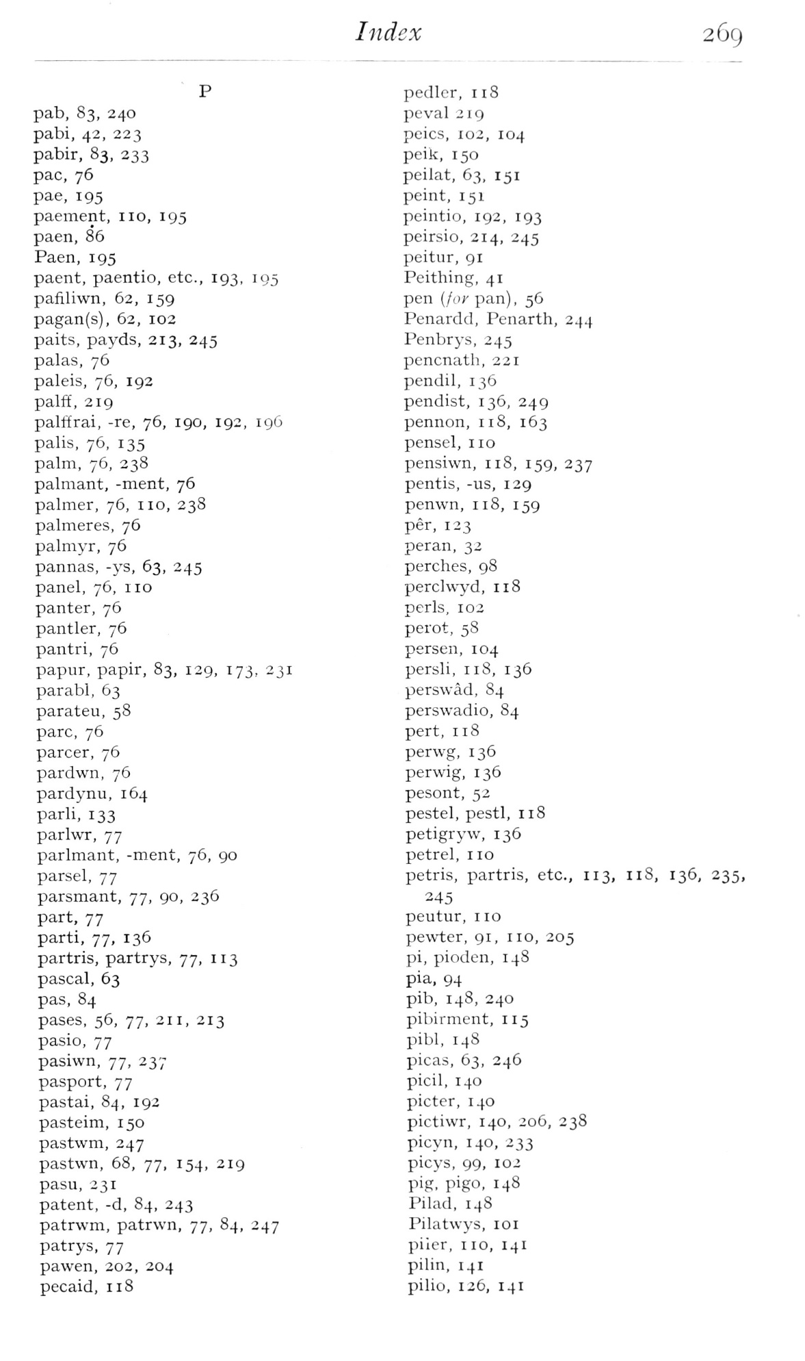  (delwedd F7020) (tudalen 269) | Index  269  pab, 83, 240  pabi, 42, 223  pabir, 83, 233  pac, 76  pae, 195  paement, no, 195  paen, 86  Paen, 195  paent, paentio, etc., 193, 195  pafiliwn, 62, 159  pagan(s), 62, 102  paits, payds, 213, 245  palas, 76  paleis, 76, 192  palfE, 219  palffrai, -re, 76, 190, 192, 196  palis, 76, 135  palm, 76, 238  palmant, -ment, 76  palmer, 76, no, 238  palmeres, 76  palmyr, 76  pannas, -ys, 63, 245  panel, 76, no  panter, 76  pantler, 76  pantri, 76  papur, papir, 83, 129, 173, 231  parabl, 63  parateu, 58  pare, 76  parcer, 76  pardwn, 76  pardynu, 164  parli, 133  parlwr, 77  parlmant, -ment, 76, 90  parsel, 77  parsmant, 77, 90, 236  part, 77  parti, 77, 136  partris, partrys, 77, 113  pascal, 63  pas, 84  pases, 56, 77, 211, 213  pasio, 77  pasiwn, 77, 237  pasport, 77  pastai, 84, 192  pasteim, 150  pastwm, 247  pastvvn, 68, 77, 154, 219  pasu, 231  patent, -d, 84, 243  patrwm, patrwn, 77, 84, 247  patrys, 77  pawen, 202, 204  pecaid, 118  pedler, 118  peval 219  peics, X02, 104  peik, 150  peilat, 63, 151  peint, 151  peintio, 192, 193  peirsio, 214, 245  peitur, 91  Peithing, 41  pen {for pan), 56  Penardd, Penarth, 244  Penbrys, 245  pencnath, 221  pendil, 136  pendist, 136, 249  pennon, 118, 163  pensel, no  pensiwn, 118, 159, 237  pentis, -us, 129  penwn, 118, 159  per, 123  peran, 32  perches, 98  perchvyd, 118  perls, 102  perot, 58  persen, 104  persli, 118, 136  perswad, 84  perswadio, 84  pert, 118  perwg, 136  perwig, 136  pesont, 52  pestel, pestl, 118  petigryw, 136  petrel, no  petris, partris, etc., 113, nS, 136, 235,  245  peutur, no  pewter, 91, no, 205  pi, pioden, 148  pia. 94  pib, 148, 240  pibirment, 115  pibl, 148  picas, 63, 246  picil, 140  picter, 140  pictiwr, 140, 206, 238  picyn, 140, 233  picys, 99, 102  pig, pigo, 148  Pilad, 148  Pilatwys, loi  piler, no, 141  pilin, 141  pilio, 126, 141
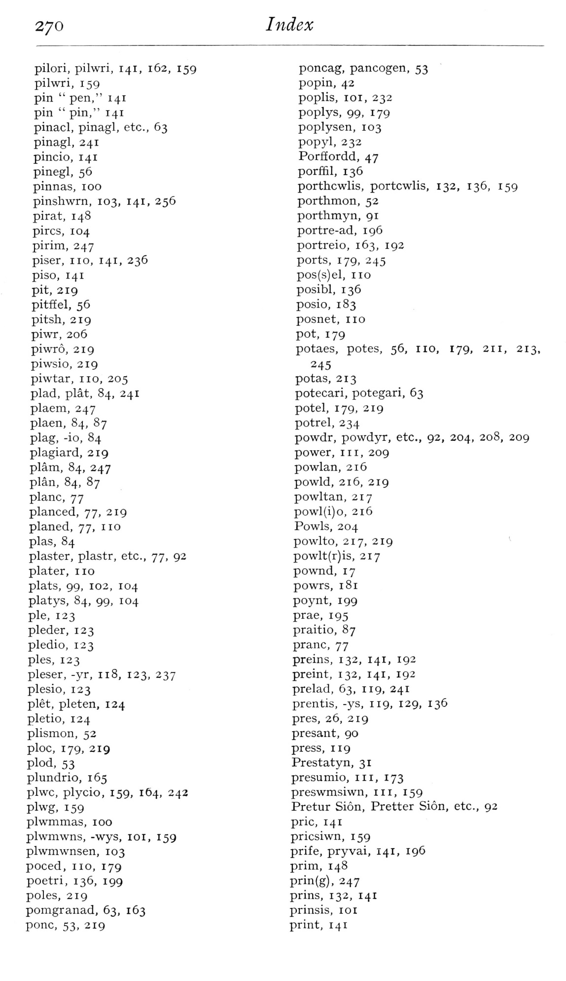  (delwedd F7021) (tudalen 270) | 270  Index  pilori, pilwri, 141, 162, 159  pilwri, 159  pin “pen," 141  pin “pin," 141  pinacl, pinagl, etc., 63  pinagl, 241  pincio, 141  pinegl, 56  pinnas, 100  pinshwrn, 103, 141, 256  pirat, 148  pircs, 104  pirim, 247  piser, no, 141, 236  piso, 141  pit, 219  pitffel, 56  pitsh, 219  piwr, 206  piwro, 219  piwsio, 219  piwtar, no, 205  plad, plat, 84, 241  plaem, 247  plaen, 84, 87  plag, -io, 84  plagiard, 219  plam, 84, 247  plan, 84, 87  plane, 77  planced, 77, 219  planed, 77, 1 10  plas, 84  plaster, plastr, etc., 77, 92  plater, no  plats, 99, 102, 104  platys, 84, 99, 104  pie, 123  pleder, 123  pledio, 123  pies, 123  pleser, -yr, n8, 123, 237  plesio, 123  plet, pleten, 124  pletio, 124  plismon, 52  ploc, 179, 219  plod, 53  plundrio, 165  plwc, plycio, 159, 164, 242  plwg, 159  plwmmas, 100  plwmwns, -wys, loi, 159  plwmwnsen, 103  poced, no, 179  poetri, 136, 199  poles, 219  pomgranad, 63, 163  pone, 53, 219  poneag, pancogen, 53  popin, 42  poplis, loi, 232  poplys, 99, 179  poplysen, 103  popyl, 232  Porffordd, 47  porffil, 136  porthcwlis, portcwlis, 132, 136, 159  porthmon, 52  porthmyn, 91  portre-ad, 196  portreio, 163, 192  ports, 179, 245  pos(s)el, no  posibl, 136  posio, 183  posnet, no  pot, 179  potaes, potes, 56, no, 179, 211, 213,  245  potas, 213  potecari, potegari, 63  potel, 179, 219  potrel, 234  powdr, powdyr, etc., 92, 204, 208, 209  power, in, 209  powlan, 216  powld, 216, 219  powltan, 217  powl(i)o, 216  Fowls, 204  powlto, 217, 219 *^  powlt(r)is, 217  pownd, 17  powrs, 181  poynt, 199  prae, 195  praitio, 87  prane, 77  preins, 132, 141, 192  preint, 132, 141, 192  prelad, 63, 119, 241  prentis, -ys, 119, 129, 136  pres, 26, 219  presant, 90  press, 119  Prestatyn, 31  presumio, in, 173  preswmsiwn, in, 159  Pretur Sion, Pretter Sion, etc., 92  prie, 141  priesiwn, 159  prife, pryvai, 141, 196  prim, 148  prin(g), 247  prins, 132, 141  prinsis, loi  print, 141
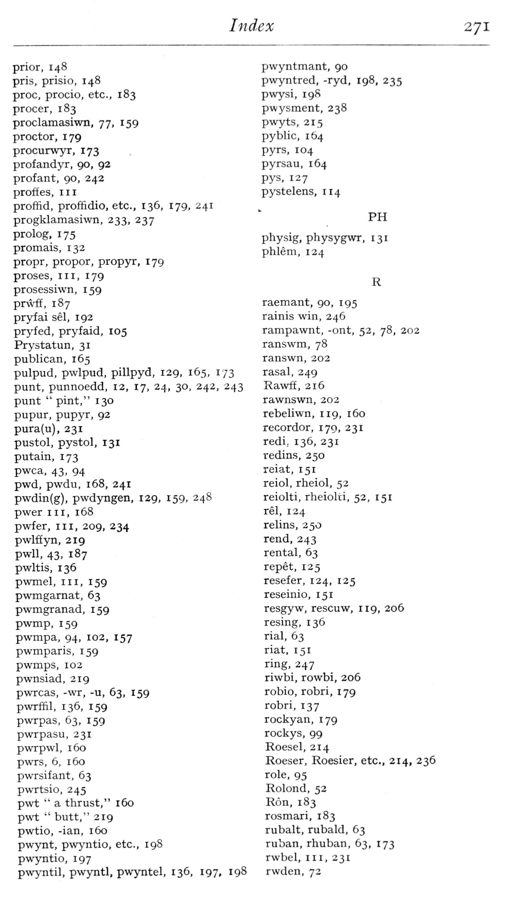  (delwedd F7022) (tudalen 271) | Index  271  prior, 148  pris, prisio, 148  proc, procio, etc., 183  procer, 183  proclamasiwn, 77, 159  proctor, 179  procurwyr, 173  profandyr, 90, 92  profant, 90, 242  proftes, III  proffid, proffidio, etc., 136, 179, 241  progklamasiwn, 233, 237  prolog, 175  promais, 132  propr, propor, propyr, 179  proses. III, 179  prosessiwn, 159  prwff, 187  pryfai sel, 192  pryfed, pryfaid, 105  Prystatun, 31  publican, 165  pulpud, pwlpud, pillpyd, 129, 165, 173  punt, punnoedd, 12, 17, 24, 30, 242, 243  punt “pint," 130  pupur, pupyr, 92  pura(u), 231  pustol, pystol, 131  putain, 173  pwca, 43, 94  pwd, pwdu, 168, 241  pwdin{g), pwdyngen, 129, 159, 248  pwer III, 168  pwfer. III, 209, 234  pwlffyn, 219  pwU, 43, 187  pwltis, 136  pwmel. III, 159  pwmgarnat, 63  pwmgranad, 159  pwmp, 159  pwmpa, 94, 102, 157  pwmparis, 159  pwmps, 102  pwnsiad, 219  pwrcas, -wr, -u, 63, 159  pwrffil, 136, 159  pwrpas, 63, 159  pwrpasu, 231  pwrpwl, 160  pwrs, 6, 160  pwrsifant, 63  pwrtsio, 245  pwt “a thrust," 160  pwt "butt," 219  pwtio, -ian, 160  pwynt, p\v>mtio, etc., 198  pwyntio, 197  pwyntil, pwyntl, pwyntel, 136, 197, 198  pwyntmant, 90  pwyntred, -ryd, 198, 235  pwysi, 19S  pwysment, 238  pwyts, 215  pyblic, 164  pyrs, 104  pyrsau, 164  pys, 127  pystelens, 1x4  PH  physig, physygwr, 131  phlem, 124  R  raemant, 90, 195  rainis win, 246  rampawnt, -ont, 52, 78, 202  ranswm, 78  ranswn, 202  rasal, 249  RawfE, 216  rawnswn, 202  rebeliwn, 119, 160  recorder, 179, 231  redi, 136, 231  redins, 250  reiat, 151  reiol, rheiol, 52  reiolti, rheiolti, 52, 151  rel, 124  relins, 250  rend, 243  rental, 63  repet, 125  resefer, 124, 125  reseinio, 151  resgyw, rescuw, 119, 206  resing, 136  rial, 63  riat, 151  ring, 247  riwbi, rowbi, 206  robio, robri, 179  robri, 137  rockyan, 179  rockys, 99  Roesel, 214  Roeser, Roesier, etc., 214, 236  role, 95  Rolond, 52  Ron, 183  rosmari, 183  rubalt, rubald, 63  ruban, rhuban, 63, 173  rwbel. III, 231  rvvden, 72
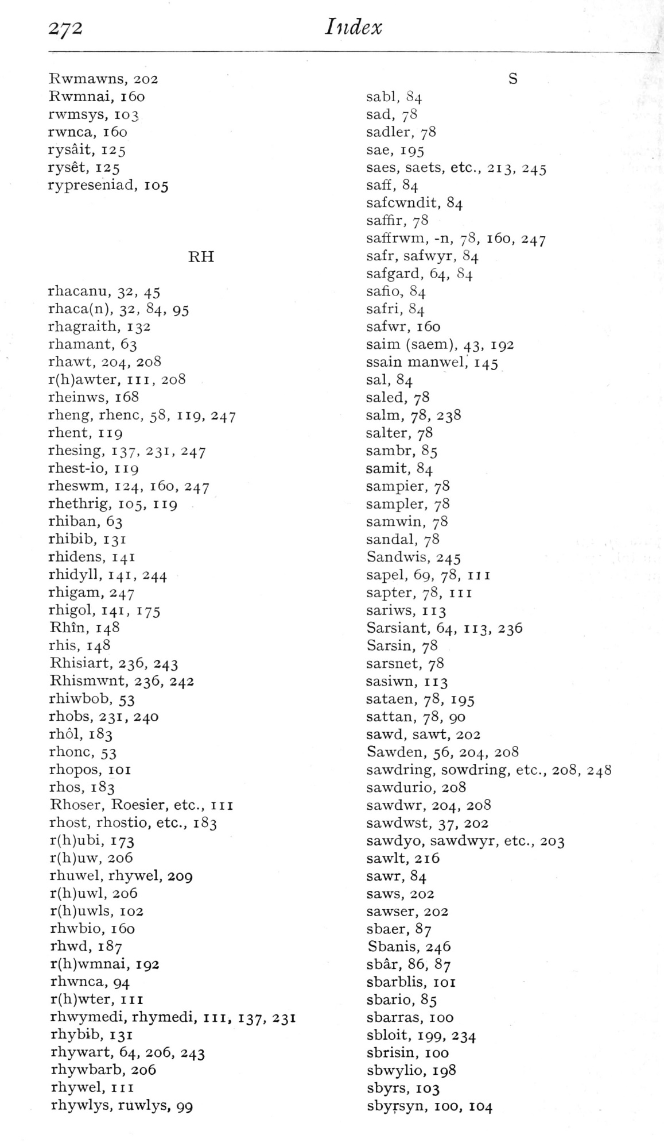  (delwedd F7023) (tudalen 272) | 272  Index  Rwmawns, 202  Rwmnai, 160  rwmsys, 103  rwnca, 160  rysait, 125  ryset, 125  rypreseniad, 105  RH  rhacanu, 32, 45  rhaca(n), 32, 84, 95  rhagraith, 132  rhamant, 63  rhawt, 204, 208  r(h)awter, 11 1, 208  rheinws, 168  rheng, rhenc, 58, 119, 247  rhent, 119  rhesing, 137, 231, 247  rhest-io, 119  rheswm, 124, 160, 247  rhethrig, 105, 119  rhiban, 63  rhibib, 131  rhidens, 141  rhidyll, 141, 244  rhigam, 247  rhigol, 141, 175  Rhin, 148  rhis, 148  Rhisiart, 236, 243  Rhismwnt, 236, 242  rhiwbob, 53  rhobs, 231, 240  rhol, 183  rhonc, 53  rhopos, loi  rhos, 183  Rhoser, Roesier, etc., iii  rhost, rhostio, etc., 183  r{h)ubi, 173  r(h)uw, 206  rhuwel, rhywel, 209  r(h)uwl, 206  r(h)uwls, 102  rhwbio, 160  rhwd, 187  r(h)wmnai, 192  rhwnca, 94  r(h)vvi;er, iii  rhwymedi, rhymedi, iii, 137, 231  rhybib, 131  rhywart, 64, 206, 243  rhywbarb, 206  rhywel, in  rhywlys, ruwlys, 99  sabl, 84  sad, 78  Sadler, 78  sae, 195  saes, saets, etc., 213, 245  saff, 84  safcwndit, 84  saffir, 78  saffrwm, -n, 78, 160, 247  safr, safwyr, 84  safgard, 64, 84  safio, 84  safri, 84  safwr, 160  saim (saem), 43, 192  ssain manwel, 145  sal, 84  salad, 78  salm, 78, 238  Salter, 78  sambr, 85  samit, 84  sampler, 78  sampler, 78  s am win, 78  sandal, 78  Sandwis, 245  sapel, 69, 78, III  sapter, 78, in  sariws, 113  Sarsiant, 64, 113, 236  Sarsin, 78  sarsnet, 78  sasiwn, 113  sataen, 78, 195  sattan, 78, 90  sawd, sawt, 202  Sawden, 56, 204, 208  sawdring, sowdring, etc., 208, 248  sawdurio, 208  sawdwr, 204, 208  sawdwst, 37, 202  sawdyo, sawdwyr, etc., 203  sawlt, 216  sawr, 84  saws, 202  sawser, 202  sbaer, 87  Sbanis, 246  sbar, 86, 87  sbarblis, loi  sbario, 85  sbarras, 100  sbloit, 199, 234  sbrisin, 100  sbwylio, 198  sbyrs, 103  sbyrsyn, 100, 104
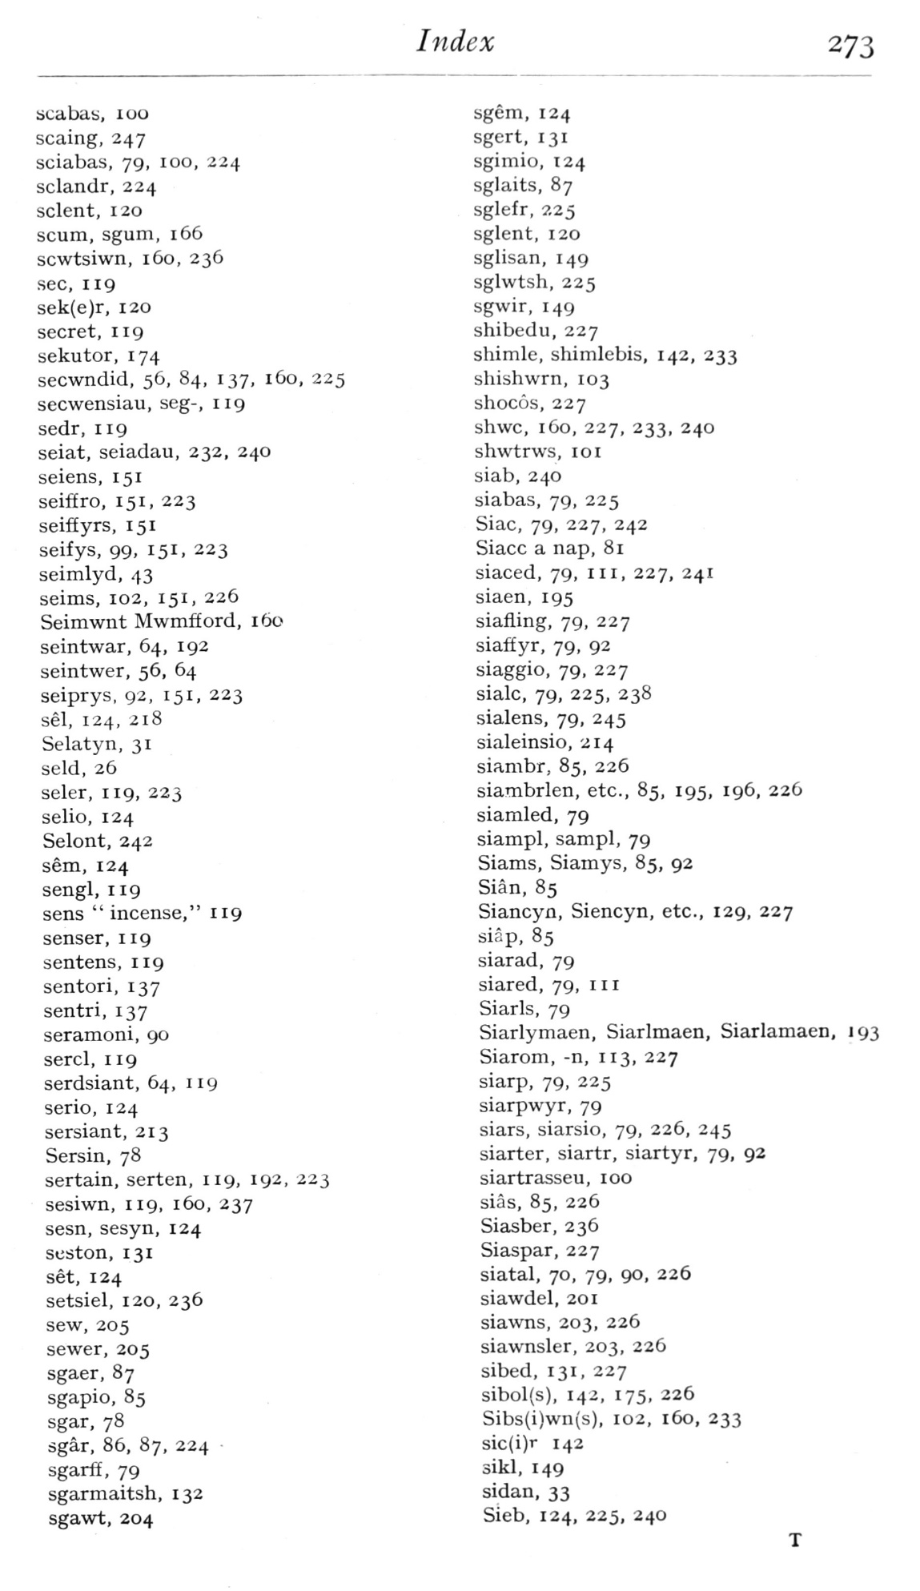  (delwedd F7024) (tudalen 273) | Index  273  bcabati, 100  scaing, 247  sciabas, 79, 100, 224  sclandr, 224  sclent, 120  scum, sgum, 166  scwtsiwn, 160, 236  sec, 119  sek(e)r, 120  secret, 119  sekutor, 174  secwndid, 56, 84, 137, 160, 225  secwensiau, seg-, 119  sedr, 119  seiat, seiadau, 232, 240  seiens, 151  seiffro, 151, 223  seifEyrs, 151  seifys, 99, 151. 223  seimlyd, 43  seims, 102, 151, 226  Seimwnt Mwmfford, 160  seintwar, 64, 192  seintwer, 56, 64  seiprys, 92, 151, 223  sel, 124, 218  Selatyn, 31  seld, 26  seler, 119, 223  selio, 124  Selont, 242  sem, 124  sengl, 119  sens “incense," 119  senser, 119  sentens, 119  sentori, 137  sentri, 137  seramoni, 90  sercl, 119  serdsiant, 64, 119  serio, 124  sersiant, 213  Sersin, 78  sertain, serten, 119, 192, 223  sesiwn, 119, 160, 237  sesn, sesyn, 124  seston, 131  set, 124  setsiel, 120, 236  sew, 205  sewer, 205  sgaer, 87  sgapio, 85  sgar, 78  sgar, 86, 87, 224  sgarff, 79  sgarmaitsh, 132  sgawt, 204  sgem, 124  sgcrt, 131  sgimio, 124  sglaits, 87  sglefr, 225  sglent, 120  sglisan, 149  sglwtsh, 225  sgwir, 149  shibedu, 227  shimle, shimlebis, 142, 233  shishwrn, 103  shocos, 227  shwc, 160, 227, 233, 240  shwtrws, 10 1  slab, 240  siabas, 79, 225  Siac, 79, 227, 242  Siacc a nap, 81  siaced, 79, iii, 227, 241  siaen, 195  siafiing, 79, 227  siaffyr, 79, 92  siaggio, 79, 227  sialc, 79, 225, 238  sialens, 79, 245  sialeinsio, 214  siambr, 85, 226  siambrlen, etc., 85, 195, 196, 226  siamled, 79  siampl, sampl, 79  Siams, Siamys, 85, 92  Sian, 85  Siancyn, Siencyn, etc., 129, 227  siap, 85  siarad, 79  siared, 79, 1 1 1  Siarls, 79  Siarlymaen, Siarlmaen, Siarlamaen, 193  Siarom, -n, 113, 227  siarp, 79, 225  siarpwyr, 79  siars, siarsio, 79, 226, 245  siarter, siartr, siartyr, 79, 92  siartrasseu, 100  sias, 85, 226  Siasber, 236  Siaspar, 227  siatal, 70, 79, 90, 226  siawdel, 201  siawns, 203, 226  siawnsler, 203, 226  sibed, 131, 227  sibol(s), 142, 175, 226  Sibs(i)wn(s), 102, 160, 233  sic(i)r 142  sikl, 149  sidan, 33  Sieb, 124, 225, 240
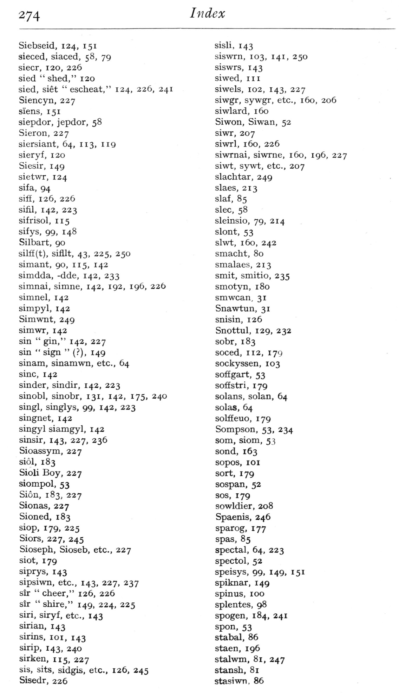  (delwedd F7025) (tudalen 274) | 274  Index  Siebseid, 124, 151  sieced, siaced, 58, 79  siecr, 120, 226  sied “shed," 120  sied, siet “escheat," 124, 226, 241  Siencyn, 227  s'iens, 151  siepdor, jepdor, 58  Sieron, 227  siersiant, 64, 113, iig  sieryf, 120  Siesir, 149  sietwr, 124  sifa, 94  sifE, 126, 226  sifil, 142, 223  sifrisol, 115  sifys, 99, 148  Silbart, 90  silff(t), sifilt, 43, 225, 250  simant, 90, 115, 142  simdda, -dde, 142, 233  simnai, simne, 142, 192, 196, 226  simnel, 142  simpyl, 142  Simwnt, 249  simwr, 142  sin “gin," 142, 227  sin “sign” (?), 149  sinam, sinamwn, etc., 64  sine, 142  sinder, sindir, 142, 223  sinobl, sinobr, 131, 142, 175, 240  singl, singlys. 99. 142, 223  singnet, 142  singyl siamgyl, 142  sinsir, 143, 227, 236  Sioassym, 227  siol, 183  Sioli Boy, 227  siompol, 53  Sion, 183, 227  Sionas, 227  Sioned, 183  siop, 179, 225  Siors, 227, 245  Sioseph, Sioseb, etc., 227  siot, 179  siprys, 143  sipsiwn, etc., 143, 227, 237  sir “cheer," 126, 226  sir “shire," 149, 224, 225  siri. siryf, etc., 143  sirian, 143  sirins, loi, 143  sirip, 143, 240  sirken, 115, 227  sis, sits, sidgis, etc., 126, 245  Sisedr, 226  sisli. 143  siswrn, 103, 141, 250  siswrs, 143  siwed, III  siwels, 102, 143, 227  siwgr, sywgr, etc., 160, 206  siwlard, 160  Siwon, Siwan, 52  siwr, 207  siwrl, 160, 226  siwrnai, siwrne, 160, 196, 227  siwt, sywt, etc., 207  slachtar, 249  slaes, 213  slaf, 85  slec, 58  sleinsio, 79, 214  slont, 53  slwt, 160, 242  smacht, 80  smalaes, 213  smit, smitio, 235  smotyn, 180  smwcan. 31  Snawtun, 31  snisin, 126  Snottul, 129, 232  sobr, 183  soced, 112, 179  sockyssen, 103  soffgart, 53  soffstri, 179  solans, solan, 64  solas, 64  solffeuo, 179  Sompson, 53, 234  som, siom, 53  sond, 163  sopos, lOI  sort, 179  sospan, 52  SOS, 179  sowldier, 208  Spaenis, 246  sparog, 177  Spas, 85  spectal, 64, 223  spectol, 52  speisys, 99, 149, 151  spiknar, 149  spinus, 100  splentes, 98  spogen, 184, 241  spon, 53  stabal, 86  staen, 196  stalwm, 81, 247  stansh, 81  stasiwn. 86
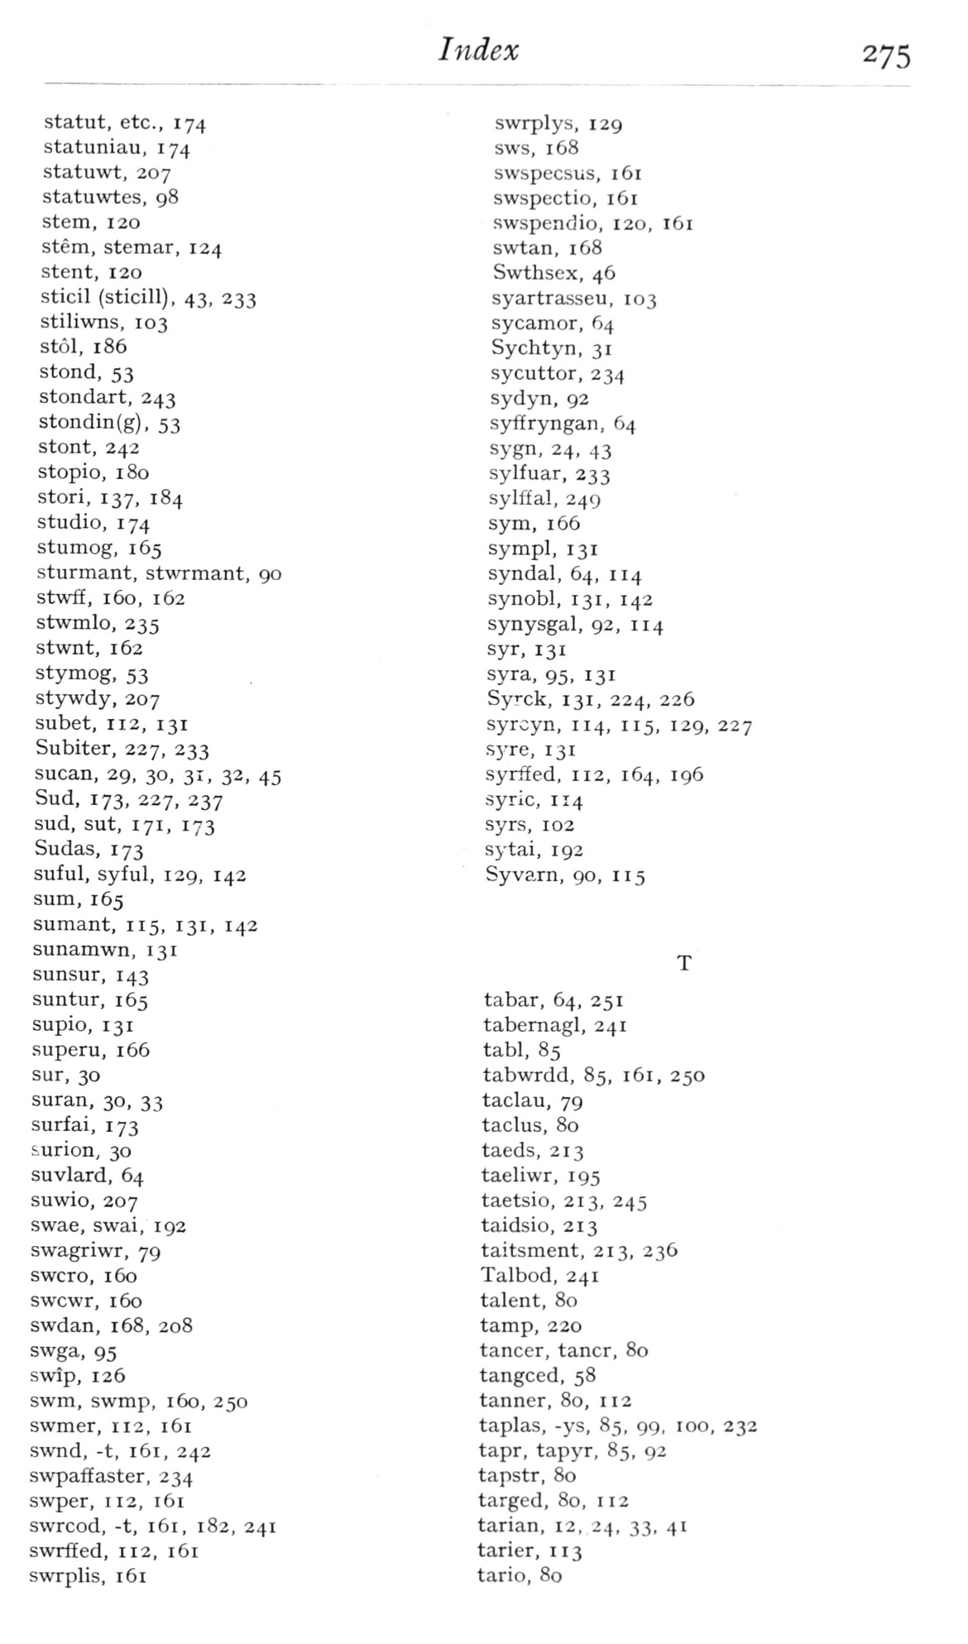  (delwedd F7026) (tudalen 275) | Index  275  statut, etc., 174  statuniau, 174  statuwt, 207  statuwtes, 98  stem, 120  stem, stemar, 124  stent, 120  sticil (sticill), 43, 233  stiliwns, 103  st61, 186  stond, 53  stondart, 243  stondin(g), 53  stont, 242  stopio, 180  stori, 137, 184  studio, 174  stumog, 165  sturmant, stwrmant, 90  stwff, 160, 162  stwmlo, 235  stwnt, 162  stymog, 53  stywdy, 207  subet, 112, 131  Subiter, 227, 233  sucan, 29, 30, 31, 32, 45  Sud, 173, 227, 237  sud, sut, 171, 173  Sudas, 173  suful, syful, 129, 142  sum, 165  sumant, 115, 131, 142  sunamwn, 131  sunsur, 143  suntur, 165  supio, 131  superu, 166  sur, 30  suran, 30, 33  surfai, 173  surion, 30  suvlard, 64  suwio, 207  swae, swai, 192  swagriwr, 79  swcro, 160  swcwr, 160  swdan, 168, 208  swga, 95  swip, 126  swm, svvmp, 160, 250  swmer, 112, 161  swnd, -t, 161, 242  swpaffaster, 234  swper, 112, 161  swrcod, -t, 161, 182, 241  swrffed, 112, 161  swrplis, 161  swrplys, 129  sws, 168  swspecsus, 161  swspectio, 161  swspendio, 120, 161  swtan, 168  Swthsex, 46  syartrasseu, 103  sycamor, 64  Sychtyn, 31  sycuttor, 234  sydyn, 92  syffryngan, 64  sygn, 24, 43  sylfuar, 233  sylfEa!, 249  sym, 166  sympl, 131  syndal, 64, 114  synobl, 131, 142  synysgal, 92, 114  syr, 131  syra, 95, 131  Syck, 131, 224, 226  syrcyn, 114, 115, 129, 227  sj-re, 131  syrffed, 112, 164, 196  syric, 114  syrs, 102  sytai, 192  Syvarn, 90, 115  tabar, 64, 251  tabemagl, 241  tabl, 85  tabwrdd, 85, 161, 250  taclau, 79  taclus, 80  taeds, 213  taeliwr, 195  taetsio, 213, 245  taidsio, 213  taitsment, 213, 236  Talbod, 241  talent, 80  tamp, 220  tancer, tancr, 80  tangced, 58  tanner, 80, 112  taplas, -ys, 85, 99, 100, 232  tapr, tapyr, 85, 92  tapstr, 80  targed, 80, 112  tarian, 12, 24, 33, 41  tarier, 113  tario, 80
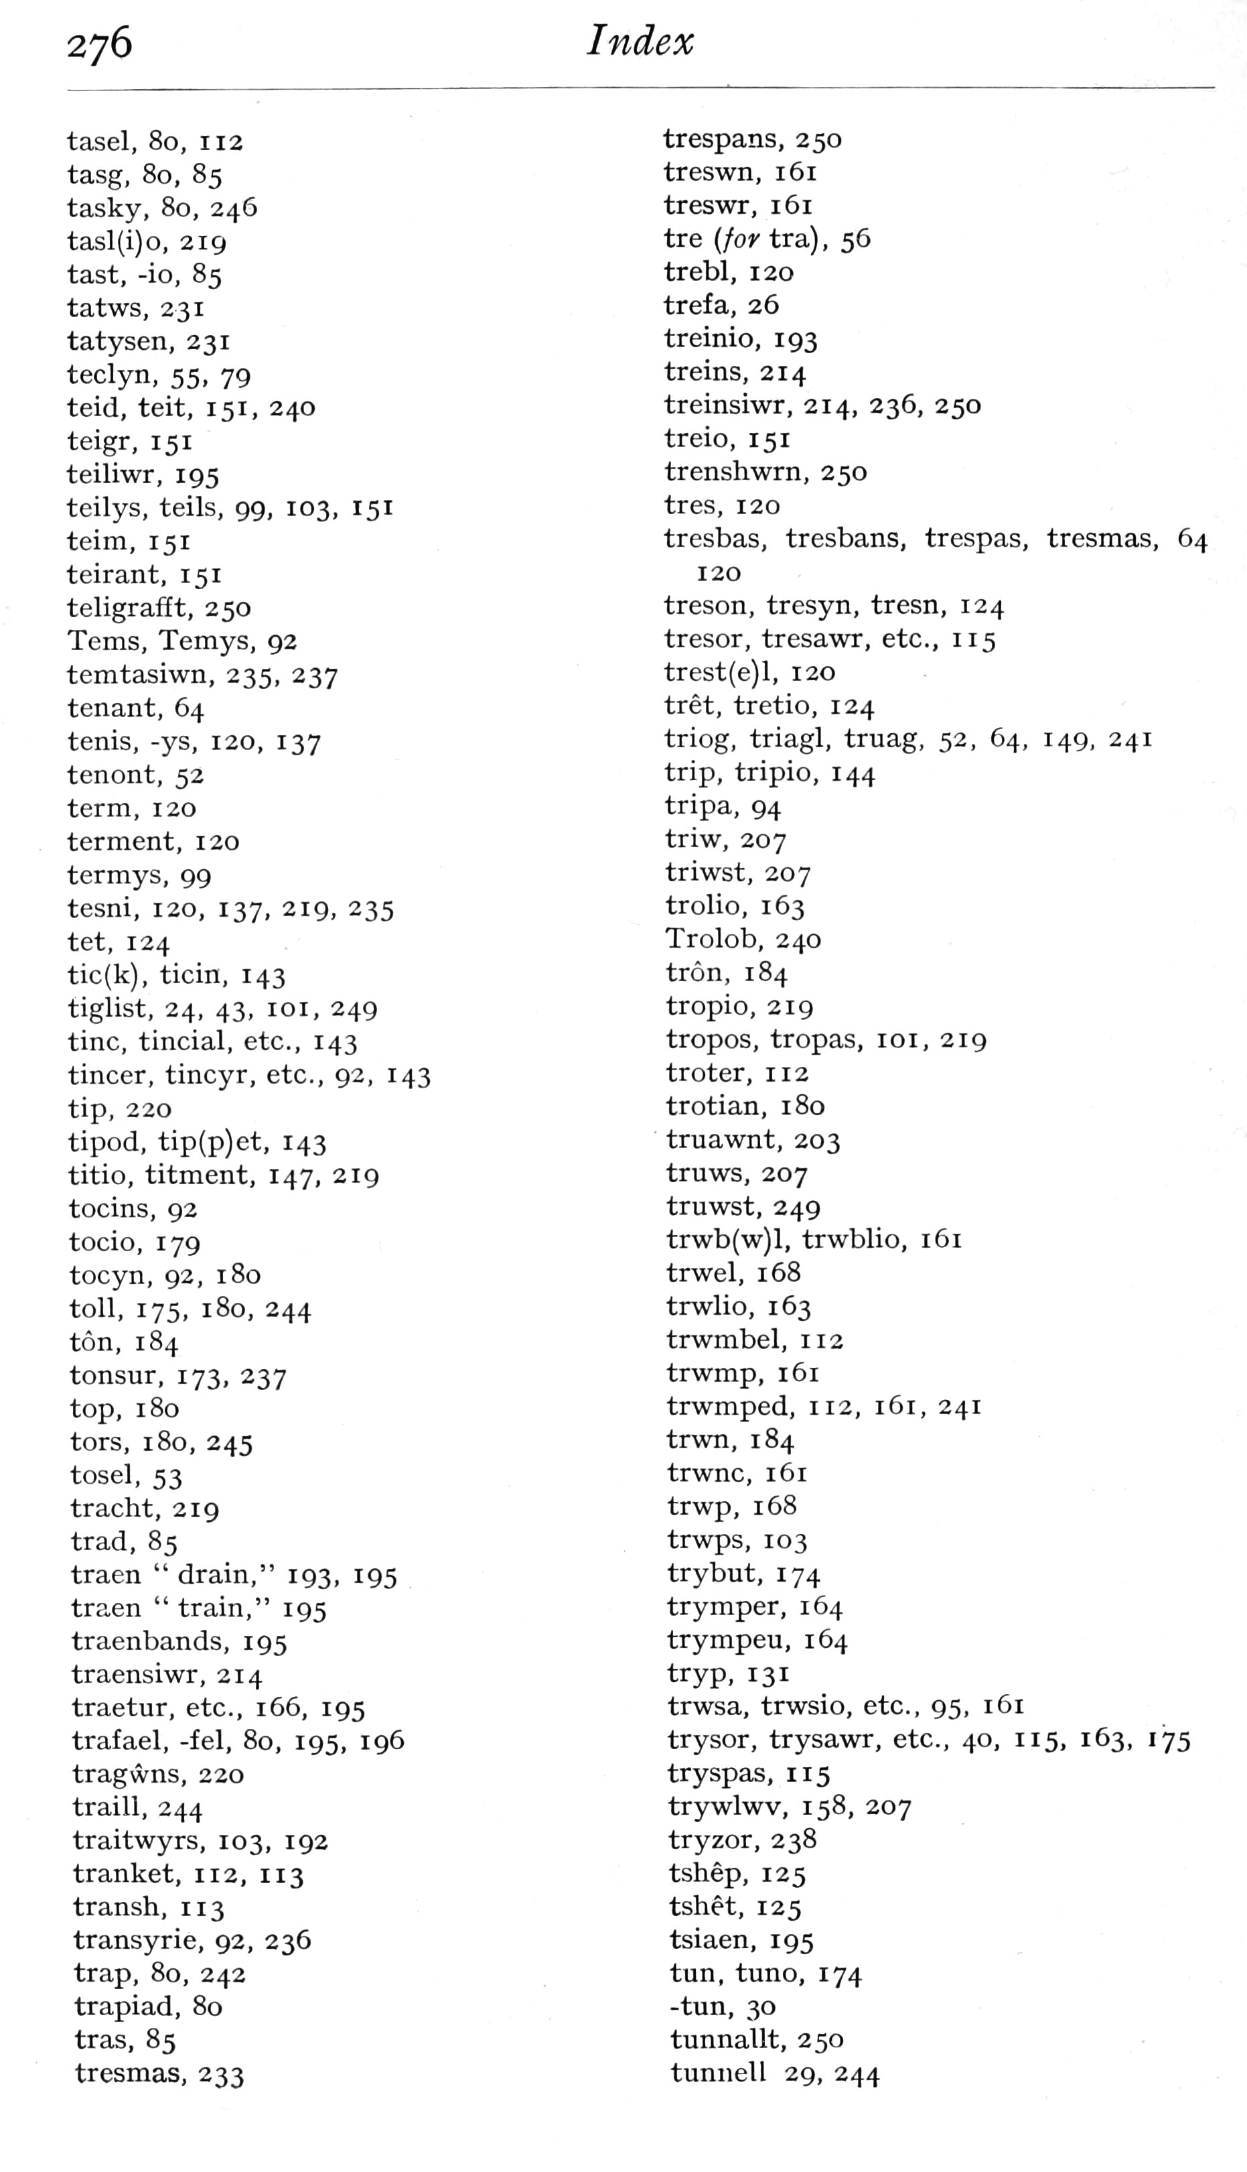  (delwedd F7027) (tudalen 276) | 276  Index  tasel, 80, 112  tasg, 80, 85  tasky, 80, 246  tasl(i)o, 219  tast, -io, 85  tatws, 231  tatysen, 231  teclyn, 55, 79  teid, teit, 151, 240  teigr, 151  teiliwr, 195  teilys, teils, 99, 103, 151  teim, 151  teirant, 151  teligrafft, 250  Terns, Temys, 92  temtasiwn, 235, 237  tenant, 64  tenis, -ys, 120, 137  tenont, 52  term, 120  terment, 120  termys, 99  tesni, 120, 137, 219, 235  tet, 124  tic(k), ticin, 143  tiglist, 24, 43, loi, 249  tine, tincial, etc., 143  tincer, tincyr, etc., 92, 143  tip, 220  tipod, tip(p)et, 143  titio, titment, 147, 219  tocins, 92  tocio, 179  tocyn, 92, 180  toll, 175, 180, 244  ton, 184  tonsur, 173, 237  top, 180  tors, 180, 245  tosel, 53  tracht, 219  trad, 85  traen “drain," 193, 195  traen “train," 195  traenbands, 195  traensiwr, 214  traetur, etc., 166, 195  trafael, -fel, 80, 195, 196  tragwns, 220  trail!, 244  traitwyrs, 103, 192  tranket, 112, 113  transh, 113  transyrie, 92, 236  trap, 80, 242  trapiad, 80  tras, 85  tresmas, 233  trespans, 250  treswn, 161  treswr, 161  tre {for tra) , 56  trebl, 120  trefa, 26  treinio, 193  treins, 214  treinsiwr, 214, 236, 250  treio, 151  trenshwrn, 250  tres, 120  tresbas, tresbans, trespas, tresmas, 64  120  treson, tresyn, tresn, 124  tresor, tresawr, etc., 115  trest(e)l, 120  tret, tretio, 124  triog, triagl, truag, 52, 64, 149, 241  trip, tripio, 144  tripa, 94  triw, 207  triwst, 207  trolio, 163  Trolob, 240  tron, 184  tropio, 219  tropos, tropas, loi, 219  troter, 112  trotian, 180  truawnt, 203  truws, 207  truwst, 249  trwb(w)l, trwblio, 161  trwel, 168  trwlio, 163  trwmbel, 112  trwmp, 161  trwmped, 112, 161, 241  trwn, 184  trwnc, 161  trwp, 168  trwps, 103  trybut, 174  trymper, 164  trympeu, 164  tryp, 131  trwsa, trwsio, etc., 95, 161  trysor, trysawr, etc., 40, 115, 163, 175  tryspas, 115  trywlwv, 158, 207  tryzor, 238  tshep, 125  tshet, 125  tsiaen, 195  tun, tuno, 174  -tun, 30  tunnallt, 250  tumiell 29, 244
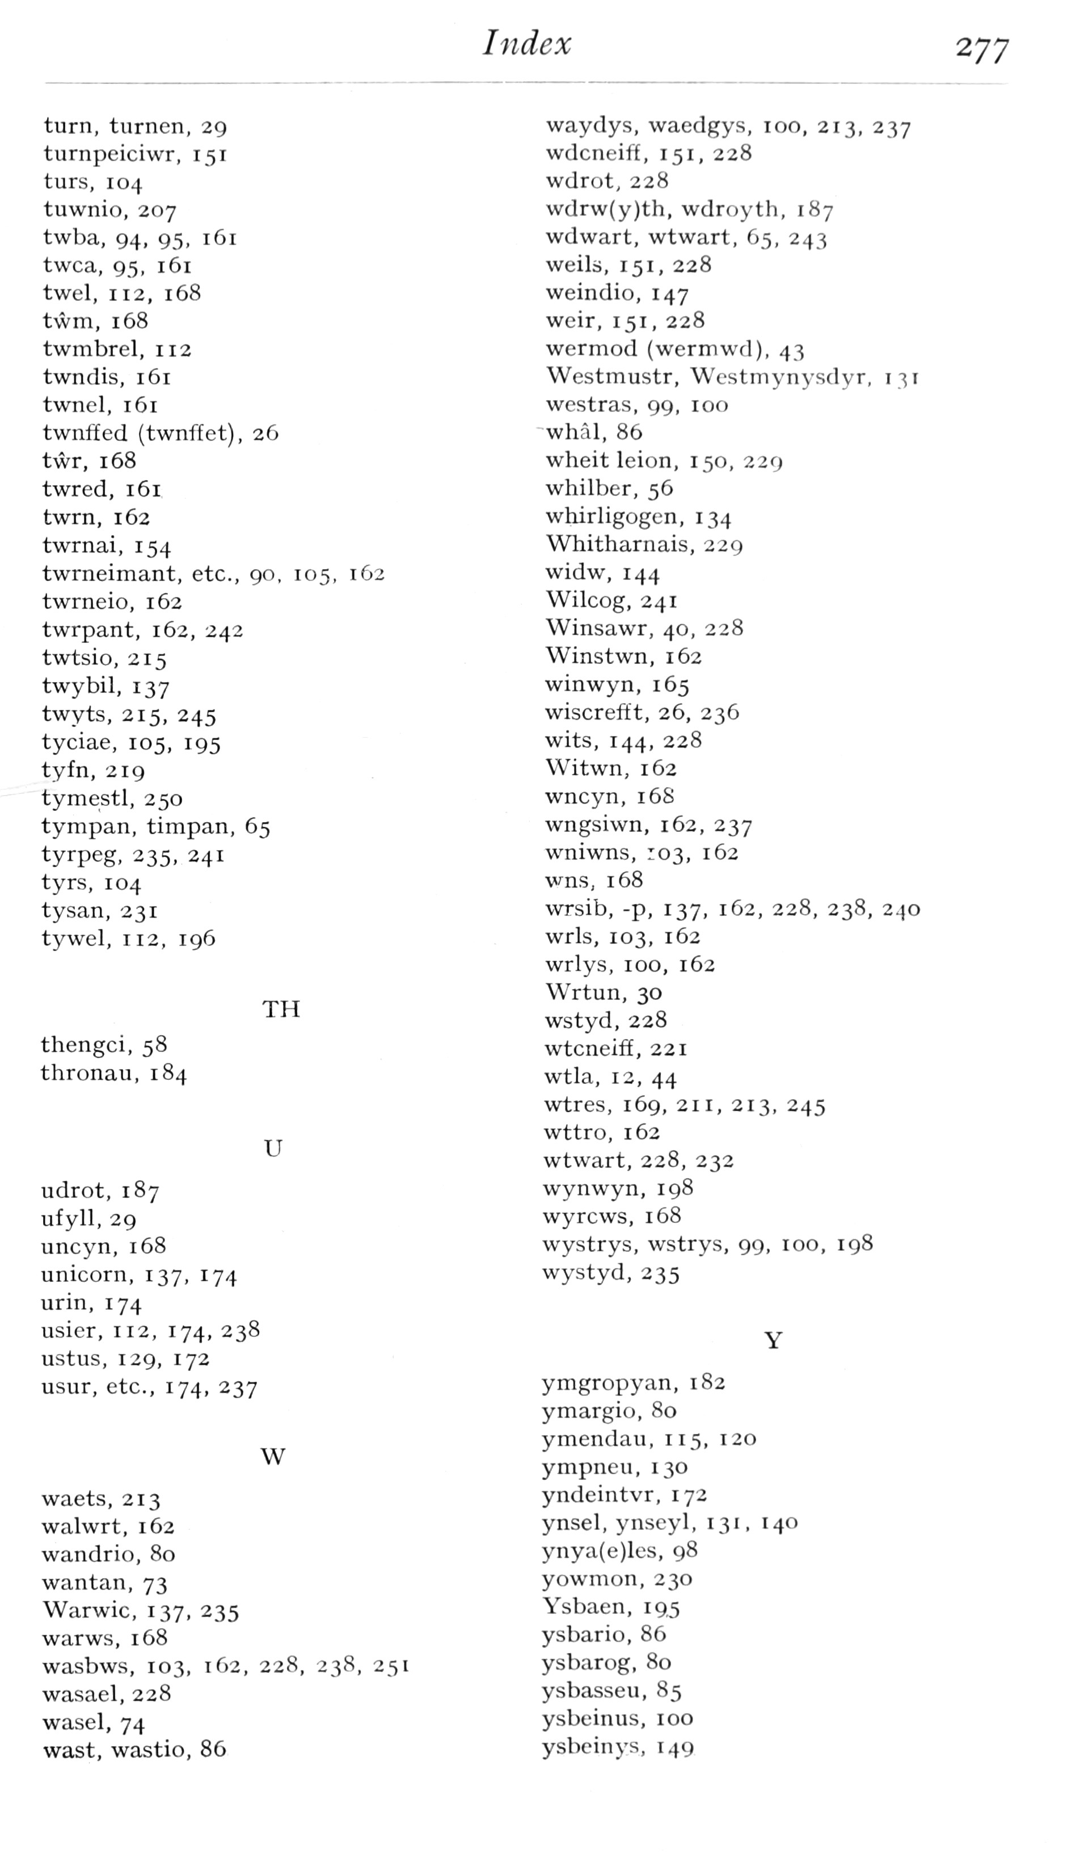  (delwedd F7028) (tudalen 277) | Index  277  turn, turnen, 29  turnpciciwT, 151  turs, 104  tuwnio, 207  twba, 94, 95, 161  twca, 95, 161  twel, 112, 168  twm, 168  twmbrel, 112  twndis, 161  twnel, 161  twnffed (twnffet), 26  twr, 168  twred, 161  twm, 162  twrnai, 154  twrneimant, etc., 90, 105, 162  twrneio, 162  twrpant, 162, 242  twtsio, 215  twybil, 137  twyts, 215, 245  tyciae, 105, 195  tyfn, 219  tymestl, 250  tympan, timpan, 65  tyrpeg, 235, 241  tyrs, 104  tysan, 231  tywel, 112, 196  TH  thengci, 58  thronau, 184  U  udrot, 187  ufyll, 29  uncyn, 168  unicorn, 137, 174  urin, 174  usier, 112, 174, 238  ustus, 129, 172  usur, etc., 174, 237  W  waets, 213  walwrt, 162  wandrio, 80  wantan, 73  Warwic, 137, 235  warws, 168  wasbws, 103, 162, 228, 238, 251  wasael, 228  wasel, 74  wast, wastio, 86  waydys, waedgys, 100, 213, 237  wdcneiff, 151, 228  wdrot, 228  wdrw(y)th, wdroyth, 187  wdwart, wtwart, 65, 243  weils, 151, 228  weindio, 147  weir, 151, 228  wermod (wermwd), 43  Westmustr, Wcstmynysdyr, 131  westras, 99, 100  -wMl, 86  wheit leion, 150, 229  whilber, 56  whirligogcn, 134  Whitharnais, 229  widw, 144  Wilcog, 241  Winsawr, 40, 228  Winstwn, 162  winwyn, 165  wiscrefft, 26, 236  wits, 144, 228  Witwn, 162  wncyn, 16S  wngsiwn, 162, 237  wniwns, 103, 162  wns, 168  wrsib, -p, 137, 162, 228, 238, 2^o  wrls, 103, 162  wrlys, 100, 162  Wrtun, 30  wstyd, 228  wtcneiff, 221  wtla, 12, 44  wtres, 169, 211, 213, 245  wttro, 162  wtwart, 228, 232  wynwyn, 198  wyrcws, 168  wystrys, wstrys, 99, 100, 198  wystyd, 235  ymgropyan, 182  ymargio, 80  ymendau, 115, 120  ympneu, 130  yndeintvr, 172  ynsel, ynseyl, 131, 140  ynya(e)les, 98  yowmon, 230  Ysbaen, 19.5  ysbario, 86  ysbarog, 80  ysbasseu, 85  ysbeinus, 100  ysbeinys, 149
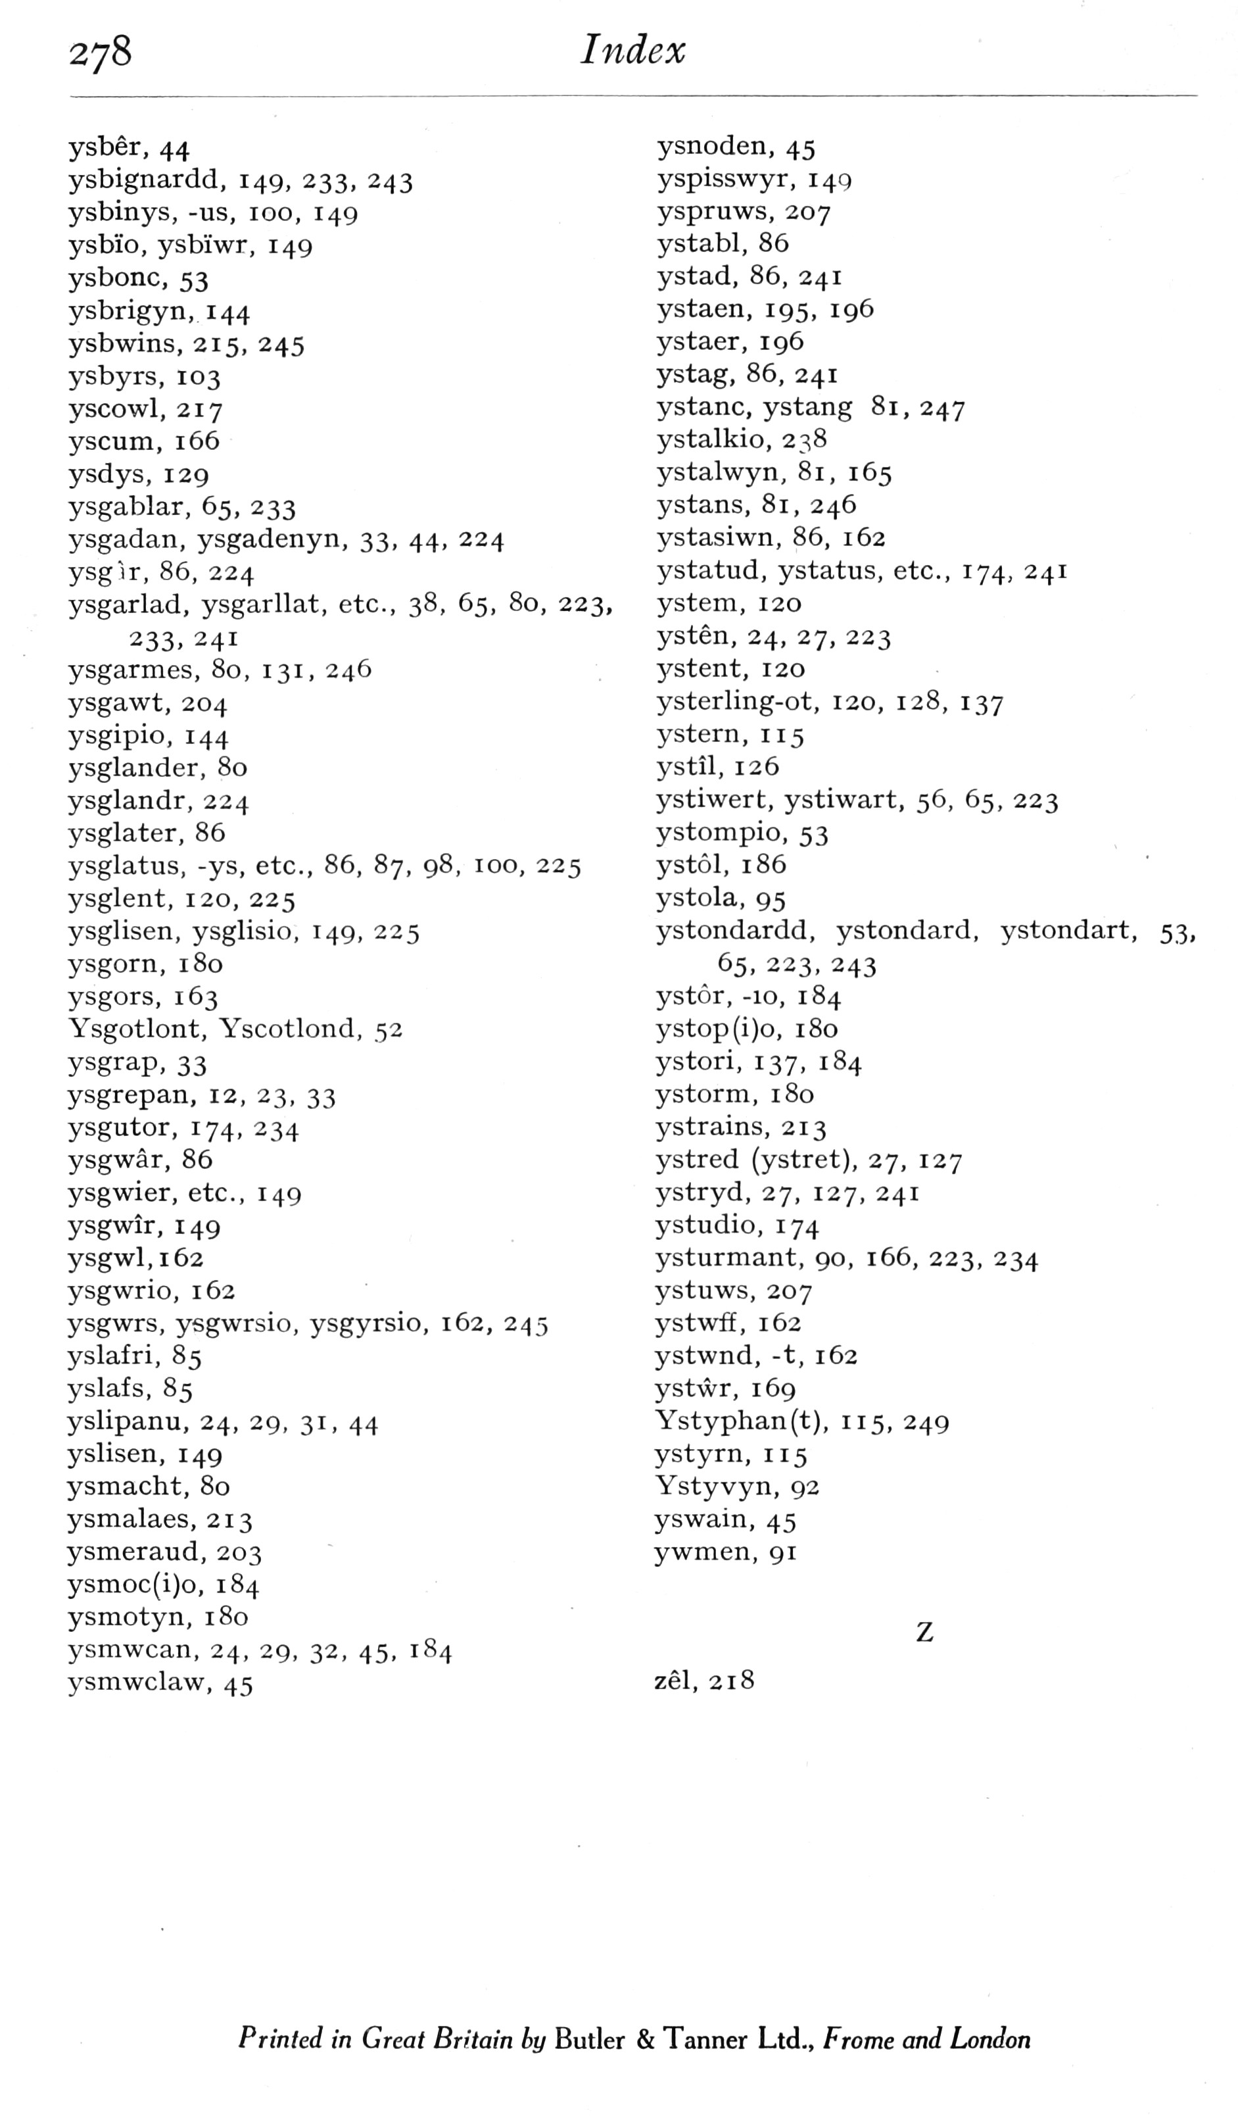  (delwedd F7029) (tudalen 278) | 278  Index  ysber, 44  ysbignardd, 149, 233, 243  ysbinys, -us, 100, 149  ysbio, ysbiwr, 149  ysbonc, 53  ysbrigyn, 144  ysbwins, 215, 245  ysbyrs, 103  y scowl, 217  yscum, 166  ysdys, 129  ysgablar, 65, 233  ysgadan, ysgadenyn, 33, 44, 224  ysglr, 86, 224  ysgarlad, ysgarllat, etc., 38, 65, 80, 223,  233. 241  ysgarmes, 80, 131, 246  ysgawt, 204  ysgipio, 144  ysglander, 80  ysglandr, 224  ysglater, 86  ysglatus, -ys, etc., 86, 87, 98, 100, 225  ysglent, 120, 225  ysglisen, ysglisio, 149, 225  ysgorn, 180  ysgors, 163  Ysgotlont, Yscotlond, 52  ysgrap, 33  ysgrepan, 12, 23, 33  ysgutor, 174, 234  ysgwar, 86  ysgwier, etc., 149  ysgwir, 149  ysgwl,i62  ysgwrio, 162  ysgwrs, ysgwrsio, ysgyrsio, 162, 245  yslafri, 85  yslafs, 85  yslipanu, 24, 29, 31, 44  yslisen, 149  ysmacht, 80  ysmalaes, 213  ysmeraud, 203  ysmoc(i)o, 184  ysmotyn, 180  ysmwcan, 24, 29, 32, 45, 184  ysmwclaw, 45  ysnoden, 45  yspisswyr, 149  yspruws, 207  ystabl, 86  ystad, 86, 241  ystaen, 195, 196  ystaer, ig6  ystag, 86, 241  ystanc, ystang 81, 247  ystalkio, 238  ystalwyn, 81, 165  ystans, 81, 246  ystasiwn, 86, 162  ystatud, ystatus, etc., 174, 241  ystem, 120  ysten, 24, 27, 223  ystent, 120  ysterling-ot, 120, 128, 137  ystem, 115  ystil, 126  ystiwert, ystiwart, 56, 65, 223  ystompio, 53  ystol, 186  ystola, 95  ystondardd, ystondard, ystondart, 53,  65, 223, 243  ystor, -10, 184  ystop(i)o, 180  ystori, 137, 184  y storm, 180  ystrains, 213  ystred (ystret), 27, 127  ystryd, 27, 127, 241  ystudio, 174  ysturmant, 90, 166, 223, 234  ystuws, 207  ystwff, 162  ystwnd, -t, 162  ystwr, 169  Ystyphan(t), 115, 249  ystyrn, 115  Ystyvyn, 92  yswain, 45  ywmen, 91  zel, 218  Printed in Great Britain by Butler & Tanner Ltd., Frame and London

xyz

Sumbolau:
Gwyddor Seinegol Ryngwladol
ˡ ɑ ɑˑ aˑ a: / æ æ: / e eˑe: / ɛ ɛ: / ɪ iˑ i: ɨ̞ / ɔ oˑ o: / ʊ uˑ u: / ə / ʌ /
ˡ ð ɬ ŋ ʃ ʧ θ ʒ ʤ / aɪ ɔɪ əɪ uɪ ɪʊ aʊ ɛʊ əʊ /
·····
·····
LLAFARIAID: a A / æ Æ / e E / ɛ Ɛ / i I / o O / u U / w W / y Y / ɥ ɥ /
.....
LLYTHRENNAU:
ŵ Ŵ / ẅ Ẅ / ẁ Ẁ / ẃ Ẃ /
ŷ Ŷ / ÿ Ÿ / ỳ Ỳ / ý Ý / ɥ
·····
MACRON: ā Ā / ǣ Ǣ / ē Ē / ɛ̄ Ɛ̄ / ī Ī / ō Ō / ū Ū / w̄ W̄ / ȳ Ȳ /
MACRON + ACEN DDYRCHAFEDIG: Ā̀ ā̀ , Ḗ ḗ, Ī́ ī́ , Ṓ ṓ , Ū́ ū́, (w), Ȳ́ ȳ́
MACRON + ACEN DDISGYNEDIG: Ǟ ǟ , Ḕ ḕ, Ī̀ ī̀, Ṑ ṑ, Ū̀ ū̀, (w), Ȳ̀ ȳ̀
MACRON ISOD: A̱ a̱ , E̱ e̱ , I̱ i̱ , O̱ o̱, U̱ u̱, (w), Y̱ y̱
·····
BREF: ă Ă / ĕ Ĕ / ĭ Ĭ / ŏ Ŏ / ŭ Ŭ / Ў B5236: B5237: ă ĕ ĭ ŏ ŭ
BREF GWRTHDRO ISOD: i̯, u̯
·····
BACHAU: ⟨ ⟩ bachau deiamwnt; « » bachau onglog dwbl; { } bachau crych, cyrliog; [ ] bachau sgwâr, petryal; ( ) cromfachau; < > bachau onglog
·····
SUMBOL / SÝMBOL Y BUNT: £
·····
Hungarumlaut: A̋ a̋
·····
DOT ISOD:
U+1EA0 Ạ U+1EA1 ạ
U+1EB8 Ẹ U+1EB9 ẹ
U+1ECA Ị U+1ECB ị
U+1ECC Ọ U+1EED ọ
U+1EE4 Ụ U+1EE5 ụ
U+1E88 Ẉ U+1E89 ẉ
U+1EF4 Ỵ U+1EF5 ỵ
·····
A’I PHEN I LAWRː ∀, ә, ɐ (u+0250) httpsː //text-symbols.com/upside-down/
·····
Y WENHWYSWEG: ɛ̄ ǣ æ
…..
ʌ ag acen ddyrchafedig / ʌ with acute accentː ʌ́

Ə́ ə́ | Shwa ag acen ddyrchafedig / Schwa with acute
·····
AMRYW:
gyn aith δ δ £ U+2020 DAGGER †
·····
SAETHAU: ← → ; ➵ U+27B5.
·····
wikipedia, scriptsource. org
https://en.wiktionary.org/wiki/ǣ
---------------------------------------
Y TUDALEN HWN: www.http://www.kimkat.org/amryw/1_testunau/english-element-in-welsh_1923_363_rhan-3_3830.htm
---------------------------------------
Creuwyd: ?-
Ffynhonnell:
Adolygiadau diweddaraf - latest updates - 2011-04-22, 2024-12-06
Ffeil gwreiddiol:
Delweddau:
....

Ble’r wyf i? Yr ych chi’n ymwéld ag un o dudalennau’r Gwefan “CYMRU-CATALONIA”
On sóc? Esteu visitant una pàgina de la Web “CYMRU-CATALONIA” (= Gal·les-Catalunya)
Weə(r) àm ai? Yùu àa(r) vízïting ə peij fròm dhə “CYMRU-CATALONIA” (= Weilz-Katəlóuniə) Wéb-sait
Where am I? You are visiting a page from the “CYMRU-CATALONIA” (= Wales-Catalonia) Website
CYMRU-CATALONIA
Edrychwch ar yr Ystadegau / Mireu les estadístiques / See Our Stats
(Llyfrau ac Erthyglau yn y wefan hon / Llibres i articles en aquesta web / Books and Articles on this Website)

